“Men Inspiring Men” is a day to set on your Calendar
Catholic Gentlemen! Please set-aside the date of Saturday, March 9, 2019 for a men’s day of recollection at Saint Julie Billiart. The Knights of Columbus Council #7970 in collaboration with the Men’s Fellowship Breakfast of St. Peter and St. Julie Billiart are presenting a day of recollection “Men Inspiring Men”.
Our day begins at 9:00 a.m. (8:45 check-in) and will run until 4:00 p.m. Coffee and donuts at check-in and lunch will be served.
Attending MIM is a blessing, with the presence of faithful friends and Catholic Brothers to provide the encouragement and accountability to our faith. Indeed, as the Scriptures tell us, “as iron sharpens iron, so one man must “sharpen another” (Proverbs 27:17).

If you have questions contact Men Inspiring Men team members Ed Kollin at edkollin@hotmail.com (440)864-7574 or Ray McConaghy at raymcconaghy2@gmail.com (440)723-7062.
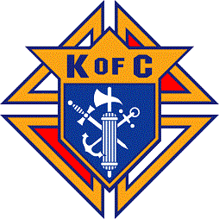
Presented bt Knights of Columbus Council #7970

--------------------------------------------------------------------------------------------------------------------------------------
Registration Form for MIM Day of Recollection Saturday, March 9, 2019
Scriptures tell us, “as iron sharpens iron, so one man must sharpen another”
(Proverbs 27:17).

Print Name _____________________________________ Parish _______________
Address ___________________________________________________________________________________
Phone # ____________________________ E-mail ___________________________________________
Any Dietary needs if required _________________________________________________________________
Name to call in an emergency___________________________________ Phone #_______________________
Registration fee is $15.00. Please make your check payable to K of C Council #7970 at check-in, or mail in advance to:
K of C ℅ Ray McConaghy, 7084 Wil-Lou Ln, North Ridgeville, OH 44039.
PLEASE CONFIRM REGISTRATION by MARCH 2, 2019 FOR PLANNING PURPOSES.
RSVP TO: Ray McConaghy raymcconaghy2@gmail.com or 440-723-7062. THANK YOU!

