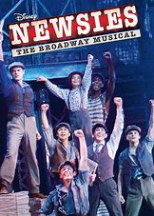

T-Shirt Order Form for Newsies!
The time has come for our annual show t-shirts! This year we are featuring the artwork of Madisyn Kaijala, Anna Labrousse, Payton MacAllister and Casey Seem. Please fill out the information below and return by Saturday February 9th

Name ____________________________________

Shirts are $10 each
Youth Small ___
Youth Medium ___
Youth Large ___
Youth XL ___

Adult Small ___
Adult Medium ___
Adult Large ___
Adult XL ___
Adult XXL ___ (please add $2)

Total Number of Shirts _____
Amount Enclosed _____

Cash ____ Check ______

