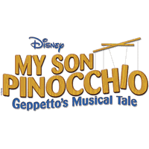
T-Shirt Order Form for Disney's My Son Pinocchio: Geppetto's Musical Tale!
The time has come for our annual show t-shirts! This year we are featuring the artwork of Olivia Plouffe and Maddie Malcolmson on our shirts. Also, Mady Kaijala, Olivia Phillips and Piper Lajoie will be featured on our tickets and programs. Please fill out the information below and return by Saturday February 15th

Name ____________________________________

Shirts are $10 each
Youth Small ___
Youth Medium ___
Youth Large ___
Youth XL ___

Adult Small ___
Adult Medium ___
Adult Large ___
Adult XL ___
Adult XXL ___ (please add $2)

Total Number of Shirts _____
Amount Enclosed _____

Cash ____ Check ______

