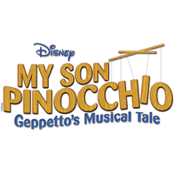
Cast Party for Disney's My Son Pinocchio: Geppetto's Musical Tale!
When: Sunday March 22nd after the stage is broken down
Where: In the HCS Cafeteria
Who’s invited: Cast members and immediate family only
Unfortunately, there is not enough room for anyone other than immediate family
Cost: $5.00 per person for food (pizza, salad, drink, and cake!)
Deadline: Sunday, March 15th
We would also like to collect a $3.00 donation towards a director’s gift
Money and the bottom of this sheet can be turned in at practice to any board member (please don’t give to the directors). Any questions, please contact hubtheatre123@gmail.com

-------------------------------------------------------------------------------------------------------------
Cast member(s) name: ____________________________________
How many people attending including cast member? ____
Total amount included for cast party ______
Total amount included for director’s gift _______

