Our Mission is to create a safe space for kids to be amazing! The students learn a 30 minute musical, plan and create their own sets, costumes and props, along with games and improv!

**Hubbardston Community Theatre Summer Camp!**

**Sign up Now!**

Contact Donna Farrell at:

[Chickenlady@charter.net](mailto:Chickenlady@charter.net)

Cost is : $175.00 for Both Weeks,and Show.

Includes T-shirt, Scripts to keep, Ice Cream Party and more!

Camp is held at The Hubbardston Center School Gym, 8 Elm Street.

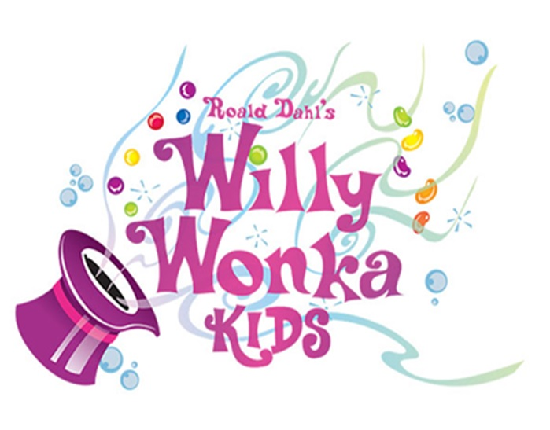

**July 8-12, 9am-3pm**

**July 15-19, 9am-3pm**

**Show July 19th : 7pm**

