

Classic Gourmet Kit - 68.95

A scrumptious selection of our classics!
10 Colored Catalogs
10 Small Carbon Copies
5 Gourmet Seasoning Blends
2 Classic Beer Breads
1 Mama's Meatloaf Mix
1 Fiesta Rice Mild Dinner
1 Ragin Cajun Jambalaya Dinner
1 Creamy Potato Soup Mix
1 Mama's Butter Pecan Muffins
1 Cake and Cobbler Mix
1 Mama's All Around Cookie Mix
1 Jam, Jelly, or Fruit Butter
1 Wickless Wax Melt Pack
Build Your Business Subscription – ($9.95 included in kit price)
- custom personal website Artwork© www.countryclipart.com​
- consultant labeled catalogs for all drop ship orders at no charge
- unlimited websites for fundraising (custom for each organization)
- enrollment into the 30, 60, 90 day bonus – earn store credits and logo items in addition to commission bonuses.

Mini Business Supplies Kit - 15.70

2 Catalogs
5 Order Forms
1 Sesame Garlic Dip Mix
Build Your Business Subscription – ($9.95 included in kit price)
- custom personal website
- consultant labeled catalogs for all drop ship orders at no charge
- unlimited websites for fundraising (custom for each organization)
- enrollment into the 30, 60, 90 day bonus – earn store credits and logo items in addition to commission bonuses.
1 Creamy Dill Dip

Mini Classic Kit - 39.90
4 of our most popular Gourmet Dips (Sesame Garlic, Creamy Cajun, Creamy Dill & French Onion)
1 Classic Beer Breads
1 Fiesta Rice Dinner
1 Mama's Butter Pecan Muffin Mix
1 Flavorful Pot Roast
1 Wickless Wax Melt Pack
Build Your Business Subscription – ($9.95 included in kit price)
- custom personal website
- consultant labeled catalogs for all drop ship orders at no charge
- unlimited websites for fundraising (custom for each organization)
- enrollment into the 30, 60, 90 day bonus – earn store credits and logo items in addition to commission bonuses.

Mini Kit Comfort Cooking – 39.90
4 Gourmet Seasonings (Daddy's Bean Dip, Country Bacon, Creamy Dill & Sesame Garlic)
1 Cinnamon Chip Sugar Biscuit
1 Mama's Meatloaf & More Mix
1 Apple Butter
1 Maple Nut Pancake
1 Wickless Wax Melt Pack
Build Your Business Subscription – ($9.95 included in kit price)
- custom personal website
- consultant labeled catalogs for all drop ship orders at no charge
- unlimited websites for fundraising (custom for each organization)
- enrollment into the 30, 60, 90 day bonus – earn store credits and logo items in addition to commission bonuses.

Mini Kit Entertain - 39.90
3 Popcorn Seasonings
1 Daddy's Bean Dip
1 Lemonade Mix
1 Hot Fudge Pudding Cake
2 Dip Mixes
1 Wickless Wax Melt Pack
Build Your Business Subscription – ($9.95 included in kit price)
- custom personal website
- consultant labeled catalogs for all drop ship orders at no charge
- unlimited websites for fundraising (custom for each organization)
- enrollment into the 30, 60, 90 day bonus – earn store credits and logo items in addition to commission bonuses.

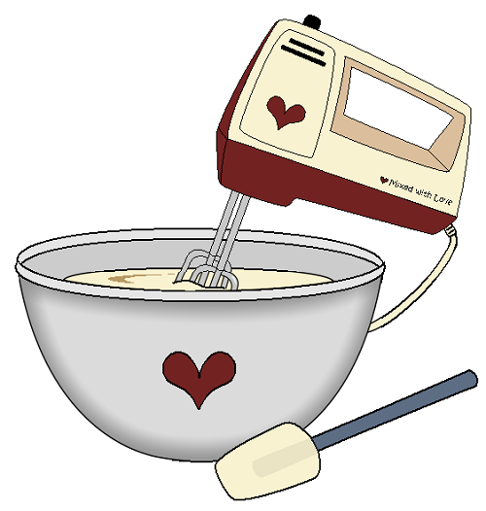
Mini Kit Family Fun – 39.90
2 Gourmet Seasoning Dip Blends
1 Buttermilk Pancake Mix
1 Fruit Jam or Jelly
1 Caramel Apple Cake Mix
1 Cheesy Baked Potato Soup
1 Family Chicken Mix
1 Wickless Wax Melt Pack
5 Catalogs
5 Order Forms
Build Your Business Subscription – ($9.95 included in kit price)
- custom personal website
- consultant labeled catalogs for all drop ship orders at no charge
- unlimited websites for fundraising (custom for each organization)
- enrollment into the 30, 60, 90 day bonus – earn store credits and logo items in addition to commission bonuses.

Artwork© www.countryclipart.com​

Pick Your Flavors Kit – 19.45
Includes 3 selections plus
2 catalogs
1 order form
Build Your Business Subscription – ($9.95 included in kit price)
- custom personal website
- consultant labeled catalogs for all drop ship orders at no charge
- unlimited websites for fundraising (custom for each organization)
- enrollment into the 30, 60, 90 day bonus – earn store credits and logo items in addition to commission bonuses.

Monthly Special Kit – 35.45
Top 10 Kit – 48.85
A selection of our top 10 best selling items plus business supplies
Chicken Enchilada Soup | Hickory Ranch Dip
Chorizo Seasoning | Hot Fudge Pudding Cake
Classic Beer Bread | Pineapple Upside Down Cake Wickless Wax Pack
Easy Alfredo | Pulled Pork
Fiesta Rice Mild | Sesame Garlic Dip

- 2 Catalogs
- 5 Carbon Copy Order Forms
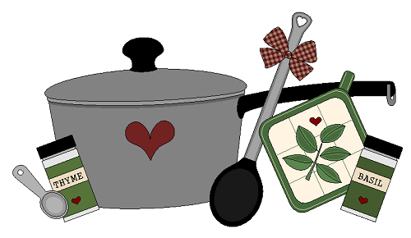
Build Your Business Subscription – ($9.95 included in kit price)
- custom personal website
- consultant labeled catalogs for all drop ship orders at no charge
- unlimited websites for fundraising (custom for each organization)
- enrollment into the 30, 60, 90 day bonus – earn store credits and logo items in addition to commission bonuses.

Artwork© www.countryclipart.com​

