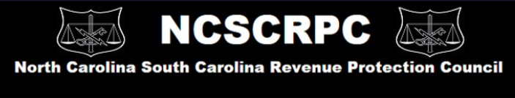

NCSCRPC upcoming annual Conference!
Plans have begun for the next NCSCRPC to be held in February 2020. There will be presentations on a variety of topics to include such items as Utility Theft Prevention, AMI Technology, Best Field Practices, Gang Recognition, Grow Houses, Situational Awareness, Field Safety, Code Enforcement Partnerships and much more!!!!

Dates: February 25, 26 & 27
Where: Marriott Grand Dunes Resort & Spa, Myrtle Beach, SC
Registration: $300
Room Rate: $135/night
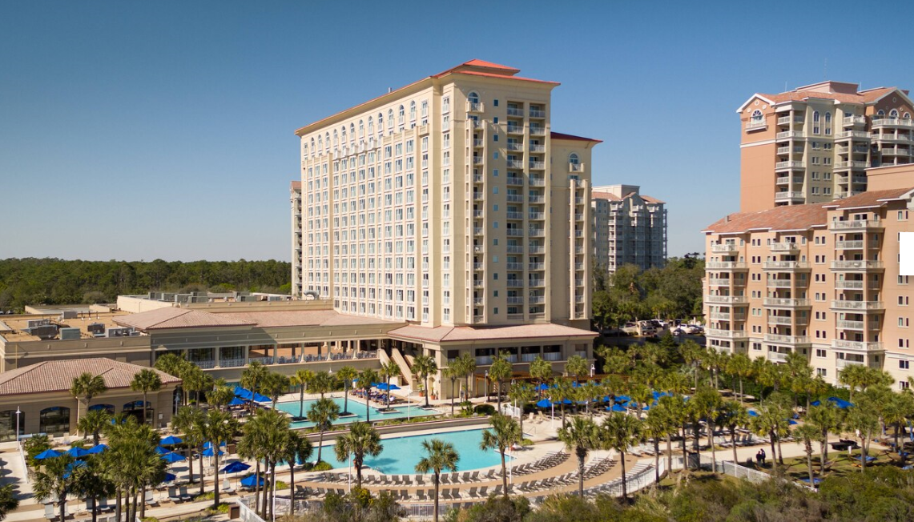
Breakfast and Lunch will be provided during conference as well as a reception.
We hope you plan to join us this year in Myrtle Beach, SC.
Details and agenda to follow at www.ncscrpc.com under “Conference Information.”

