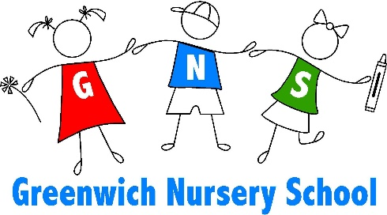
17 Greenwich Church Road
Stewartsville, NJ 08886
Phone 908-479-6886 • Fax 908-479-4269
www.greenwichnursery.com

GREENWICH NURSERY SCHOOL TUITION POLICY
Greenwich Nursery School (GNS) is a non-profit organization, organized in the State of New Jersey. For over 40 years we have been dedicated to the students and families of this community. Our reputation is built on the solid foundation of quality, caring and continuing teachers. To ensure that tradition is carried on we have developed the following policies and procedures.
Upon enrolling your child in Greenwich Nursery School, please be certain you understand and agree to the following tuition policy.

Registration Fee
A non-refundable, non-transferrable registration fee of $65.00 must accompany your child’s application to secure his/her enrollment in the program. This is a separate fee and is not applied toward tuition.

Tuition Cycle
Tuition is billed in three (3) trimester installments. Payments for the school year beginning in September 2015 are due July 1, 2015, November 1, 2015 and February 1, 2016.

Tuition not received within (15) days of published due date(s) will be assessed a $20.00 late charge. A 30-day delinquency shall constitute grounds for review of your account among the Board finance committee. Should tuition for the first trimester go unpaid before the start of the school year, we will consider this as your decision to remove your child from the program and thus, replace their spot with another child.

GNS Tuition Refund Policy
With enrollment in GNS, parents assume responsibility for the full years’ tuition. Tuition, net of costs associated with your child’s enrollment in the program, may be refunded only if the following criteria are met:
- A note is provided from the child's physician stating he/she must be removed from the program for health/medical reasons
- If the GNS director and/or staff determine a child does not successfully adjust to the program
- If a family moves or is transferred from the area

Program Withdrawal
If a child is to be withdrawn from the program for any other reason, the parent must provide GNS (30) days written notice of the withdrawal date. Parents will be responsible for the balance of tuition or be charged a $200 withdrawal fee, whichever is less.
Any other requests for refunds will be reviewed by the Board and considered on a case by case basis. Refunds are at the sole discretion of the Board.

