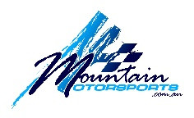
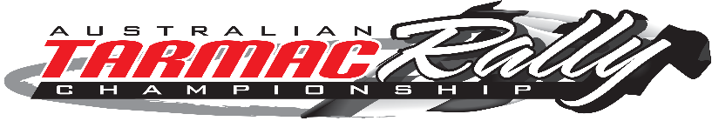
Australian Tarmac Rally Championship
2018 Series Offer
(offer available to first 20 applicants or until January 10, 2018)
Round 1 | LAKE MOUNTAIN SPRINT | 10 – 11 February, 2018
Round 2 | MT BAW BAW SPRINT | 10 – 11 March, 2018
Round 3 | SNOWY RIVER SPRINT | 22 – 23 September, 2018
Round 4 | GREAT TARMAC RALLY | 13 – 14 October, 2018
Competition $8,100 Super Sports $7,400 Target Time $6,500

ENTRANT
Name
Address
Town/Suburb Postcode
Phone: (M) (W) (F)
Email
VEHICLE
Make Model Year
Engine Capacity (CC) Reg No Colour
Forced Induction Yes No Four Wheel Drive Yes No
Modified Yes No
PAYMENT DETAILS
I/We enclose cheque for $_____________ (Payable to MOUNTAIN MOTORSPORTS P/L)
OR
Please charge my credit card $_____________ M/C VISA
Card Number Cardholder Name
Exp Signature
OR
BENDIGO BANK Acc Name Mountain Motorsports
BSB 633 108 Acc Number 1266 411 41

Bank Transfer

Please return completed form and payment to:
Mountain Motorsports OR peter@mountainmotorsports.com.au
PO Box 34
Kilsyth Vic 3137

