Gethsemane Lutheran Church
2696 Melbourne Dr., SD 92123
ADULT STUDY & DISCUSSION!
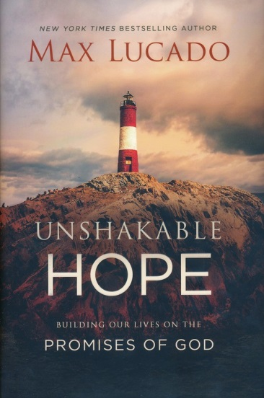
Starting Saturday,
October 12 at 10:00 a.m. – Noon
The course is free but you should buy the book in your preferred format. Unshakable Hope by Max Lucado. A sign-up sheet is available in the Narthex or contact the office to be added. (858) 277-6572 or email: Church@gethsemanesd.org

Classes will be Oct. 12 & 26, Nov. 9 & 23,
Dec. 14 & 28

All are welcome!
Bring a friend or family member with you…

