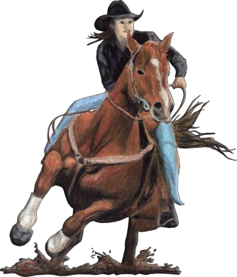
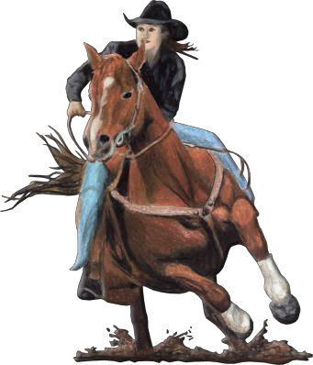
NY 07
CHRISTMAS TREE STABLES
Auburn, NY
SUNDAY, May 22, 2016
Exhibitions Start@ 9:00 a.m. Exhibition $ 5.00 per run =
NBHA Open * MIN 40 riders or will be sweepstaked 80% $400.00 added $25.00 e/f
NBHA Youth * MIN 15 riders or will be sweepstaked 80% RO $75.00 added $15.00 e/f
NBHA Senior * Min 5 riders or will be sweepstaked 80% RO $25.00 added $15.00 e/f
Lil’ Britches $ 5.00 e/f
e/f
MITCHELL WESTERN WEAR *MIN 12 riders or will be sweepstaked 80% $250 SHOOTOUT $ 20.00 e/f Pays 1st in 1D ($125) 2D ($75) 3D ($50), full second splits (if no 2D winner – will ½ split the 2D)
Green Horse Straight Pay $10.00 e/f
2D Dash * min 10 riders or will be sweepstaked 80% $25.00 added $10.00 e/f
2D Poles * min 10 riders or will be sweepstaked 80% $50.00 added $15.00 e/f
NBHA Member Fee $3.00
NBHA Non-Member Fee $10.00
Office Fee per horse/rider combination $5.00
$5.00
Total Due: * Sorry, No Refunds
funds *$

RIDER NAME:
NBHA DIST#
NBHA ID#

HORSE’S REG. NAME:

ADDRESS: CITY STATE_
ZIP_

*IN SUBMITTING MY ENTRY, I HEREBY RELEASE THE SHOW ORGANIZER, THE NBHA, AND ANY OFFICIAL, EMPLOYEE, DIRECTOR OR AGENT OF THE SAME, FROM CLAIM OR RIGHT TO DAMAGES AND/OR INJURY WHICH MAY OCCUR TO MYSELF, MY FAMILY MEMBERS, MY HORSE(S) OR MY PERSONAL PROPERTY AT THIS SHOW OR IN TRANSIT.

*Signature:
*MUST BE SIGNED BY PARENT/GUARDIAN IF UNDER 18
COMPETITION RULES:
- NBHA Rules will be strictly enforced.
DATE:

- NBHA members must present membership card @ registration. Non-mem will be required to pay an add’l $10.00 permit fee.
- Current Rabies and Coggins will be required for all horses on grounds.
- Entries must be made by 11:00 a.m. in order to be entered in the draw.
- OPEN NOT TO START BEFORE 11:30 A. M.
- Each horse/entry will be accessed a $5.00 office/time fee, including “exhibition only” horses

All decisions of District Director are final.
Office Use Only
Method of Payment: Cash Check#_ Draw #_ Entry taken by
OPEN YOUTH SENIOR ______ SHOOTOUT _________
DASH POLES GREEN

