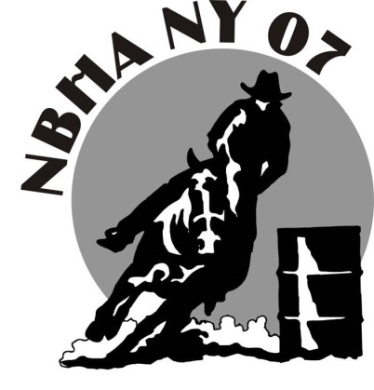
What is the National Barrel Horse Association? The National Barrel Horse Association, headquartered in Georgia, has become the largest barrel racing organization in the world since its inception in 1992. The NBHA has almost 23,000 members from across the United States and affiliates in six other countries: Canada, Italy, France, Panama, Brazil and the Netherlands. NBHA Members of all ages can compete at the District, State, National and World Championship level. Each state is divided into competition districts. Members can compete for money and prizes at a local level. New York District 07 is comprised of 8 counties, stemming from Route 20 North, to the Canadian border. Our local membership is strong and rapidly increasing in size. This year New York District 07 plans to host up to twenty events across the entire region. We will be sanctioning events at many venues, including the Great New York State Fair. This offers an inexpensive opportunity for businesses to reach, not just our members, but their families and the many spectators attending our shows. All sponsorship donations are tax deductible. Without business sponsorships, our shows would not be nearly as successful; in return, the people associated with NBHA NY 07 are very loyal and supportive of our sponsors.
SPONSORSHIP OPTIONS
** $550 Trophy Saddle Sponsor **
The sponsor of the saddle will have their business name stamped on one side of the division champion saddle. These saddles are proudly used by each one of our division winners. You will also receive:
- A brief ad write up that will be announced at all shows.
- A two page ad in the annual program, and a link from our website to yours.
- We will display all banners or other promotional material provided to us, at all shows.
- Your business name announced as a sponsor at all shows a minimum of five times.
** $500 Shootout Sponsor, or $300 Shootout Sponsor **…add $70.00 to get a banner made for your business
At each NBHA sanctioned show, we want to run an exciting Shootout! Shootouts are limited in entries but
the purse is big! This Shootout is named after your business, and heavily advertised. To book your Shootout Sponsorship and choose your show, please contact our NY07 Director, Amy Galway @ 315-264-6840
- A brief ad write up that will be announced at all shows/ you banner will be hung at all shows.
- You are welcome to set up a vendor display at your chosen show.
- Your business logo will be printed on all show bills and entry forms for your chosen show.
- A two page ad in the annual program, and a link from our website to yours.
- Your business name announced as a sponsor at all shows.
- We will display any banners or other promotional material provided at all shows.
** $200 Two Page Sponsor **…add $70.00 to get a banner made for your business
- A two page ad in the annual program, with a link on our website to yours.
- Your business name announced as a sponsor at all shows/ and your banner will be hung at all shows.
- We will display any banners or other promotional materials provided at all shows.
** $100 One Page Sponsor**…add $70.00 to get a banner made for your business
- A one page ad in the annual program and a link from our website to your /your banner will be hung at all shows.
- Your business name announced as a sponsor at all shows.
$50 - Half Page Sponsor -receive a half page ad in our annual program
$20 – Encouraging Note- A good luck note in the program to your someone special.

All program advertising sponsors can be booked through an NBHA NY 07 member or by sending the bottom of this page along with a check made payable to NBHA NY 07. If you have any questions, please call Amy Galway at 315-264-6840
_________________________________________________________________________________________
COST TO SPONSOR = $ _______________ NBHA Member: ______________________________
Sponsor Name: ______________________________ Phone: _______________________________________
Address: _________________________________________________________________________________
THANK YOU FOR YOUR CONSIDERATION!
Mail Sponsor Form & Sponsor Monies to:
Jessica Taylor 376 Grenadier Drive Liverpool, NY 13090 (315) 944-7111 epiduralacres@yahoo.com

