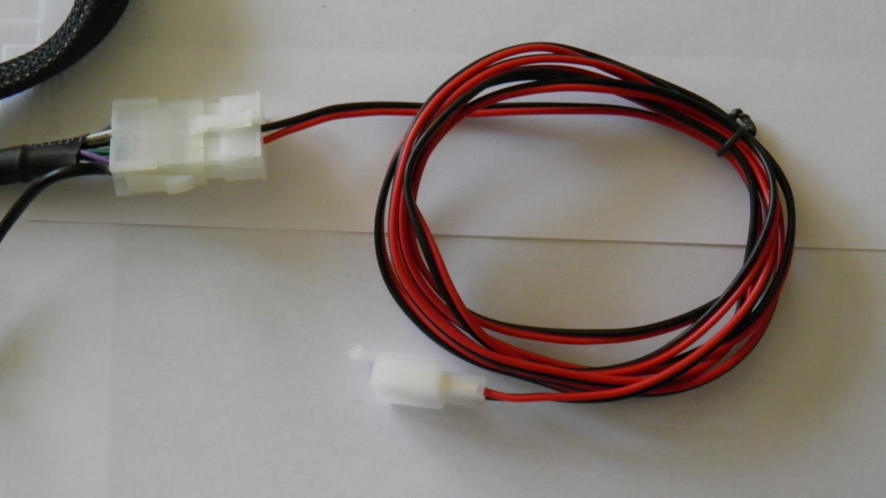

**This is used for metric Bikes or American when the other adapter does not fit!**

**Cut the smaller white connector end above off and connect the red to your positive power source and black to your ground**

**Disregard the ( diagram only ) of the wiring on the manufacturers wiring directions, Its wrong!**

**I would advise to add a 7 Amp fuse and switch to your red wire for as an extra margin of safety!**

**The fuse and switch is not included with the system!**

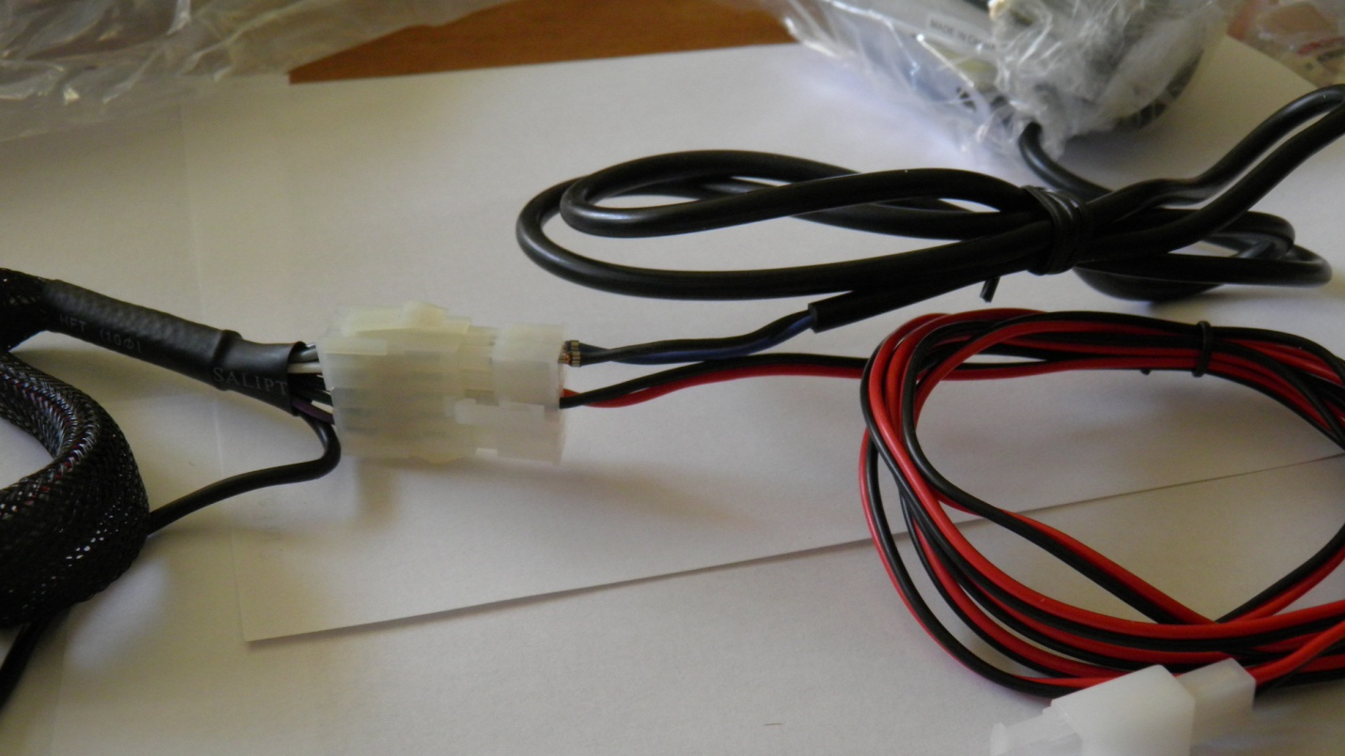

**Speaker wires are pushed in 1st speaker top/ 2nd next down**

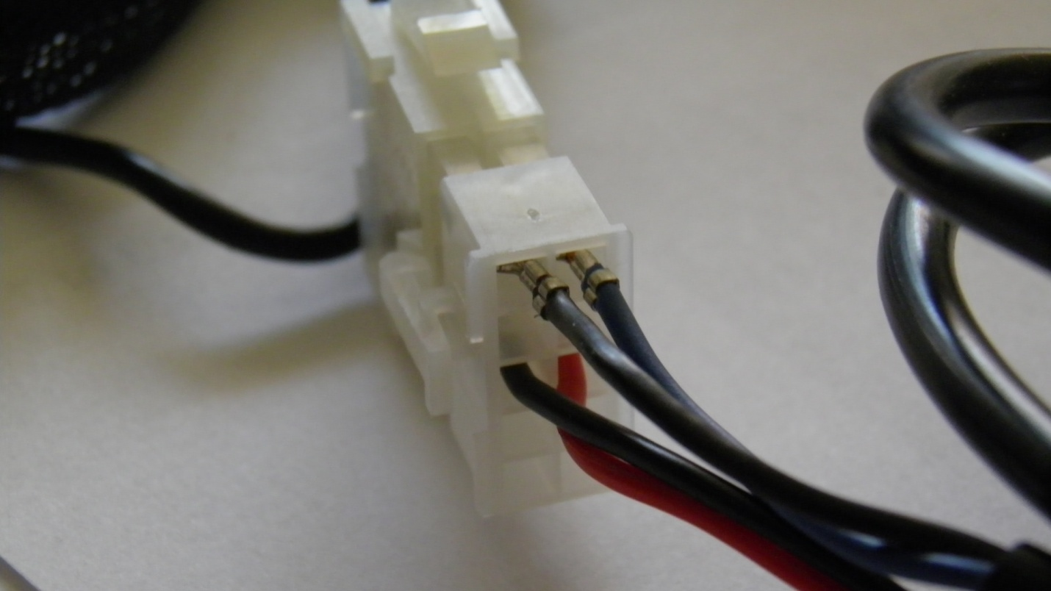

**Black speaker neg wire to right / Blue speaker Pos wire to left**

**Solid wires are positive and solid with stripes are Neg**

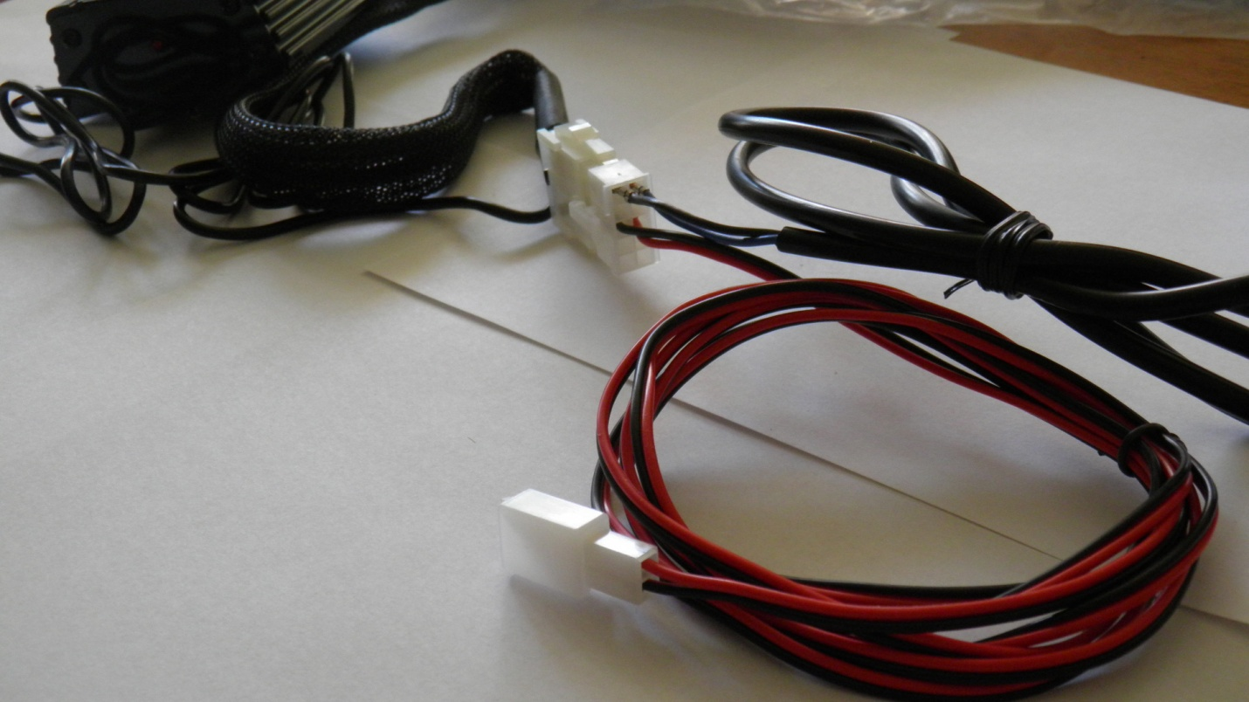

**Cut the plug off the end with two wires RED/ BLK and replace with terminals and a fuse**

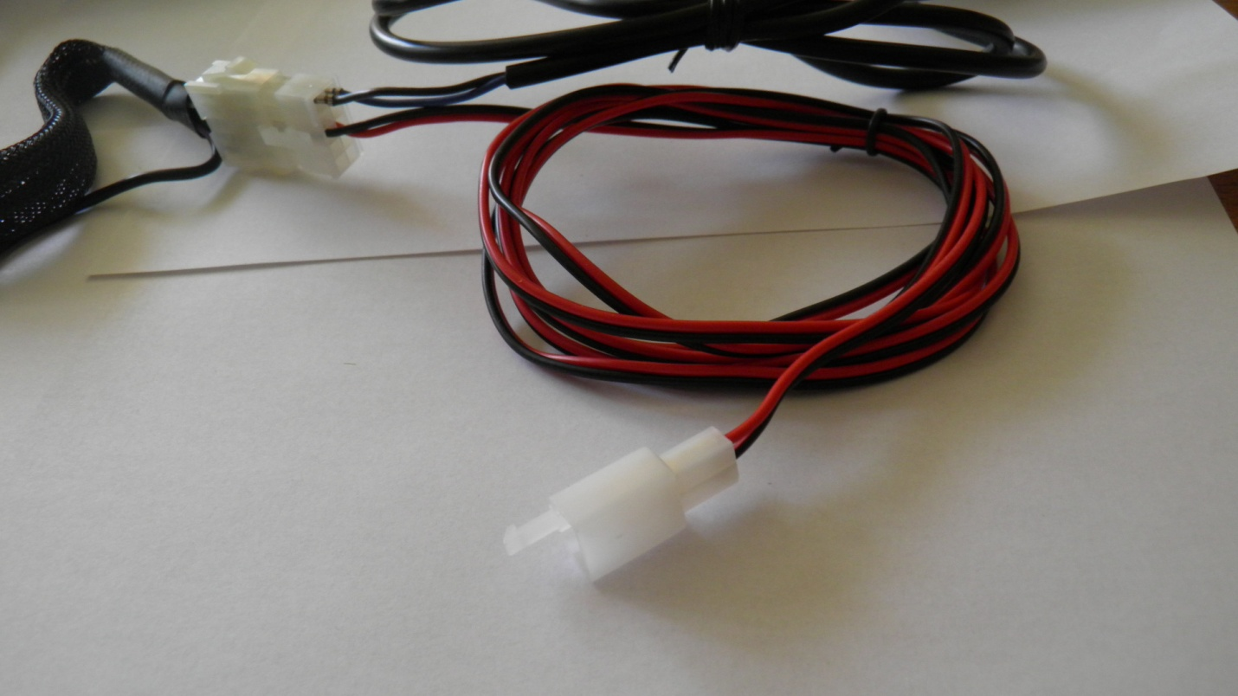

**Red to positive / Black to negative**

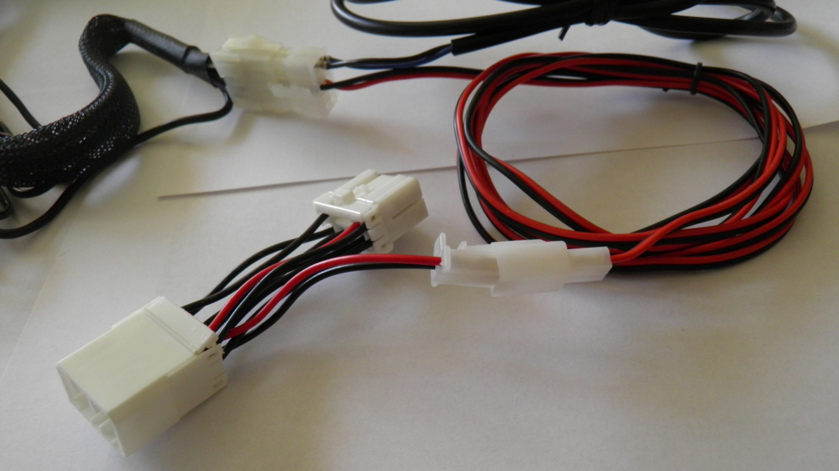

**Inline adapter for most of American made bikes**

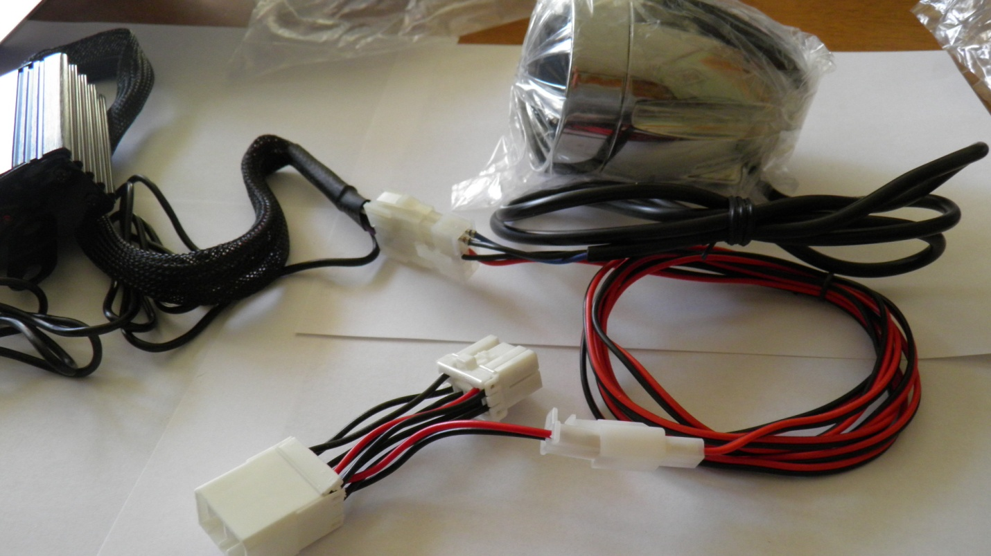

**Hopes this helps**

**NOTE: This system does not include a switch or fuse, I would advise to include the above with your installation or at least connect to a power source that shuts off when you shut the bike off!**

**This information was formatted by Cruising with Tunes and not the manufacturer to assist you with your installation.**

**Dave**

[**www.cruisingwithtunes.com**](http://www.cruisingwithtunes.com)

**PS: we now offer X-tra speakers for this system!**

**PS: To eliminate confusion per Lanzar Tech Support**

**( solid wires are positive ) and ( solid with stripes are neg )**

**These are the wires in the plastic connector from the amplifier**

**The speaker wires from the speakers are**

**( Blue is positive )**

**( Black is negative )**