March 30 2019
Kairos Outside of CT
Is hosting a pasta fundraiser for the upcoming women’s weekend in June 2019.
Location: Trinity Episcopal Church
91 Church Street
Seymour, CT
4pm to 7pm
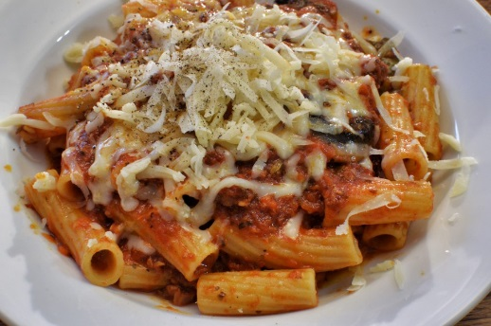
MENU: ZITI, MEATBALLS, SALAD, BREAD, BEVERAGE
& DESSERTS
TICKETS: Adults-$10.00
Kids (12 & under)-$6.00
THERE WILL BE A TEA CUP RAFFLE OF BEAUTIFUL GIFT BASKETS!
http://www.kairosprisonministry.org
Changing Hearts, Transforming Lives, impacting the World

