KAIROS PRISON MINISTRY OF CONNECTICUT
KAIROS OUTISDE CHAPTER FUNDRAISER
WEDNESDAY – MARCH 21st

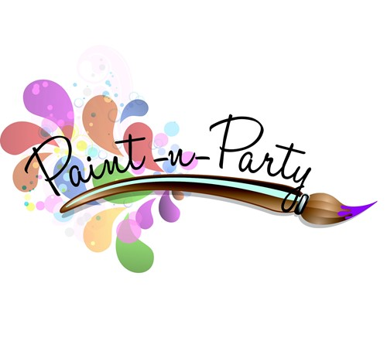
Location: Brush Stroke Paint Party Studio
205 Church Street – Naugatuck, CT
Date & Time: Saturday – March 21st 6:30pm to 9:00pm
Ocean Landscape Scene
Cost: $40.00 ($15 donated to Kairos Outside by the Studio)
Additional Accoutrement’s: Appetizers; Desserts; Refreshments
There will also be a Raffle tickets .50₵ or 12 for $5

Contact Karen DeGeorge 203-729-5999 for any questions or concerns.

