Save the date!
Sunday September 22th Kairos Picnic
Time: 1 to 5 p.m.

Place: Black Rock State Park, Watertown
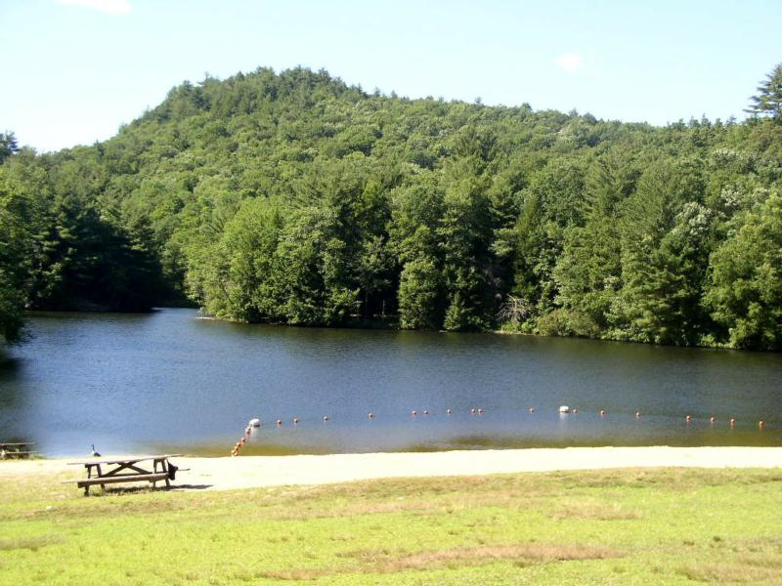

Our WISH Is For You to Bring Your Favorite DISH! Family and Friends Welcomed!
(Hamburgers, Hotdogs and buns will be provided)
Bring Your Bathing Suits and Towels there is a swimming area!
Free admission to CT residents.

