Save the date!
Saturday July 20th Kairos Picnic
Time: 12Noon to 4pm

Place: Black Rock State Park, Watertown
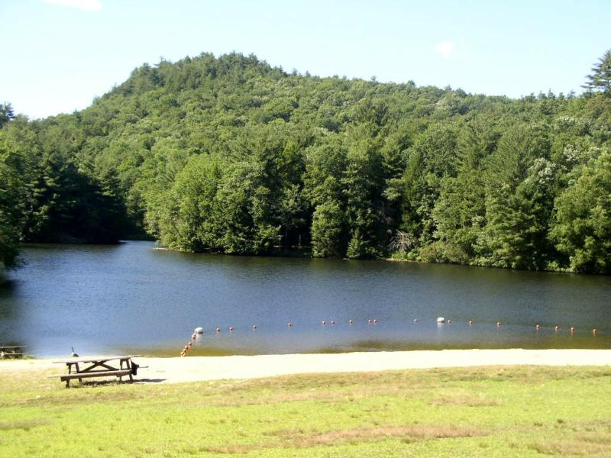

Our WISH Is For You to Bring Your Favorite DISH! Family and Friends Welcomed!
(Hamburgers and Hots will be provided)
Bring Your Bathing Suits and Towels! Free to CT residents.

