Climate policy implications of nonlinear decline of Arctic land permafrost and other cryosphere elements
Dmitry Yumashev, Nature, 23 April 2019 https://www.nature.com/articles/s41467-019-09863-x
(Total under various scenario added see end )
Arctic feedbacks accelerate climate change through carbon releases from thawing permafrost and higher solar absorption from reductions in the surface albedo, following loss of sea ice and land snow. Here, we include dynamic emulators of complex physical models in the integrated assessment model PAGE-ICE to explore nonlinear transitions in the Arctic feedbacks and their subsequent impacts on the global climate…
The Arctic region is warming twice as fast as the global average1, manifested by a decrease in sea ice, snow and glaciers and permafrost degradation relative to their benchmark average states for the period between 1979 and 20052–6. These changes can accelerate global warming further through a variety of climatic feedbacks. Carbon from thawing permafrost released into the atmosphere results in the permafrost carbon feedback (PCF)7,8. Decreasing sea ice and land snow covers increase solar absorption in high latitudes, causing the surface albedo feedback (SAF)9,10. Both feedbacks amplify the anthropogenic signal
The PCF and SAF represent three of the thirteen main tipping elements the Earth’s climate system identified in recent surveys. Tipping elements are physical processes acting as positive nonlinear climate and biosphere feedbacks that, after passing a threshold, could irreversibly shift the planetary system to a new warmer state13. They could cause additional impacts on ecosystems, economies and societies throughout the world
Despite significant advances documented by the IPCC 5th Assessment Report (AR5)6, projections of future climate using general circulation models (GCMs) from the 5th climate model inter-comparison project (CMIP5) do not include the PCF, although several models are set to incorporate the PCF in their next versions as part of CMIP6. Consequently, most climate policy assessments based on results from the GCMs underestimate the extent of global warming in response to anthropogenic emissions. The SAF, on the other hand, is present in GCM climate projections through the coupling of sea ice and land surface models to atmosphere and ocean models. However, existing estimates of the total economic impact of climate change under different policy assumptions using integrated assessment models (IAMs) assume that radiative forcing from the SAF increases linearly with global mean temperature, which is inconsistent with predictions of the GCMs.
In addition to the PCF and SAF, Arctic feedbacks include carbon emissions from thawing sub-sea permafrost, boreal forest uptake and changes in ocean circulation from the melting of the Greenland ice sheet13,25, which we do not explicitly simulate it in this study. Emissions from thawing sub-sea permafrost on Arctic shelf are poorly understood in comparison with land permafrost emissions26. The boreal forest and Greenland ice sheet feedbacks are beyond the scope of this study, along with the non-Arctic tipping elements and other major uncertain elements in the climate system such as the cloud feedback.
Our results show that the PCF gets progressively stronger in warmer climates, while the SAF weakens. Both feedbacks are characterised by nonlinear equilibrium responses to warming. The PCF also develops state-dependent lagged behaviour. Compared with zero PCF and constant SAF, which are the legacy values that have been used in climate policy modelling to date, the combined nonlinear PCF and SAF cause statistically significant extra warming globally under the low and medium emissions scenarios.
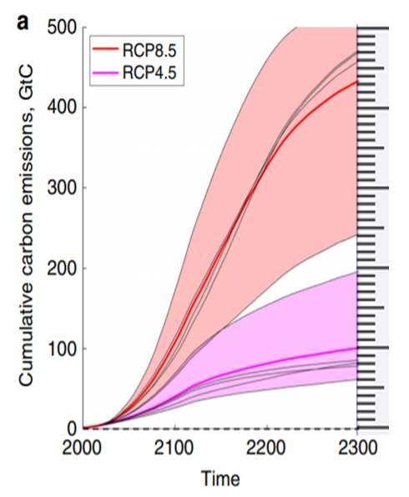
Fig. 1 Cumulative carbon emissions from thawing land permafrost simulated using specialised land surface models. CO2 component of cumulative emissions of carbon from thawing land permafrost, obtained from iBCASA.
RCP 8.5 is high emissions worst case scenario which reaches a global warming of 4.3°C by 2100, still increasing Current global emissions are tracking close to RCP 8.5.
RCP 4.5 is a global warming of 2.4°C by 2100, still increasing
For RCP 8.5 (global warming 4.3°C by 2100) there is rapid increase in extra Arctic cumulative emissions to 2200, which slows but is still increasing at 2300. This is 100Gt by 2100, 330 Gt at 2200, and 430 GT at 2300, still increasing.
For RCP 4.5 (global warming 2.4°C by 2100) additional cumulative Arctic CO2, for is 40Gt by 2100, 80 Gt at 2200 and 100 Gt at 2300 still increasing.

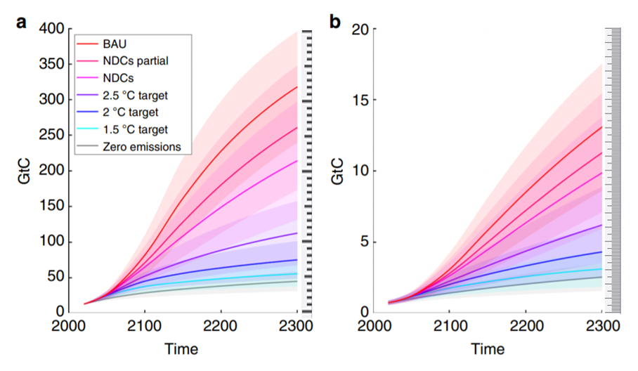
Fig. 7 Cumulative carbon emissions from the permafrost simulated using the dynamic emulator. Cumulative carbon emissions from thawing land permafrost for (a) CO2 and (b) methane components simulated by the new statistical emulator of SiBCASA and JULES (equal weighting) under the chosen range of climate scenarios until the year 2300
Zero emissions
2100
(Note: Global fossil fuel CO2 emissions in 2018 was 35.9 Gt CO2 (Global Carbon Project 2018) Total GHG emissions in 2017 was 55.1 GT CO2 eq. (Trends in global CO2 and total greenhouse gas emissions: 2018 Report PBL Netherlands Environmental Assessment Agency)
2°C (by 2100)with no further increase in atmospheric GHGs
2100
CO2 40 Gt CH4 2Gt Total 42 Gt
2200
CO2 60 Gt CH4 3.2 Gt Total 63.2 Gt
2300
CO2 70 Gt CH4 4.2 Gt Total 74.2 Gt

1.5°C (by 2100)
2100
CO2 35Gt CH4 2 Gt Total 37 Gt
2200
CO2 48 Gt CH4 2.5 Gt Total 50.5 Gt
2300
CO2 52 Gt CH4 3Gt Total 55 Gt

Business as Usual
2100
CO2 80Gt CH4 3Gt Total 84 Gt
2200
CO2 220Gt Ch4 8.5Gt Total 228.5 Gt
2300
CO2 320 Gt CH4 13Gt Total 333 Gt
NDCs (national emissions targets)
2100
CO2 60 Gt CH4 2.2 Gt Total 62.2 Gt
2200
CO2 85 Gt CH4 4.2 Gt Total 89.3 Gt
2300
CO2 110 Gt CH4 7Gt Total 117 Gt

