Pituitary Focus Activity 1

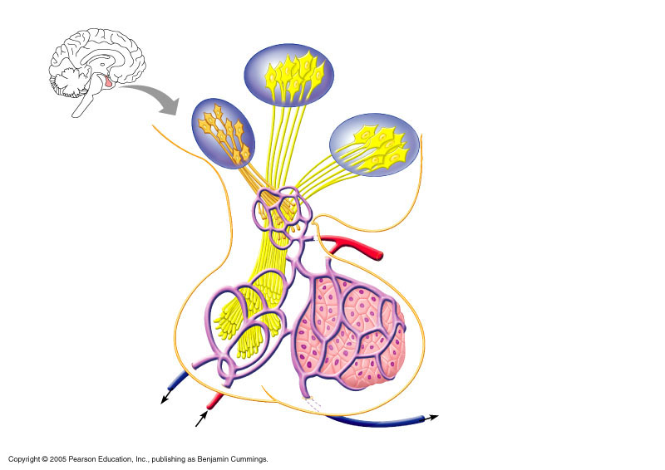 | Hormones found in Anterior Lobe:  1  2  3  4  5  6
Hormones Found in Posterior Lobe:
7

8

9. The anterior lobe of the pituitary is also called the __________________________.
10. The posterior lobe is also called the _____________________________.
11. The _________________________ is the stalk that connects the pituitary to the hypothalamus of the brain.
12. The pituitary is also known as the __________________ gland because it controls the ___________________, _________________________, and _____________________________.

