Intro to Chap 10 – Muscle Arrangements

Instructions: Match up the 7 different muscle arrangements* with the appropriate answer response. You may use pages 286 – 287 as a reference.

I. Matching – Muscle Arrangements
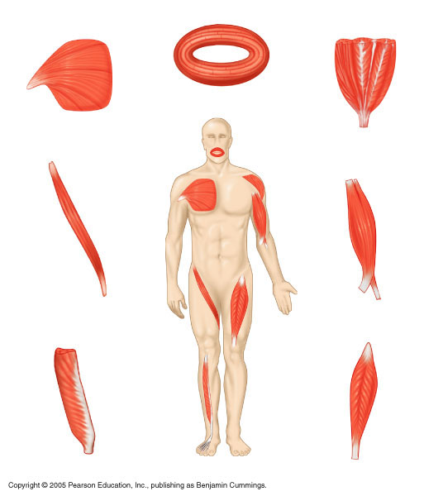 | - Circular  - Convergent  - Parallel  - Unipennate  - Multipennate  - Fusiform  - Bipennate

II. Defining Muscle Arrangements
Instructions: Write a brief explanation for each of the muscle shapes and site an example of its location(s) where possible.

- Circular

- Convergent

- Parallel

- Unipennate

- Multipennate

- Fusiform

- Bipennate

III. Incorporating Previous Knowledge

Instructions: In Chap 9, we began learning about muscle structure and labeled the 3 connective sheaths (epimysium, perimysium, and endomysium) on a diagram like the one shown below. A) Go back to Chap 9, page 250, and find the term “Fascicle” at this time and label it on the drawing below. B) You will also find a definition for term on that same page. Take some time now to define the term “Fascicle” below.

A. Labeling

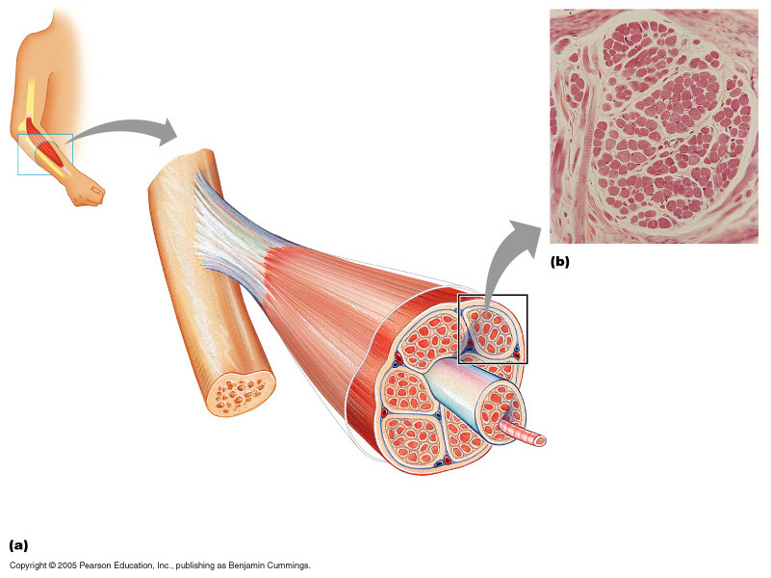

B. Fascicle – (Define the term here)

*NOTE: The muscle arrangements you labeled were based on arrangement of the fascicles.

