Chapter 18 - Part II Practice
I. Structures

Label these on the diagram above
- splenic artery
- hepatic artery
- celiac trunk
- gastric artery

___5  ___6  ___7  ___8  ___9 | 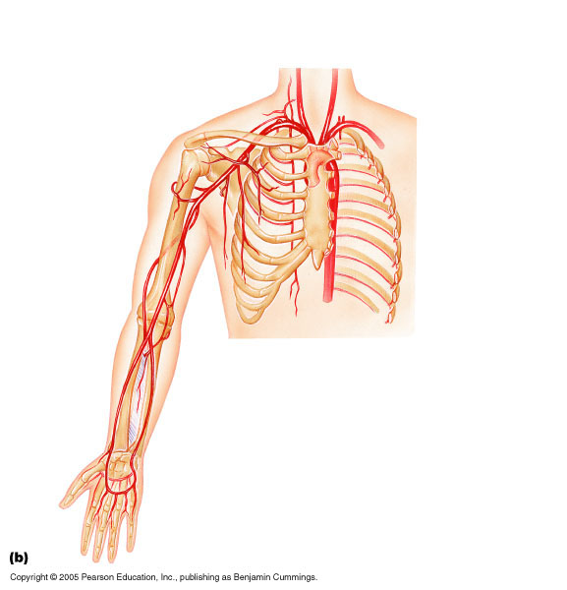
Find and label these on the diagram above:
- radial artery
- axillary artery
- ulnar artery
- superior palmar arch
- deep palmar arch

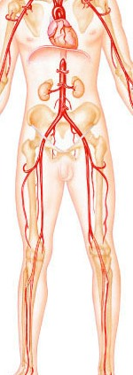
Find and label these on the diagram above:
- popliteal artery
- femoral artery
- iliac artery
- renal artery
- gonadal artery

II. Fill-in-the-Blank (for study purposes)

15. Ascending aorta branches into the _______________ and ___________________ __________________ arteries.

16. Left subclavian branches into the L. ___________________ and L. ______________ arteries.

17. The 3 branches of the aortic arch are _____________________________________,

__________________________________________, and

__________________________.

III. Short Answer

18. Describe the difference (in location) between the deep palmar arch and the superior palmar arch.

19. How can you tell when the iliac artery has become the femoral artery? Explain at least 2 ways.

