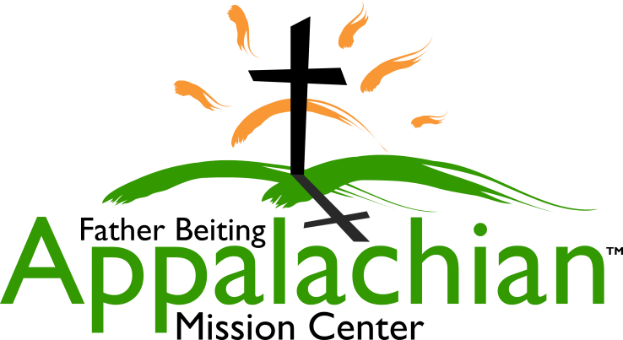
524 Hwy 3 South, Louisa, KY 41230 606-638-0219
volunteers@fbamc-ky.org
www.fbamc-ky.org
An outreach ministry of the Catholic Diocese of Lexington

What Every Pastor and Youth Minister Wants to Know About Volunteering:

Spiritual Growth: Daily mass & weekly Eucharistic Adoration attendance is required. Evening reflections are encouraged and the responsibility of the group leaders, evangelization by working side by side with area residents when possible, and daily prayer before and after work.

Costs breakdown: Mission Fee: $150 per person (non-refundable). Materials cost: $350 per job site (plan for @6 volunteers per job site). Food: volunteers are responsible for all food costs, shopping, & preparation. Transportation: volunteers are responsible for their own vehicles, gas, maintenance, & getting to/from jobsites.

Safety: Within the Volunteer Contract, Photo Release, Hold Harmless Agreement various safety issues are addressed such as drug and alcohol usage, a code of chaste sexual behavior, firearms and other safety concerns

Age requirement: All youth must be entering 9th grade or older.

Insurance: The Diocese of Lexington, Kentucky is insured by Catholic Mutual. The coverage is written at a diocesan level and extends to the parishes and locations in the diocese, such as the Father Beiting Appalachian Mission Center. Included in this coverage is liability. Volunteers are included as a “Protected Person (s)” while acting within the scope of their assigned duties for the church.

Administrative needs: All forms & mission fees need to be submitted timely to insure your scheduled date is not cancelled. College Spring break group needs are due prior to their winter break; other trips are due as follows: March/April trips due January 15, May/June trips due March15, July/August trips due April 15, September-November trips due July 15.

Food: The volunteers are responsible for food and preparation. There are Wal-Mart and Food City grocery stores in the community. The kitchens are residential styled with all essential utensils, and 2 refrigerators at each location

Housing: Bedroom-style sleeping arrangements, separated for men and women, separate bathrooms and showers, shared dining area and common areas. NOTE: the group leader is responsible for setting up shower schedules when youth and adults are in the same group. You must bring sheets (twin) or a sleeping bag, towels, & toiletries (pillows and blankets are supplied).

Child protection: All adults including volunteers and mission center staff (18 & over) must complete Safe Environment Training & have a criminal background clearance completed timely by the sending organization.

Dress Code: Required worksite dress code is long pants, t-shirt, closed shoes. Overall dress code is one of modesty. We ask no short shorts, tank/muscle shirts, strapped/strapless tops, clothing revealing undergarments or with vulgarity.

Adult/youth ratio: For groups of up to 15: 7 or fewer volunteers/2 adult minimum, 8-15 a 4-adult minimum.
For groups of up to 30: 6 or fewer volunteers/2 adult minimum, 7-13/4 adult minimum, 14-20/6 adult minimum, 21-25/8 adult minimum, & 25-30/10 adult minimum

