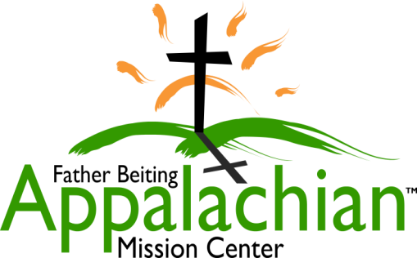
524 Hwy 3 South
Louisa, KY 41230
606-638-0219
www.fbamc-ky.org

Father Beiting Appalachian Mission Center
An “Outreach Ministry” of the Diocese of Lexington Kentucky
Service Report 2018 / 2019
Camps – Boys 13 & Girls 15
Vacation Bible School – Martin County - 26
Home Repairs - 56 – Average material cost per job $304
Other- 3 (furniture given)
Community Contacts – 43
Includes: Well Visits – 20
God’s Food Pantry – 10
Lawrence County Health Care Facility – 7
Martin County Health Care Facility – 6

Christmas Gifts - 900
Volunteer & Internship Programs - Seasonal Volunteers 314
– Interns 4

************ ************ ************ ************ ************ ************

The intent is to continue these programs through the 2019/2020 fiscal year with the exception of VBS due to safety concerns with recruiting and diminishing daily numbers.
In addition, we will expand our assistance in the food pantry, do elderly outreach of winter weatherization and smoke alarm installations, and assist appropriate clients with public housing applications.

