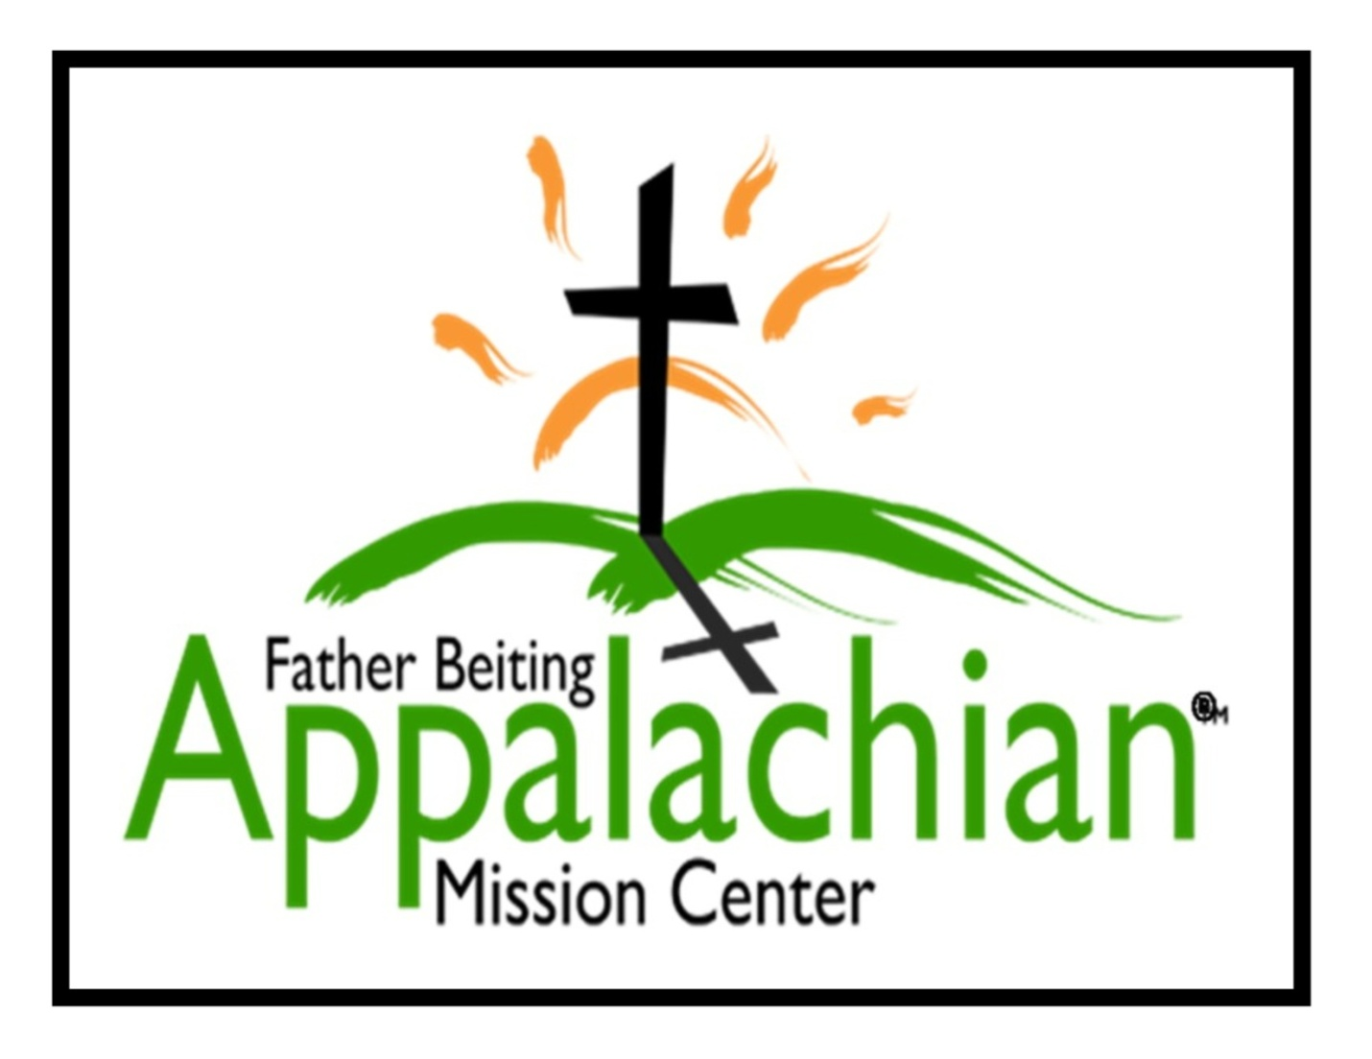
A Day of a Mission Volunteer
Get Started Package
2020

Father Beiting Appalachian Mission Center
524 Hwy 3 South, Louisa, KY 41230
Cindy Capria, Volunteer Coordinator
606-638-0219
volunteers@fbamc-ky.org
www.fbamc-ky.org

1
The Typical Day of a Mission Volunteer
Our mission’s purpose is to bring the love of Jesus Christ to the poor and impoverished of Appalachia. Your mission experience is a spiritual journey led by God. We ask you keep your focus on God, seek Him out in all you do, and pray with those you are serving as well as with your service group. Your mission experience at the Father Beiting Appalachian Mission Center includes daily mass and weekly adoration to aid you in keeping your focus on God and His plan for your journey.

Daily Mass for all volunteers:
St. Jude’s Catholic Church, Louisa, KY
7:30 a.m. Monday, Tuesday, Thursday and Friday
6 p.m. Wednesday & 5 pm Adoration

Mornings
As you will see from the daily schedule, breakfast will need to be eaten before mass. Please plan accordingly.

First Day
Mass at 7:30 a.m. St. Jude’s Catholic Church
Meet at the Father Beiting Appalachian Mission Center at 8:00am for your Orientation with the Volunteer Coordinator followed by an introduction to your assigned family, gathering worksite needs, and heading out to your work site.

All Following Days:
Morning mass then work day begins at 8 a.m.

Wednesday morning, at 9 am, volunteers will do a prayer walk, experience local culture, and attend gospel singing at the St. Jude Thrift store from 10:30-11:30. Afterwards they will enjoy their lunch in the Lou Brinker activity center at FBAMC. Volunteers will not be at their worksite on Wednesday.

Job Assignments — work projects are reviewed and assigned to groups based on the needs of the Father Beiting Mission Center and the groups’ skill levels. Typical assignments are home repair including sub-flooring, walls, windows, ramps, outdoor/yard work, painting, etc., also (in July) door-to-door recruiting for Vacation Bible School. FBAMC does not do new home construction. It is important to be prepared to serve with an open heart as needed.

Work teams of 4-6 will be assigned & dispatched to project sites. (i.e. - a group of 30 volunteers will have 5 work teams that they assign their volunteers to, based on the needed skills for the assigned project.) The volunteers will receive directions on the project and be escorted to the worksite. Begin your work in prayer inviting the family to pray with you.

Lunch 30 minutes - Bring your own lunch to the work sites.

2
Afternoons
Continue the assigned work and assess your project needs for the next day. Keep track of supplies or tools needed. Do not leave tools at the worksite overnight. If the project is complete or near completion, notify the Volunteer Coordinator. New assignments will be handed out as needed. Conclude your day with a prayer of thanks again inviting the family to pray with you. Work day ends at 4:30 p.m. Report the job status (via call or text) to the Mission Center and return to the volunteer housing.
Wednesday afternoon will include a well visit with those previously served by the Mission Center or to a nursing home. This will allow for ample time to attend evening adoration & mass.

Evenings
We ask that all groups share scriptures and reflection on their own each evening. Each week we have one evening when two mission representatives will share a meal with the volunteers and offer a reflective interaction. On Wednesday evenings there is Adoration prior to mass. Information on local cultural experiences & activities will be given and groups are encouraged to attend such activities on their own.

Home Repair Projects:
Each repair project is assessed in advance by the Mission Outreach Coordinator and Home Repair Manager. These specialists are full-time employees. They determine what work needs to be done, what materials are needed, and the skill level required of the volunteers. These decisions are based on cost efficiency and prioritized need and are discussed with the homeowner in advance. A Mission representative will stop at the job site to give direction and guidance.
Groups will be notified of their job assignments up to 1 month in advance to aid their preparation process. Groups may choose to bring needed tools. We require $350 per job site to offset the FBAMC costs of outreach home repair projects.

FBAMC engages those being served in the helping process. We request that a family member or friend work on the project with our volunteers. This person takes pride in participating and many families are motivated to continue forward movement after the volunteers leave. Most families we serve live in poverty and are unable to pay for any needed materials. Participation gives them the opportunity to make a meaningful contribution to the project. This has proved to be beneficial and a blessing to all; FBAMC, the family and our volunteers.

3
Volunteer Housing
The Fr. Beiting Appalachian Mission Center will provide housing for volunteers. The FBAMC main location in Lawrence County has a volunteer property that can comfortably accommodate up to 15 or 30 volunteers per week. This facility, “Padre’s Place”, near Yatesville Lake, has two buildings with 15 beds in each to sleep a total of 30 volunteers. It has twin size beds, pillows and blankets, fully equipped kitchens, bathrooms and showers. The group leader is responsible for setting up shower schedules when youth and adults are in the same group. Volunteers are asked to bring their own sheets or a sleeping bag, towels and toiletries. Volunteers are responsible for their own food preparation. Often groups will have parishioners prepare dinners ahead of time and freeze them for use on their trip. This involves others in the parish in the mission experience as well as blessing the missionaries with a wonderful meal after a busy day. Volunteer quarters have plenty of Christian reading materials.

The costs of your mission
The mission fee is $150 per person. Each group is responsible for the cost of their own food and travel to and from the mission location as well as during the mission trip. We require $350 per job site to offset the FBAMC costs of outreach home repair jobs. Plan on 4-6 people per job site. Often groups will have fund raisers to offset the home repair costs. Parish or Knights of Columbus donations are also utilized resources. Last year FBAMC completed 56 home repair projects.

Administrative needs
All forms and payment need to be submitted timely in order to avoid cancellation. This includes a Volunteer Sign-up Sheet, Volunteer Skills Summary, Volunteer Contract, Pastoral certification letter for Safe Environment and criminal clearance (see below), and religious Certificate of Good Standing for all attending priests, deacons, or religious (required by the diocese of Lexington).

Safe Environment and Criminal Clearance
All volunteers 18 years old and over need to have a Safe Environment training and a criminal background clearance. This is the responsibility of the sending organization/church. FBAMC will provide a sample certification letter to verify this. Be sure to check youth birth dates; anyone turning 18 prior to the end of your mission week will need to comply with this.

4

What are the next steps for signing up?
Mission Volunteer Coordinator will be the single point of contact for the entire sign-up process. Below is a list of what happens next:
- Initial introductions will be made via telephone or email.
- The volunteer group leader will be emailed the Volunteer Group Application and Overview Letter.
- Volunteer group leader will complete and return the application.
- Confirmation letter will be sent to the volunteer group leader It will include the following:
  - Date confirmation and overview letter
  - Volunteer Sign Up Sheet
  - Volunteer Skills Summary Form
  - Volunteer Contract, Photo Release, Hold Harmless Agreement
  - Sample letter to confirm all criminal background checks and Safe Environment trainings are complete
  - Visiting priests, deacons, and religious protocol
  - Volunteer Personal Checklist
- Volunteer group leader reviews all forms with all participants.
- Volunteer group leader submits completed forms & payment according to the following due dates:

College Spring break groups are due prior to their winter break.

March/April (non-college) trips due January 15

May/June trips due March15

July/August trips due April 15

September-November trips due July 15

Volunteer Coordinator contact information:
606-638-0219
volunteers@fbamc-ky.org

5

