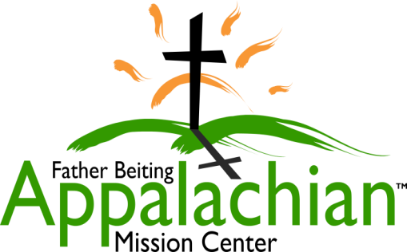
524 Hwy 3 South
Louisa, KY 41230
606-638-0219
volunteers@fbamc-ky.org
www.fbamc-ky.org
An outreach ministry of the Catholic Diocese of Lexington Kentucky

What You Need To Know About The FBAMC 2020 Summer Internship Program:

How will my spiritual growth be nourished?
Through daily mass attendance, reconciliation, Eucharistic Adoration, household reflections, spiritual growth meetings, reflections with volunteer groups, evangelization by working side by side with area residents, and daily prayer before and after projects.

So, what will I be doing?
Supporting FBAMC volunteer & outreach programs by leading volunteer groups in home repair and non-skilled projects, running two weeks of youth overnight camp, leading group reflective discussions, sharing meals with volunteer groups, cleaning volunteer quarters, and so much more!

What skills do I need?
The desire to evangelize in the name of the Catholic Church in an ecumenical fashion, the ability to manage and accomplish an unfamiliar task using leadership, logic and people skills, a basic aptitude of (or willingness to learn) building tools & basic projects, and a willingness to live in community with other interns. Must be at least 21 years old and complete a Safe Environment Training and criminal clearance.

What are the important dates I need to remember?
March 31, 2020 - Application deadline
April 29-30. 2020 – Phone interviews
May 2, 2020 - Notification of program acceptance decision
Monday, May 25–Sunday, August 2, 2020 -10-week FBAMC Summer Internship Program

Where will I live?
Communal living in a duplex located next to the Mission Center. The Ladies side houses 4 interns and the Men’s side houses 6 interns. It is situated in a local community.

Is there compensation?
Yes, there is a $200 monthly food allowance, a $100 monthly Stipend, a mission vehicle with insurance & gas provided for mission work, as well as housing (including utilities).

I am interested, what now?
Inform us of your interest and obtain an application and complete overview package by calling the Volunteer Coordinator at 606-638-0219 or emailing at volunteers@fbamc-ky.org.

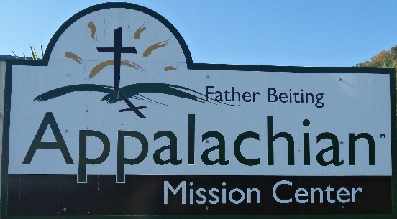

524 Hwy 3 South
Louisa, KY 41230
606-638-0219
volunteers@fbamc-ky.org
www.fbamc-ky.org
An outreach ministry of the Catholic Diocese of Lexington

What You Need To Know About The FBAMC 2020 Summer Internship Program:

How will my spiritual growth be nourished?
Through daily mass attendance, reconciliation, Eucharistic Adoration, household reflections, spiritual growth meetings, reflections with volunteer groups, evangelization by working side by side with area residents, and daily prayer before and after projects.

So, what will I be doing?
Supporting FBAMC volunteer & outreach programs by leading volunteer groups in home repair and non-skilled projects, running two weeks of youth overnight camp, leading group reflective discussions, sharing meals with volunteer groups, cleaning volunteer quarters, and so much more!

What skills do I need?
The desire to evangelize in the name of the Catholic Church in an ecumenical fashion, the ability to manage and accomplish an unfamiliar task using leadership, logic and people skills, a basic aptitude of (or willingness to learn) building tools & basic projects, and a willingness to live in community with other interns. Must be at least 21 years old and complete a Safe Environment Training and criminal clearance.

What are the important dates I need to remember?
March 31, 2020 - Application deadline
April 29-30. 2020 – Phone interviews
May 2, 2020 - Notification of program acceptance decision
Monday, May 25–Sunday, August 2, 2020 -10-week FBAMC Summer Internship Program

Where will I live?
Communal living in a duplex located next to the Mission Center. The Ladies side houses 4 interns and the Men’s side houses 6 interns. It is situated in a local community.

Is there compensation?
Yes, there is a $200 monthly food allowance, a $100 monthly Stipend, a mission vehicle with insurance & gas provided for mission work, as well as housing (including utilities).

I am interested, what now?
Inform us of your interest and obtain an application and complete overview package by calling the Volunteer Coordinator at 606-638-0219 or emailing at volunteers@fbamc-ky.org.

