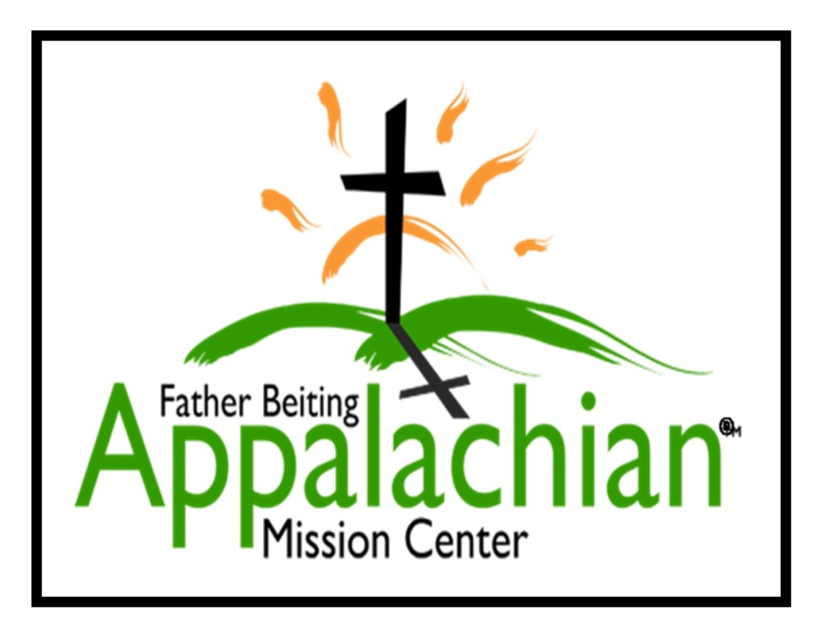

Summer Internship Program
2020
524 Hwy 3 South
Louisa, Kentucky 41230
Telephone 606-638-0219
www.fbamc-ky.org

History
Father Beiting Appalachian Mission Center

Monsignor Ralph Beiting, Founder - January 1, 1924—August 9, 2012
Mission Center Established 2006

Father Ralph Beiting was ordained in 1950 and since 1951 has spread the love of God and the Catholic Church to one of the poorest sections of our country, the Appalachian Mountains of Eastern Kentucky. Father Beiting began his efforts with a Bible school for children and street preaching.
In his over six decades of ministry this amazing priest built 10 churches and established two parishes, repaired 5,000 homes, created a transitional housing community, opened 5 thrift shops, provided emergency housing to anyone who needed a place to stay and welcomed over 60,000 mission volunteers. Father Beiting had a special concern for children who lived in poverty. He organized Bible Camps and shared with them his love of boating. He firmly believed that providing poor children with hope was one key to breaking the cycle of poverty. Spiritual growth is continually promoted through all these programs.
Our Mission Statement: The Father Beiting Appalachian Mission Center is an outreach ministry of the Catholic Diocese of Lexington serving the needs of the Appalachian region of eastern Kentucky. We will walk together in the Kingdom of God as a holy presence that impacts a community in need with spiritual and material support. Through face to face interactions, home repairs and safety needs, and programs for the youth and elderly we bring the presence of God and reach out to those in need.
On August 9, 2012 Father passed away at the age of 88. Because of Father’s work and love of God and His people he was extremely popular throughout the country. In the weeks after his death, there were three memorial services and two funeral masses to accommodate hundreds of friends, family and former volunteers to pay their respects to this remarkable man.
Father’s legacy lives on as the Father Beiting Appalachian Mission Center continues his mission work and dedication to serving the “whole person.” The Mission Center works closely with people who are reaching out for help. The Mission Center is dedicated to providing spiritual guidance, family, and employment to an ecumenical community.
2
FBAMC Summer 2019 Internship Program Description

Your Invitation!
The best way to learn if the FBAMC Internship Program is right for you and your organization is to witness the work being done spreading the gospel and interacting with local people. You will see the beauty of the Appalachian Mountains and the alarming poverty that persists today. It can be arranged for you to make home visits with our professional staff, see home repairs, visit a thrift store, tour our facility and see the internship and volunteer housing. We welcome all who are involved in the decision-making process such as Young Adult and College Campus Ministers, Pastoral Associates, Formation Teams and Directors of Pastoral Interns. We invite you to an on-site visit!
Our Organization
The Father Beiting Appalachian Mission Center is an outreach ministry of the Diocese of Lexington, Kentucky. It is in Louisa, Kentucky in the far Eastern part of the state, just across the Big Sandy River from West Virginia. FBAMC provides programs and services to residents of several eastern Kentucky counties. Throughout the year and especially during the spring and summers, we rely on volunteers to help us work on dozens of projects. FBAMC will coordinate approx. 350 volunteers per year. The volunteers are primarily high-school-age youth groups, adult groups, and college students from throughout the nation.
St. Jude Catholic Church
St. Jude Catholic Church is the parish for Louisa and all of Lawrence County. The parish has 35 families. There is daily mass and weekly Eucharistic Adoration. The religious are Fr. Mike Ramler, Sister Pat Cataldi, CPS and Deacon Jim Dalton. The office of the Diocese of Lexington is approximately 150 miles away. There are two other Lexington Diocese priests within 30 miles.
Internship/Practicum
The internship offers a balance of prayer life and service. A partnership will be created between the FBAMC, the seminary, college/university or Newman Center and the student. The parties need to agree on the conditions of the program. The following information outlines the goals and objectives of the program.
The amount of academic credit, if any, will be determined by the academic institution. 3
Job Description
Our intern should wish to evangelize in the name of the Catholic Church in an ecumenical fashion. Here in Appalachia you will find Christ in the eyes of the poor. We are seeking Catholic seminarians or practicing Catholic college students and young adults. The individual must have good leadership and organizational skills. During the summer months, volunteer groups (30 people per week) will be working with the Mission Center. The atmosphere is very busy and hectic. The intern may be given an unfamiliar task and be expected to get it done using logic and people skills. The intern will be involved in the details of managing volunteer groups.
Learning Objectives /Goals
- Demonstrate competence in all projects and tasks below
- Relate directly to course curriculum at the institution such as third year non-pastoral internship requirements for seminarian or college campus ministry
- Lead by example and integrate the seven key themes of Catholic social teaching in all interaction with volunteer and Appalachian residents
- Evangelize Appalachian residents who are unfamiliar with the Catholic faith.
Start and End Date
- Start date Monday, May 25, 2020 End date Sunday, August 2, 2020

Projects and Tasks Assigned to the Intern
- Supervising volunteers--set expectations, answer questions, give direction, while maintaining a safe environment
- Navigate vehicles to remote areas—follow directions and maps to work sites because often there is no GPS or cell service
- Assist and conduct volunteer orientations as needed—using role modeling, participation, anecdotal stories etc.
- Routine clerical work and computer skills—typical office work (minimal)
- Home repair/construction work—be able to use basic tools and take direction
- Bible camp support-oversee camp, engage with campers, support needs
- Assist in spiritual growth activities—be involved in evening reflection with volunteer groups and fellow interns
- Cleaning/maintaining volunteer housing—volunteers are required to clean their quarters before departure, but additional work is needed
- Working side by side with Appalachian residents—evangelizing by showing solidarity with a different culture
- Participation in weekly Spiritual Growth meetings
4
Preferred Skills
- Leadership experience—have led groups, held chair positions in clubs
- Organization and logistics—been involved in project management
- Communication experience— comfortable giving direction and speaking to groups of volunteers
- Youth ministry experience—have worked at a parish level
- Grade-school-aged children experience—have worked at parish level
- Musical talent—be able to share your talent with a group
- Construction /home repair—able to use or learn to use basic tools to complete a basic project

Program Requirements
- Be available May 25 – August 2, 2020
- Be at least 21 years of age and in good physical and mental health
- Attend daily Mass & weekly adoration at St. Jude Catholic Church in Louisa
- Committed to a life of Catholic spiritual development
- Knowledge of Catholic Social Teaching as it relates to social justice
- Live in community with other interns and/or Long-Term Volunteers
- Leadership skills
- Work well with others
- Be open and flexible to the needs of FBAMC
- Complete a Safe Environment Training Program
- Clear a criminal background check
- Valid driver’s license and insurable by the Diocese of Lexington

Training Opportunities

- Will be mentored by FBAMC full-time employee, Volunteer Coordinator
- Public speaking
- Home repair
- Leading and attending spiritual growth sessions
- Individual and group leadership
- Volunteer supervision

Assessments and Monitoring
Intern will have access to the Volunteer Coordinator for regular feedback. Goals will be set at the start of the internship and reflections will be asked for and observations discussed at 2-3-week intervals. 5
Work Day Hours
- Daily mass 7:30 a.m.
- Weekdays 8 a.m. to 4:30 p.m. and some evenings 6:30 p.m. to 8:30 p.m.
- Weekend work varies – usually Saturday 9a.m. – 12 a.m. and Sunday off
- On call for unexpected needs

Compensation
- A $200 food allowance plus a $100 Stipend per month (total $300 per month)
- Mission vehicle and gas provided for mission work
- Mission vehicle insurance provided
- Group housing provided – including all utilities.

Documents needed to apply
- Cover letter
- Resume
- Internship Application (email volunteers@fbamc-ky.org to obtain)
- 3 Personal References (form included in application)

Apply to:
Volunteer Coordinator
Fr. Beiting Appalachian Mission Center
524 Hwy 3 South OR Email: volunteers@fbamc-ky.org
Louisa, Kentucky 41230

Applications are due by March 31, 2020

6
Addendum 1. Seven Themes of Catholic Social Teachings
Life and Dignity of the Human Person, Call to Family, Community and Participation, Rights and Responsibilities, Options for the Poor, The Dignity of Work and the Rights of Workers, Solidarity, Care for God’s Creation
Father’s Legacy
Father Ralph Beiting has a legacy that flourishes today at the Mission Center. Father has embraced helping the “whole person” materially and spiritually. Father was a practical man and he believed in a “pre-Gospel approach”, meaning that before a person is able to hear and respond to the word of God, his basic material needs must be met. Father’s legacy addresses drug and alcohol addiction, affordable housing, family unity, childhood development, sustainable job creation, ecumenism and government awareness and involvement.
The Seven Themes of Catholic Social Teachings are intertwined in the normal day-to-day life of the Mission Center. The region, the location, the isolation and all the problems in Appalachia have created fertile ground to examine a commitment to Christ. The interns will have many hands-on opportunities to embrace the Seven Themes of Catholic Social Teaching and discover the dignity of the human person.
Here are some examples:
The Fr. Beiting Appalachian Mission Center works with non-Catholic local ministers to address needs in the community and coordinate combined prayer events.

The Fr. Beiting Appalachian Mission Center assists at the local foodbank and volunteers visit local nursing homes.
The Fr. Beiting Appalachian Mission Center assists the local emergency management team.
Overnight and daily Bible camps are conducted by FBAMC volunteers during the summer and we pick up and return the children who need transportation.
Our volunteers work side by side with local residents on home repair projects.
The link
As you can see, Father’s legacy is directly linked to the Seven Themes of Catholic Social Teaching. Fr. Beiting worked his entire priestly career to advance the teaching of the Catholic Church in an ecumenical way. In solidarity with the people in Appalachia, a conscience effort is made by FBAMC and all our volunteers and interns to celebrate Appalachia and promote Catholic social teaching.

7
Addendum 2. Pastores Dabo Vobis
Following Christ as the Apostles Did
The Fr. Beiting Appalachian Mission Center recognizes the importance of the four areas of priestly formation: the human, the spiritual, the intellectual and the pastoral. Our goal, and indeed Fr. Beiting's legacy, is to “help the whole person materially and spiritually”. By serving the Diocese of Lexington Kentucky, focusing on the poor in Eastern Kentucky, the FBAMC will strengthen and supplement all four pillars of priestly formation in a practical way.
Below are examples of our understanding:
Human Formation: The Basis of All Priestly Formation
The men are called to be the “living image” of Jesus Christ. Of special importance is the capacity to relate with others. This is fundamental for a person who is called to be responsible for a community and to be a “man of communion”.
The seminarians will be “living images” by being role models for the volunteers with whom they come in contact. Because of the age and generation of the interns, the men will be particularly relatable to young adults, college and high-school-age volunteers. The seminarians will have ample opportunities to develop leadership skills on job sites, be available for discussions, lead spiritual growth sessions and work side by side with Appalachian residents daily.
Spiritual Formation: In Communion with God and the Search for Christ
The spiritual formation is an extremely important element of a priest’s education. An essential element of spiritual formation is prayer, which is without a doubt a primary value and demand of spiritual formation. The spiritual formation is also tied closely with “seeking Christ”. The synod fathers state that “without spiritual formation, pastoral formation would be left without a foundation.”
Interns and volunteers attend daily mass and weekly adoration. The FBAMC begins at 8 a.m. every morning with prayer, using the Magnificat, in their chapel. Eucharistic Adoration is offered weekly during the summer at St. Jude Catholic Church. There will be many opportunities to seek and find Christ by exploring needs of the Appalachian residents living in poverty today. The interns will have bi-weekly, 2-hour, spiritual growth sessions conducted by an experienced and trained spiritual leader. Weekly reflections and house meetings are also part of the Internship program.
8
Intellectual Formation: Understanding the Faith
The intellectual formation of a future priest is based and built on the study of sacred doctrine of theology and philosophy. The theologian is a believer who asks himself questions about his own faith with the aim of reaching a deeper understanding and interpretation of faith itself. He also contemplates his own person’s freedom and relationship with the world and the Word of God.
Each week the interns will run a spiritual reflection on the group’s experiences. Sessions are informal and are a perfect opportunity for the interns to engage in discussions. The discussion will parallel their studies of philosophy, theology, and evangelization and test their own thinking. Leading a reflection session may advance skills and add clarity to one’s own theological and philosophical thinking. Also, living in community with other seminarians and interns will set the stage for intellectual discussion and debate.
Pastoral Formation: Communion with the Charity of Jesus Christ the Good Shepherd
A decree by Optatam Totius states clearly “The whole training of the student should have as its objective to make them true shepherds of souls after the example of our Lord Jesus Christ, teacher, priest and shepherd.” The synod fathers have proposed several concrete examples such as visiting the sick; caring for immigrants; refugees and nomads; and various social work activities that express charitable zeal. It is particularly important to prepare future priests for cooperation with the laity. They should be willing to listen to lay people, give brotherly considerations to their wishes and recognize their experience and competence in their different fields of human activity.
There will be many opportunities for the interns to be true shepherds and express charitable zeal. Home repair projects start and end with prayer with non-Catholic families. Visitation to shut-ins and nursing homes offer the opportunity to see and be God’s light. Accompanying workers on home assessment visits offer tools for working with the poor. Previous seminarian interns have shared that their growth in this particular formation has been abundant in their intern experience.
The interaction of the interns and laity covers a broad spectrum. The interns will be directly supervised by the FBAMC Volunteer Coordinator who is laity. The interns may take direction from other staffers and possibly long-term volunteers who are committed Christians, all of whom are laity. Conversely, the interns may take direction, share meals and find friendship with people who may have little or no religious upbringing.
9

