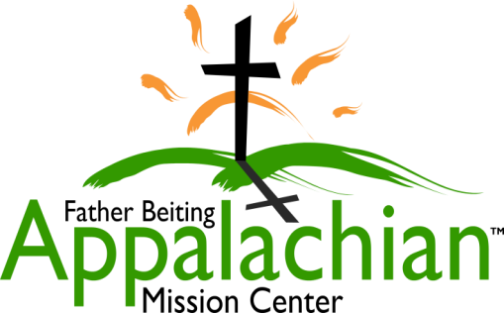
524 Hwy 3 South, Louisa, KY 41230
Phone: 606-638-0219

volunteers@fbamc-ky.org
www.fbamc-ky.org
An outreach ministry of the Catholic Diocese of Lexington

Isaiah 6:8 Then I heard the voice of the Lord, saying, "Whom shall I send, and who will go for us?" Then I said, "Here am I. Send me!"

Dear College Spring Break Group Leader,
Welcome to the start of your Christ centered volunteering journey at the Father Beiting Appalachian Mission Center (FBAMC). Attached is our Spring Break Volunteer Application. Please complete and return it to begin your planning process. We will in turn send you a confirmation package with the remainder of the administrative needs. There is much to consider in deciding to serve at FBAMC. We ask you to prayerfully reflect on the following guidelines as a group before committing.

- ADMINISTRATIVE NEEDS ARE TO BE SUBMITTED TIMELY TO AVOID CANCELLATION.

All forms & fees are due PRIOR TO YOUR WINTER BREAK.

- There is a non-refundable Program Fee of $150 per person.
- Materials fee: $350 per job site (plan for @5 volunteers per job site)
- All adults, 18 & up, must complete a safe environment training & a criminal background clearance. This is the responsibility of the sending organization.
- Mission Trips begin on Sunday evening and end Saturday morning.
- Volunteers are coming to do the work assigned and need to remain open and flexible to all types of work ministries. Work site dress code is pants and t-shirt (or the like) and closed shoes. Work is assigned based on the skills of your group.
- All visiting religious need to submit in advance a Certificate of Good Standing.
- Daily mass & weekly adoration attendance is required by all to aid in our continued focus on God and enhancing our mission experience.
- FBAMC work can be draining both physically and emotionally. Plan daily evening prayer time for your group to reflect, share, & pray together.
- Our volunteer quarters house up to 15 people in a community setting. You are asked to bring your own sheets (twin), towels, & toiletries. Kitchen cooking supplies are complete for meal preparation.
- All food, food preparation, & transportation are the responsibility of the group.
- You are representing Catholics in communities of less than 1% Catholic. Your actions, interactions, works, and dress need to reflect Christian values and morals.
- Communal living limits privacy. Personal sacrifices will be present. You will need to abide by a code of chaste sexual behavior while staying on FBAMC property.
- No fireworks, firearms, or weapons of any kind are permitted. No drug use will be tolerated. No tobacco use at volunteer quarters or on any FBAMC properties. Minors are not permitted to use tobacco products.

God’s blessings,
Cindy Capria
Volunteer Coordinator

524 Hwy 3 South, Louisa, KY 41230
Phone: 606-638-0219

volunteers@fbamc-ky.org
www.fbamc-ky.org
An outreach ministry of the Catholic Diocese of Lexington

Matthew 25:40 ‘Truly, I say to you, as you did it to one of the least of these my brethren, you did it to me’

Spring Break Volunteer Application
This application is used to reserve a date for your Mission trip to the Father Beiting Appalachian Mission Center. Please complete all areas of information and return it. Confirmation or denial will be based on availability of your chosen date and notification of this will not occur prior to October. Confirmed reservations will receive an information packet via email. Denied reservations will be notified via email. We ask that you contact us immediately with any changes to the information provided and please print or type.

Mission Trip Contact Person:
Phone: (Home) (Cell) (Other)
Email:
Mailing Address:

College name:
College address:

Newman Center/Parish name:
Parish address:

Parish phone number:
Parish Pastor:
Diocese (if applicable):

Estimated Number of People (MAXIMUM of 15): ______________

Arrival time is Sunday between 4-5 pm and departure time is Saturday by 9am.

Desired Mission Trip Dates | Arrival Date | Departure Date
First Choice

Second Choice

