|  |  |  |
| --- | --- | --- |
| RFID at METRO Group | October 20  BUAD 6600 | |
| **SCMers**  Meagan Frances Ayers  James Franks  Emelie Hall  Jean-Hubert Trahan | | Instructor: Sachin Modi |

**Objective/Scope**

The purpose of this article is to determine if METRO Group should implement a Radio Frequency Identification (RFID) tagging system and on what level METRO group should implement the system (i.e. pallet tagging versus case tagging). If METRO Group implements an RFID system, the company must also decide how much costs it will incur and how much of the costs will be deferred to its manufacturers.

**Recommendations**

Through careful analysis, it is recommended that:

* METRO Group uses a case level tagging system for larger suppliers,
* METRO Group uses a pallet level tagging system for smaller suppliers, and
* The costs related to the implementation of the technology would be assumed by larger suppliers and negotiated with smaller suppliers.

**Analysis**

*Cost Saving for METRO Group*

Cost savings of case level tagging to Extra stores could be significant. With an average savings of €7.12 per pallet (€0.089 per case), the benefits of case level tagging could range from €8.3M to €13.8M per year. (See Exhibit 2) Most of this savings can be attributed to an estimated 25% reduction in shrink related costs. Other cost benefits of case level tagging are reductions in stock outs, labor, and mis-picked cases. It should also be noted that the cost of RFID chips is given in US dollars, distorting the true cost to METRO. Currency exchange rates have been considered in the analysis shown in Exhibit 2.

Cost savings to Extra stores of pallet level tagging are estimated to be minimal in some years and non-existent in others. (See Exhibit 2) In fact, our projection estimates losses in some years. This is due to the fact that there are no reductions in shrink related expenses with pallet level tagging. Pallet level tagging yields manufacturers more than three times the cost benefits than it does METRO. Consequently, there might be some potential cost savings to METRO if manufacturers agree to cover all or part of the expenses related to supplying RFID tags.

There will also be an upfront investment which METRO will have to make in order to procure the proper number of RFID portals and RFID printers. At a price of €8,500 per portal and an average price of €2,335 for a printer, we do not feel that these costs will significantly decrease the benefits of case level tagging. The cost of the portals and printers should be considered an investment in property, plant, and equipment as opposed to an immediate expense like the RFID tags. Expenses related to this equipment will be accelerated MACRS depreciation, maintenance, any interest expense if financed, and any devaluation or loss on sale of equipment if the RFID program should fail.

Because case level tagging does offer manufacturers a cost savings of €0.07 per case, or an average of €5.60 per pallet, METRO’s larger suppliers should purchase their own RFID portals and printers. We will also want to negotiate a cost sharing agreement that will split the cost of RFID tags between METRO and its suppliers. (See discussion below)

*Cost savings for suppliers*

It is imperative in the implementation of the program that suppliers see a benefit of using the tagging system. Unfortunately, only a certain number of suppliers would see a direct monetary benefit of using RFID technology and assume all the costs related to it. This is why only the larger suppliers will be asked to take responsibility for the costs of both the portals and printers since the volume exchanged between our companies will allow METRO to convince the manufacturers to pay the investment associated with the technology. A break-even analysis was developed to see at what volume suppliers would recover on their investment. It was calculated that if they purchase one portal and one printer only, they would have to ship METRO 154,785 cases or 1,934 pallets for the case-level tagging, and 21,670 pallets for pallet-level tagging per year to break even (See Exhibit 3 and 4). Since volume numbers from each supplier are yet to be received, it was assumed that larger suppliers would easily exceed those numbers.

Since it would be required of smaller suppliers to only pay for the printers, 4,670 pallets would have to be shipped per year for the manufacturers to start seeing benefits (See Exhibit 5). These numbers also assume that METRO would reimburse the companies for individual tags.

*Benefits of RFID for Pallet Tagging*

Tagging on a pallet level will benefit both METRO groups distribution centers (DC) and its manufacturers by increasing efficiency in labor productivity. Implementing RFID will provide time and money saving by eliminating manual bar coding and scanning.

Benefits to the manufacturer include:

* + Time savings in truck loading,
  + Automatic bar code scanning, and
  + Eliminating assembly and storing locations for pallets by sending pallets to truck-loading area as it arrives.

Benefits to METRO Group include:

* + Automatic bar code scanning when receiving, storing, or shipping pallets, and
  + Time savings in truck loading.

*Benefits of RFID for Case Tagging*

Tagging on a case level will benefit both METRO groups DCs, its stores, and the manufacturers by increasing efficiency in product availability, labor productivity, and shipment accuracy. Case tagging reduces shrink costs (i.e. inventory theft) and stock-outs. It will also provide time and money savings by eliminating manual bar coding and scanning.

Benefits to the manufacturer include:

* + Time savings in truck loading,
  + Automatic bar code scanning,
  + Eliminating assembly and storing locations for pallets by sending pallets to truck-loading area as it arrives, and
  + Better on-shelf status.

Benefits to METRO Group DCs include:

* + Automatic bar code scanning when receiving, storing, or shipping pallets,
  + Time savings in truck loading,
  + Elimination of case counting and sample checks of mixed pallets,
  + Labor reduction of picking mixed pallets, and
  + Reduction in inventory counts

Benefits to METRO Group stores include:

* Shipment accuracy, and
* Better on-self status.

**Assumptions**

* $0.20 passive tags are assumed to be of sufficient quality.

**Implementation** **Plan**

*Pallet-Level RFID*

METRO Group will implement pallet-level tagging to 250 stores and 10 warehouses within a five year time frame. Pallet tagging will also be required for all METRO Group suppliers. Because larger suppliers receive a higher cost savings with pallet RFID tagging than METRO (50 euro-cent versus 15.7 euro-cent), METRO Group will negotiate with larger suppliers to cover all, or part, of the expenses related to RFID tags in order to gain potential cost savings. Smaller suppliers who do not gain any cost benefits by investing in RFID technology must still agree to place RFID tags on all pallets before the shipment arrives at METRO DCs or stores. On a case by case basis, METRO Group will consider reimbursing smaller suppliers for the cost of the RFID tags if those suppliers are unwilling to invest in RFID technology. However, RFID printer costs will be incurred by all suppliers.

All manufacturer products that contain metal or liquids will continue with pallet-level tagging within the five year time frame due to low readability ratings with the RFID tags. Once the technology evolves, RFID tagging will discontinue on the pallet-level, and case-level tagging will begin for large suppliers.

*Case-Level RFID*

METRO Group will implement case-level tagging with an extra 30 of its largest suppliers within a five year time frame. In order to successfully convert to this new process, major manufacturers will be required to purchase more tags to be placed on individual cases. The ‘slap and stick’ method used for pallet-level tagging can still be implemented on the case level. Tags should be placed on the outside of the case after it is boxed but before it is placed on the pallet for wrapping.

METRO Group will implement information technology (IT) changes once case-level tagging is implemented. The investment in IT will differentiate between backroom and selling floor items. It will also use point of sale (POS) information to compile and suggest restocking orders.

*Negotiation with Large Suppliers*

Because case level tagging does offer manufacturers a cost savings of approximately €5.60 per pallet, METRO will negotiate a cost sharing agreement that will split the cost of RFID tags between METRO and its suppliers during a contracted time frame. This will give more manufacturers an incentive to invest in RFID case tagging. Also, because METRO’s IT system will be able to capture POS information, suppliers will be able to know how many units of inventory are selling through METRO stores, allowing them to make better merchandising decisions.

*Training*

Implementing RFID systems, whether it be case or pallet tagging, will require employee training at METRO DCs and stores. Conference-style training will be given at DC and store locations to employees. Specialized IT training will also be given to employees higher on the chain of command, such as managers.

**Appendix**

*Exhibit 1*







|  |  |  |  |  |
| --- | --- | --- | --- | --- |
| Assume 52 week fiscal year |  |  |  |  |
| Assume $0.20 RFID chips are adequate | |  |  |  |
| *Assume mid year rates from http://www.x-rates.com/cgi-bin/hlookup.cgi* | | | | |

*Exhibit 2*







*Exhibit 3*



*Exhibit 4*



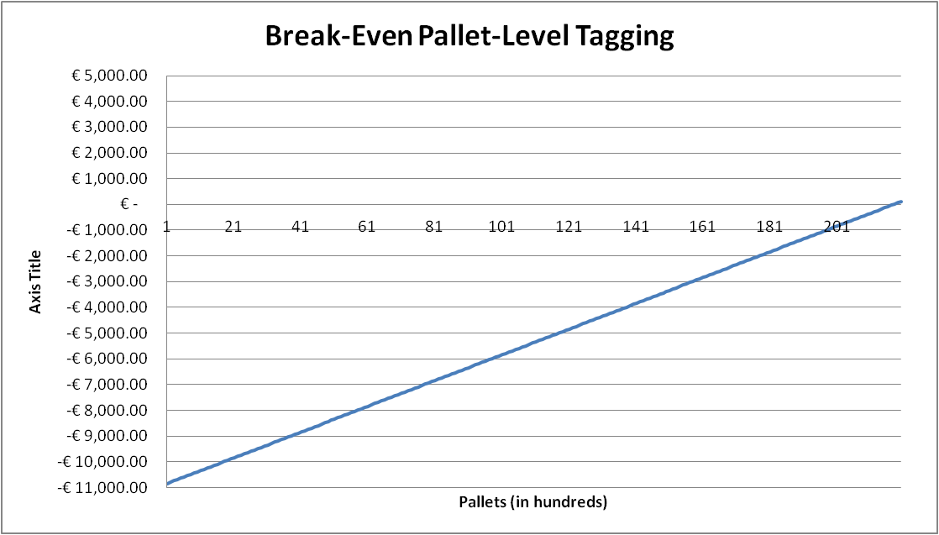

*Exhibit 5*



