**Spring 2011**

Meagan Frances Ayers

R 00056418

Is There a Correlation Between Being Overworked and One’s Stress Levels?



567-277-8429

HURM 6730

**Introduction**

During this course, the amount of time spent on determining how to balance work and home life seemed fairly significant. This topic has always intrigued me as most people I know say they are overworked, underpaid, underappreciated, and stressed out about it. The topic became of particular interest after studying abroad in Australia for a semester. While there, I learned that their work weeks were shorter and I realized how much more free time (and money) they had. The most significant observation was the fact that everyone we met was much more relaxed and laid back than those of the United States (US).

I have always wondered if this had any direct link to the fact that they work less hours than many people within the US. Therefore, my interest also took a look at comparing the US with other westernized countries to compare and analyze whether or not the amount of hours worked affects the level of stress for its people. For this purpose, my intention was to determine the following and then compare the findings: how overworked are individuals of other countries, what do the stress levels of individuals working in other countries look like, and are they related or linked in some way. To determine this, I first gathered statistics and analyzed them, and then proceeded to conduct a survey among peers to conclude whether or not there is truly a connection.

Upon reaching a conclusion, I then determined what the repercussions were for being overstressed and proceeded to uncover ways to lower stress levels for those individuals. In all, it is detrimental to one’s health to be overstressed but there are many ways to limit these levels. Managers should also take great care in ensuring that their employees take care in limiting their stress levels in order to remain vibrant and productive in the workplace setting.

**Research Study**

*Research Analysis*

Multitudes of statistics were gathered to determine whether or not being overworked is in fact linked to being stressed. [1-11] The data was then compiled and analyzed to determine if a correlation could be found. The following statistics were used to rank 17 countries in order of most favorable conditions (working less hours):

* Hours worked to buy bread, [1]
* Part-Time employment percentages, [3]
* Percentage of workers who regularly work over 40 hours a week, [4]
* Number of annual average days off of work, [5] and the
* Minimum number of vacation days (including holidays). [6]

Once these were all ranked, an average number was determined with regards to that countries’ position compared to the other 16 countries on the list. The countries were ranked in order of most favorable conditions to least favorable (least overworked to most overworked). It was then determined that the most overworked country was Japan, with the USA, Sweden, Italy, and Austria following behind respectively. The 6 least overworked countries were found to be the Netherlands, Norway, Germany, the UK, Finland, and Australia respectively. (See Appendix A)

Once this was found, the next step was to determine which countries are most stressed in order to determine if the two conditions are correlated. The factors that were used to determine stress for the 17 countries were their divorce [9] and suicide rates [8, 10]. The same process as earlier was applied; they were ranked by most favorable conditions (lower suicide and divorce rates) and then an average was determined with regards to their position on the list as compared to the other 16 countries and these positions were then ranked. (See Appendix A)

It was determined that the most stressed country was Switzerland, and then Finland, Belgium, New Zealand, and Denmark respectively. The least stressed countries were determined to be Italy, the Netherlands, Canada, Germany, Norway, and the UK respectively. (See Appendix A) It was then beneficial to compare this to an article [7] which had also determined the most stressed countries. While their list only had 10 countries, the 5 most stressed countries determined via this analysis were synonymous with those on the articles list; lending credibility to my findings.

Results

The last step was to apply a correlation statistical formula to the data to determine if there truly was a correlation between being overworked and being stressed (expressed as R). The ultimate findings were actually quite surprising. On a scale of -1 to 1, the relationship is positive if R>0 and the relationship is negative if R<0. Also, the closer the output is to the absolute integer of 1, the stronger the correlation. [11] Once this formula was applied to the data of stress levels and being overworked, it was determined that the correlation between all the numbers was .08 which is a very poor correlation; meaning the numbers are not related. Interestingly enough however, when just looking at the top 6 with the most favorable conditions in both categories, the correlation jumps significantly to .93; a *very* *strong* correlation. (See Appendix A)

Seeing the correlation was not surprising for the top 6 favorable conditions because 4 of the six countries that were least overworked were found to also be the least stressed. The surprising part was that the most overworked countries did not correlate with the most stressed countries. What can be determined from these findings is that while being overworked might not lead directly to being stressed, not being overworked can in fact lead to lower levels of stress. This is a very important concept to remember as a manager whose job is to take care of their employees.

*Questionnaire/Survey*

The next steps in the process was to survey peers to determine if they are stressed and see if that stress is directly related to working too many hours (being overworked). SurveyMonkey.com was used to ask 7 questions followed by an area for response. There were 26 respondents and the questions asked and the responses were as follows:

1. Do you currently work: Full-Time (57.7%), Part-Time (34.6%), Do Not Work (7.7%)
2. How many hours per week do you currently work? <10 (7.7%), 11 – 20 (7.7%), 21 – 30 (11.5%), 31-40 (53.8%), 41-50 (15.4%), >50 (3.8%)
3. Do you generally feel stressed in life? Yes (32%), Somewhat (56%), No (12%)
4. Do you think that your stress is attributed to your work? Yes (61.5%), No (30.8%), Unsure (7.7%)
5. Do you think your stress is attributed to the number of hours you work weekly (disregard the amount of money you make for the number of hours you work, purely focus on the amount of time you are away from home)? No (50%), Yes – I work too many hours (38.5%), Yes – I work too little hours (disregard money) (11.5%)
6. If you worked less, would you be less stresses? Yes (46.2%), No (53.8%)
7. Any additional thoughts?

Issues

While the survey provided invaluable insight as to how people correlate stress and work in their own lives, there were a few factors that inhibited the results. The control over the study was limited; filters were not an option to determine if the one who, for example, said that work adds stress to their life were working full-time or part-time. The other issue was that, after reviewing the free responses to question 7, question 4 might have been confusing to some participants. Another thing I would do differently, but did not think of until it was too late, was to add a question that asks if he/she thinks that their stress from work affects their home life and families.

**Work Hours Historical Information**

When beginning to search for historical trends within the US regarding work week hours, my assumption was that this number has increased over the past few years and/or decades. The best place to get accurate information is the US Census. According to them, the number of hours worked per week did in fact decline 15.14% (40.3 to 34.2 respectively) from the period of 1947 to 2002 [14]. (See Appendix C) This could be attributed to a number of reasons: changing laws and regulations, increased part-time workers, increased retirement age workers, increased student workers, introduction of the internet, workplace trends (see the Trends heading below), etc…

Nonetheless, the trend in hours worked per week within the US has seen a fairly steady decline over the past 50+ years. This is a worthy idea because less work hours is synonymous (according to the statistical analysis) to lower levels of stress and less stressed individuals are more productive, creative, and generally in a better mood which creates a more pleasant and productive work environment for all employees.

**Trends**

Since being overworked has become an issue of great concern over recent years, a few trends are emerging within the workplace. These trends are important for managers and HR professionals to consider when creating employee work schedules. Some of the trends are as follows:

* *Flex-Time* – This allows an employee to make their own work week schedule within the constraints set by an employer. The employee might come in early and leave early, or come in late and leave late. Another option is to work more hours on a couple days to take extra time off on another. While the benefits of flex-time for an employee can be astronomical on their home-life, there are benefits for the employer as well.

“The obvious benefit to an employer is the ability to accommodate employees who have trouble balancing their jobs and their families. In order to retain those employees, it would be in the company's best interests to allow their staff to have a flexible schedule. A less obvious benefit would be a decrease in overhead costs. Employees working flexible schedules can share expensive equipment such as computers, and even desk space, as long as their schedules don't overlap. Flextime is good for the environment too. With some workers commuting four days each week, not five, fewer cars are out on the road. Fewer cars equal less air pollution, and less congestion on the roads.” [18]

* *4 Day Work Week* - “A study released by two Brigham Young University professors suggests four 10-hour days during the work week may increase job satisfaction and productivity in city offices.” Further, “companies that have adopted the four-day week have been rewarded by easier recruiting, lower turnover of scarce skilled workmen, and less absenteeism. At the George H. Bullard Co. of Westboro, Mass., average absenteeism dropped from 6% of the work force to less than 1%.” [15]
* *Telecommuting* – With the invention, increased usage of, and increased trust in the internet, companies are now utilizing it for the work week of their employees. This trend is the ability to work from home via the internet by linking to a company server from anywhere with an internet access point. “About 6 percent of the American work force telecommutes to company jobs from their homes on either a part-time or full-time basis, and the number is increasing.” [19] The benefits of this are great as well; not only can an employee stay at home with their family while working, but they are not contributing to overhead cost or once again polluting the air.

**Effects of Stress**

A critical step is to determine how stress affects people within the workplace and their home life. For the survey conducted (See Appendix B), it was important to determine the number of respondents who feel the effects of stress. It is truly a part of our lives considering the fact that 32% said yes they are stressed and 56% said they are somewhat stressed. Therefore, it is prevalent in the lives of roughly 88% of people (according to this survey). While “stress isn’t always bad,” as we all know that “in small doses, it can help you perform under pressure and motivate you to do your best,” [13] there is a point when stress can become overwhelming and take a toll on you in a variety of ways: your health, home life, and workplace.

*Health*

What are the implications of being stressed and what are the consequences of not dealing with this stress? “Long-term exposure to stress can lead to serious health problems. Chronic stress disrupts nearly every system in your body. It can raise blood pressure, suppress the immune system, increase the risk of heart attack and stroke, contribute to infertility, and speed up the aging process. Long-term stress can even rewire the brain, leaving you more vulnerable to anxiety and depression [13].” These symptoms of stress can mean big problems, and medical bills, for anyone who accumulates these problems.

The following are just a few other health related symptoms you can experience when stress level become too high:

* “Digestive problems, heart disease, obesity, autoimmune diseases, skin conditions (such as eczema), diarrhea or constipation, nausea, dizziness, chest pain, rapid heartbeat, frequent colds, loss of sex drive,
* Memory problems, inability to concentrate, poor judgment, procrastinating or neglecting responsibilities,
* Seeing only the negative, anxious or racing thoughts, constant worrying, moodiness, irritability or short temper, agitation, inability to relax,
* Feeling overwhelmed, sense of loneliness and isolation, depression or general unhappiness, isolating oneself from others, and
* Eating more or less, sleeping too much or too little, using alcohol, cigarettes, or drugs to relax, or obtaining nervous habits (e.g. nail biting, pacing).” [13]

*Home Life*

When looking at the list above, it is not hard to see how these symptoms of stress can create problems in the home. It is a known fact that a person’s mood can alter the mood of another. For example: if a husband is stressed and moody, negative, and isolating himself, the entire family will suffer. The whole family will take in this negative energy and will not be able to benefit from their fathers presence. This can lead to long-term relationship issues such as not being close with your children or maybe even divorce if not taken care of.

*Workplace*

For the survey conducted (See Appendix B), question 4 asked if the respondent felt that their stress was attributed to their work. The response was incredible, a massive 61.5% said yes; thus, some of their stress is *directly* related to their work. Therefore, this stress is being accumulated within the workplace which can breed hostility, resentment, and job dissatisfaction. For a manager who is interested in producing results, a stressed employee will not be as productive as a non-stressed employee. Therefore, if work-related stress is being brought into employees’ homes, it is imperative that managers and HR address this issue before an employee gets so fed up with work stress that there is an incident; such as an out-lash, an employee quitting, or sometimes workplace violence.

**Recommendations/ Management’s Implications**

One question asked during the survey (See Appendix B) was, “If you worked less hours, would you be less stressed?” Not so surprisingly, 46.2% of respondents said yes. This is a key response that managers can utilize to determine how to help employees cope with stress. It is imperative that managers keep their employees the least stressed as possible for increased alertness, a positive attitude, increased loyalty (lower turnover), increased productivity, etc…

*Discourage Workaholic Behavior*

Working part time would be one obvious fix to the issue of relieving work stress due to being overworked. However, this is not an option for many people or employers/managers, especially considering the current economic state. In fact, there has been an increase in the number of “workaholics” within the US who are desperate to keep their jobs, or advance in their career, and are therefore working longer hours. It does not seem so far-fetched of an idea considering the fact that “people who work longer hours tend to make more money and earn more promotions than employees who race for the door at the end of the day.” [17]

This can be easy to fix for a manager. It is important for a manager to adhere to strict maximum work week hours and ensure that employees are not working after hours. It is also beneficial for managers to ensure that employees are confortable in feeling that they have job security with the company. If this is the case, employees will not feel the need to be a “workaholic” just to keep their position, or advance in their career, within the company. Mangers should remember that low job security can create a workaholic environment to get on top; loyalty to your employees is vital. [17] Managers and companies need to adopt an attitude focused on quality of work rather than hours spent at the office. Additionally, if all employees are forced to work the same amount of hours, it will level the playing field among employees who are stressing themselves out to become number one.

*Implement and Encourage Use of Health and Wellness Programs*

Health and wellness programs are a new and evolving trend among the workplace which encourages employees to eat right, exercise, and alleviate stress levels. HR and managers should come up with a plan to help employees find ways to relieve stress levels so they can be happier and more productive. One great example is to facilitate a weekly Yoga session for all employees within the company which is an amazing stress reliever.

The problem with these programs is that employees and managers alike are not quick to embrace them due to lack of time, busy schedules, seeing it as an inconvenience, family obligations, or just plain procrastination. [16] However, managers must lead by example and convince employees that lower stress levels lead to higher productivity, increased health benefits, and an improved home life experience. Managers should encourage participation and maybe even reward those employees who take advantage of the program. In fact, some HR professionals are now giving discounts on employee health insurance costs if the employee participates in their health and wellness programs in order to encourage increased health of their employees.

*Adopt and Encourage New Habits*

There are a few habits a manager can adopt which are beneficial for stress levels. Once a manager has adopted these habits, they can then lead by example and should encourage their employees to adopt these small changes as well. It is imperative that managers let employees know that they will see big results in all facets of their lives if adhered to. Some of these new habits include:

* *Track Your Time* **–“**Track everything you do for one week, including work-related and personal activities.” Once you have done this, you can then decipher which activities are value-added and which ones are non-value- added. You can do this for your home life and work schedule alike. You might be surprised how much more you are able to accomplish while at work if you are only doing things that add value; the same goes for the activities in your home life. Once you have made this a habit, you will be surprised with not only how much more proficient and effective you are, but also how much more results you will see. [12]
* *Manage Your Time –* “Organize household tasks efficiently, such as running errands in batches or doing a load of laundry every day, rather than saving it all for your day off. Put family events on a weekly family calendar and keep a daily to-do list.” [12] As Clinton Longenecker always says, it is better to brush your teeth for 5 minutes a day instead of 35 minutes a week.
* *Leave Work at Work* **-** This is becoming increasingly more important with the trend of telecommuting. While this trend is a great idea for spending more time at home, it can also become a curse for those workaholics who go to work and then come home and are still tempted to work more hours. “Make a conscious decision to separate work time from personal time. When you're with your family for instance, turn off your cell phone and put away your laptop computer.” [12]
* *Learn to Say No* **–** This habit can be useful within the workplace, in your home life, and with friends, family, or school when you are asked to take on extra projects. It is important to “remember that it's OK to respectfully say no. When you quit doing the things you do only out of guilt or a false sense of obligation, you'll make more room in your life for the activities that are meaningful to you and bring you joy.” [12]
* *Bolster Your Support System* **–** Having a strong support system is essential to giving you flexibility and support when things get rough. Although we are expected more and more to be like Superman, it is not possible to do everything without cracking. “At work, join forces with co-workers who can cover for you, and vice versa, when family conflicts arise. At home, enlist trusted friends and loved ones to pitch in with child care or household responsibilities when you need to work overtime or travel.” [12]
* *Nurture Yourself –* While we can all become busy and overwhelmed, it is imperative to remember to take care of yourself. A few good habits to adopt are eating healthy, sleeping enough, and exercising regularly. “Set aside time each day for an activity that you enjoy, such as practicing yoga or reading. Better yet, discover activities you can do with your partner, family, or friends; such as hiking, dancing or taking cooking classes.” [12]

*Implement Flexible Work Schedules*

Implementing flex-time or a 4 day work week obviously has increased mental, physical, and monetary benefits for the employee and the employer. Therefore, companies should make the workplace more open to different work week schedules for employees in order to boost morale and loyalty, while simultaneously reducing stress levels of employees.

**Conclusion**

Stress is in fact linked to being overworked with long work schedules. Therefore, managers and HR professionals should take care to ensure that their employees are not stressed from their work environment. They can implement changes in the workplace (programs, work schedules, or adhering to maximum work hours) that can result in benefits for the employee as well as the employer. Managers and HR professionals can lead their employees to a lifestyle that can enhance their work life, home life, and overall health by making small changes that produce big effects.

**Appendix A – Statistics Analysis**







**Appendix B – Survey Questionnaire**

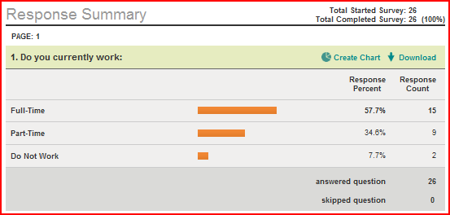

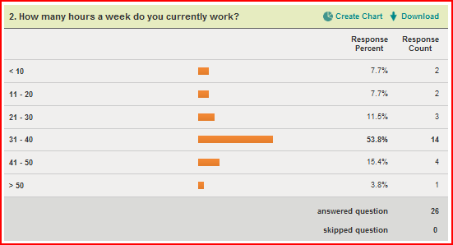

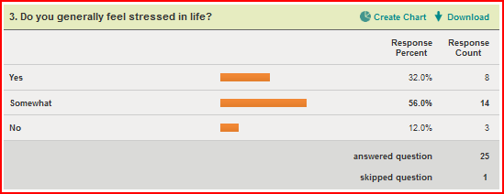

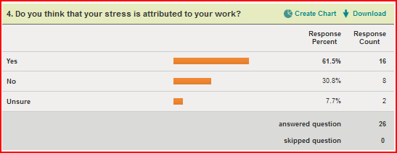

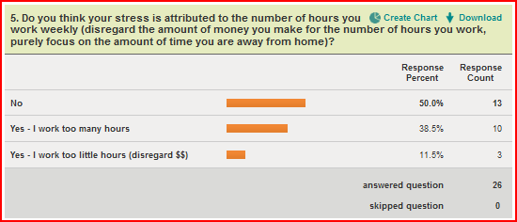

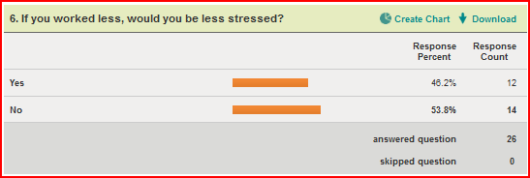

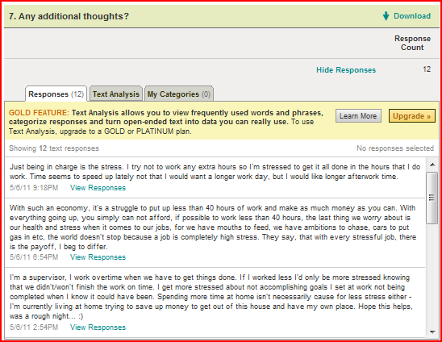

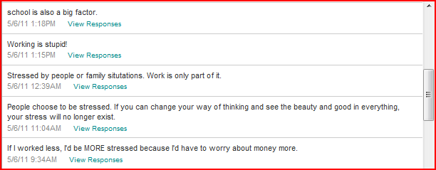

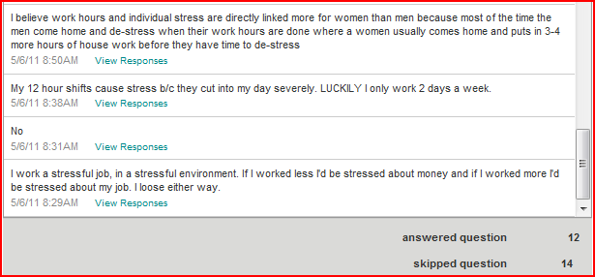

**Appendix C – US Census Historical Hours Worked**

 **[14]**

**Citations**

1. "Working Time to Buy Bread by Country. Definition, Graph and Map." *NationMaster - World Statistics, Country Comparisons*. Web. 05 May 2011. <http://www.nationmaster.com/graph/lab_wor_tim_to_buy_bre-labor-working-time-buy-bread>.
2. "Hours Worked (most Recent) by Country." *NationMaster - World Statistics, Country Comparisons*. Web. 05 May 2011. <http://www.nationmaster.com/graph/lab_hou_wor-labor-hours-worked>.
3. "Employment Part-time Employment by Country. Definition, Graph and Map." *NationMaster - World Statistics, Country Comparisons*. Web. 05 May 2011. <http://www.nationmaster.com/graph/lab_emp_par_emp_inc_of_par_emp-labor-employment-part-time-incidence>.
4. "More Than 40 Hours Work Time Statistics - Countries Compared - NationMaster." *NationMaster - World Statistics, Country Comparisons*. Web. 05 May 2011. <http://www.nationmaster.com/graph/lab_wor_tim_mor_tha_40_hou-time-more-than-40-hours>.
5. "Days off Work (most Recent) by Country." *NationMaster - World Statistics, Country Comparisons*. Web. 05 May 2011. <http://www.nationmaster.com/graph/lab_day_off_wor-labor-days-off-work>.
6. "Minimum Vacation Time Around The World Vacation Statistics - Countries Compared - NationMaster." *NationMaster - World Statistics, Country Comparisons*. Web. 05 May 2011. <http://www.nationmaster.com/graph/lab_vac_min_vac_tim_aro_the_wor_leg_req-time-around-world-legally-required>.
7. "Countries with Lowest Stress Levels | LoveToKnow." *Stress Management | Signs of Stress*. Web. 05 May 2011. <http://stress.lovetoknow.com/Countries_with_Lowest_Stress_Levels>.
8. "WHO | Country Reports and Charts Available." Web. 06 May 2011. <http://www.who.int/mental_health/prevention/suicide/country_reports/en/index.html>.
9. "Divorce Rate (most Recent) by Country." *NationMaster - World Statistics, Country Comparisons*. Web. 06 May 2011. <http://www.nationmaster.com/graph/peo_div_rat-people-divorce-rate>.
10. "World Suicide Rates by Country." *The Washington Post: National, World & D.C. Area News and Headlines - The Washington Post*. Web. 06 May 2011. <http://www.washingtonpost.com/wp-srv/world/suiciderate.html>.
11. Richmond, Michael. *A simple example of correlation analysis* . N.p., 22 May 2009. Web. 6 May 2011. <http://spiff.rit.edu/richmond/baseball/order/correlation_example.html>.
12. "Work-life balance: Tips to reclaim control." *Adult health*. Mayo Clinic, 29 May 2010. Web. 6 May 2011. <http://www.mayoclinic.com/health/work-life-balance/WL00056>.
13. "Understanding Stress: Signs, Symptoms, Causes, and Effects." *Helpguide.org: Expert, Ad-free Articles Help Empower You with Knowledge, Support & Hope.* Web. 06 May 2011. <http://helpguide.org/mental/stress_signs.htm>.
14. "The 2011 Statistical Abstract: Historical Statistics." *Census Bureau Home Page*. Nonfarm Employment, Hours, and Earnings by Industry. Web. 06 May 2011. <http://www.census.gov/compendia/statab/hist_stats.html>.
15. "Study Finds Four-day Work Week Optimal." *Utah News From The Daily Herald Newspaper*. Web. 06 May 2011. <http://www.heraldextra.com/news/local/article_e5e96c0c-7ee6-5787-b46f-c8ac9990c440.html>.
16. Longenecker, Clinton O., and Robet Yonker. "Observations on the Connection Between High Performance and Managerial Health." *Journal of Compensation and Benefits* Jan. (2008). Print.
17. "The 40-Hour Work Week Is Obsolete | Trends Magazine — Www.trends-magazine.com." *Trends Magazine :|: Trends, a Publication by Audio-Tech, Aims at Forecasting Business Trends. Subscribers Receive Trends Magazine Every Month for One Year. Trends Range in Categories Such as Demography, Ecoloy, Economic Outlook, Finance, Internet Technology, Nano Technology, Politics, Security.* Web. 06 May 2011. <http://www.trends-magazine.com/trend.php/Trend/990/Category/45>.
18. McKay, Dawn Rosenberg. "Flextime - Flexible Work Schedules." *Career Planning - Career Planning Guide*. Web. 06 May 2011. <http://careerplanning.about.com/cs/flextime/a/flextime.htm>.
19. "Telecommuting." *University of Oregon Human Resources*. Web. 06 May 2011. <http://hr.uoregon.edu/policy/telecommuting.html>.