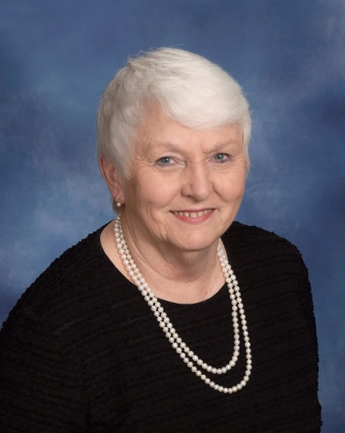 | Adams, Faye  172 Highland Drive  Greenwood, SC 29648  (864) 229-3199
Adams, Sherri
Sarah-Kathe, Graham
102 Rock Knoll Drive #6
Greenwood, SC 29649

(864) 229-6319

Adams, Tony
307 Manning Road
Greenwood, SC 29649-2322

Addis, Kevin & Leigh
Caroline, Cameron
207 Cheekwood Road
Greenwood, SC 29649

(864) 227-1452

Addy, Frank, Jr. & Kelly
Robert, Grayson
106 Arthur’s Point
Greenwood, SC 29649

(864) 223-3714
kellyaddy@live.com

Addy, Mary Kay
105 Stratford Road
Greenwood, SC 29649

(864) 223-4512

Alexander, Jonsie
Grant, Katelyn Miller
574 Hwy. 185 S.
Donalds, SC 29638

(864) 379-8583

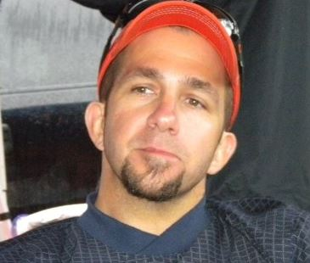 | Alexander, Keith  1103 Northlake Drive  Greenwood, SC 29649  (864) 992-3083  keithalexander99@yahoo.com
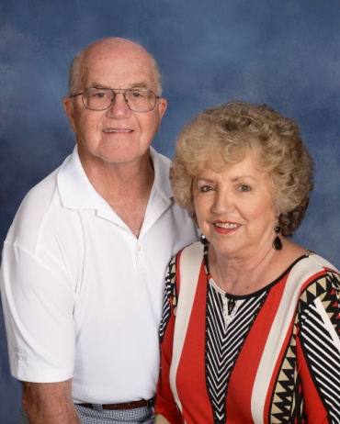 | Alexander Sr., Kirk & Judy  128 Rutledge Road  Greenwood, SC 29649  (864) 223-6268  judykirk01@nctv.com
Anderson, Don and Jamie
Lauren
942 Sunset Drive
Greenwood, SC 29649

(864) 227-0865

Anderson, Mary Ellen
1830 Alexander Road W.
Greenwood, SC 29646

(864) 223-5275
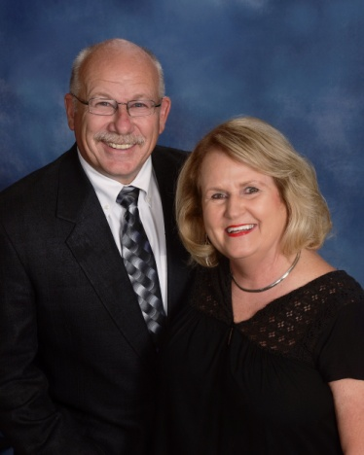 | Anderson, Neil & Maree  102 St. Augustine Drive  Greenwood, SC 29649-3210  (864) 223-8818  nmanderson@embarqmail.com
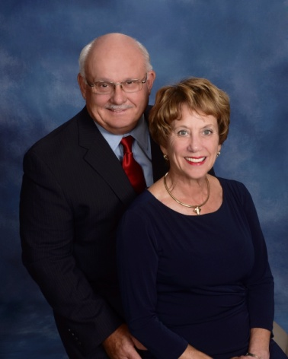 | Arnett, Cliff & Carol  707 Swing About  Greenwood, SC 29649  (706) 575-4988 (Cliff)  (304) 320-3464 (Carol)  Clhill0824@gmail.com
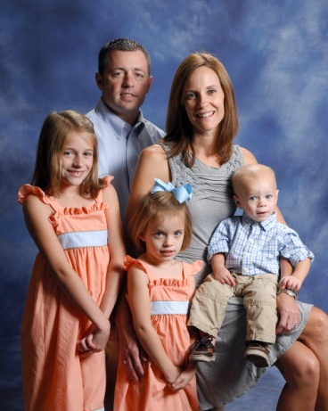 | Arnold, Jason & Elizabeth  Emma Grace, Eva, Davis  115 PC Jean Road  Ninety-Six, SC 29666  (864) 980-5496  elizabethjo@embarqmail.com
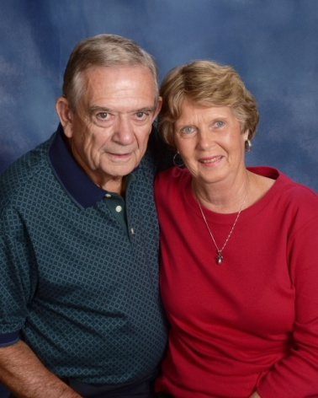 | Arnold Jr., TR & Bobbie  2497 Hwy. 72 E.  Abbeville, SC 29620  (864) 229-2974  Barnold001@centurylink.net

Arnoti, Justine
802 W. Deadfall Road
Greenwood, SC 29649

(864) 229-9075

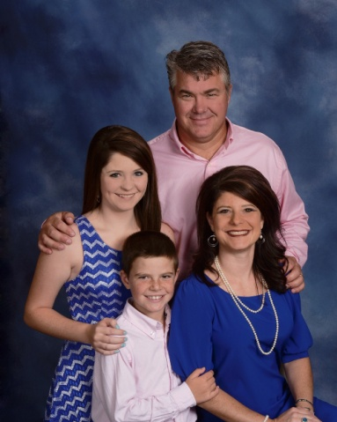 | Ashley, Keith & Amy  Kellynn , Hampton  118 Puckets Pointe Road  Greenwood, SC 29649  (864) 554-4926  amy.safehousevalve@gmail.com
Ashley, Sonan
105 Ashley Lane
Greenwood, SC 29649

(864) 223-1683

Attaway, Talmadge & Denise
Crystal, Tammy
221 Park Street
Ninety-Six, SC 29666

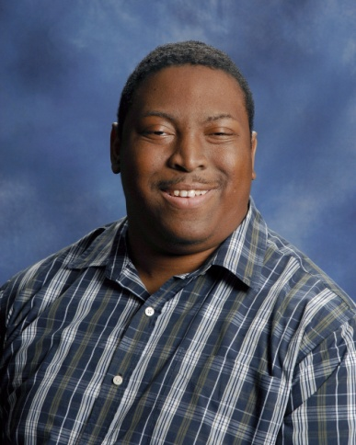 | Austin, Tim  119A S. Hospital Street  Greenwood, SC 29646  (864) 358-1191

Babb, John & Sue
116 Charles Street
Greenwood, SC 29649

(864) 993-8768

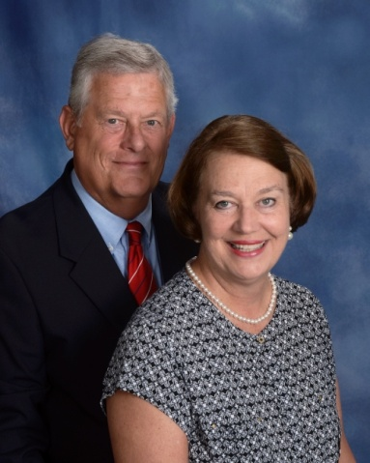 | Babb Jr., Waddy & JoAnne  364 Tranquil Road  Greenwood, SC 29646  (864) 229-6932  wandjbabb@centurylink.net
Bailey, Jim & Johnnie
112 St. Andrews Lane
Greenwood, SC 29646

(864) 229-4794

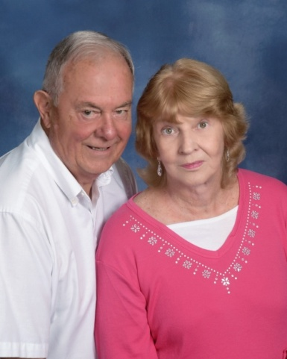 | Bailey, Robert  312 Nautical Way  Greenwood, SC 29649  (864) 223-3839
Baker, Wendy
Coleton Lollis, Lawson
100 Westwood Road
Abbeville, SC 29620

(864) 229-9031

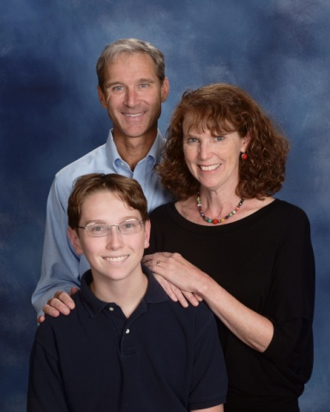 | Ball, Richard & Martha  Danny  205 Harvest Lane  Greenwood, SC 29649  (864) 388-0939  martha@rmbhome.net
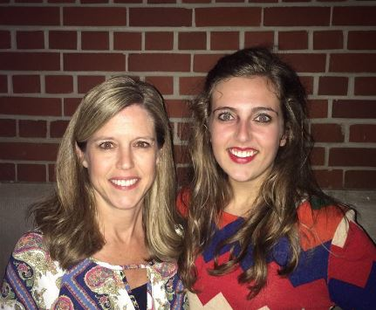 | Bartley , Amy  Lauren Strickland  117 Carriage Court  Greenwood, SC 29646  (864) 229-3598  bartleya@gwd50.org
Bartley, Mike & Pam
120 Queens Court
Greenwood, SC 29649

(864) 223-3303

Bass, Beth
119 Janeway
Greenwood, SC 29649

(864) 223-3233

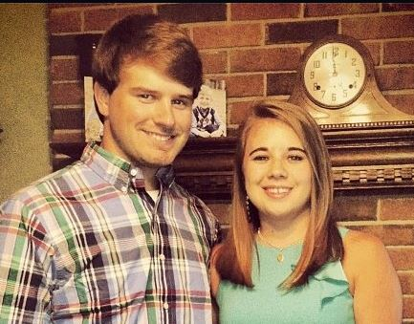 | Beale, Jr., John & Kayla  103 Shortleaf Court  Greenwood, SC 29649  (864) 941-6712  kaylaechrisley@gmail.com
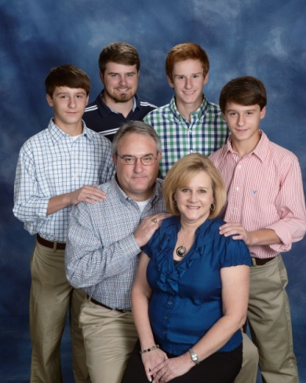 | Beale Sr., John & Beth  John Edward, Zachary, Chase, Chandler  108 Woodridge Road  Greenwood, SC 29646  (864) 229-0692  beales@nctv.com
Bean, Steve & Beth
211 Daly Place
McCormick, SC 29835

(864) 391-8381

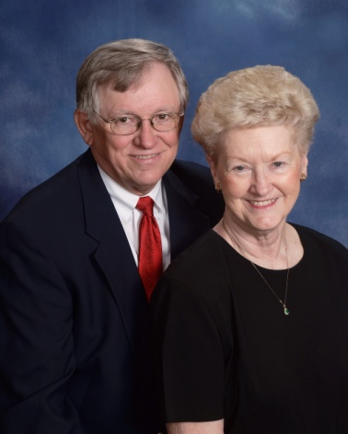 | Bearden, Dannie & Gloria  320 Compass Point  Ninety-Six, SC 29666  (864) 941-0690  gloria_bearden@embarqmail.com
Beardsley, Tom & Donna
226 Chatham Drive
Greenwood, SC 29649

(864) 992-5795
beardsley5@yahoo.com

Beauford Jr., John & Susan
John Robert, Blake
225 Edgewood Drive
Abbeville, SC 29620

(864) 446-2278

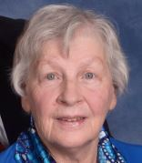 | Bedenbaugh, Jean  512 Marietta Drive  Greenwood, SC 29646  (864) 223-6705  jeanjerry@embarqmail.com
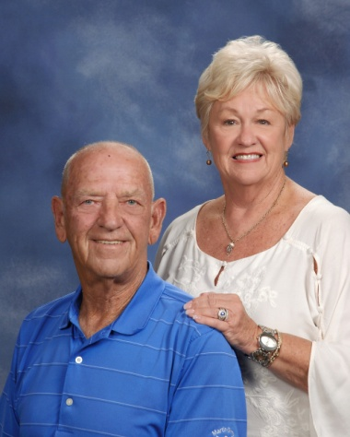 | Bell, Jimmy & Cheryl  27 Curltail Road  Abbeville, SC 29620  (864) 993-5003  cbell@lander.edu
Bell, Tammy
109 Curltail Road
Abbeville, SC 29620

(864) 229-6703

Bettis, Chad & Jami
Will
106 N. Hill Court
Hodges, SC 29653

(864) 223-8895
bettisj@gwd50.org

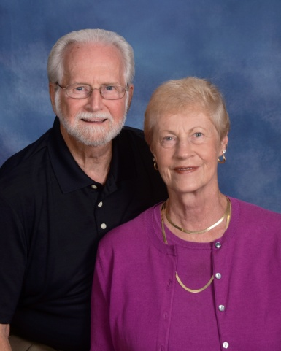 | Bickerton, Tom & Miriam  109 Runnymeade Court  Greenwood, SC 29649  (864) 227-9761  tandmbickerton@embarqmail.com
Bishop, Cary & Beth
Matthew
111 Creekside Court
Greenwood, SC 29649

(864) 229-2017

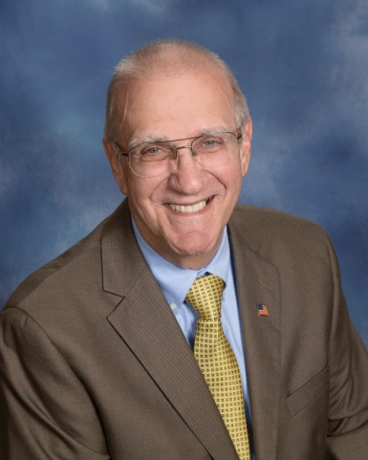 | Blackburn, Wayne  101 Pin Oak Drive  Greenwood, SC 29649  (864) 992-7736  wblackburn@centurylink.net
Blakely, Hope
223 Woodlawn Street
Greenwood, SC 29649

(864) 943-0309

Bledsoe, Scott & Lisa
Evan, Meredith
118 Sand Trap Lane
Greenwood, SC 29649

(864) 223-0780
lbledsoe0404@gmail.com

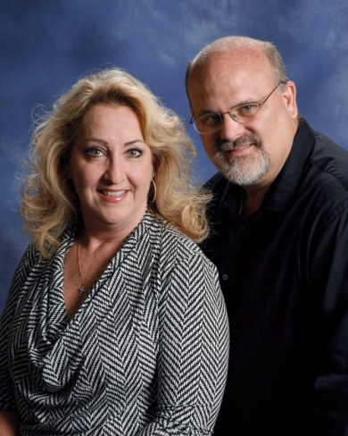 | Boazman, Joe & Sandi  113 Dunns Creek Road  Donalds, SC 29638  (864) 554-9463  joeboazman@nctv.com
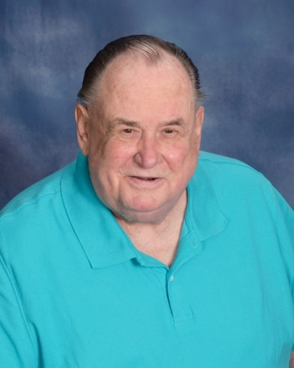 | Boehling, Hank  109 Patriot Pointe Court  Ninety-Six, SC 29666  (864) 543-4610  hank1238@embarqmail.com
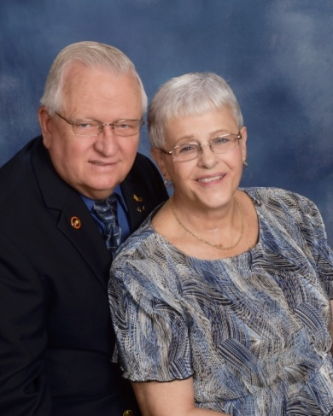 | Boerger, John & Donna  106 Culbertson Court  Greenwood, SC 29649  (864) 980-8361 (John)  (864) 344-7737 (Donna)  boergerh@nctv.com
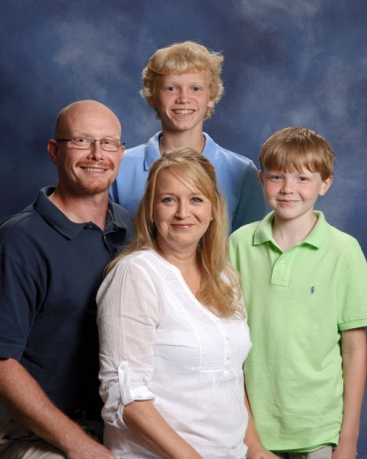 | Boggs, Benji & Kristi  Parker, Evan  144 Kensington Drive  Greenwood, SC 29649  (864) 993-5741  boggk@gwd50.org
Boggs, Lauren
5222 Hwy. 185
Hodges, SC 29653

(864) 223-1168

Bond, Susan
P. O. Box 1092
Abbeville, SC 29620

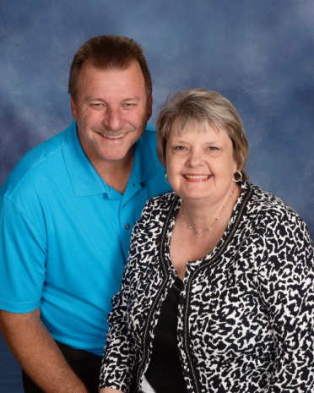 | Boone, Jerry & Kim  214 Curl Creek Road  Greenwood, SC 29649  (864) 223-9486  kwbridges@hotmail.com
Bosler, Kevin & Sandra
78 Rivers Way
Abbeville, SC 29620

(864) 941-6180

Bouknight, Mike & Sherry
Brittany, Daniel
208 Salak Road
Greenwood, SC 29646

(864) 229-1622

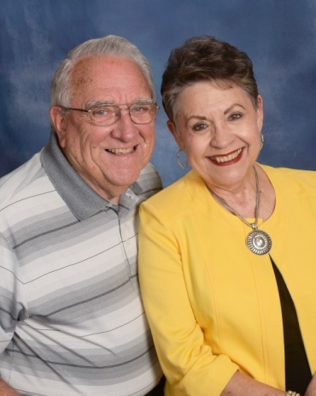 | Bowers, Elbert & Bobbie  120 Orchard Park Drive  Greenwood, SC 29649  (864) 227-0868  bobbiebowers@hotmail.com
Boyd, Laura
Jack, Sam
202 Hutson St.
Greenwood, SC 29649

(864) 980-1880
lboyd@greenwoodeyeclinic.com

Boyer, Dale & Ginger
229 Circle Drive
Greenwood, SC 29646

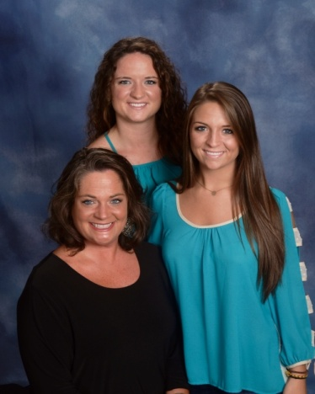 | Bradley, Kayce  Jordan, Grae  310 Belle Meade Road  Greenwood, SC 29649  (864) 550-0118  kaycebradley420@gmail.com
Braid, Ted & Jacqueline
728 Eagles Harbor Drive
Hodges, SC 29653

(864) 374-7651
tejac@aol.com

Brandt, Dave & Janet
107 Luton Place S.
Greenwood, SC 29649

(864) 229-3427

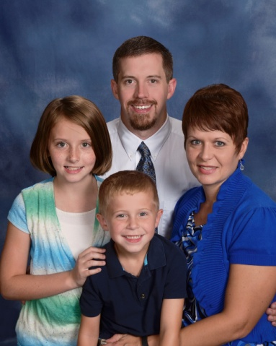 | Branyon, Cal & Nicole  Amaris, Cooper  1106 Jefferson Street  Greenwood, SC 29646  (864) 980-0408  a11504maris@gmail.com
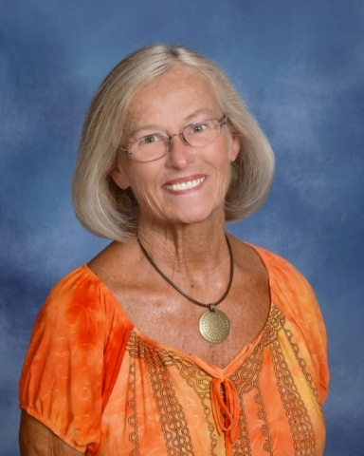 | Braxton, Judie  109 Sheffield Road  Greenwood, SC 29646  (864) 992-4661
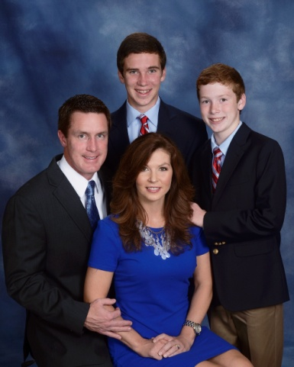 | Brewington, Tyler & Sheri  Mathis, Trevor  207 Windtree Road  Greenwood, SC 29649  (864) 388-7802  twinkletoesspb@yahoo.com
Brock, Dorman & India
105 Coursey Drive
Waterloo, SC 29385

(864) 616-7518
dorman.brock@yahoo.com
Indiabrock59@yahoo.com

Brock, Randy & Edie
520 Clem Road
Greenwood, SC 29649

Brogan, Steve & Barb
Emily, Joseph
403 Jennings Avenue
Greenwood, SC 29649

(864) 388-2109

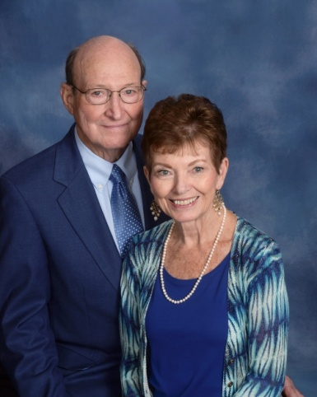 | Broome, Budgie & Ann  1139 Frazier Road  Ninety-Six, SC 29666  (864) 543-1550  abroome41@embarqmail.com

Brothers, Harriett
Mary Fran McCammon
303 Haltiwanger Road, Apt. 11
Greenwood, SC 29649

(864) 229-6621

Brown, Chris & Shelia
Sydney, Brantlee
116 St. Andrews Lane
Greenwood, SC 29646

(864) 943-0307

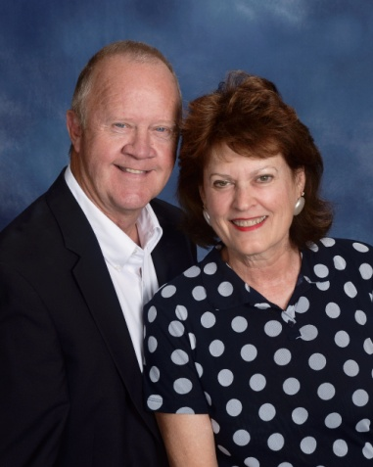 | Brown, Dubie & Fran  112 River Birch Court  Greenwood, SC 29649  (864) 942-0797  franbrown112@gmail.com
Brown, Ed
209 Autumn Trace
Greenwood, SC 29649

(864) 223-5627

Brown, Jerry
125 Heathwood Drive
Greenwood, SC 29649

(864) 227-3711

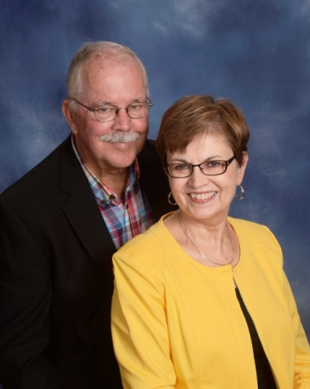 | Brown, Jim & Jean  105 Reid Court  Hodges, SC 29653  (864) 992-9959 (Jim)  (864) 992-7915 (Jean)  (864) 374-3460 (Home)  jeabro@centurylink.net
Brown, Tommy & Maxine
Alana
226 Greenway Drive
Greenwood, SC 29649

(864) 229-2003

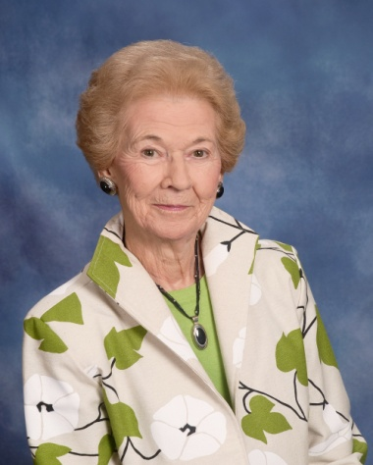 | Brown, Wini  Wesley Commons  1110 Marshall Road  Greenwood, SC 29646  (864) 330-1310
Brownlee, Beth
1110 Northlake Drive
Greenwood, SC 29649

Bruce, Bonnie
100 Tomason Point
Greenwood, SC 29649

(864) 942-0744

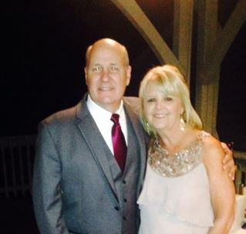 | Bruce Sr., Wilson & Cyndi  Will, Motsy, Winston, Derek  115 Culbertson Court  Greenwood, SC 29649  (864) 223-2883  wrbruce@tcgrd.com
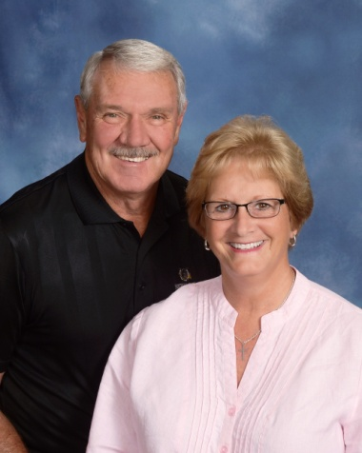 | Bryant, George & Jane  122 Folly Bend Drive  Greenwood, SC 29649  (864) 538-4556  janej23@nctv.com
Buckshorn, David & Kelly
Abby, Will, Benjamin
108 Northwoods Road
Greenwood, SC 29649

(864) 942-2918
thebuckshornhouse@msn.com

Bundrick, Chad & Laura
Reese, Kate, Ben, Luke
104 Milford Springs Road
Greenwood, SC 29649

(864) 992-5912
chadlaurabundrick@yahoo.com

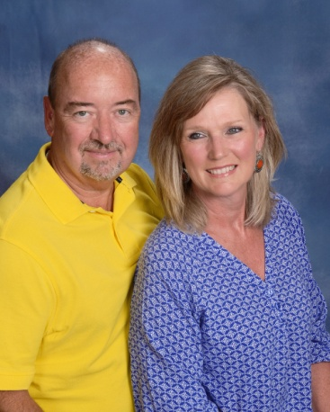 | Burch Jr., Carroll & Deb  716 Fairway Lakes Road  Greenwood, SC 29649  (864) 942-9686  cburchjr@yahoo.com
Burch, Jacob & Amie
Leah, Sawyer
129 Limerick Road
Greenwood, SC 29649

(864) 992-2151
amielee01@yahoo.com

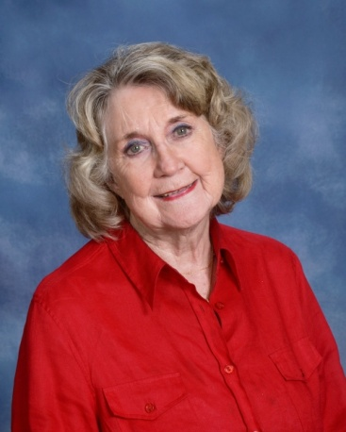 | Burch, Jean  103 Dorsey Court  Greenwood, SC 29649  (864) 223-9667  jeanburch32@gmail.com
Burch, Jr., Susan
103 Lands End
Greenwood, SC 29649

(864) 993-0999
susan@grandharbor.net

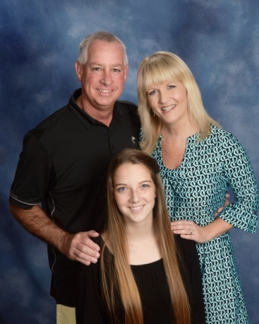 | Burke, Jimmy & Tracey  Raine Templeton  833 Callison Road  Bradley, SC 29819  (864) 910-2882  tltb70@yahoo.com
Burton, Beverly
Burton Runyan, Wesley Runyan
211 Melrose Terrace
Greenwood, SC 29649

(864) 223-1676

Burton, Jimmy & Linda
412 Tranquil Road
Greenwood, SC 29646

(864) 229-1969
lindakennedyburton@gmail.com

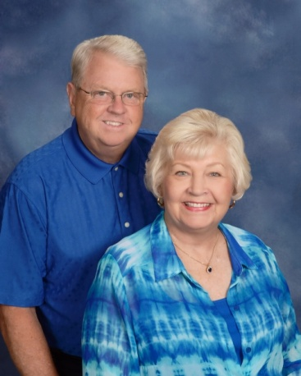 | Burton, Tommy & Patty  208 Sheffield Road  Greenwood, SC 29646  (864) 223-5556  alagrane@nctv.com
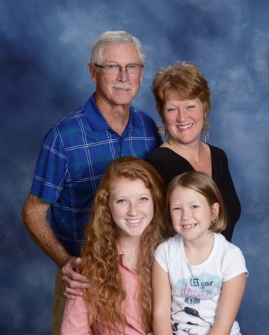 | Burton, Wayne & Paula Prince-Burton  Aylah Burton, Lily Prince  105 White Oak Lane  Greenwood, SC 29646  (864) 227-8032  bigdogsandgraydays@yahoo.com
Butler, Jack & Gail
Jarrett
103 Tally Ho Drive
Greenwood, SC 29649

(864) 223-6461

Cade, Katherine
111 Lilly Lane
Greenwood, SC 29649

Calvert, Derrell
117 Wingard Street
Ninety-Six, SC 29666

Camp, Bill & Denise
Drew Stockman, Jeremiah, Isaiah
205 Chatham Drive
Greenwood, SC 29649

(864) 942-0282

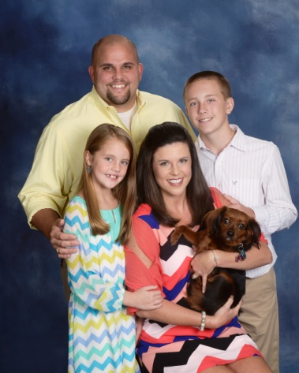 | Camp, Hugh & Twyla  Garrett Luquire, Kylie, Pippa  109 Old Oak Drive  Greenwood, SC 29649  (864) 229-3626  twylamh@yahoo.com
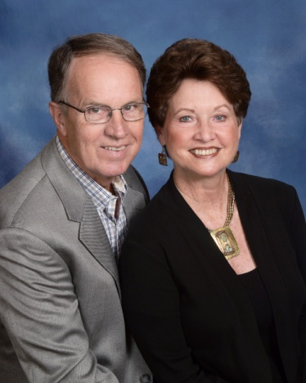 | Campbell, Joe & Dale  103 Hampton Road  Greenwood, SC 29649  (864) 223-5827  joeanddale@gmail.com
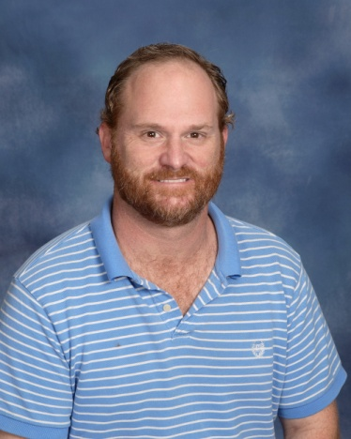 | Campbell, Josh  120-A Abbey Drive  Greenwood, SC 29646  (864) 953-0009  joshkanecampbell@gmail.com
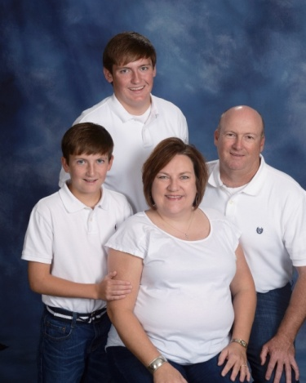 | Campbell, Ken & Dena  Jake, Tyler  310 Dukes Avenue  Greenwood, SC 29646  (864) 229-0912  denacampbell@embarqmail.com
Campbell, Kevin & Christa
Kylie, Kaylynn
110 Bee Pond Road
Ninety-Six, SC 29666

(864) 227-1380

Campbell, Rev. Taylor & Joyce
101 Shannon Street
Greenwood, SC 29646

(864) 942-0414

Case, Steve & Rachel
Sydney, Taylor
110 Wagon Tree Lane
Greenwood, SC 29646

(864) 223-8348

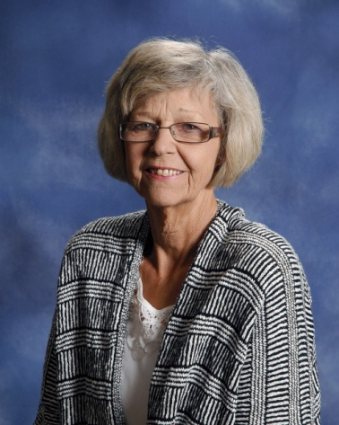 | Cawood, Sandra  222 Autumn Trace  Greenwood, SC 29649  (864) 388-0960

Chandler, Jan
318 Heritage W. Court
Greenwood, SC 29649

(864) 223-0571

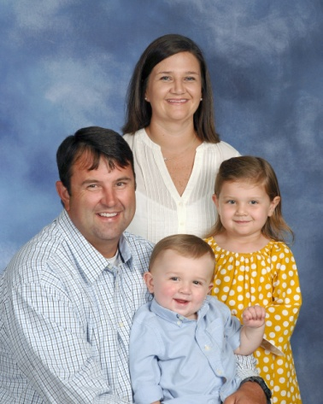 | Chapman, Corey & Jessica  Addi Grace, Tucker  206 Wentworth Drive  Greenwood, SC 29649  (864) 229-7183
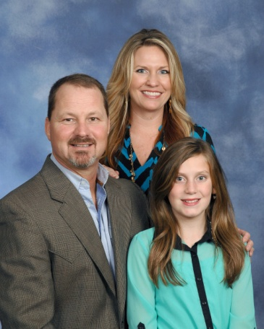 | Chappell, Tommy & Windy  Savannah Mallon  103 Ridge Pointe  Greenwood, SC 29649-8765  (864) 992-2487  windychappell@yahoo.com
Christenson, Marvin & Lorraine
625 Fairway Lakes Road
Greenwood, SC 29649

(864) 227-3740

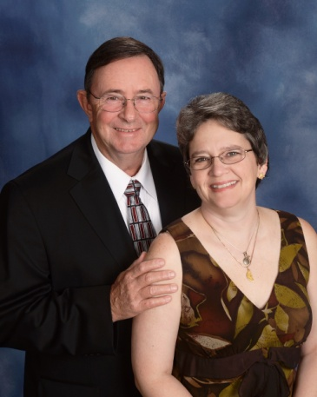 | Christian, Grover & Teresa  614 Salak Road  Greenwood, SC 29646  (864) 227-8227  chrisfam@embarqmail.com

Clamp Jr., Vernon & Glynnis
Lauren
1124 Northlake Drive
Greenwood, SC 29649

(864) 538-0345
vclamp@nctv.com

Clark, Ben
314 Marietta Drive
Greenwood, SC 29646

(864) 942-0214

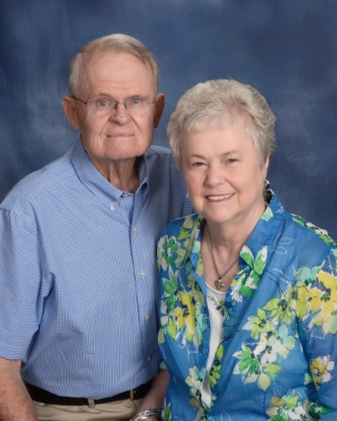 | Clark Jr., Ruth  119 Tryon Court  Greenwood, SC 29649  (864) 223-0860  clarkr384@yahoo.com
Clark, Elizabeth
811 Old Calhoun Falls Road
Abbeville, SC 29620

(864) 391-1676

Clark, Eric
124 Anderson Drive
Greenwood, SC 29646

(864) 871-3109

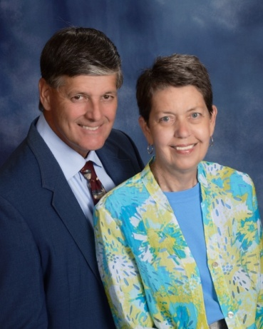 | Clegg, Tom & Anne  1340 Calhoun Road  Greenwood, SC 29649  (864) 229-2395  tomclegg@embarqmail.com
Clem, Chris & Sudie
Sudie, Macy
101 Thornblade Drive
Greenwood, SC 29649

(864) 227-2699

Cobb, Ken & Leslie
Kensley
5225 Hwy 185
Hodges, SC 29653

(864) 374-3314

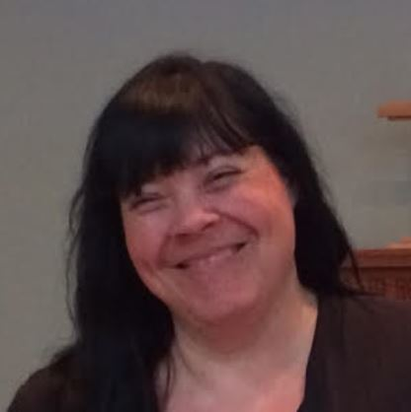 | Cobb, Stephanie  29 North Greenwood Ave. Ext., F-7  Ware Shoals, SC 29692  (864) 378-8839  creativesteph1@yahoo.com
Coleman, Bill & Gay
Tara
P. O. Box 17
Hodges, SC 29653

(864) 980-1430

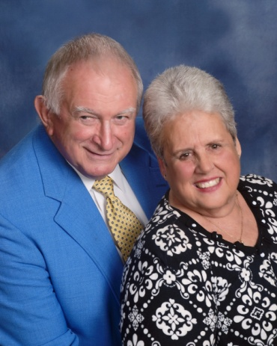 | Conley, Jim & Dodie  402 Heritage W. Court  Greenwood, SC 29649  (864) 389-1230  drcc27@gmail.com
Cook, Ron & Karen
120 Luton Place N.
Greenwood, SC 29649

(864) 943-0561
kkcook@nctv.com

Cooley Jr., Fred & Linda
Chris
109 Wimbledon Court
Greenwood, SC 29646

(864) 229-9458

Coon, Michael & Nancy
515 Pascal Drive
Greenwood, SC 29649

(864) 554-7927
coon.m@ptc.edu

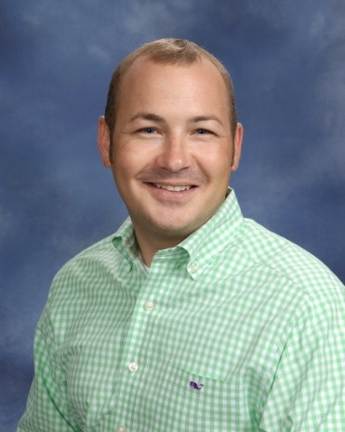 | Corley, Joseph  325 W. Cambridge Avenue  Greenwood, SC 29646  (864) 993-9073  josephcorley@live.com
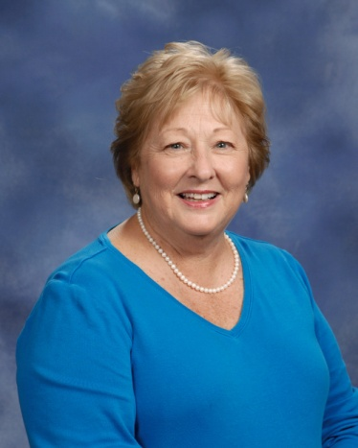 | Corley, Nancy  314 Curl Creek Road  Greenwood, SC 29649  (864) 941-6891  nbcorley@hotmail.com
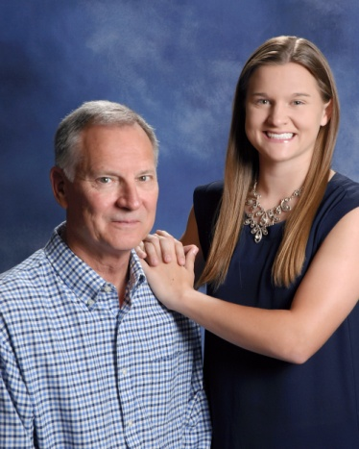 | Corriher, Doug  Emily  101 Mayapple Street  Greenwood, SC 29649  (864) 992-0074
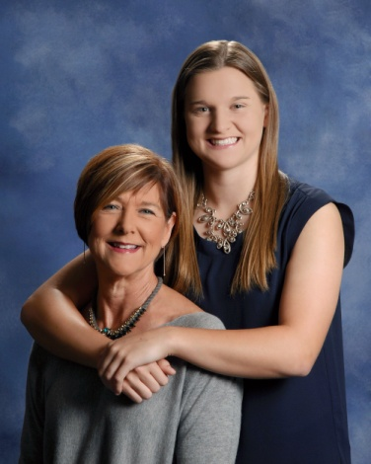 | Corriher, Judy  Emily  321 Gatewood Drive, A-4  Greenwood, SC 29646  (864) 993-1526  corriherj@yahoo.com
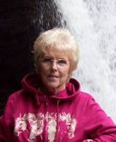 | Coursey, Nancy  206 Haltiwanger Road  Greenwood, SC 29649  (864) 229-0069
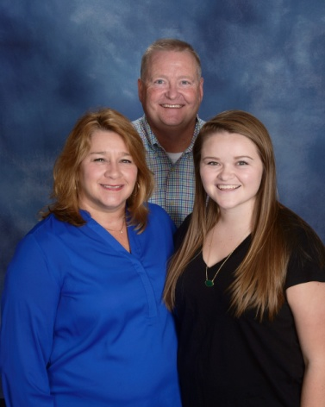 | Coyle, Frank & Holley  Maddie  130 Hatchers Pass  Greenwood, SC 29646  (864) 223-5572  holleycoyle@yahoo.com
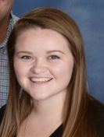 | Coyle, Maddie  2011 University Station  Clemson University  Clemson, SC 296342
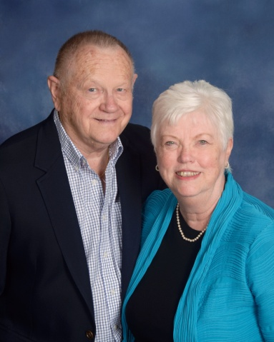 | Crane, George & Betty  1110 Marshall Road  Greenwood, SC 29646  (864) 227-7314  crane2569@mywesleycommons.org
Crawford, Dan & Lisa
Hannah, Rachel
107 Appaloosa Lane
Greenwood, SC 29646

(864) 223-4559

Crenshaw, Roger & Dana
Jason, Robin, Matthew
102 Timberlane Drive
Greenwood, SC 29646

(864) 229-6048

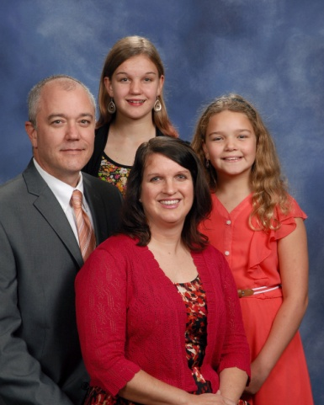 | Creswell, Jonathan & Jennifer  Jasmine, Julia  1107 Saddle Hill Road  Greenwood, SC 29646  (864) 229-3802  jsc41297@gmail.com
Crosby, Tripp & Taylor
5221 Hwy. 185
Hodges, SC 29653

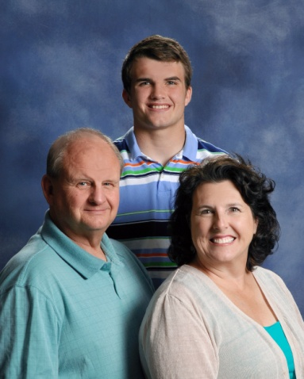 | Crowder, Doug & Jeanine  Steven  107 Nabors Road  Hodges, SC 29653  (864) 456-3308  tdcrowder@gmail.com  crowderjeanine@gmail.com
Cullens, Doug & Katie
Rylie, Reece
108 Timber Lane
Greenwood, SC 29646

(864) 992-7082

Cullens, Kevin & Shannon
Patrick, Catalin
248 Oak Ridge Drive
Greenwood, SC 29649

(864) 229-6704

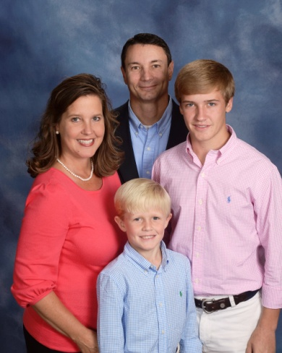 | Dalton, Todd & Connie  Thomas, Matthew  101 Bridle Court  Greenwood, SC 29646  (864) 992-3057 (Todd)  (864) 344-1152 (Connie)  tdalton@fujifilm.com
Daniels, Bob & Judith
1220 Devonshire Road
Coatesville, PA 19320

Davenport, Carole
133 Meadow View Lane
Greenwood, SC 29649

(864) 227-8691

Davis, Adrian & Katherine
120 Hammond Road
Greenwood, SC 29646

(864) 229-4819

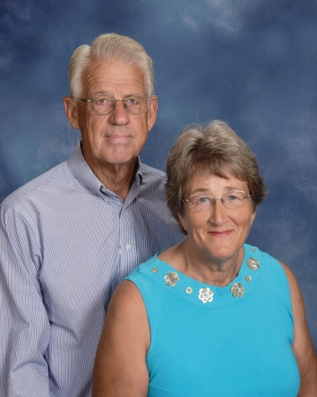 | Davis, Harlan & Kay  110 Greenside Drive  Greenwood, SC 29649  (864) 992-0033  kdavismallardct@gmail.com
Davis, Stephen & Reva
Laniey, Jacob
308 Fawnbrook Drive
Greenwood, SC 29646

(864) 223-5919

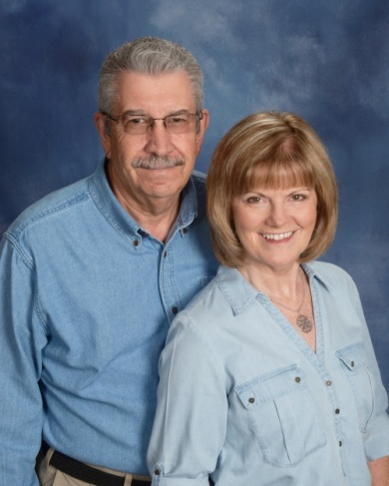 | Dean, Jay & Jeanie  110 Kings Grant Lane  Greenwood, SC 29649  (864) 388-9023  jaydean@embarqmail.com
Decker, Jim
434 S. Mill Road
Greenwood, SC 29646

(864) 223-0523

Dedo, Don & Brenda
420 Lorenzo Road
Greenwood, SC 29649

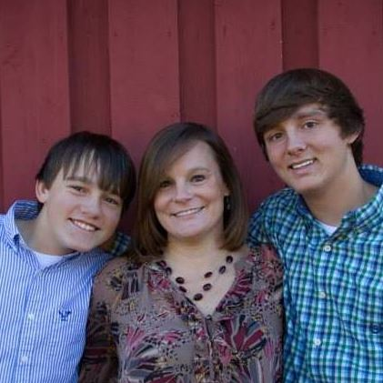 | Deloach, Beth  Hunter, Dylan  213 Saco Avenue  Greenwood, SC 29646  (864) 993-0918
Deloach, Lamont
119 Anderson Drive
Greenwood, SC 29646

(864) 229-0454

Descoteaux, Roger & Cheryl
1225 Mathis Road, Unit 14
Greenwood, SC 29649

(864) 227-1392

Dickey, Cameron & Amy
Chandler, Peyton
204 Charles Road
Greenwood, SC 29649

(864) 227-1791

Dixon, Jack & Dottie
512 Heritage W. Court
Greenwood, SC 29649

(864) 223-0447

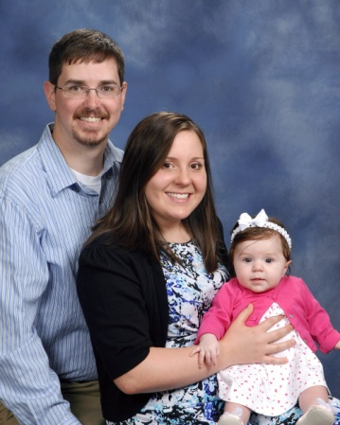 | Dominick, Henry & Kim  Olivia  2415 Bethel Church Road  Prosperity, SC 29127  (803) 271-2638  kimhdominick@gmail.com

Dorn Sr., Mike
132 Crescent Road
Greenwood, SC 29649

(864) 229-1946

Dorn, Rickey & Ana
Braydyn
435 Grove Street
Greenwood, SC 29649

(864) 227-3523

Dorroh III, Griff
105 Summit Street
Greenwood, SC 29649

(864) 377-0932

Dorroh II, Noah
105 Pine Needle Lane
Greenwood, SC 29649

(864) 388-7525

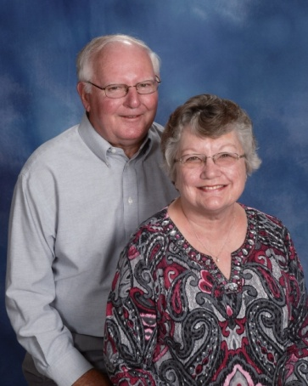 | Dorroh Jr., Olin & Kathy  202 Locksley Drive  Greenwood, SC 29649  (864) 223-4479  godorroh111@embarqmail.com
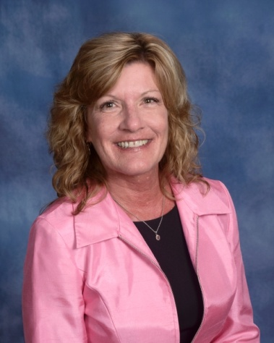 | Dorroh-Byrd, Dena  215 Eastman Drive  Greenwood, SC 29649  (864) 943-9122  dena.byrd@dcrotts.com
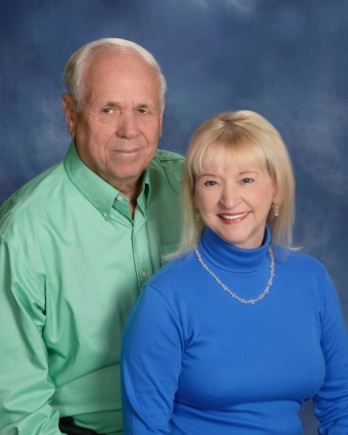 | Durden III, George & Mary  111 Westgate Drive  Greenwood, SC 29646  (864) 223-7685  gdurdeniii@aol.com
Eaddy, Jay & Sherrill
Sara Grace, Anna Kate
107 Wenmount Court
Greenwood, SC 29646

(864) 942-0879

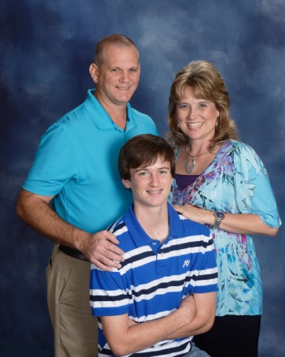 | Ebert, Frank & Angela  Ryan  132 Limerick Road  Greenwood, SC 29649  (864) 980-4952  ebertfw0319@yahoo.com
Edwards, Bill & Joy
109 Barkwood Lane
Greenwood, SC

(864) 992-3415
bnjedwards@gmail.com

Elgin, Cathy
522 Circle Drive
Greenwood, SC

(864) 980-9150
honeycathyhoney2015@outlook.com

Ellis, Angie
P. O. Box 49803
Greenwood, SC 29649

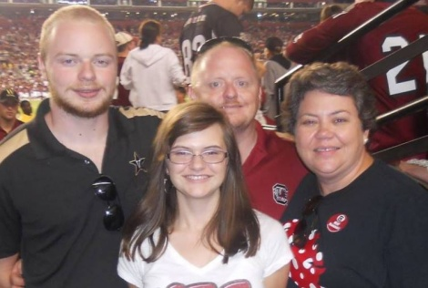 | Elmore Jr., John and Kay  JC, Hannah  308 Clairmont Drive  Greenwood, SC 29649  (864) 345-0776  john@stmarkgreenwood.com
Engeler, Marc & Jami
108 P C Jean Road
Ninety-Six, SC 29666

(864) 554-9879

Engeler, Sharon
Davis
5 Crystal Springs Road
Apt 250
Greenville, SC 29615

Eppelsheimer, John
111 Kingston Road
Greenwood, SC 29649

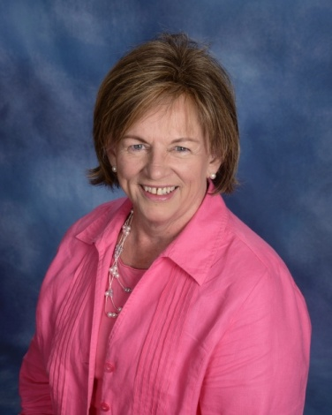 | Eppley, Pinka  122 Pin Oak Drive  Greenwood, SC 29649  (864) 380-6109  pinkaeppley@yahoo.com
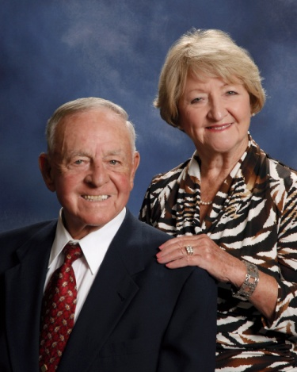 | Ethridge, Tim & Jo Marie  123 Chinquapin Road  Greenwood, SC 29646  (864) 993-3214  Joree60@nctv.com

Eubanks, Sam & Joanna
Jacob
110 Sawgrass Place
Greenwood, SC 29649

(864) 227-3244

Evans, James & Mary Anna
508 Chinquapin Road
Greenwood, SC 29646

(864) 229-2980

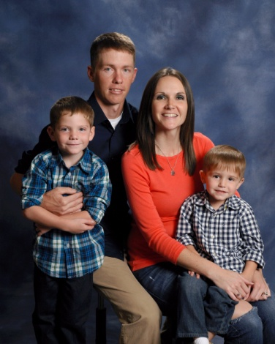 | Evans, Ray & Angela  Jacob, Carter  110 Draper Street  Ninety-Six, SC 29666  (864) 543-4450  Evans_angela@gmail.com
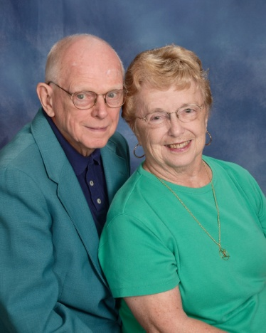 | Eyman, Dick & Doris  Wesley Commons  1110 Marshall Road  Greenwood, SC 29646  (864) 330-1353  rdeyman@mywesleycommons.org
Fain, Brandon
125 Kathy Hill Road
Greenwood, SC 29646

Fain, Maddie & Gray
213 Oak Ridge Drive
Greenwood, SC 29646

(864) 388-9239

Fain, Shannon
522 Circle Drive
Greenwood, SC 29646

(864) 980-9150

Fair, Bobbie
209 Oaklane Drive
Greenwood, SC 29646

(864) 554-3021

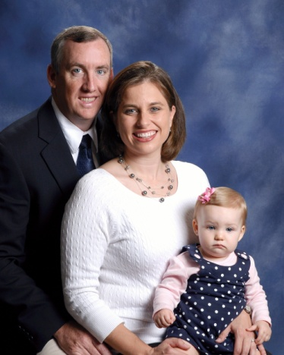 | Farren, Kevin & Leslie  Caroline, Connor  118 Beech Run Drive  Greenwood, SC 29649  (864) 980-2317  les_pt@yahoo.com
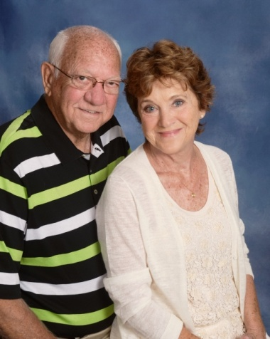 | Fellows, Sam & Margie  107 Westgate Drive  Greenwood, SC 29646  (864) 223-7149  smfellows@embarqmail.com
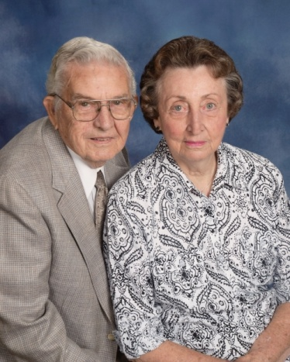 | Fennell, Dick & Evelyn  308 Marietta Drive  Greenwood, SC 29646  (864) 223-7449

Ferguson, Greg & Julie
Nick
103 Longleaf Court
Greenwood, SC 29649

(864) 229-1836

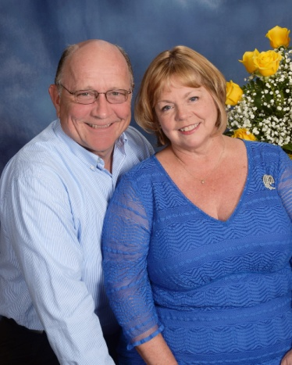 | Fezler, David & Martine  610 Fairway Lakes Road  Greenwood, SC 29649-8435  (864) 223-8160  mfezler@lander.edu
Fields, Cliff
896 Old Abbeville Hwy.
Abbeville, SC 29620

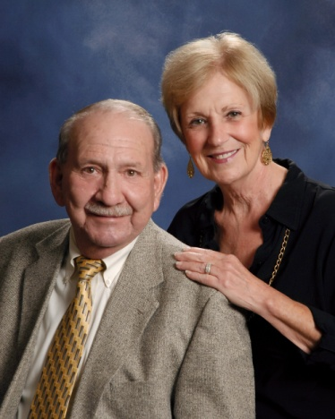 | Finney, Larry & Karen  285 Tranquil Road  Greenwood, SC 29646  (864) 223-6058  karen1945@embarqmqail.com
Fitzgerald, Doris
102 Wood Creek Drive
Greenwood, SC 29649

(864) 223-1859

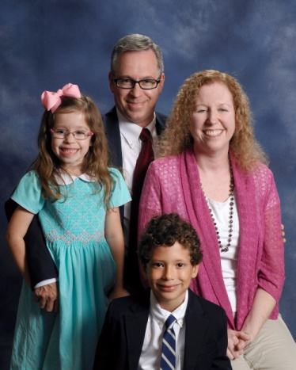 | Fitzgerald, Russ & Ana  Eli, Claire  183 Highland Drive  Greenwood, SC 29649  (864) 323-8855  russ.fitzgerald@gmail.com
 | Florence, Lori
Frady, David & Brenda
107 Broken Ridge Drive
Greenwood, SC 29649

(864) 229-698

Franke, Tom
5 Griffin Drive
Ware Shoals, SC 29692

Franks, Joe & Kelly
Williams, Brent, Driggers, Spencer
41 North Acres Road
Greenwood, SC 29649

(864) 229-1090

Free, Bubber
105 E. Durst Avenue
Greenwood, SC 29649

(864) 223-6246

Free, Wiley
205 Rock Knoll Drive
Greenwood, SC 29649

(864) 223-0189

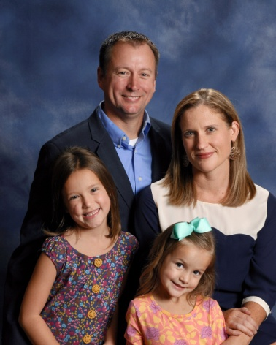 | Frick, Andy & Stephanie  Addison, Maddie  113 Verde Court  Greenwood, SC 29649  (864) 223-0402  frickstephanie@yahoo.com
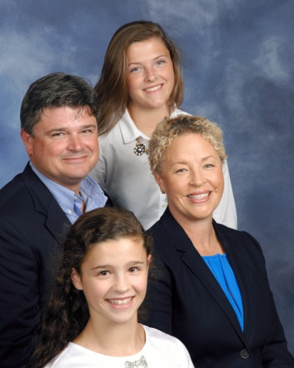 | Furman, Courtney & Caroline  Christian, Mae, Ella  204 E. Creek Road  Greenwood, SC 29646  (864) 943-1858  caroline.s.furman@gmail.com
Gantt, Jerry & Bernice
206 Beech Wood Circle
Greenwood, SC 29646

(864) 229-4163

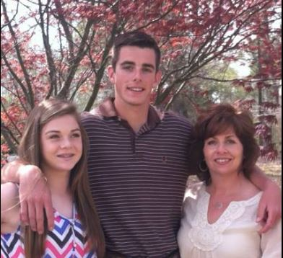 | Gantt, Sally  Kolby, Kylie  119 Rhett Court  Greenwood, SC 29649  (864) 942-0141  momof2onthemove@yahoo.com
Garren, Steve & Pam
Kathryn, Blayne
102 Woodlawn Court
Greenwood, SC 29649

(864) 992-2391
ppgarren@outlook.com

Garrett, Brian & Emily
Parks, Josie
219 Janeway
Greenwood, SC 29649

(864) 227-8424
garrette@gwd50.org

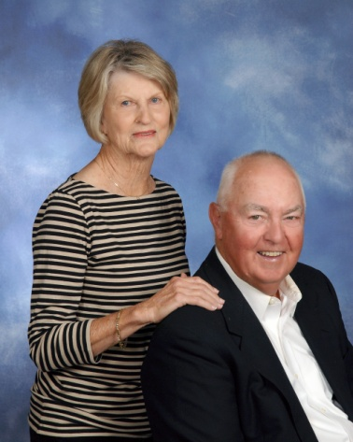 | Garrett, Harry & Pat  110 St. Andrews Lane  Greenwood, SC 29646  (864) 223-5637  hgarrett@embarqmail.com
Garvin, Josh and Mai
Annie, Laila, Stella, Jordan Lovett, Max
212 Oakmonte Circle
Greenwood, SC

(864) 554-4859
maigarvin@gmail.com

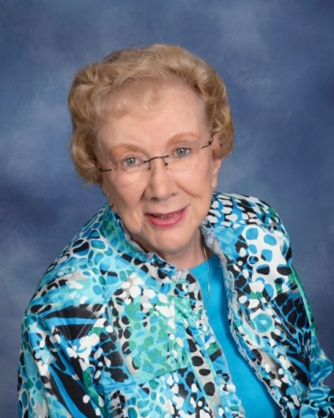 | Gault, Helen  P. O. Box 49432  Greenwood, SC 29649  (864) 229-0904
Geiwitz, Allen & Nancy
224 Swing About
Greenwood, SC 29649

(864) 229-1191

Genevie, Michael & Kathy
Meg
103 Brookview Drive
Abbeville, SC 29620

(864) 366-9588

Gentry, Robbie & Janice
128 Effie Drive
Greenwood, SC 29649

(864) 229-2580

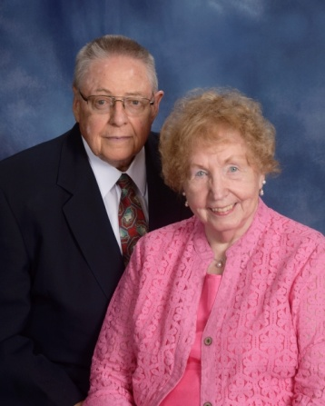 | Gillespie, Ray & Mary  Wesley Commons  1110 Marshall Road  Greenwood, SC 29646  (864) 227-7352  rgillespie@mywesleycommons.org
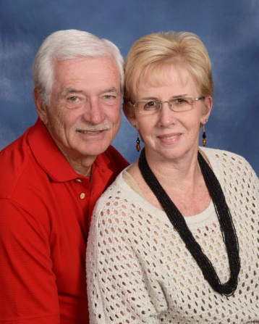 | Gilliam Jr., Harold & Jan  105 Kinkade Drive  Greenwood, SC 29648  (864) 223-2917  haroldgilliam@embarqmail.com
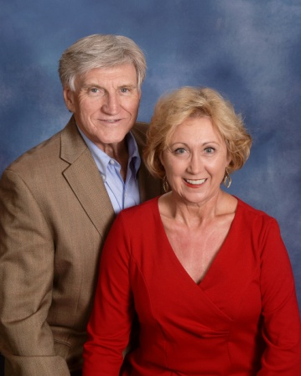 | Gillian Jr., Ernie & Candy  216 Briarwood Road  Greenwood, SC 29646-8700  (864) 223-5463  cgillian@embarqmail.com
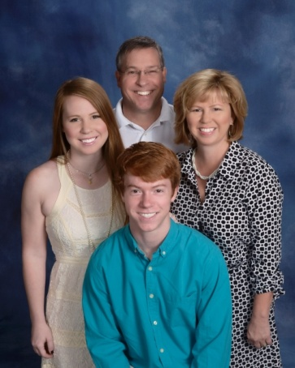 | Glanton, Craig & Kelly  Kaitlyn, Grayson  425 Saddle Hill Road  Greenwood, SC 29646-9480  (864) 223-7552  glanton_k@yahoo.com
Godwin, Tim & Allye
Will, Josh, Luke
128 Folly Bend Drive
Greenwood, SC 29649

(864) 538-0925
timothy.godwin@capsugel.com

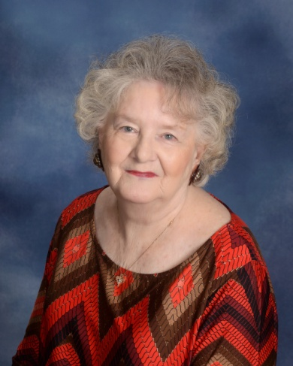 | Goff, Sylvia  508 Marietta Drive  Greenwood, SC 29646  (864) 229-3860  sylviagoff45@gmail.com
Goforth, Edith
Ali
157 Cherokee Drive
Greenwood, SC 29646

(864) 223-4644

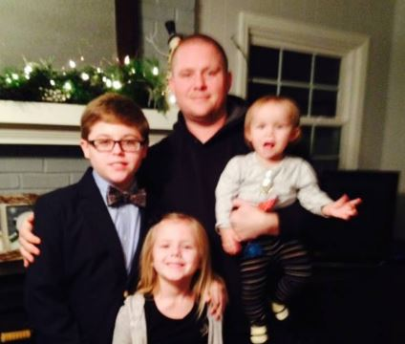 | Goforth, Jacob  Culler, Abigail  157 Cherokee Drive  Greenwood, SC 29646  (864) 223-4644  P00054252@live.ptc.edu

Golden, Tommy & Denise
Greenwood, SC 29649

Gonce, Jonah & Amanda
Kimberlee, Eli, Savannah, Autumn
307 Sirrine Street.
Ninety-Six, SC 29666

(864) 993-7669
agonce2009@gmail.com

Goodman, Danny & Kim
Blake
306 Mathews Heights Road
Greenwood, SC 29646

(864) 229-3288

 |  | Gordy, Chris
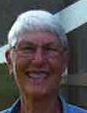 |  | Gravelee Jr., George & Diane  210 Summit Street  Greenwood, SC 29649  (864) 554-2328  dggravlee@gmail.com
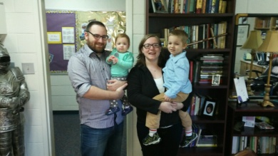 |  | Graves, Shawn and Samantha  Brody, Sara  114 Winter Way, Unit H  Greenwood, SC 29649  (864) 714-7125 (Shawn)  (864) 221-5048 (Samantha)  sslgraves@gmail.com
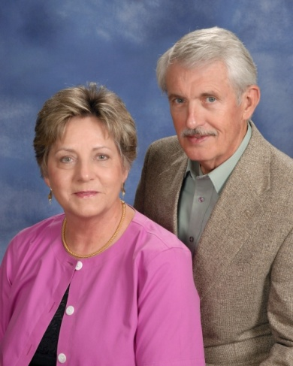 |  | Gregory, Derrell & Kay  139 Roman Circle  Greenwood, SC 29649  (864) 554-4740 (Kay)  (864) 554-4739 (Derell)  kgreg@nctv.com  dgreg@nctv.com
Gretta, Dan and Pam
108 Morningside Drive
Greenwood, SC 29649

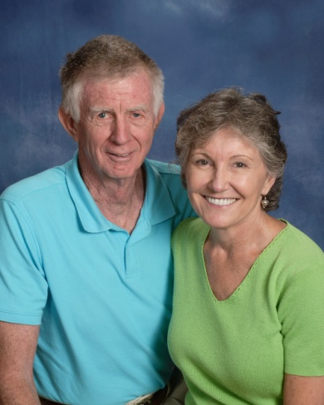 |  | Griffin, Buck & Jean  1223 Hwy. 246 N.  Greenwood, SC 29649  (864) 923-1245  jeansg57@gmail.com
 |  | Grogan, Karen
Grogan, Bobby & Susan
103 Baldwin Road
Ninety-Six, SC 29666

(864) 388-9240

Grooms, Jo
115 Arthurs Point
Greenwood, SC 29649

(864) 229-9666
rjgroomes@nctv.com

Gunnells, Sam
204 Fairway Lakes Road
Greenwood, SC 29649

(864) 943-1105

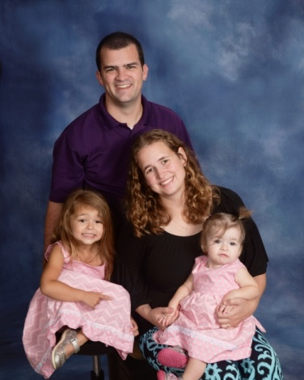 | Hackett, Tom & Stephanie  Caitlyn, Carsyn, Mackenzie  253 Oak Ridge Drive  Greenwood, SC 29649  (864) 245-5959  slarnold@gmail.com
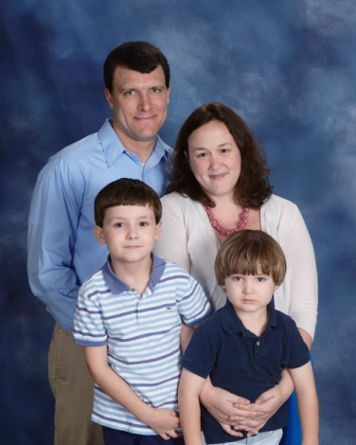 | Hadd, Josh & Cathi  Avery, Grady  307 E. Henrietta Avenue  Greenwood, SC 29649  (864) 992-7865
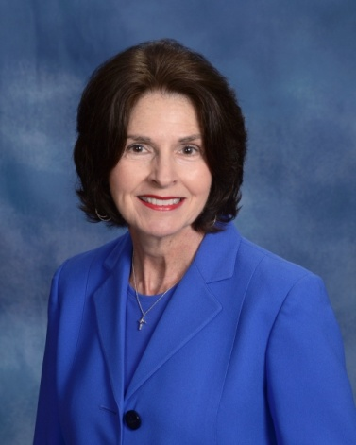 | Hagen, Linda  108 Kensington Drive  Greenwood, SC 29649  (864) 223-3683  ljgh.0727@gmail.com
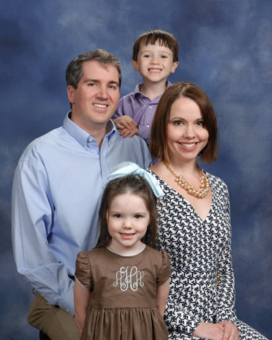 | Haigler Jason & Mary  Austin, Aly  320 Johns Creek Road  Hodges, SC 29653  (864) 993-4470  mchaigler@hotmail.com
Hamilton, Doug
Paul, Blake
223 Ware Street
Greenwood, SC 29646

(864) 223-8673

Hamilton, Russ & Teresa
664 Mill Road South
Greenwood, SC 29646

(864) 554-6991

Hammett, Joe
Ross
138 Crescent Road
Greenwood, SC 29649

(864) 223-3337

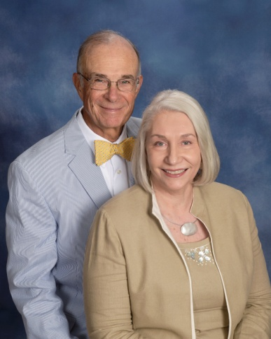 | Hannah, David & Patsy  104 Kensington Drive  Greenwood, SC 29649  (864) 229-6997  phannah@nctv.com

Harley Jr., Jim
103 Carnoustie Court
Greenwood, SC 29646

(864) 229-6057

Harman, Arlie & Barb
Wesley Commons
1110 Marshall Road
Greenwood, SC 29646

(864) 330-1316

Harris, Alan & Allison
109 Curl Drive
Greenwood, SC 29649

Harrison, Michelle
Hannah
205 Parkwood Road
Greenwood, SC 29646

(864) 943-1008

Harter, Rick & Mary Jane
223 St. Augustine Drive
Greenwood, SC 29649

(864) 388-7807
Harwood, Brian & Melissa
Hayden, Holland, Halle
103 Erica Place
Greenwood, SC 29649

Hays, Kristi
Wesley Crooks, Will
104 Windtree Court
Greenwood, SC 29649

Hazel Jr., Joey & Marissa
Jace
216 Holly Avenue
Greenwood, SC 29649

(864) 992-8310

Hazel Sr., Joseph & Donna
209 Sanders Drive
Greenwood, SC 29649

(864) 223-0752
hazeld@gwd50.org

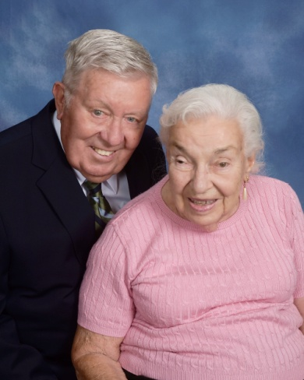 | Heintzelman, Skip  Wesley Commons  1110 Marshall Road  Greenwood, SC 29646  (864) 227-7421  skiph@mywesleycommons.org
Helker, Don & Sondra
107 Bel Arbor Lane
Mauldin, SC 29662

(864) 942-0935

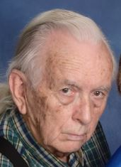 | Helms, Charlie  109 Brookhaven Drive  Greenwood, SC 29646  (864) 227-6017
Hembree, Ray
Hodges, SC 29653

(864) 229-5891

Henderson Jr., Charles
P. O. Box 1784
Greenwood, SC 29648

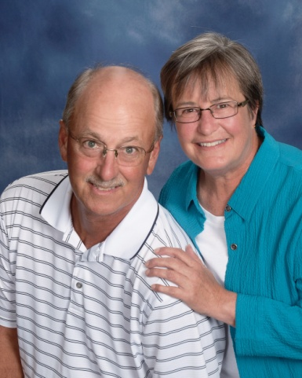 | Henderson, Rick & Nancy  137 Kensington Drive  Greenwood, SC 29649  (864) 223-4819  nlhenderson@embarqmail.com
Hill, Mary
125 York Drive
Greenwood, SC 29649

(803) 229-1076

Hill, Frank and Wanda
109 Deerwood Lane
Greenwood, SC 29646

(864) 992-1132 (Frank)
(864) 993-0013 (Wanda)
wandahill@gmail.com
tfrankhill@yahoo.com

Hitt, Cindy
506 Marietta Drive
Greenwood, SC 29646

(864) 223-6786

Hodges, Lynn
703 Johns Creek Road
Hodges, SC 29653

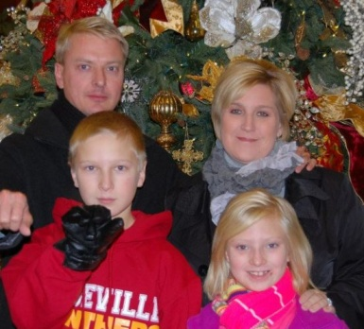 | Hodges, Tim & Paige  Carson, Mary Elliott  47 Oakwood Farms Court  Greenwood, SC 29649  (864) 223-3562  timhodges@embarqmail.com

Holland, Andrew and Holly
Eli Fender
107 WE Smith Road
Greenwood, SC 29649

holleyF14@aol.com

Holland, Becky
Lily Kate, Cory
111 Saint Kitts Court
Greenwood SC 29649

(864) 554-0955

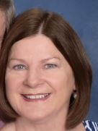 | Holland, Penny  116 Tifton Drive East  Greenwood, SC 29649  (864) 223-2914
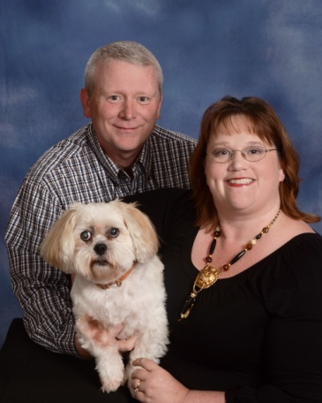 | Holley, Russell & Paige  507 Marietta Drive  Greenwood, SC 29646  (864) 554-7922  office@stmarkgreenwood.com
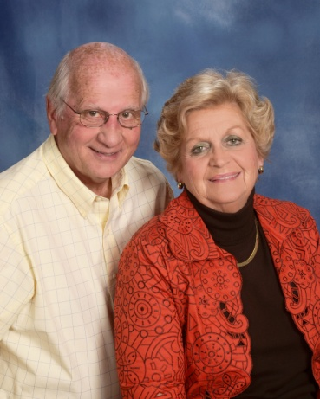 | Hood, Eddie & Susan  107 Devon Park  Greenwood, SC 29649  (864) 229-0844 (Susan)  (864) 993-4603 (Ed)  ehood@hoodmail.com
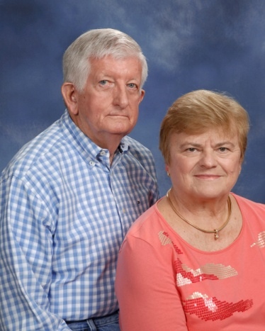 | Hook Jr., Louis & Linda  402 Gatewood Drive  Greenwood, SC 29646  (864) 229-5852  alhirh@earthlink.net
Hoole, Billy & Martha
2939 Ninety Six Hwy.
Ninety-Six, SC 29666

(864) 543-9943
mhoole@embarqmail.com

Hornyak, Lisa
115 Shortleaf Court
Greenwood, SC 29649

House, Bill & Betty
Greenwood, SC

(864) 223-2612

Howard, Marquavius & Kenslie
Karsen Howard
235 Florida Avenue, Apt. 60
Greenwood, SC 29646

(864) 321-7717

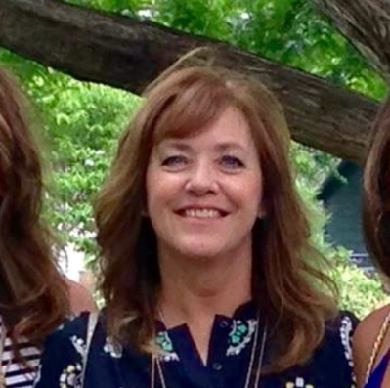 | Howell, Sydney  408 Farmdale Road  Hodges, SC 29653
Hudgens Jr., Nolan
134 Creek Road E.
Greenwood, SC 29646

(864) 229-2078
nolan_hudgens@yahoo.com

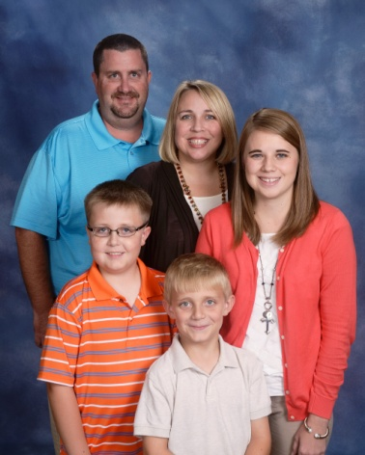 | Hudson, JJ & Lara  Kayla Chrisley, Dawson, Thomas  103 Shortleaf Court  Greenwood, SC 29649  (864) 941-6712  lhudson@greenwoodymca.org
Hughes, Claude
305 Fairway Lakes Road
Greenwood, SC 29649

(864) 942-7152

Hughes Jr., Rusty
109 Gannt Road
Greenwood, SC 29646

(864) 993-2528

Human Jr., Bill & Fran
115 Deerwood Lane
Greenwood, SC 29646

(864) 229-1209

Hunley, Sam
305 Milford Springs Road
Greenwood, SC 29649

(864) 223-9340

Huntsberger, Mat and Jennifer
Grant, Katelyn Miller
2907 Hwy 246S
Ninety-Six, SC 29666

(864) 910-2982
matt.huntsberger@gmail.com
jennalexrm@gmail.com

Huntsberger, Lee
323 W. Commodore Drive
Cross Hill, SC 29332

(864) 998-9036

Huskey, Sidney
509 Norwood Avenue
Greenwood, SC 29646

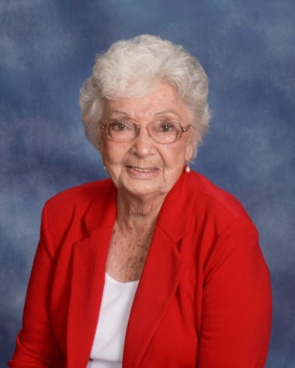 | Jackson, Rekah ‘Sig’  111 Rosemont Drive  Greenwood, SC 29646  (864) 223-1190
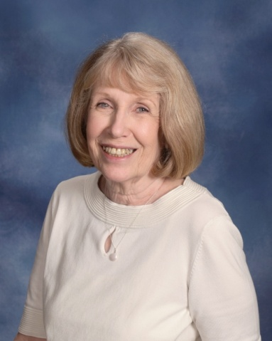 | Jaffe, Sue  110 P. C. Jean Road  Ninety-Six, SC 29666  (864) 543-3290  csajaffe@gmail.com
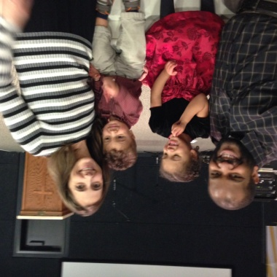 | Johnson, CJ and Megan  Andrew, Lilly  111 Tifton Drive East  Greenwood, SC  (803) 707-2856 (Megan)  (864) 653-0193 (CJ)  cjjohnson2009@gmail.com  coonsmegan@gmail.com
Johnson, Harold & Melanie
Taylor, Sarah Ellen, Jase
724 Windsor Road
Hodges, SC 29653

(864) 374-7838
johnsonm@gwd50.com

Johnson, Terri
Greenwood, SC 29649

Jolly, Brenda
P. O. Box 201
Greenwood, SC 29648

(864) 229-7089

Jolly, Kevin & Gina
Rachel
506 Watford Avenue
Greenwood, SC 29649

Jones, Brad & Mary
Jessica Chandler, Bryce
120 Kensington Drive
Greenwood, SC 29649

(864) 388-0144
mjones0328@yahoo.com

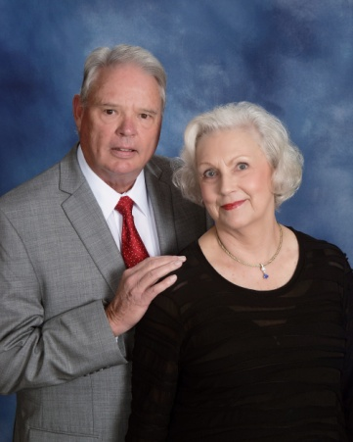 | Jones, Charlie & Carol  117 Watersedge Road  Greenwood, SC 29649  (864) 554-4324 (Charlie)  (864) 554-3683 (Carol)  ccjones@embarqmail.com
Jordan III, George
523 Clem Road
Greenwood, SC 29649

(864) 229-9422

Kapfer, Brad & Samantha
107 Deer Run Lane
Greenwood, SC 29646

Keaser, Grace
411 North Street
Greenwood, SC 29649

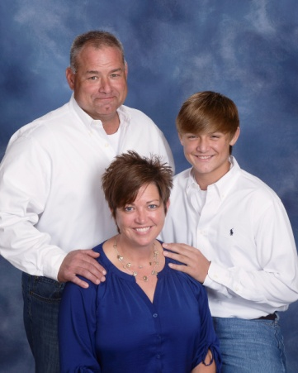 | Keller, Tony & Shana  Evan  114 Emili Lane  Greenwood, SC 29646  (864) 344-6099  shana.keller@selfregional.org
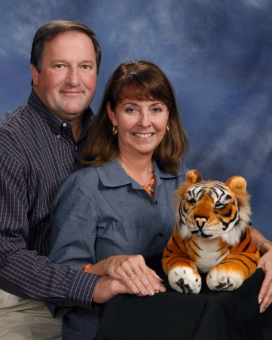 | Kelley, Chuck & Janey  Will, Reed  217 Old Calhoun Falls Road  Abbeville, SC 29620  (864) 223-0273  janeytkelley@yahoo.com  chuckkelley@ksc.org

Kelley, Ladd & Lynn
Lake
125 Tally Ho Drive
Greenwood, SC 29649

(864) 229-7710

Kelley, Ron & Carolyn
103 Foxmeadow Court
Greenwood, SC 29649

(864) 223-1739

Kelly, Keenan & Beth
Joshua, Brett
1877 Cedar Springs S.
Abbeville, SC 29620

(864) 446-2661
kelly.s.b.k@gmail.com

Kennedy, Nancy
515 Pascal Drive
Greenwood, SC 29649

(864) 554-7927

Kennedy, Verna
NHC
P. O. Box 3109
Greenwood, SC 29648

(803) 229-2759

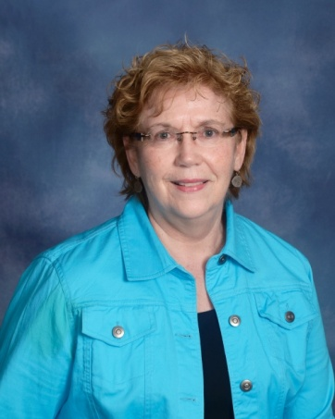 | Kennerly, Margaret  106 Chelsea Square  Greenwood, SC 29649  (864) 223-0909  mkennerly@embarqmail.com
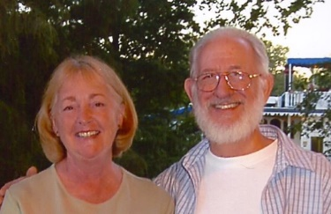 | Keppler, Tim & Dottie  209 W. Commodore Drive  Cross Hill, SC 29332  (864) 365-6655  tkeppler@gmail.com
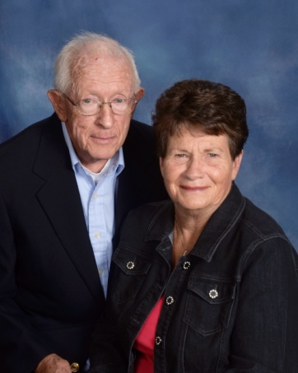 | Kilgore, Tom & Joyce  148 Highland Drive  Greenwood, SC 29649  (864) 229-6055
Kirby, Thomas & Brooke
104 Woodbury Drive
Greenwood, SC 29649

Kneece, Emily
Maddie Brown
Hodges, SC 29653

(864) 729-8217

Knight, David & Velma
208 Kathy Hill Road
Greenwod, SC 29646

(864) 227-2646

Knight, Jimmy
108 Hampton Road
Greenwood, SC 29649

(864) 943-2446

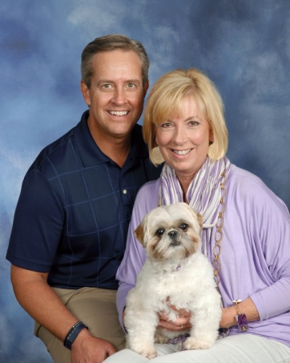 | Knott, Brad & Vicki  Charlee  108 Fairway Court  Greenwood, SC 29649  (864) 229-3355  vknott@greenwoodcpw.com
Kolar, Zoe
104 Rock Creek Drive
Greenwood, SC 29646

(864) 229-5639
kolar46@yahoo.com

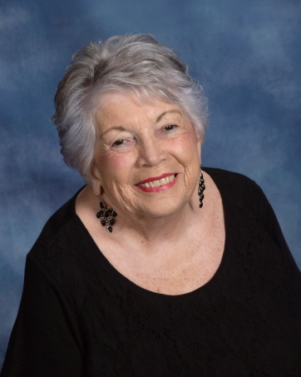 | Koone, Charlotte  104 Heritage W. Court  Greenwood, SC 29649  (864) 227-6942
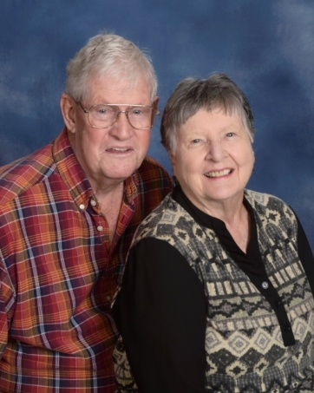 | Kruzan, Jim & Lee  Wesley Commons  1110 Marshall Road  Greenwood, SC 29646  (864) 227-7339  lekruz35@yahoo.com
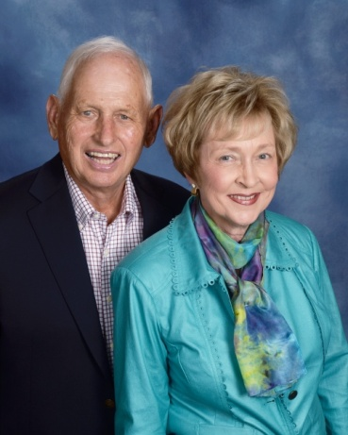 | Lacoste, Bill & Pat  314 Lodge Drive  Greenwood, SC 29646  (864) 229-3339  bplacoste@icloud.com
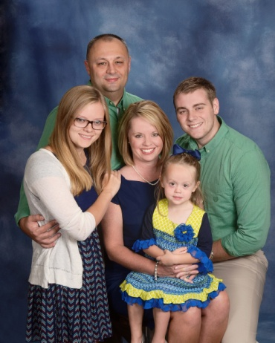 | Lake, Calvin & Teresa  Brett Clark, Jessica Clark, Mallory  406 Twisted Oak Drive  Greenwood, SC 29646  (864) 981-3238  lakecalvin75@gmail.com
Landrith, Amy
Lauryn
112 Fawn Brook Drive
Greenwood, SC 29646

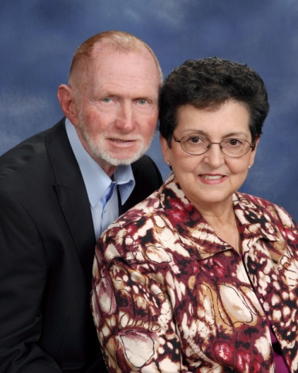 | Langley, Ed & Doris  303 Lynn Street  Greenwood, SC 29649  (864) 229-2334  doublerock@embarqmail.com
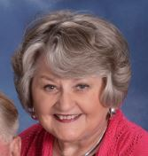 | Langley, Jean  106 Colonial Drive  Greenwood, SC 29649  (864) 992-1661  jlangley5584d@nctv.com
Laswell, Miriam
104 Thornbrook Court
Greenwood, SC 29646

(864) 223-6710

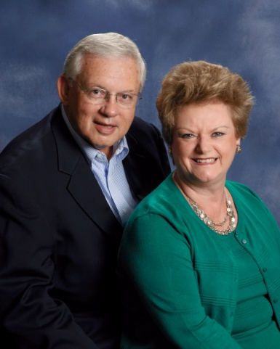 | Latham, Fred & Betty  601 Gatewood Drive  Greenwood, SC 29646  (864) 223-4097  flatham@earthlink.net
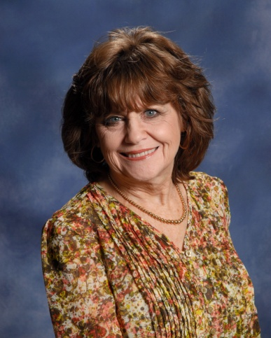 | Latham, Jo  118 Shortleaf Court  Greenwood, SC 29649  (864) 223-3659  jolatham@yahoo.com
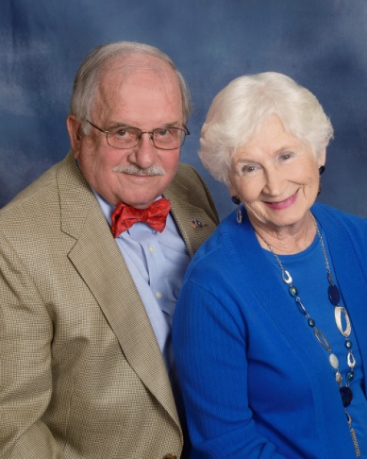 | Lax Sr., Colonel Robert & Jean  1135 Frazier Road  Ninety-Six, SC 29666  (864) 543-3271  relax06@embarqmail.com
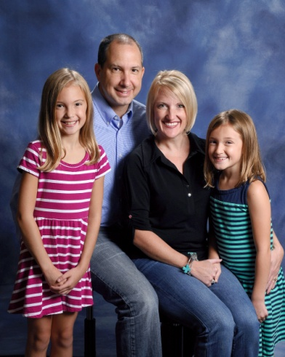 | Layland, Ralph & Erin  Lexi, Charlee  105 Chipping Court  Greenwood, SC 29649  (864) 388-7919  erin.layland@parksterlingbank.com
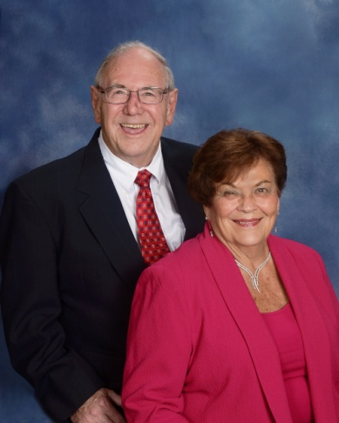 | Leaman, Sam & Dot  208 Heritage W. Court  Greenwood, SC 29649  (864) 229-1251  samleamanjr@embarqmail.com
Lee, Gilliean & Marae
116 Folly Bend Drive
Greenwood, SC 29649

(864) 229-1478

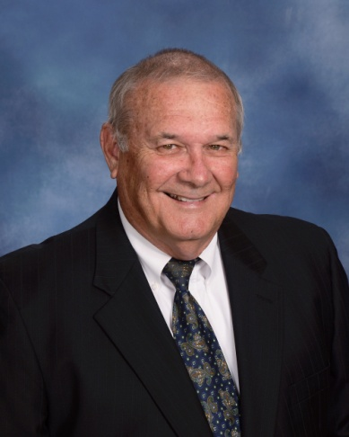 | Lee, Sonny  109 Country Village Lane  Greenwood, SC 29649  (864) 229-0347  leek1942@embarqmail.com
Lee, Starla
210 Curl Creek Road
Greenwood, SC 29649

(864) 388-2115

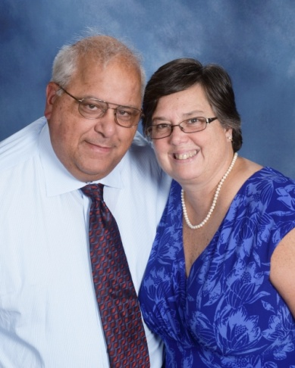 | Leo, Conrad & Jaye  909 Saddle Hill Road  Greenwood, SC 29646  (864) 993-3225  jayeleo57@gmail.com
Leopard, Johnny
Peyton, Austin, Jewel Malone
112 Nottingham Lane
Greenwood, SC 29649

(864) 223-6939

Lepp, Heather
435 Haltiwanger Road, Apt. 27
Greenwood, SC 29649

(864) 223-4544

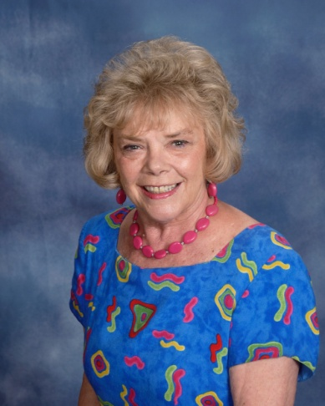 | Leslie, Faye  104 Windsor Oaks Court  Greenwood, SC 29649  (864) 980-3036  lesliesassy2002@yahoo.com
Lightsey, David & Betty
119 Orchard Park Drive
Greenwood, S C 29649

(864) 223-6725

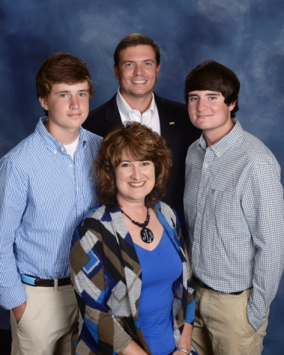 | Lindler, Phil & Jennifer  Blake, Rhett  228 Chatham Drive  Greenwood, SC 29649-9512  (864) 941-0460  lindlerj@gwd50.org
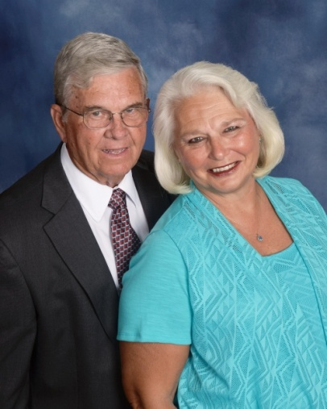 | Lindley, Billy Joe & Sherlyn  1218 Saddle Hill Road  Greenwood, SC 29646  (864) 941-7469  sherlyn7726@gmail.com

Liner, Chris & Meredith
Cade, Emma
5392 Hwy. 76 W.
Laurens, SC 29360

(864) 227-9013

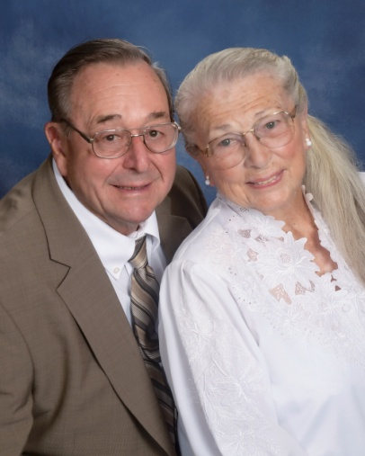 | Logan, Verne & Margie  228 Pumphouse Road  Greenwood, SC 29649  (864) 554-8632
Lollis, Dean & Denise
Grace, Kayden
108 Hidden Lake Court
Greenwood, SC 29646

(864) 321-2708
d2lollis@gmail.com

Lollis Jr., James
108 Culbertson Court
Greenwood, SC 29649

(864) 943-1366

Long, Jason
204 Winter Ridge Court, Apt. C
Greenwood, SC 29649

Long, Jeff & Glenda
Kierstin Cook
4 Royal Oak Drive
Greenwood, SC 29649

(864) 223-5277

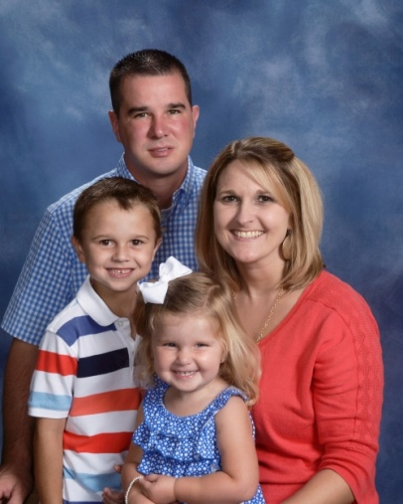 | Long, John & Amanda  Gentry, Aubrey  311 Johnston Road  Ninety-Six, SC 29666  (864) 993-7113  along@phgrp.com
Long, Ronnie & Betty
102 Evergreen Drive
Greenwood, SC 29649

(864) 229-4351

Long, Ted & Ann
222 Swing About
Greenwood, SC 29649

(864) 223-2016

Long, Wheeler & Nancy
125 Donegal Drive
Greenwood, SC 29646

(864) 223-3384

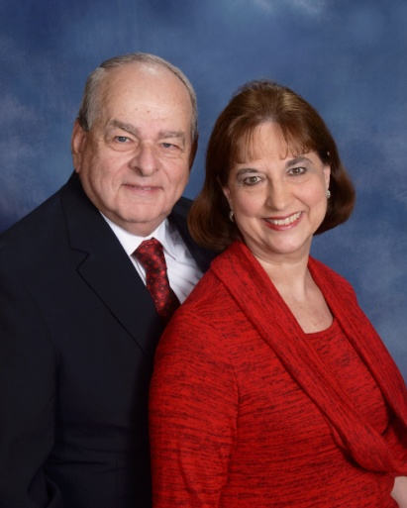 | Lucas, Linda & Phil  120 North Acres Road  Greenwood, SC 29649  (864) 229-7252  lindalucas@nctv.com

Lybrand, Bill and Thomasine
101 Kenilworth Drive
Greenwood, SC 29649

(864) 910-0665 (Bill)
(864) 910-2962 (Thomasine)
bill.lybrand@gmail.com
thomasine.lybrand@gmail.com

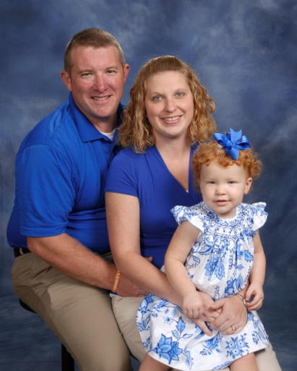 | Lybrand IV, Billy & Susan  Addison  302 Loblolly Circle  Greenwood, SC 29649  (864) 993-7104  srlybrand@gmail.com
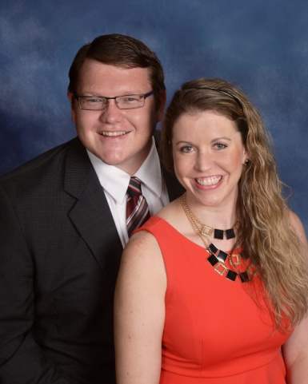 | Lybrand, Robby & Jennifer  434 Sagewood Road  Greenwood, SC 29646  (864) 980-3927  rtlybrand@liberty.edu
Lyles, Jamie & Lauren
Steven
210 Winding Oak Way
Blythewood, SC 29016

Lynch, Kevin & Sandra
1007 S. Main Street
Greenwood, SC 29646

(864) 229-0519

Malacky, Mike & Jackie
John Michael
P. O. Box 49091
Greenwood, SC 29649

(864) 341-6057

Mallon, Keith
201 E. Creek Court
Irmo, SC 29063

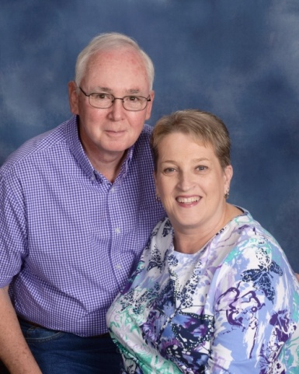 | Manley, Doug & Kathy  405 Pascal Drive  Greenwood, SC 29649  (810) 624-5358  ck_manley@hotmail.com
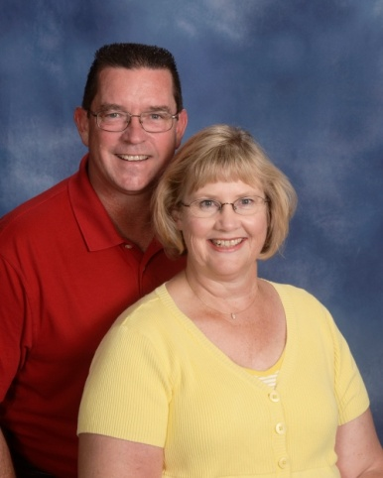 | Manning, Peter & Sharon  107 Brookfield Drive  Greenwood, SC 29646  (864) 229-2126  sharonmanning@nctv.com
Manning, Sammie Jo
11 Sombrero Blvd, Unit 11
Marathon, FL 33050

(864) 993-5262
manningsamm@gmail.com

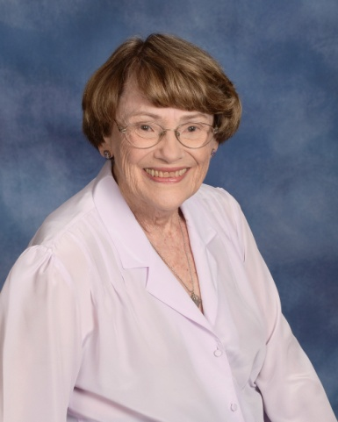 | Mannion, Louise  Wesley Commons  1110 Marshall Road  Greenwood, SC 29646  (864) 330-1303  jmannion@mywesleycommons.org
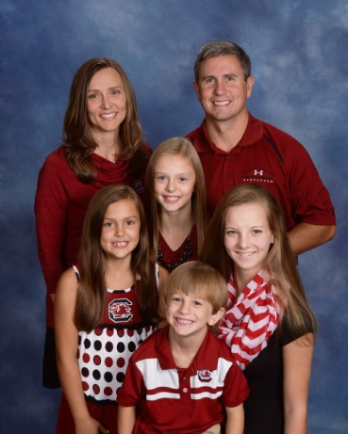 | Mapes, Mark & Jennifer  Jessica Steepy, Tyler, Jordan, Jillian  420 Johns Creek Road  Hodges, SC 29653  (864) 953-2150  jennifer.mapes@sageai.com
Marcengill II, Jimmy & Whitney
Harrison
108 Carriage Court
Greenwood, SC 29646

(864) 223-3477
marcengillj@yahoo.com

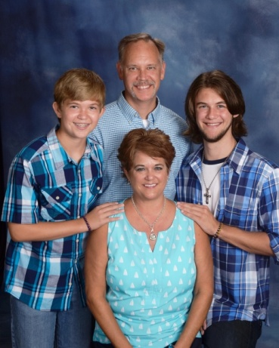 | Markward, Todd & Cindy  Austin, Quintin  107 Tryon Court  Greenwood, SC 29649  (864) 993-1356  tcaq@embarqmail.com
Marshall, Joe & Shannon
110 Planters Court
Greenwood, SC 29649

(864) 223-3126

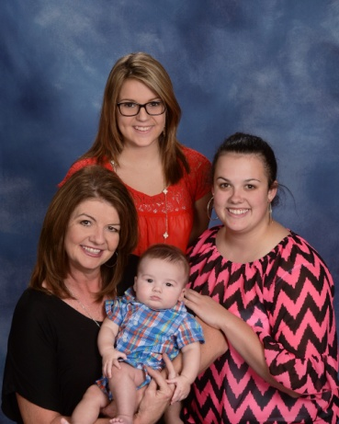 | Marshall, Tammy  Kendall O’Quinn, Ally Grace, Daniel O’Quinn  119 Crescent Road  Greenwood, SC 29649  (864) 910-1256  tmarshall29649@gmail.com
Marshall, Walter & Gay
113 Heathwood Drive
Greenwood, SC 29649

(864) 223-4201

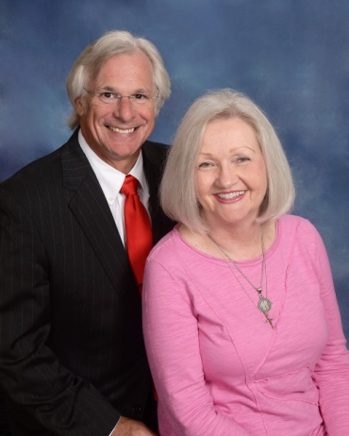 | Martin, George & Margaret  203 Hatchers Pass  Greenwood, SC 29646  (864) 388-4247  gmartin@greenwoodmetro.com
Matthews, Buddy & Annette
1111 Old Abbeville Hwy
Greenwood, SC 29649

(864) 229-7619

Matthews, Tim & Rhonda
Graham
821 Mt. Moriah Road
Greenwood, SC 29646

(864) 223-9137
timandrhondamatthews@yahoo.com

Matzke, Christina
58 Falling Leaf Drive
Waterloo, SC

(864) 677-2525
McAlister III, Rob & Susan
Clark, Will
1105 Reedy Creek Road
Bradley, SC 29819

(803) 227-9367

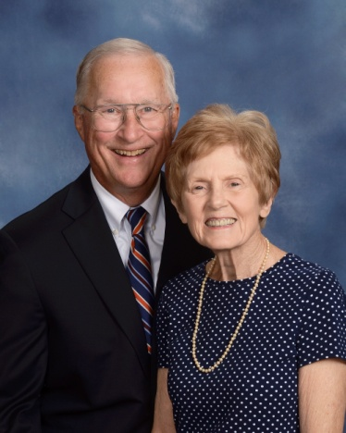 | McCaffrey, Glenn & Julie  101 Wendover Road  Greenwood, SC 29649  (864) 223-0879
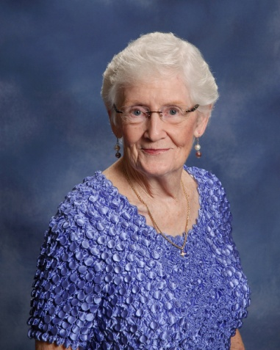 | McCall, Wilma  Hannah Cronic, Cindy  142 Pinehaven Drive  Ninety-Six, SC 29666  (864) 543-2223  wilmamccall@embarqmail.com
McCallum III, Edward & Jeannie
104 Blue Heron Court
Greenwood, SC 29646

(864) 229-2903

McCarty, Scott
204 Loblolly Circle
Greenwood, SC 29649

(864) 942-1647

McClain, Rick
715 New Market Street
Greenwood, SC 29646

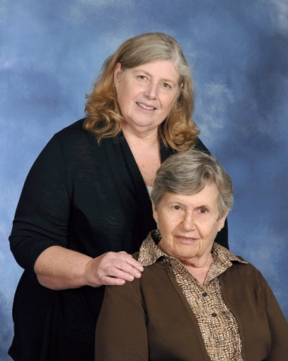 | McClain, Debbie & Martha Talbert  204 Heathwood Drive  Greenwood, SC 29649  (864) 223-9477
McClinton, Jessica
125 Rivers Way
Abbeville, SC 29620

(864) 223-4888

McClinton, Kathy
101 Faye Drive
Ninety-Six, SC 29666

(864) 543-2627

McClinton, Sam & Becky
Haven, Erica
111 Appaloosa Lane
Greenwood, SC 29646

(864) 227-1407

McColl, Jim & Ruth
117 Creek Road E.
Greenwood, SC 29646

(864) 229-2106

McCrea, Tommy & Tricia
Sadie, Gray
108 Tryon Court
Greenwood, SC 29649

(864) 227-8742

McCullough, Adam
2605 Bel Ivy Road
Newberry, SC 29108

McCurry, Austin
Abbeville, SC 29620

(864) 227-9974

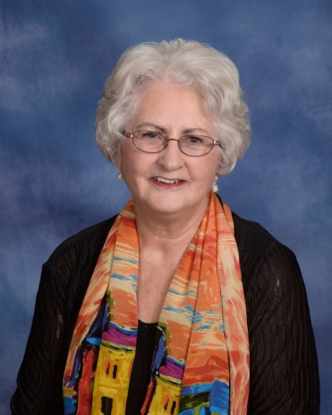 | McDaniel, Audrey  724 Rockhouse Road  Greenwood, SC 29646  (864) 227-1502  mcdaniela@centurylink.net
McDonald, Charles & Harriett
P. O. Box 49942
Greenwood, SC 29649

(864) 223-9534

McDonald, Stewart and Jennifer
112 Greenbriar Road
Greenwood, SC 29649

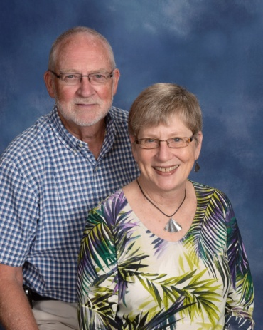 | McFarland, Bill & Susan  216 Starboard Tack  Greenwood, SC 29649  (864) 227-8175  smcfarland216@gmail.com  o.william.mcfarland@gmail.com
McGehee, Pat & Patti
Emily
116 Emili Lane
Greenwood, SC 29646

(864) 223-4496

McGill, Preston
201 Athens Court
Greenwood, SC

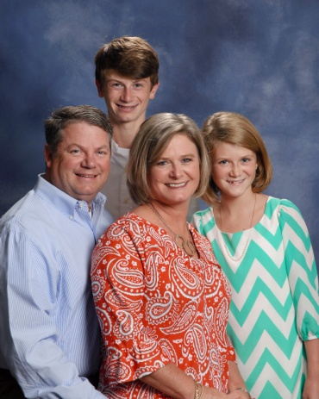 | McGovern, Jimmy & Tracie  Patrick, Meg  108 Palmer Place  Greenwood, SC 29649  (864) 223-1402  jtmcgovern@centurylink.net
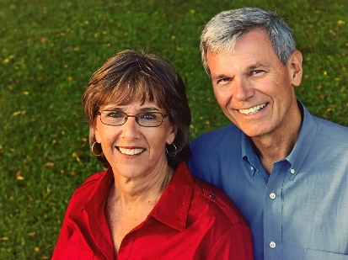 | McIntosh, Dave & Becky  Ted Sullivan, Ben  918 Olde Pucketts Ferry Road  Greenwood, SC 29649  (864) 993-6501  beckymc@embarqmail.com
McIntosh, Lisa
Lauren Powell, Ryan Coffey, Eric
812 Hunters Creek Boulevard
Greenwood, SC 29649

(864) 229-6730
southcarolinagc@yahoo.com

McKellar, Elizabeth
1804 McCormick Hwy
Greenwood, SC 29646

(864) 223-5460

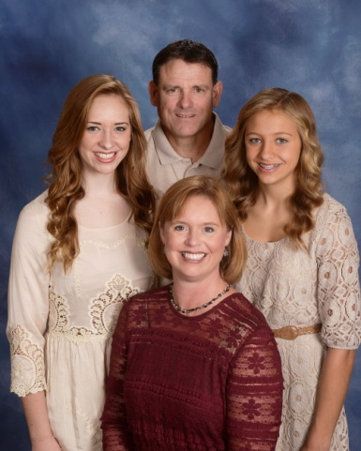 | McLaughlin, Kevin & Julie  Anna Grace, Haley  1213 Saddle Hill Road  Greenwood, SC 29646  (864) 910-1567  julie@stmarkgreenwood.com
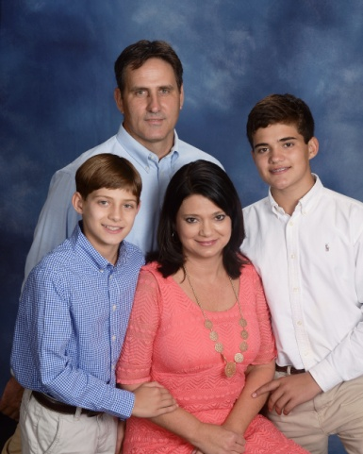 | McLaughlin, Tom & Kim  Jacob, Caleb  103 Appaloosa Lane  Greenwood, SC 29646  (864) 388-0474  kimberlym@embarqmail.com
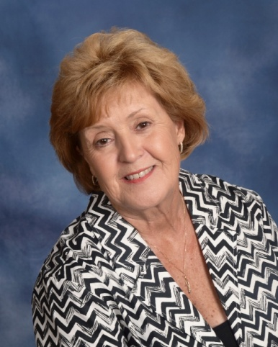 | McMahan, Janice  105 Pin Oak Drive  Greenwood, SC 29649  (864) 391-7360  jpmcmahan@embarqmail.com
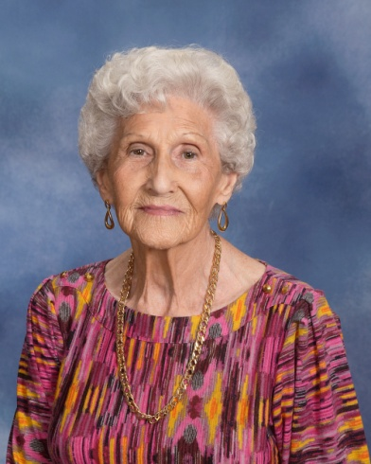 | McManus, Annell  110 Northgate  Greenwood, SC 29649  (864) 229-1596

McManus, Chaz
112 Loblolly Circle
Greenwood, SC 29649

(803) 223-2931

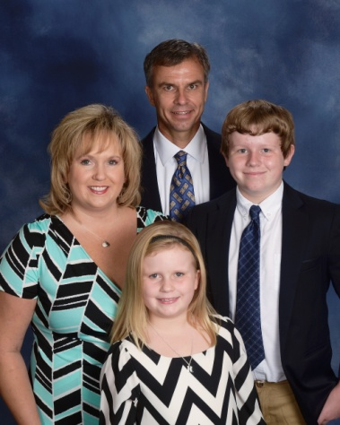 | McManus, Zvi & Gina  Tyler, Rylee  106 St. Augustine Drive  Greenwood, SC 29649  (864) 554-4938  zviandgina@embarqmail.com
McWhorter, Rick & Joy
101 Amherst Drive
Greenwood, SC 29649

(864) 223-5382

Mechtensimer, Vernon & Carol
1110 Marshall Road
Greenwood, SC

Medlock, Bobby & Diane
Kevin, Brian
113 Culbertson Court
Greenwood, SC 29649

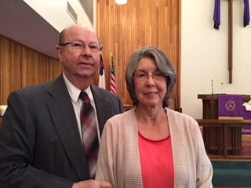 | Meints, Jerry & Sandra  311 Hunters Creek Boulevard  Greenwood, SC 29649  (864) 223-9656  belanstar@icloud.com
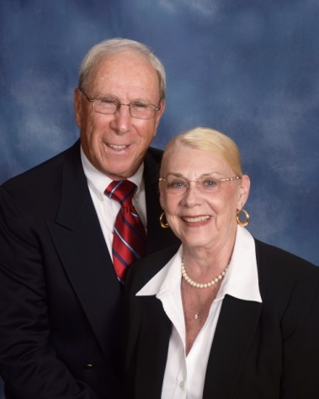 | Menaker, Stuart & Jackie  105 Hunters Village Drive  Greenwood, SC 29649  (864) 229-2387  Jmenaker77@gmail.com  stujack@embarqmail.com
Miles, Sondra
208 Forest Lane
Greenwood, SC 29649

(864) 223-2719

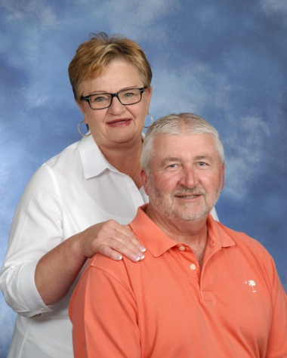 | Millender, Ronnie & Brenda  319 Hammond Road  Greenwood, SC 29646  (864) 223-4091  millender@emeraldis.com
Miller, Amsey & Catherine
104 Rivers Run
Greenwood, SC 29649

(864) 538-6254

Miller, Chris & Jenny
251 Oak Ridge Drive
Greenwood, SC 29649

(864) 942-0071

Miller, David & Linda
Drew, Erin
121 Woods Drive
West Union, SC 29696

(864) 888-2416

Miller, Katelyn
242 Dry Branch Court
Greenwood, SC 29649

Miller, Lee & Cathy
Benjamin
206 Gentry Run
Greenwood, SC 29649

(864) 229-4854
calamiller@outlook.com

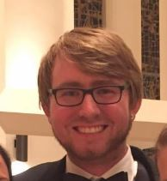 | Miller, Matthew  204 Gracemont Drive  Greenwood, SC 29649  (864) 554-6013  matthew@stmarkgreenwood.com
Miller, Reid
RR 2, Box 549-A
Saluda, SC 29138

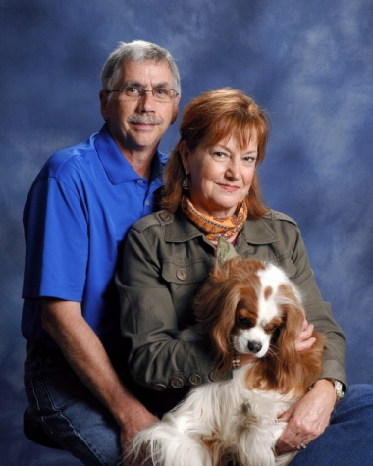 | Miller, Sam & Patti  Charlie  126 Windsor Oaks Court  Greenwood, SC 29649  (864) 992-5756  pattim285@gmail.com

Miller, Tom and Bobbie
251 Oak Ridge Drive
Greenwood, SC 29649

(864) 229-7787
robertamiller@hotmail.com

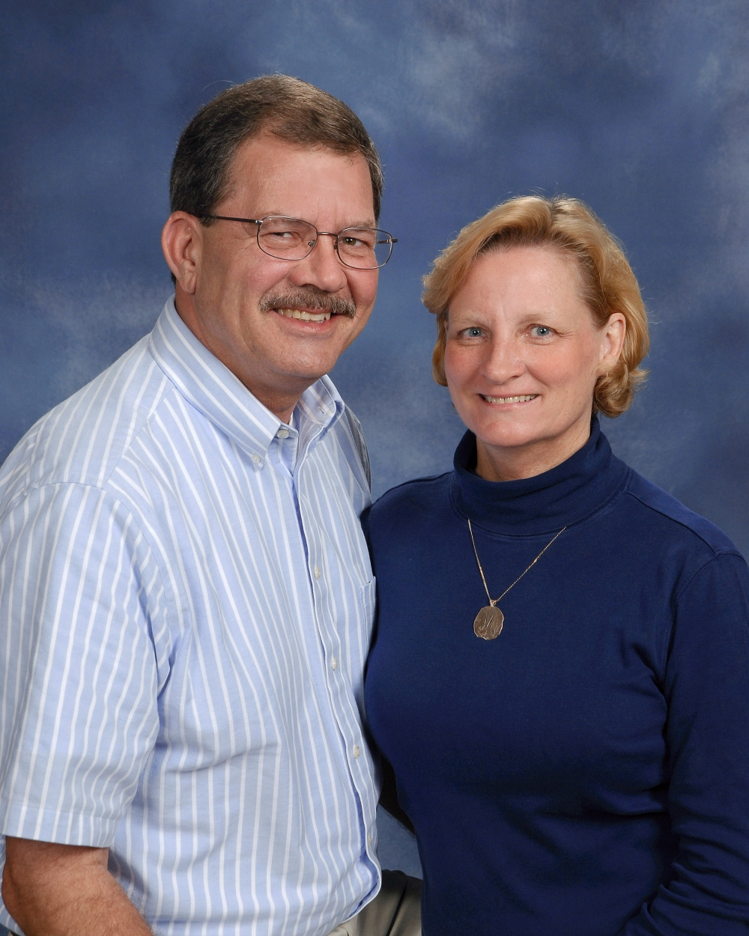 | Miller, Tom & Debbie  108 E. Forest Drive  Greenwood, SC 29646  (864) 942-0254  tommiller@centurylink.net
Milner, Ben
409 Woodlawn Road
Greenwood, SC 29649

(864) 223-4537

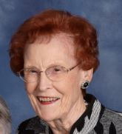 | Miskelly, Mary  109 Locksley Drive  Greenwood, SC 29649  (864) 229-3672
Mitchell, Jerry & Linda
130 Hunters Village Drive
Greenwood, SC 29649

(864) 229-6790

Mock, Holly
249 Oakridge Drive
Greenwood, SC 29649

(920) 983-7628

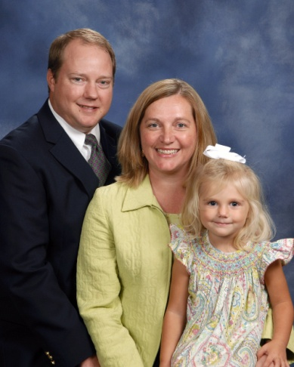 | Moeller, Marcus & Elizabeth  Lillie, Ella Cate, Emma  128 Crescent Road  Greenwood, SC 29649  (864) 980-9825  ecrs80@yahoo.com
Moeller, Steve
57 Edgewood Harbor Drive
Waterloo, SC 29384

(864) 677-2020

Moffitt, Harold & Chris
218 Heathwood Drive
Greenwood, SC 29649

(864) 229-7924

Molenda, Chuck & Gwen
1626 Lincolnshire Drive
Deland, FL 32724

(864) 543-2071

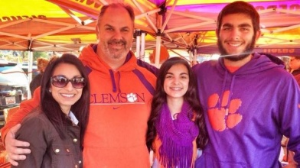 | Monda, Cam & Uzma  Amaan, Laila  116 Tally Ho Drive  Greenwood, SC 29649  (864) 953-0017
Montgomery, Bee & Sally
Zoey
1014 Deadfall Road East
Greenwood, SC 29649

sallysamzoey8@yahoo.com

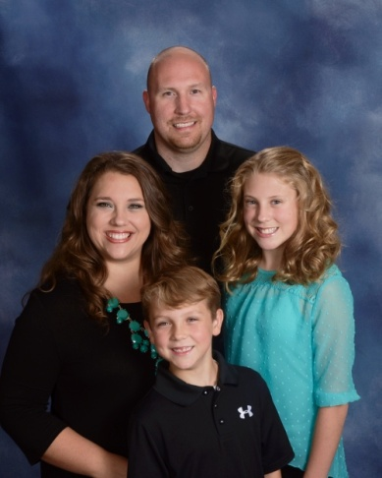 | Moore, Harley & Melissa  Zoe, Gavin  203 Forest Park Drive  Greenwood, SC 29649  (864) 229-0778  hmzgmoore@embarqmail.com
Moore, John and Annette
918 Willard Road
Greenwood, SC 29649

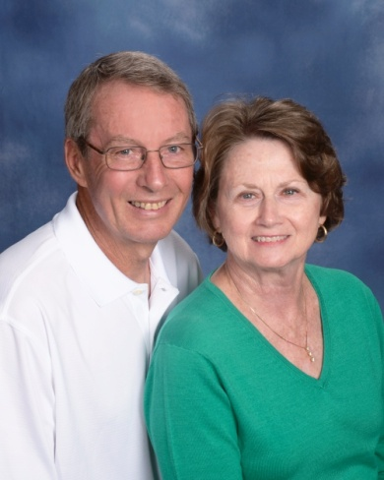 | Moore, Toby & Elaine  106 Brandon Drive  Hodges, SC 29653  (864) 992-9668  elainejonesmoore@yahoo.com
Moose, Kerri
121 Roman Circle
Greenwood, SC 29649

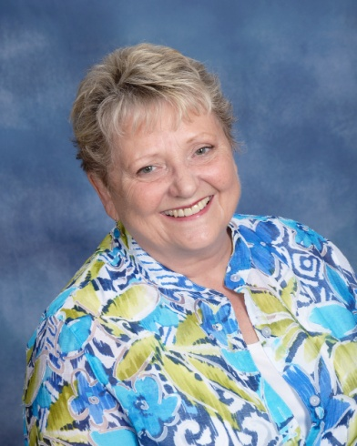 | Morgan, Pam  121 Violet Court  Greenwood, SC 29649  (864) 227-8885  pam128@gmail.com

 | Morris, Ian
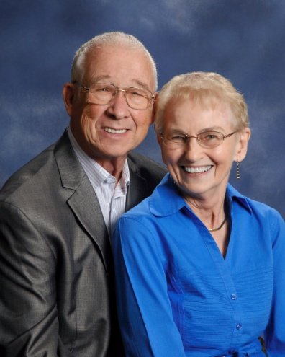 | Morse, Richard & Nancy  1781 Almighty Blvd.  Rockledge, FL 32955  (864) 227-8446  dicknansc04@gmail.com
Mosley, Heather
1707 E. Durst Avenue
Greenwood, SC 29649

(864) 229-3460

Moss Jr., J. B.
93 Beltline Road
Abbeville, SC 29620

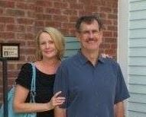 | Moss, Dr. Lewis & Holly  105 Deer Wood Lane  Greenwood, SC 29646  (864) 229-1506
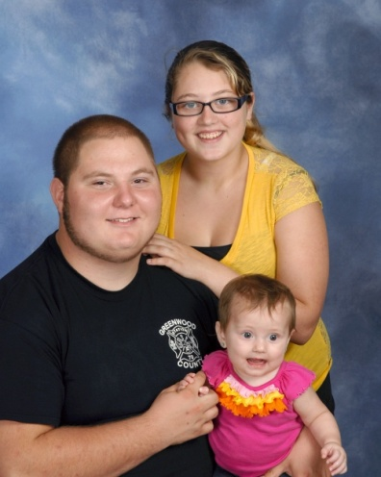 | Mullikin, Timothy & Brenanna  Aubree  727 Callison Road  Bradley, SC 29819  (864) 992-1742  efdff721@gmail.com

Mumford, George & Dayle
2009 Mt. Moriah Road
Greenwood, SC 296546

(864) 223-2250

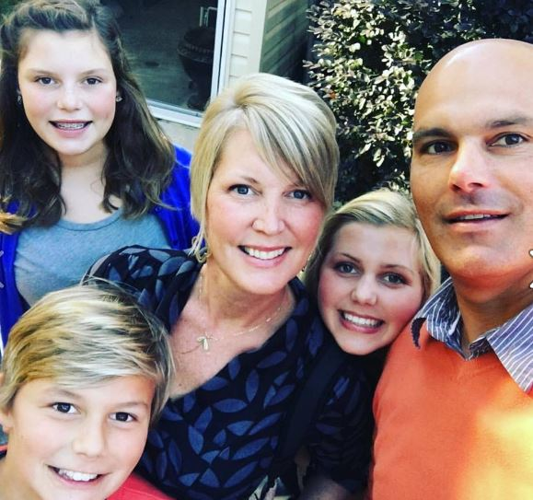 | Murray, Michael & Becca  Gloria Grace, Olivia, Beatty  317 Starboard Tack  Greenwood, SC 29649  (864) 388-7455  murrayr@gwd50.org
Nasrollahi, Sammy & Jan
Josh
133 Kingston Road
Greenwood, SC 29649

(864) 223-2279

Neeley, Dennis & Cornelia
110 Parkwood Road
Greenwood, SC 29646

(864) 229-9080

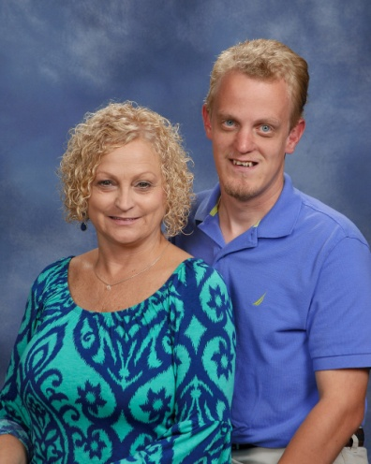 | Neighbors, Kim  Sam  218 Winding Creek Drive  Greenwood, SC 29649  (864) 993-2989
Nelson, Ray & Jamey
Andy, Philip
207 Rock Knoll Drive
Greenwood, SC 29649

(864) 223-9571

New Jr., Ellis
Erin
638 Fairway Lakes Road
Greenwood, SC 29649

(864) 229-3498

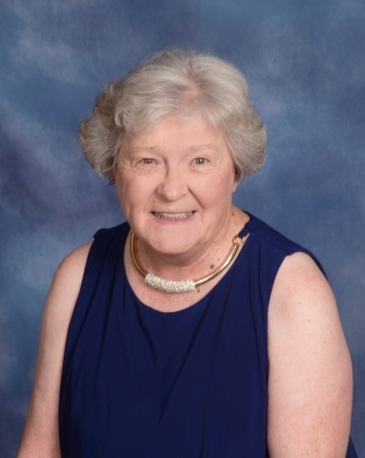 | Newman, June  123-4 Edinborough Circle  Greenwood, SC 29649  (864) 223-5171  junini45@juno.com
Newton, Kevin & Hope
Bryan
P. O. Box 182
Waterloo, SC 29384

(864) 677-2828

Nicoletti, Mabel
113 Chatham Drive
Greenwood, SC 29649

(864) 229-4887

Nicoletti, Terri
105 Lanette Street
Greenwood, SC 29649

(864) 223-7212

Odell, Gayle
112 Devon Park
Greenwood, SC 29649

(864) 943-0905
gayle@odellcorp.com

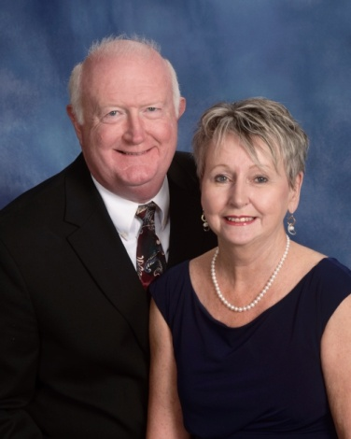 | O’Dell, Harold & Debbie  327 Green Oaks Road  Greenwood, SC 29649  (864) 941-3393  harold1217@embarqmail.com
Olson, Scott & Joy
Ella
209 Wentworth Drive
Greenwood, SC 29649

(864) 980-6203
joyrush75@hotmail.com

Orde, John & Corrina
Jasper, Max
107 Culbertson Court
Greenwood, SC

(864) 248-4892

Ott, Tim & Renee
Courtney, William, Chad
821 Deadfall Road
Greenwood, SC 29649

(864) 229-1932

Ouzts, Gene
310 Marietta Drive
Greenwood, SC 29646

(864) 223-8733

Owen, Bob & Elizabeth
Jenna
105 Starboard Tack
Greenwood, SC 29649

(864) 223-2858

Owens, Renaye
116 Hilltrace Drive
Bradley, SC 29819

(864) 321-5475
renayeowens7@gmail.com

Owens, Ronni
105 Winter Ridge Ct.
Apt G
Greenwood, SC 29649

Owings, Steve & Margaret
Steven
167 Highland Drive
Greenwood, SC 29649

(864) 227-2711

Papke, Ray & Jannie
624 Grand Harbor Boulevard
Ninety-Six, SC 29666

(864) 543-1566

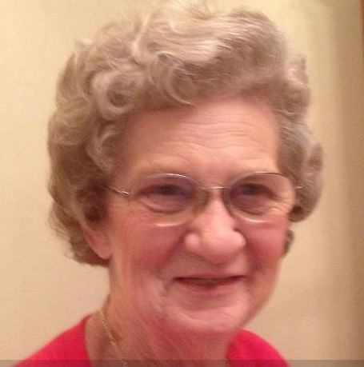 | Parkman, Hilda  115 Hill & Dale Drive  Greenwood, SC 29646  (864) 227-2542  hildaparkman@nctv.com
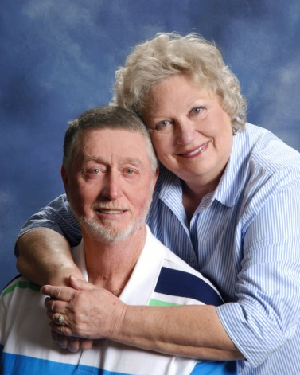 | Parnell, Olin & Millie  101 Carriage Court  Greenwood, SC 29646  (864) 910-1824 (Millie)  (864) 980-2464 (Olin)  milliepster@gmail.com  o.parnell@hotmail.com

Pate, Jim & Marie
Brad
128 Devon Park
Greenwood, SC 29649

(864) 229-5033

Patterson, Beth
P. O. Box 1252
Greenwood, SC 29649

Patterson, Brandon
107 Wenmount Court
Greenwood, SC 29646

(864) 942-0879

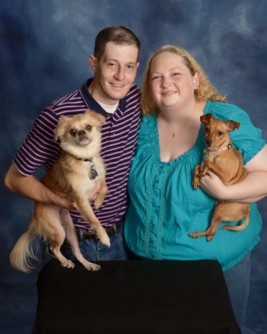 | Patterson, Carey & Monica  Gizmo, Daisy  1319 Hwy. 185 S.  Donalds, SC 29638  (864) 379-8191  mnickles@hotmail.com
Patterson, Laura & Tracy
Evan
406 Chinquapin Road
Greenwood, SC 29646

(864) 229-1373
lpseawall@gmail.com

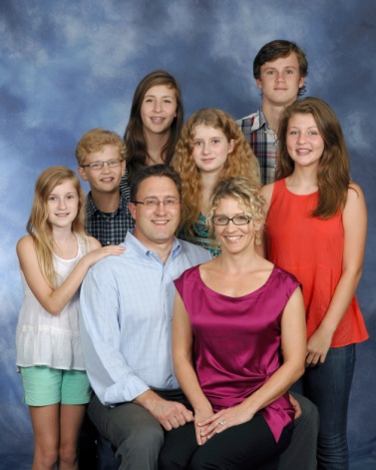 | Patterson Sr., Lee & Angie  Andrew, Caroline Cormeny, Margaret Cormeny, Annika, Amelia, Finn Cormeny  104 Hawthorne Court  Greenwood, SC 29646  (864) 228-8660
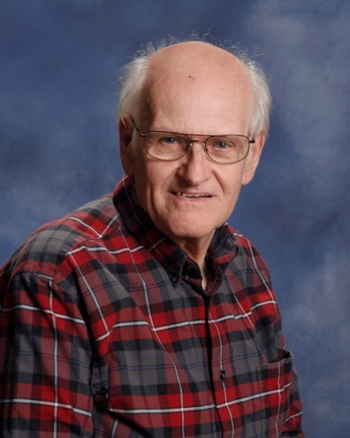 | Patterson, Randy  5352 Hwy. 72 W.  Calhoun Falls, SC 29628  (864) 378-0294  rpatterson@wctel.net
Patton, Rick & Rosa
Rachel
114 Culbertson Court
Greenwood, SC 29649

(864) 223-0199

Payne Jr., Fred & Pam
411 Joe Wells Road
Greenwood, SC 29646

(864) 223-2292

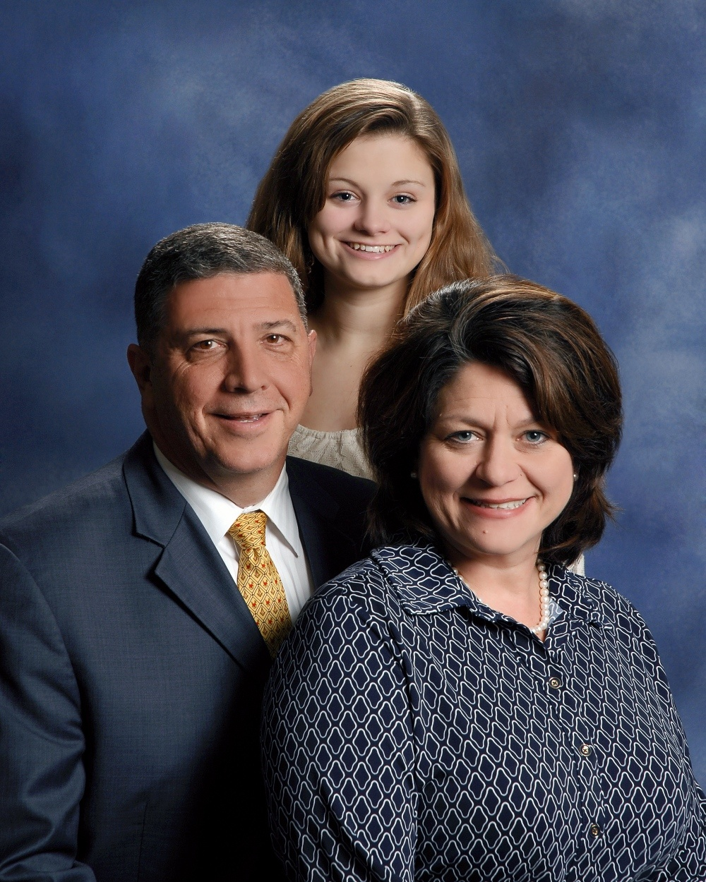 | Pearson, Jay Adam & Dianna  Caroline  128 Abbey Court  Greenwood, SC 29649  (864) 227-1738  jaydianna@gmail.com
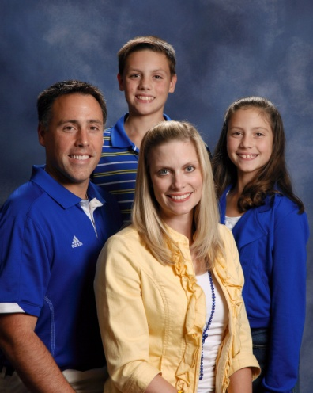 | Pederson, Kevin & Adair  Conner, Clary  112 Tifton Drive E.  Greenwood, SC 29649  (864) 992-2556  adairclaryped@yahoo.com
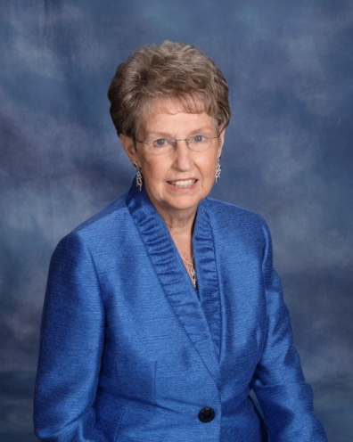 | Peebles, Sallie  110 Colonial Drive  Greenwood, SC 29649  (864) 229-2783  felnsal7@gmail.net
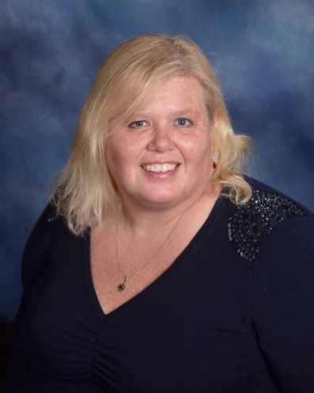 | Peksa, Annette  Banner  100-C Windtree Court  Greenwood, SC 29649  (864) 279-8305  peksa.annette@gmail.com
Pepitone, Kim
131 Serene Drive
Waterloo, SC 29384

(864) 872-0507
miramidget@gmail.com

Perez, Hugo & Catherine
106 Spruce Court
Greenwood, SC 29649

Perkey, Robert & Jenny
Ashlynne
101 Mimi’s Manor
Greenwood, SC 29649

(918) 299-3971

Perrin, Glenn and Alyson
Noah, Wiley, Sawyer
715 Fairway Lakes Road
Greenwood, SC 29649

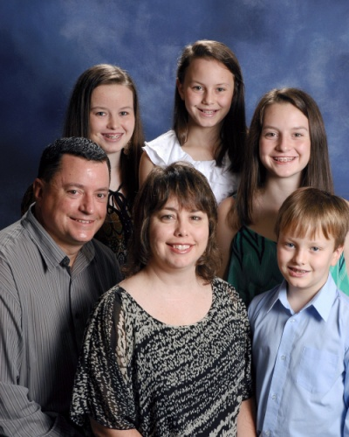 | Philcox, Todd & Christine  Meghan, Kynslea, Rhianna, Eric  119 Limerick Road  Greenwood, SC 29649  (864) 344-3393  gtdadof4@yahoo.com
Pierce, Betty
116 Enterprise Court
Greenwood, SC 29649

(920) 783-7628

Pippin, Chadd & Rhonda
Casey, Cody, Allison
110 Loblolly Circle
Greenwood, SC 29649

(864) 229-6715

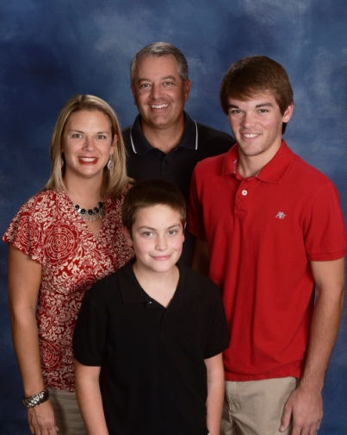 | Pitts, Billy & Meredith  Rylan, Landon  103 Barrett Drive  Greenwood, SC 29649  (864) 227-6757  thepitts@embarqmail.com
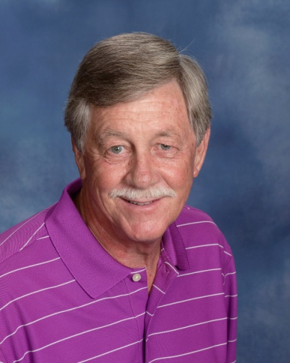 | Polatty, Ronnie Joe  346 Tranquil Road  Greenwood, SC 29646  (803) 223-6226  ronniejoepolatty@hotmail.com
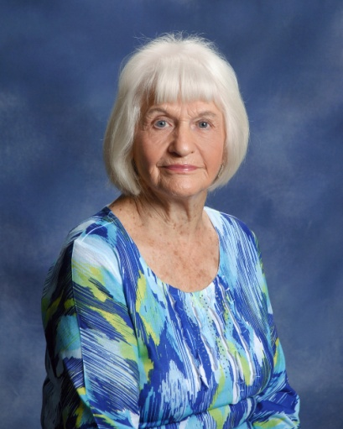 | Pollard, Dorothy  1632 Mathis Road  Greenwood, SC 29649  (864) 229-4044  djp1632@gmail.com
Pollard, Tiffany
Kalyn James, Casey Abercrombie, Chase Abercrombie
1109 Durst Avenue E.
Greenwood, SC 29649

(864) 943-0465

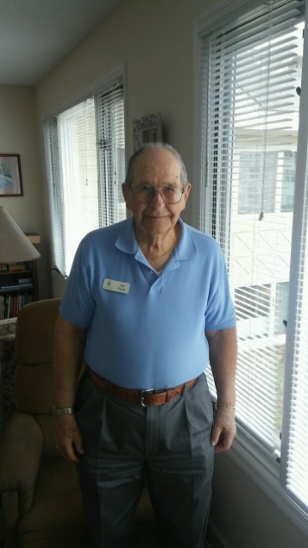 | Poole, Pat  Wesley Commons  1110 Marshall Road  Greenwood, SC 29646
Poore, Bryan & Christi
Kirsten, Kinsley
1103 Marshall Road
Greenwood, SC 29646

(864) 388-9572

Poore, Greg & Laura Beth
Caden
204 Andrews Avenue
Greenwood, SC 29646

(864) 993-2950
lbcpoore@yahoo.com

Poore, Nell
Chris
1102 Marshall Road
Greenwood, SC 29646

(864) 227-8422

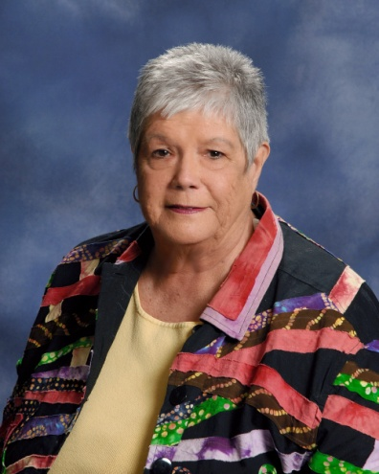 | Powell, Betsy  107 Mayapple  Greenwood, SC 29649  (864) 229-0555  bybetsy@centurylink.net
Powers, Mike & Jodi
6818 Hwy. 25 S.
Ninety-Six, SC 29666

Price, Carol
1103 Sweetwater Road
Greenwood, SC 29646

(864) 227-6608

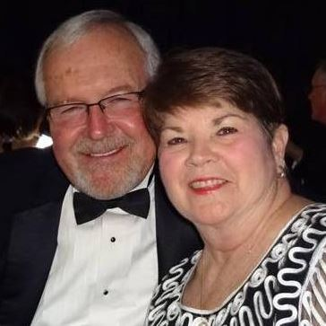 | Price Jr., Harold & Patsy  308 Fairway Lakes Road  Greenwood, SC 29649  (864) 227-2650
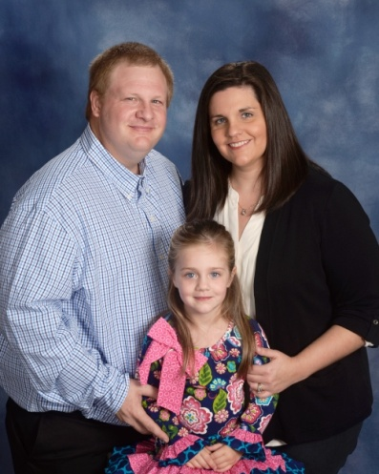 | Price, Jamie & Megan  Natalee  420 E. Grumling Road  Hodges, SC 29653  (864) 980-9465  jprice2ndlt@gmail.com
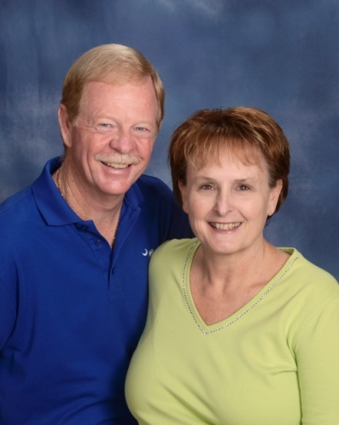 | Price, Ray & Jeannie  506 E. Grumling Road  Hodges, SC 29653  (864) 374-3669  jeanprice09@yahoo.com
Pridmore Jr., Bob & Paula
106 Montclair Drive, Apt. G
Greenwood, SC 29649

(864) 223-4486

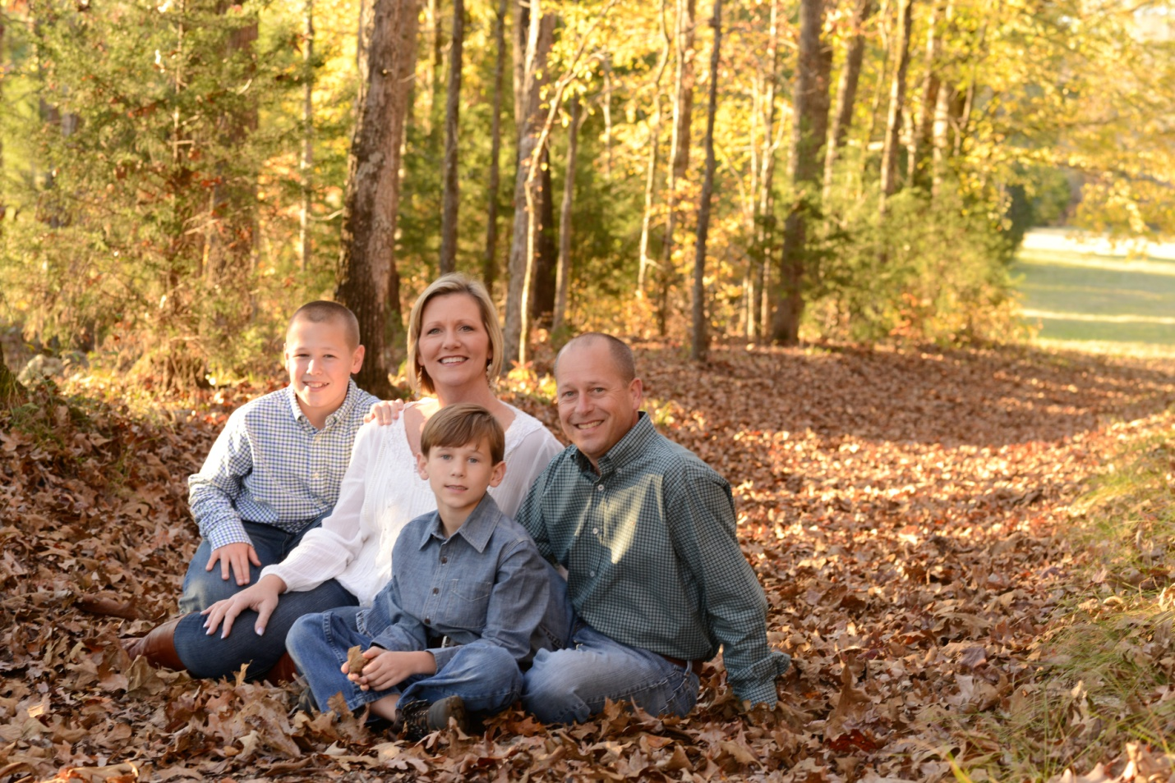 | Prince, Patrick & April  Wyatt, Adam  309 W. Creek Road  Greenwood, SC 29646-8518  (864)993-8734 (April)  (864) 993-1562 (Patrick)  april.prince@parksterlingbank.com
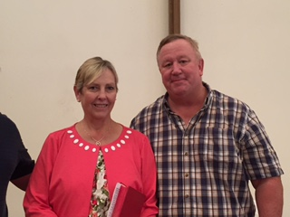 | Propester, Bob & Gail  309 Starboard Tack  Greenwood, SC 29649  rspdallas@aol.com
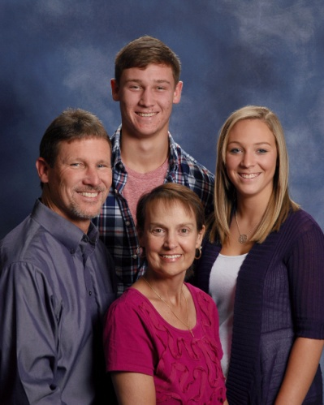 | Pruitt, Dayne & Traci  Megan, Brandon  18 Roxanna Drive  Ninety-Six, SC 29666  (864) 337-5842  dayne.pruitt@gmail.com
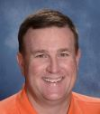 | Pundt, Carl  139 Cedar Drive North  Greenwood, SC 29649  (864) 993-5431  cpundt@gmail.com
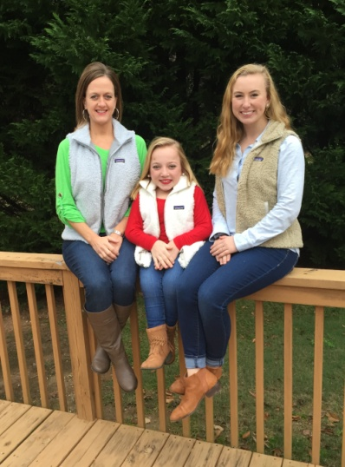 | Pundt, Carrie  Leeann, Carlie  114 Morningside Drive  Greenwood, SC 29649  (864) 980-6373  cgpundt@embarqmail.com
Quattlebaum, Chad
204 Crestmont Drive
Greenwood, SC 29649

(864) 223-2944

Rambo, Barry & Sara
3892 Curltail Road
Bradley, SC 29819

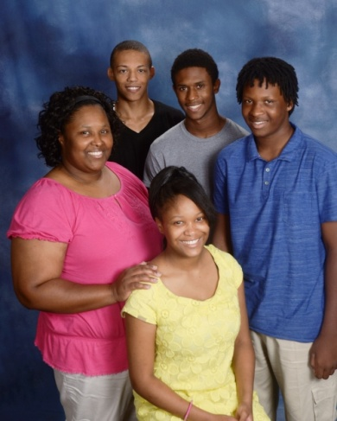 | Rapley, Jhana and Charles  Kya Brownlee, Aaron Brownlee  235 Florida Avenue, Apt. 41  Greenwood, SC 29646  (864) 910-0461  jhanag@yahoo.com
Ready, Janet
3892 Curltail Road
Bradley, SC 29819

(864) 223-3035

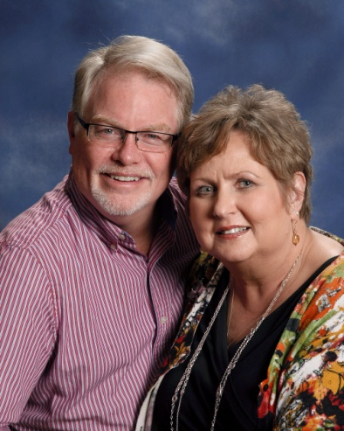 | Redfern, John & Taina  108 Burnham Court  Greenwood, SC 29649  (864) 992-2592  tainaredfern@gmail.com
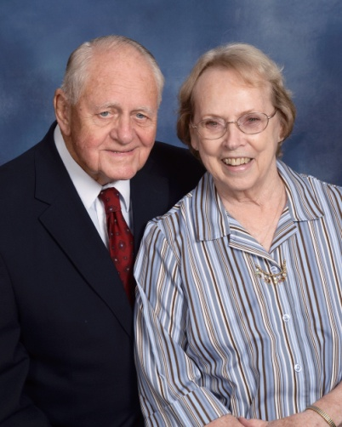 | Reece, Walter & Jenny  P. O. Box 307  Due West, SC 29639  (864) 379-9759  wcrvcr@yahoo.com

Reese, Chad & Karen
133 Creek Road E.
Greenwood, SC 29646

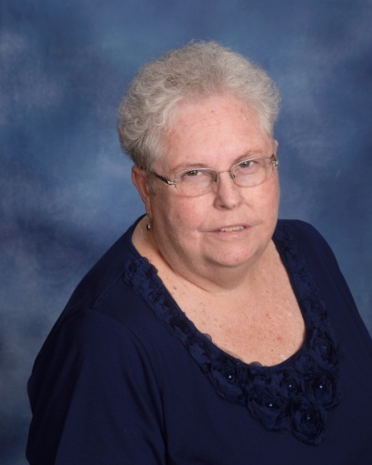 | Reighley, Faye  510 Marietta Drive  Greenwood, SC 29646  (864) 229-4646  freighley@gmail.com
Rhoads, Kent & Vickie
205 Swing About
Greenwood, SC 29649

(864) 227-8948
vickierhoads@aol.com

Rhodes, Carter
207 Twisted Oak Drive
Greenwood, SC 29646

rhodescarter3@gmail.com

Rice, Frank and Skippy
Sam
302 Hatchers Pass
Greenwood, SC

serfmrice@embarqmail.com

Richey, Denise
Greenwood, SC 29649

Riley, Mel & Mary Ann
612 Cobb Road
Greenwood, SC 29649

(864) 229-1385

Roark, Hunter
Greenwood, SC 29649

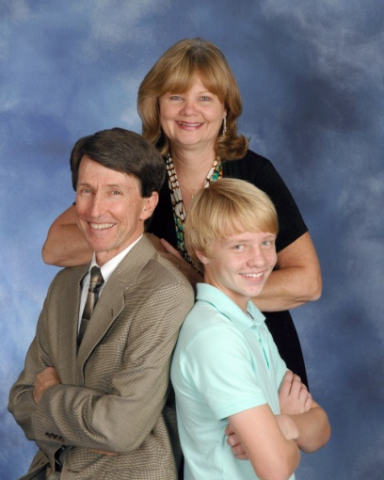 | Robinson, Coleman & Debra  Abigail, Zach  120 Partridge Road  Greenwood, SC 29649  (864-942-7132  debra@stmarkgreenwood.com
Robinson, Judy
125 Shannon Drive
Greenwood, SC 29646

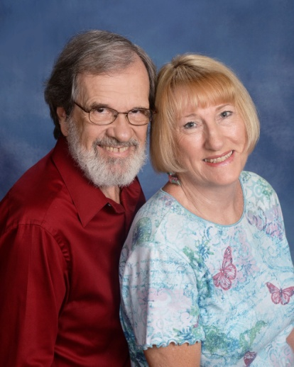 | Roby, John & Susan  209 Lakeview Drive  Greenwood, SC 29646  (864) 388-9987  jsroby@embarqmail.com
Rochelle, Carolyn
214 Laurel Ridge Way
Greenwood, SC 29649

Rochester, Wes and Elizabeth
Maggie, Susie
206 Evergreen Drive
Greenwood, SC 29649

(864) 506-1383
esnipes@lander.edu

Rodriguez, Micky
Schanen Palmerin
105 Biltmore Street
Greenwood, SC 29649

(864) 554-3337

Rogers, Vergil & Peggy
5314 Kinards Road
Ninety-Six, SC 29666

(864) 543-2425

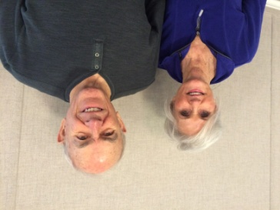 | Rollings, Jim and Deanna  101 Sand Trap Lane  Greenwood, SC 29649  (864) 590-6883  jrollings@bellsouth.net
Roper, Gary & Jane
301 Fairway Lakes Road
Greenwood, SC 29649

(864) 223-0957
jroper@wesleycommons.org

Rork, Diane
115 Reedy Cove Lane
Greenwood, SC 29649

(864) 227-2570

Rose, Loretta
204 Seabright Circle
Cross Hill, SC 29332

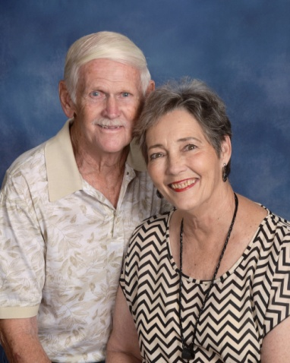 | Ross, David & Toni  110 Pin Oak Drive  Greenwood, SC 29649  (864) 229-4674

Ross, Denise
Stan Getzelman, Clint Getzelman
306 Kelli Drive
Greenwood, SC 29649

(864) 229-0989
samandboo@embarqmail.com

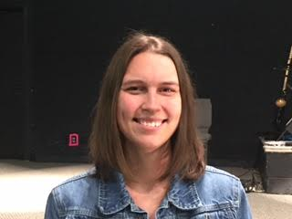 | Rousey, Nicole  101 Yosemite Drive  Greenwood, SC  cosh.nicole@yahoo.com
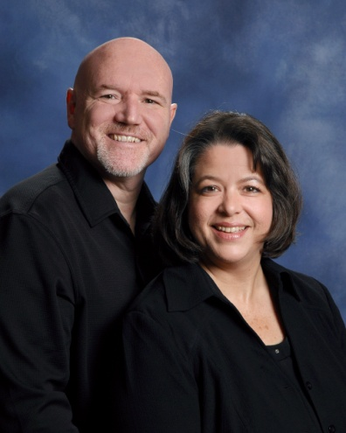 | Roy, Bob & Teresa  109 Hailey Court  Greenwood, SC 29649-2273  (864) 993-3192 (Teresa)  (864) 554-3380 (Bob)  tpr109@yahoo.com
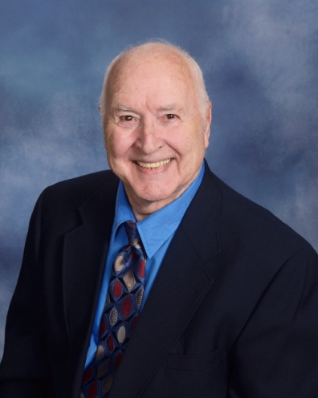 | Roy, Elmer  407 Lake Forest Road  Greenwood, SC 29649  (864) 223-8131
Rucker, Suzanne
308 Rivers Run Road
Greenwood, SC 29649

(864) 388-7864

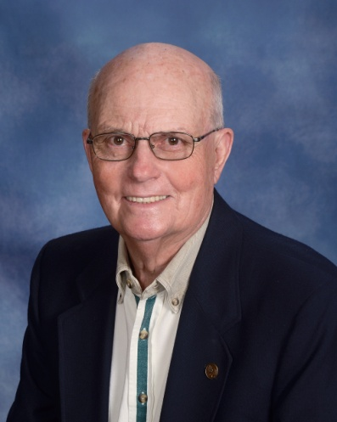 | Rush, Archie  122 Kings Grant  Greenwood, SC 29649  (864) 388-7969  archierush@nctv.com
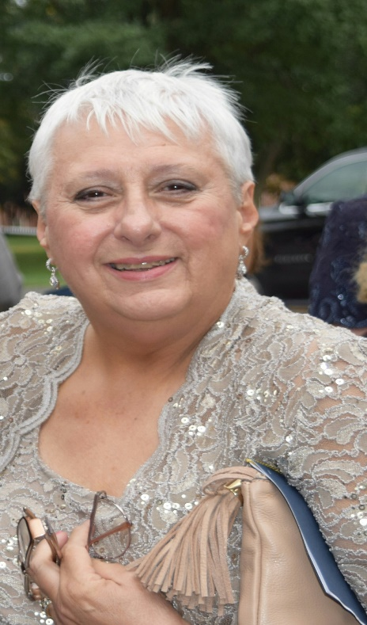 | Russell, Kim  412 Rivers Run  Greenwood, SC 29649  (864) 388-0494  kim9561@gmail.com
Rylander, Andrew & Mary
Griffin Medford
229 Chatham Drive
Greenwood, SC 29649

(864) 828-0349
maryhelton@gmail.com

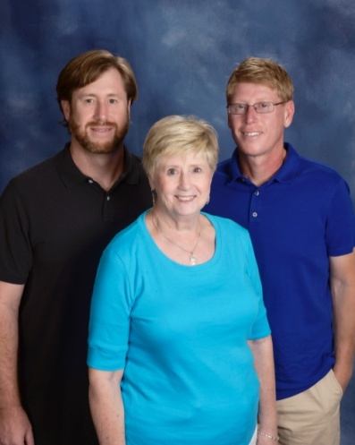 | Sample, Fay  Chris, Mike  207 Abbey Lane  Greenwood, SC 29649  (864) 992-3609  ffsamp2@yahoo.com
Sanders, Connie
122 Woodhaven Court
Greenwood, SC 29649

(864) 223-3774

Sanders, James
108 Ferry Cove Road
Greenwood, SC 29649

Sanders, Marilyn
105 Hutira Lane
Greenwood, SC 29649

(843) 364-7676

Sanders, Tim
P. O. Box 49037
Greenwood, SC 29649

(864) 223-9694

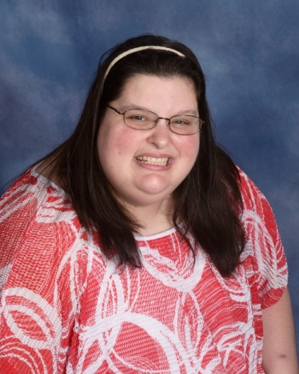 | Sartin, Danielle  136 Cambridge Avenue W.  Greenwood, SC 29646  (864) 941-7469  sherlyn7726@gmail.com
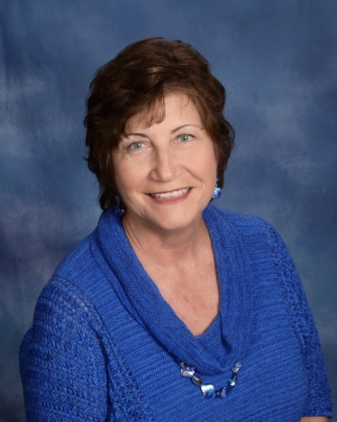 | Sauerwein, Linda  938 Central Shiloh Road  Abbeville, SC 29620  (864) 446-2196  yochem@wctel.net
Scarborough, Ostell & Patti
225 Swing About
Greenwood, SC 29649

(864) 223-2360

Schmidt, Kathy
1005 E. Laurel Avenue
Greenwood, SC 29649

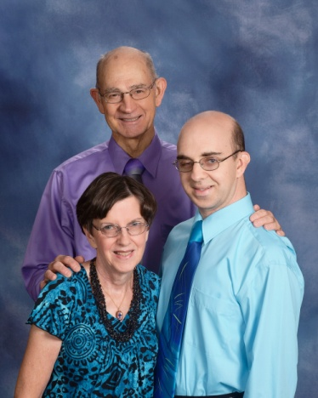 | Schwarzmann, Henry & Kaye  Karl  146 Kingston Road  Greenwood, SC 29649  (864) 229-2065  jkpschwarzmann@hotmail.com
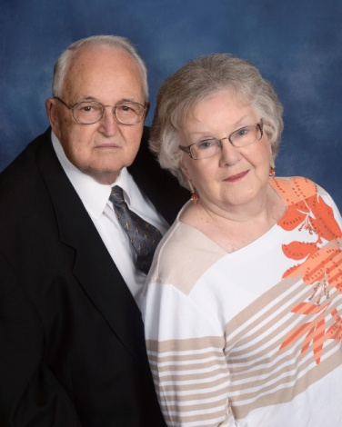 | Scott, W. O. & Sondra  950 Sunset Drive  Greenwood, SC 29646  (864) 223-7987  oimay@embarqmail.com
Scurry, Ro
Greenwood, SC 29649

Scurry, Tricia
204 Janeway
Greenwood, SC 29649

Seagle, Vickie
P. O. Box 835
Greenwood, SC 29648

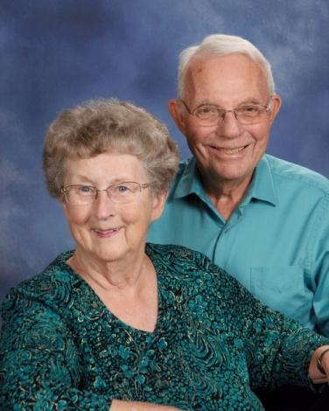 | Search, Bud & Mary  Wesley Commons  1110 Marshall Road  Greenwood, SC 29646  (864) 227-7416  searchparty@mywesleycommons.org
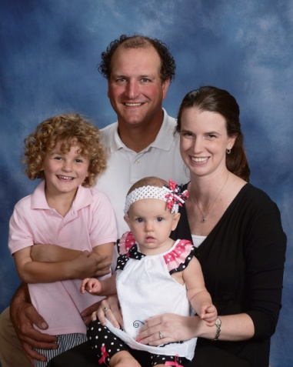 | Sears, Greg & Abbey  Jennings, Sophia  108 Kinkade Drive  Greenwood, SC 29649  (864) 388-7933  abbeycsears@yahoo.com
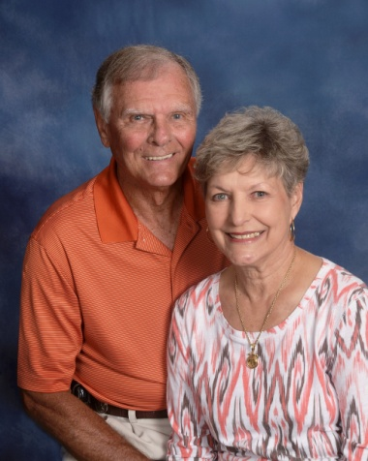 | Sears, Homer & Kaye  402 Marietta Drive  Greenwood, SC 29646  (864) 229-5066  kayefsears@yahoo.com
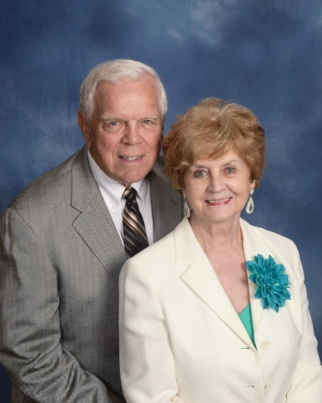 | Sease, Bill & Dawn  111 Rutledge Road  Greenwood, SC 29649  (864) 223-0194  billdawn@embarqmail.com
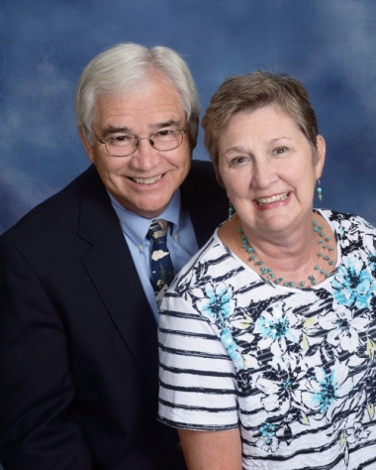 | Sexton Jr., Chuck & Jennifer  206 Moore Street  Greenwood, SC 29649  (864) 223-9713  chucksexton@embarqmail.com
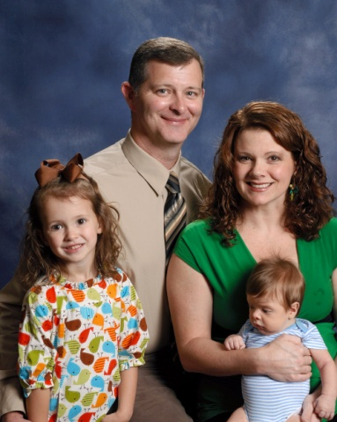 | Shaw, Eddie & Suzy  Annie, Jake  606 Woodland Street  Greenwood, SC 29649  (864) 554-4226  suzycshaw@yahoo.com
Shaw, Daniel and Haley
Mattie,Bailey, Tyler
137 Patrick Road
Greenwood, SC 29646

(864) 388-7429
dshaw@abbevillecountysc.com

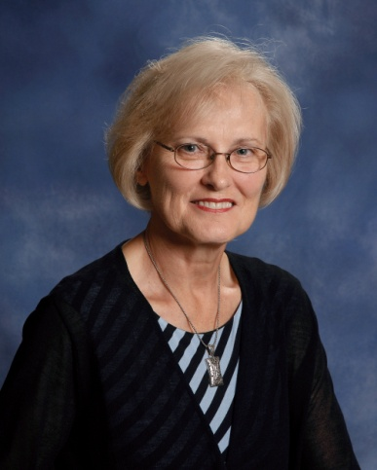 | Shelton, Shirley  116 Queens Court  Greenwood, SC 29649  (864) 223-1694  skip.shelton@gmail.com
Shepherd, Larry & Levelle
202 Flatwood Road
Hodges, SC 29653

(864) 337-5272

Shinall, Darrell & Sue
Ashley, Timmy
2832 Hwy. 25 N
Hodges, SC 29653

Shirley, Richard & Pegge
16 Lawton Street
Greenwood, SC 29649

(803) 229-6411

Simmons, Judy
214 Abbey Lane
Greenwood, SC 29649

(864) 229-0085
judys811@gmail.com

Skeen, Roger & Sandy
114 Creekside Court
Greenwood, SC 29649

(864) 223-0424

Skipper Jr., Lee & Holly
104 Bamboo Court
Greenwood, SC 29649

(864) 229-7220
lskipper50@embarqmail.com

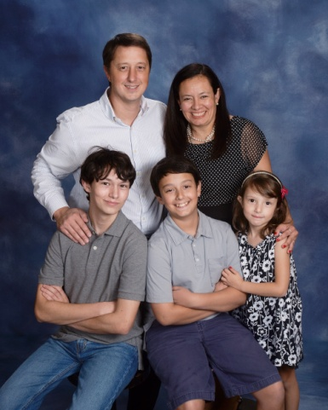 | Smathers, Ian & Tony  Michael, Patrick, Isabel  221 St. Augustine Drive  Greenwood, SC 29649  (864) 227-6016  smathem@centurylink.net
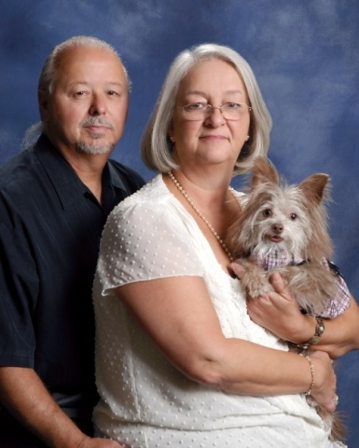 | Smathers, Jerry & Debbie  Rosie  114 Valley Road  Greenwood, SC 29646  (864) 223-9353  djsmathers@yahoo.com
Smeal, Jordan & Luann
1109 Northlake Drive
Greenwood, SC 29649

(864) 942-0253

Smith, Charles & Carol
116 Pinsonville Road
Greenwood, SC 29649

(864) 229-1389

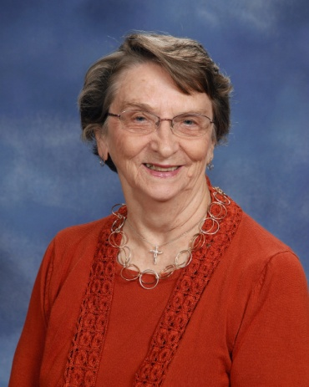 | Smith, Barbara Jean  224 Elm Court  Greenwood, SC 29646-2281  (864) 223-9474
Smith, Randy & Connie
201 E. Grumling Road
Hodges, SC 29653

(864) 374-3227

Smith, Ronney & Joan
106 Firethorne
Greenwood, SC 29649

(864) 943-3376

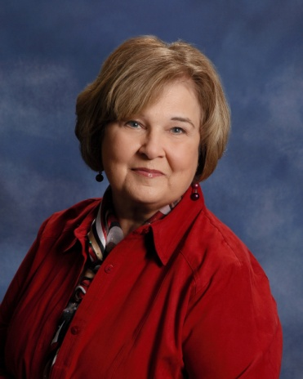 | Smith, Sandy  105 Mayapple  Greenwood, SC 29649  (864) 993-6989  sgs29649@gmail.com
Smith, Dr. Scott & Catherine
Zachary, Joshua, Elijah
1851 Delacourt Ave.
Mt. Pleasant, SC 29466

(864) 223-8121

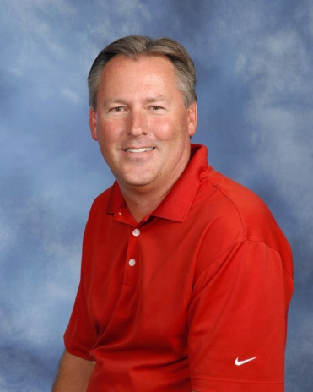 | Smith, Stan  125 Heathwood Drive  Greenwood, SC 29649  (864) 993-7850
Smyth, Dan
Luke, Nathan
145 Highland Drive
Greenwood, SC 29649

(864) 538-0393

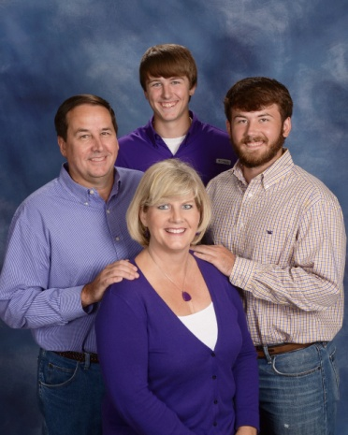 | Sparks, John & Kim  Brig, Brenden  110 Hillside Road  Greenwood, SC 29646  (864) 227-9569  skrapsk@embarqmail.com
Stafford, Jerri
124 Hatchers Pass
Greenwood, SC 29646

(864) 227-8194

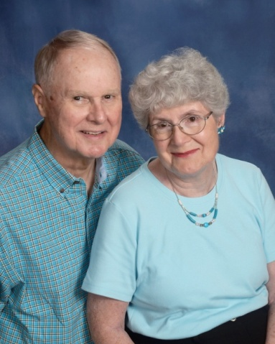 | Staley, Dale & Ann  111 Woodcrest Street  Greenwood, SC 29649-1664  (864) 223-4413
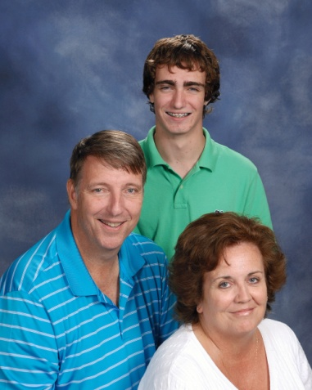 | Stallworth, Gray & Michelle  Ashleigh, Asa  103 Coosaw Run  Greenwood, SC 29649  (864) 223-1949  mstallworth2001@yahoo.com
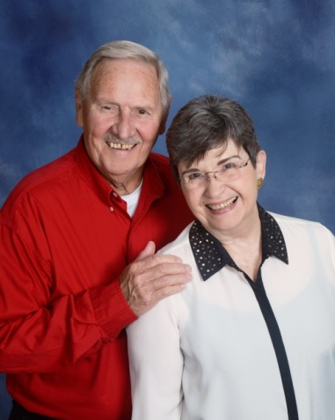 | Stanton, Tom & Paula  569 Ridgewood Drive  Waterloo, SC 29384  (864) 677-3947  pdstanton1@prtcnet.com
Steifle, Gregg & Ross Ann
Ashley, Brock
109 Rutledge Road
Greenwood, SC 29649

(864) 388-9015

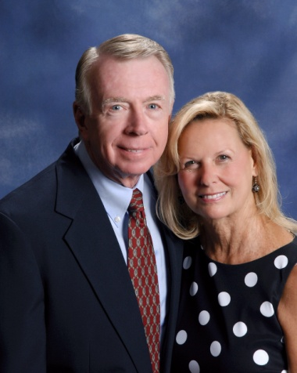 | Steifle, Neil & Jenelle  142 Roman Circle  Greenwood, SC 29649  (864) 223-2157
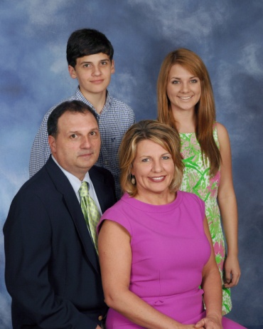 | Stevens, Greg & Christy  Julie, Reid  110 Twisted Oak Drive  Greenwood, SC 29646  (864) 229-2267  thestevens12@embarqmail.com
Stewart, Kim
Jennie, Brad
106 Summerhill Drive
Greenwood, SC 29649

(864) 229-5559

Sthare, Barbara
118 Rutledge Road
Greenwood, SC 29649

(864) 229-1246
bsthare@yahoo.com

Stillwell, Ada
Wesley Commons, Apt. 5005
1110 Marshall Road, Box 175
Greenwood, SC 29646

(864) 330-1358

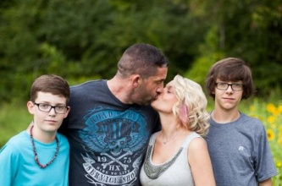 | Stockman, Trae & April  Thomas, Max  104 Winter Ridge Court, Unit G  Greenwood, SC 29649  (864) 992-5419
Stone, Clyde & Kimberly
Austin
130 Kensington Drive
Greenwood, SC 29649

(864) 223-4486

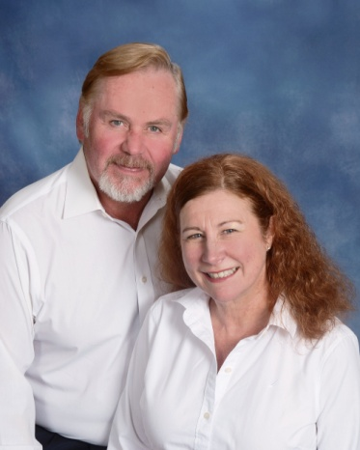 | Strawn, Chuck & T. J.  Wes, Jessica, Tess  103 Blue Heron Court  Greenwood, SC 29646  (864) 229-8069  tjstrawn@embarqmail.com
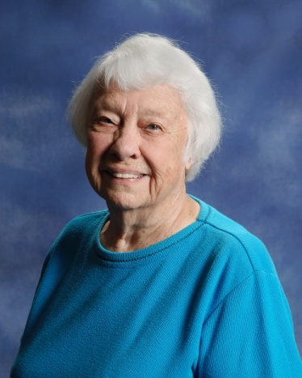 | Strom, Carolyn  115 Devon Park  Greenwood, SC 29649  (864) 223-6106
Strom, Steve
303 Lawton Street
Greenwood, SC 29646

(864) 229-3188

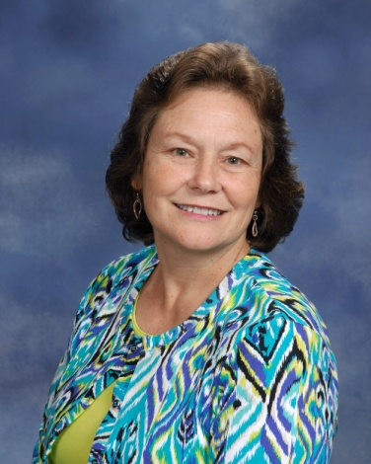 | Strom, Yvonne  315 Green Oaks Road  Greenwood, SC 29649  (864) 229-3188  yostrom@gmail.com
Strong, Jim & Carla
2106 Briarwood Road
Greenwood, SC 29646

(864) 223-4977
jcstrong4@gmail.com

Sutherland, George
108 Kennedy Court
Greenwood, SC 29649

(864) 223-0966

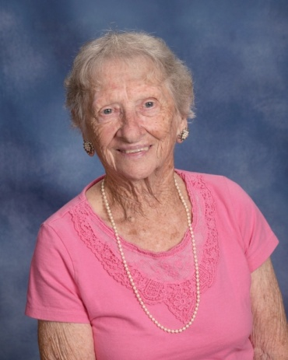 | Sutton, Sara  450 Dogwood Drive  Greenwood, SC 29646  (864) 223-7444
Svenningsen Sr., Tommy & Dana
Tommy
RR 1, Box 88
Waterloo, SC 29384

Swartzentruber, Adam & Jill
Mollie
140 St. Kitts Court
Greenwood, SC 29649

(864) 229-2525

Sweet, Ashley
203 Harvest Lane
Greenwood, SC 29649

(864) 223-5051
ashley.sweet@selfregional.org

Swygert, Karen
315 Marietta Drive
Greenwood, SC

(864) 227-3179

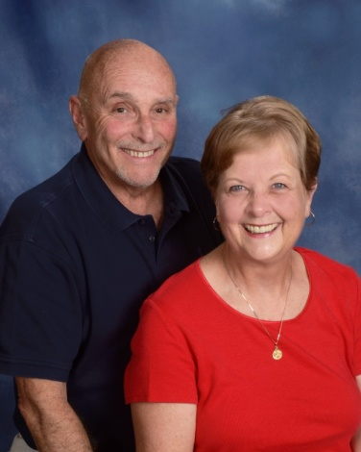 | Tabor, Mike & Betty  318 Driftwood Drive  Greenwood, SC 29649  (864) 992-7459  2tabors@gmail.com
Tafta, Tony & Shirley
111 Broken Ridge Court
Greenwood, SC 29646

(864) 942-0944

Talbert, Martha (see McClain, Debbie)
444 Dogwood Drive
Greenwood, SC 29646

(864) 223-7016

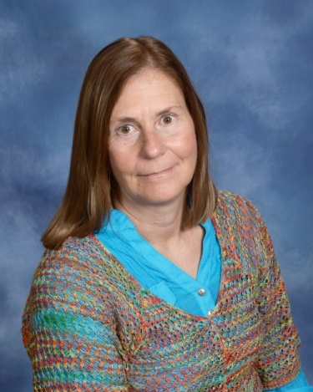 | Talcott, Betsy  107 Winter Way, Apt C  Greenwood, SC  (864) 229-6788  betsyft@yahoo.com
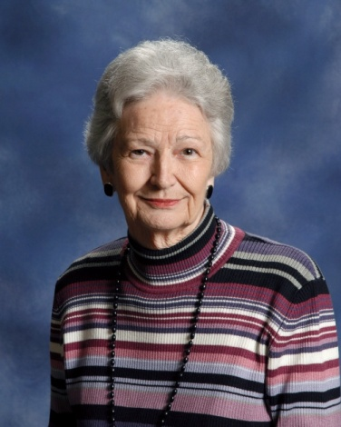 | Taylor, Carlyne  204 Cheekwood Road  Greenwood, SC 29649  (864) 388-0282
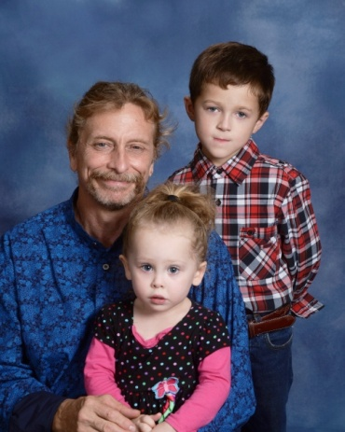 | Taylor, Chuck  Mark Watts, Ariella  3003 County Farm Road  Greenwood, SC 29646  (864) 341-4775  thechuckyt@hotmail.com
Taylor, Moriah
29 N. Greenwood Ave. Ext.
Ware Shoals, SC 29692

(864) 684-9001
moriah365@gmail.com

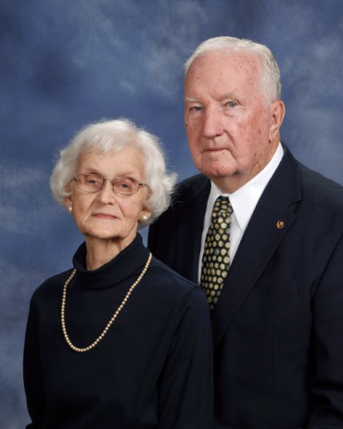 | Teeter, Fred & Barbara  108 Belcourt Drive  Greenwood, SC 29649  (864) 223-5000
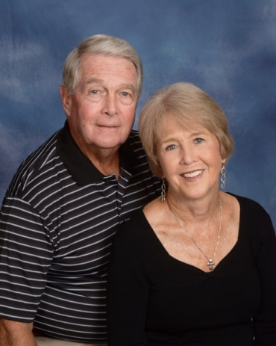 | Templeton, Bob & Mabel  105 Evergreen Drive  Greenwood, SC 29649  (864) 223-4677  mbtempleton@embarqmail.com
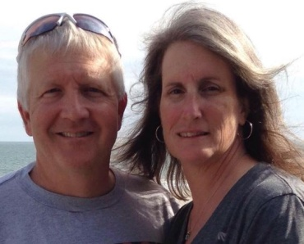 | Templeton Jr., Robbie & Robin  Reed, Ryan  210 Yosemite Drive  Greenwood, SC 29649  (864) 223-3585  5rtemp@embarqmail.com
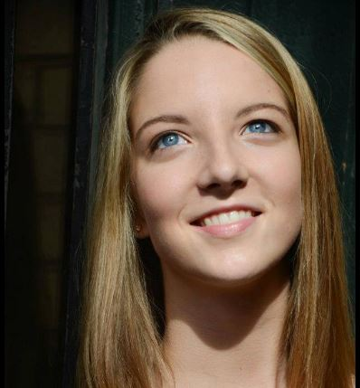 | Templeton-Bradley, Raine  811 Issaqueena Trail  Apt. 1814  Central, SC 29630  (864) 633-5242  raine.temp@gmail.com
Thomas, Ken & Gloria
115 Egret Lane
Greenwood, SC 29649

(864) 229-0331

Timmerman III, Lynn
190 Old Douglas Mill Road
Abbeville, SC 29620

(864) 366-8983

Timmerman, Robert & Cach
Katelyn
123 Heathwood Drive
Greenwood, SC 29649

(864) 227-3955

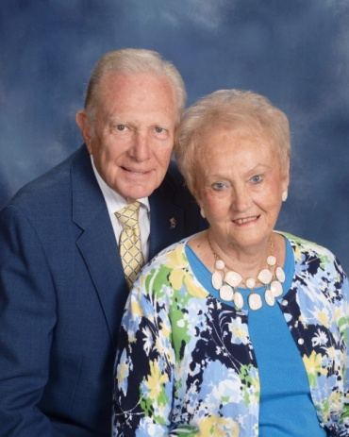 | Todd, Gene & Faye  114 Amherst Drive  Greenwood, SC 29649  (864) 229-4260 (Home)  (864) 554-1105 (Cell)  fayetodd59@gmail.com
Todd, Luke
212 Camelia Circle
Greenwood, SC 29646

(864) 942-0356

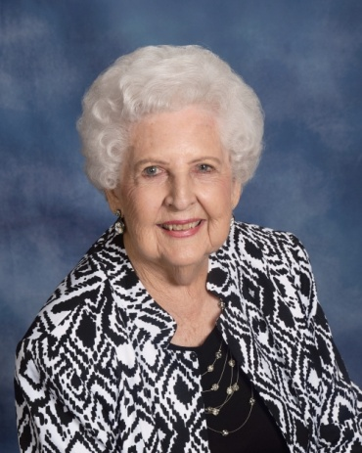 | Tolbert, Irene  308 Milford Springs Road  Greenwood, SC 29649  (864) 229-6492
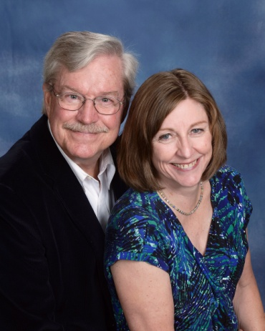 | Tolbert, Sam & Margo  217 Old Distillery Road  Hendersonville, NC 28739  (864) 992-0944  tolbert.margo@gmail.com
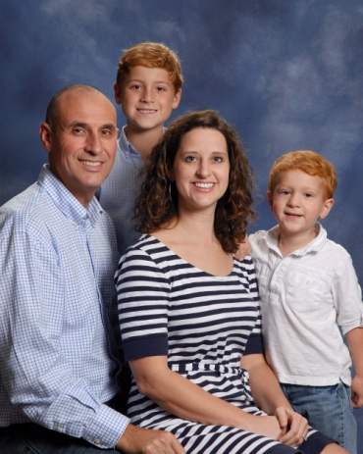 | Tompkins, David & Casey  Liam, Max  114 Sand Trap Lane  Greenwood, SC 29649  (864) 554-1083  dclmtompkins@gmail.com
Trammell, Rick & Cindy
Anna
P. O. Box 50612
Greenwood, SC 29649

(864) 229-7840

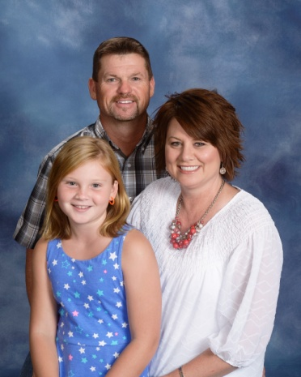 | Trasak, David & Robbie  Kinsley  1516 Old Abbeville Hwy.  Greenwood, SC 29649  (864) 223-9284  rtrasak@yahoo.com
Travis, Carolyn
710 #B Bucklevel Road
Greenwood, SC 29649

(864) 993-4622
nanniecarolyn1@gmail.com

Traynham, Jacob & Beth
Jennifer, James
Greenwood, SC 29649

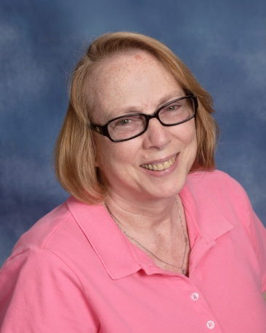 | Trevino, Cathy  111 Siloam Acres Drive  Greenwood, SC 29646  (864) 992-2228  cathyt24@yahoo.com
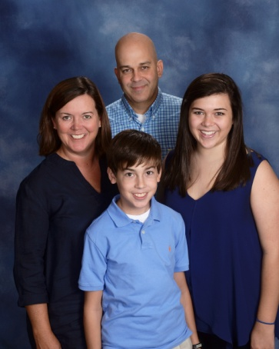 | Tripp, Chris & Missy  Madison, Andrew  115 Greenside Drive  Greenwood, SC 29649  (864) 388-0100  tripp@embarqmail.com
Turner, Allen & Emily
Sara Myles
811 Sunset Drive
Greenwood, SC 29646

Underhill, Thomas & Trieste
Emily, Stephen
183 Old Woodlawn Road
Greenwood, SC 2946

(864) 388-0364

Vail, Scott
Jeff
Greenwood, SC

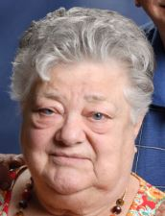 | Valkenburg, Jenny  119 Creek Road E  Greenwood, SC 29646  (864) 223-0987
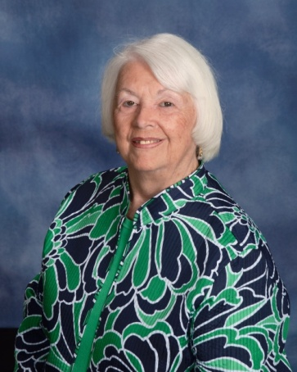 | Vaughn, Jeanette  422 Sagewood Road  Greenwood, SC 29646  (864) 223-7352
Vaughn, Neal
128 Cherokee Drive
Greenwood, SC 29649

(864) 229-7038

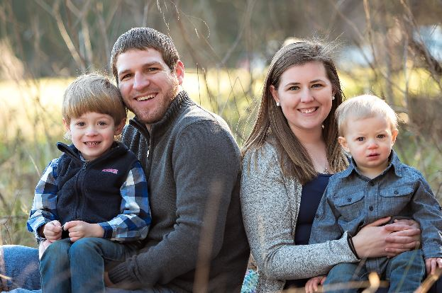 | Vickery, Andrew & Randi  Sperry, Walker, Bennett  (does not want address listed)  Greenwood, SC 29649  (864) 993-0771  vickeryea@yahoo.com
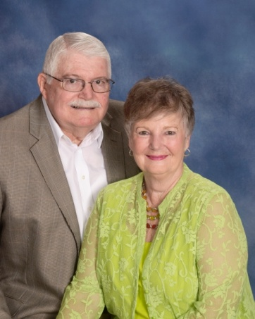 | Wade, Bobby & Gaynell  107 Windsor Oaks  Greenwood, SC 29649  (864) 223-8275
Walden, Chris & April
Sean Cornelsen
5115 Emerson St.
Hodges, SC 29653

christian.walden@us.atlascopco.com
april.j.walden@selfregional.org

Walden, Kenneth & Paige;
Way, Alex, MacKenzie, Avery
207 N. Hill Road
Greenwood, SC 29646

(864) 229-8055
waldenpaige@yahoo.com

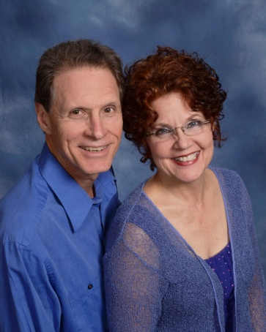 | Waldrep, Brian & Denise  318 Creek Road W.  Greenwood, SC 29646  (864) 223-9440  (864) 377-0579  bwaldrep@greenwoodmetro.com
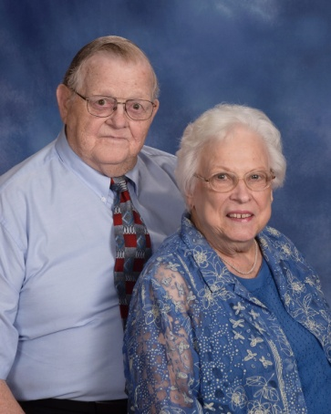 | Waldrep, Frank & Lorene  106 Evergreen Drive  Greenwood, SC 29649  (864) 229-5049
Waldrep, Todd & Sara
Savannah, Niles
114 Summitt St.
Greenwood, SC 29649

(864) 227-3195

Waldrop, Ragen & JC
103 Thames Court
Greenwood, SC 29649

Ward Jr., Frances
106 Crescent Drive
Greenwood, SC

(864) 227-6624

Walker, Mary Beth
2909 County Farm Road
Greenwood, SC 29646

(803) 227-3945

Ward Jr., Grant & Frances
106 Crescent Drive
Greenwood, SC 29649

Ward III, Trey & Ann
Jack, Harriet
304 Stonewood Drive
Greenwood, SC 29649

(864) 993-4227

Warner, Mark & Teresa
15 Central Avenue
Honea Path, SC 29654

(864) 369-2320

Warren, Gene & Kendall O’Quinn
Daniel O’Quinn
119 Crescent Road
Greenwood, SC 29649

Watkins, Anne
18911 Hwy. 76 W.
Honea Path, SC 29654

(864) 377-0329

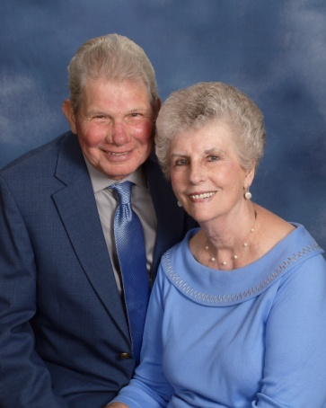 | Watkins, Charles & Helen  116 Greenbriar Drive  Greenwood, SC 29649  (864) 223-5395  hcwatkins@embarqmail.com
Watkins, Chrystal
Jon Preston Medlin
18911 Hwy. 76 W
Honea Path, SC 29654

(864) 337-1254

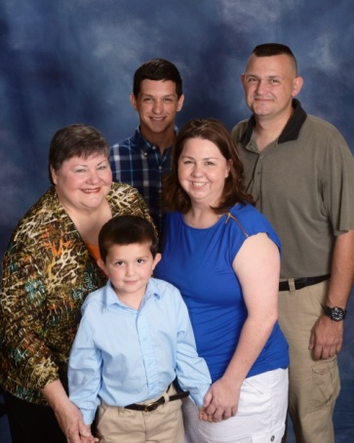 | Watkins, James & Paula  Bret, Jackson, Zoe Kolar  109 N. Hill Road  Greenwood, SC 29646  (864) 554-2216  ervetchick@yahoo.com
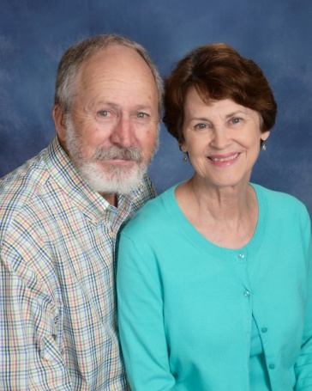 | Watkins, Tom & Betsy  126 Laguna Lane  Greenwood, SC 29646  (864) 223-4734 (Tom)  (864) 993-4302 (Betsy)  etwwatkins@gmail.com
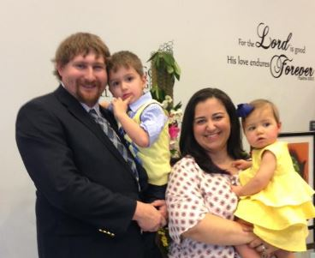 | Watts, Christopher & Sally  Isaiah, Zoe  208 Bypass 225  Greenwood, SC 29646
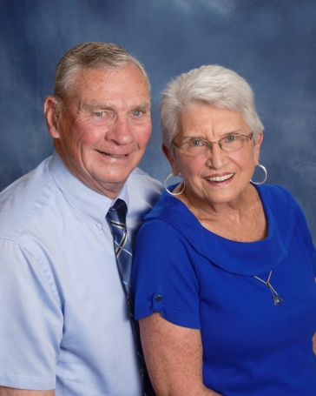 | Wedeking, Bill & Carolyn  101 Thornhill Road  Greenwood, SC 29649  (864) 223-1439
Weeks, Chris & Freeda
1403 Woodlawn Road
Greenwood, SC 29646

(864) 229-2948

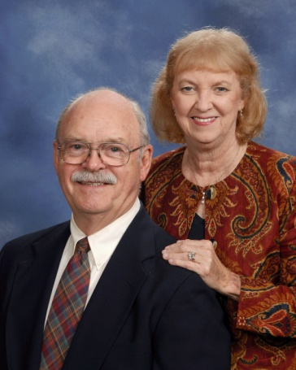 | West, Al & Jane  203 N. Acres Road  Greenwood, SC 29649  (864) 980-7209 (Al)  (864) 980-8212 (Jane)  aljawest@gmail.com
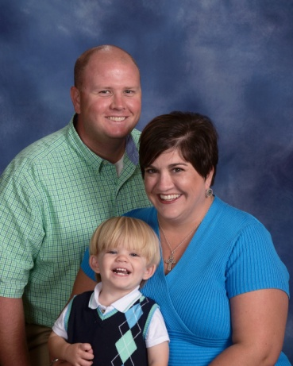 | Westmoreland, Brandon & Stacie  Max  407 Bond Avenue  Greenwood, SC 29646  (864) 941-7546  scstaciew@gmail.com
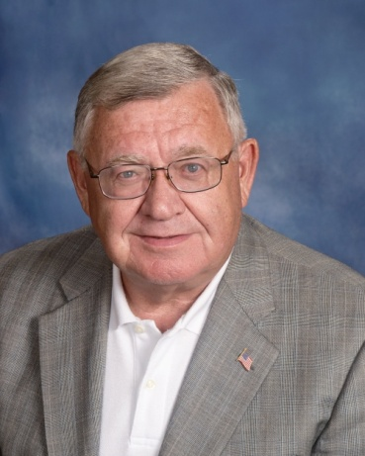 | Wheeler, James  122 Orchard Park Drive  Greenwood, SC 29649  (864) 337-5412  wheelerjm83@yahoo.com
White, Betty
104 Country Village Court
Greenwood, SC 29649

(864) 229-1981

White Elyse
Greenwood, SC 29649

(864) 979-4341

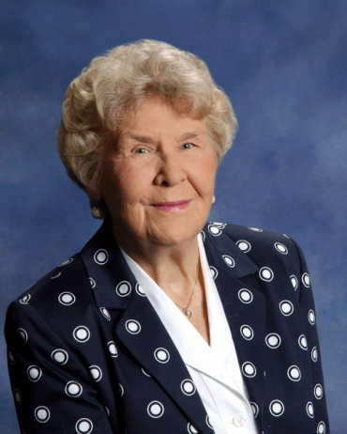 | Whitlock, Helen  125 Pin Oak Drive  Greenwood, SC 29649  (864) 223-8658
Will, Todd & Michelle
Nicholas, Lindsey, Tyler
114 Surrey Court
Greenwood, SC 29649

(864) 227-5242

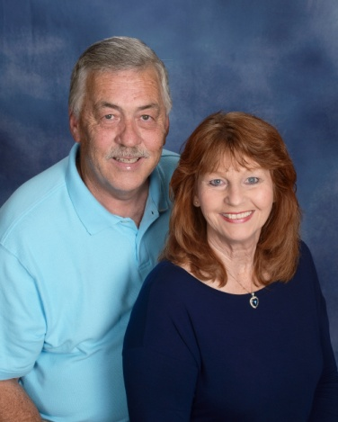 | Williams Jr., Mike & Pat  100 Windsor Oaks Court  Greenwood, SC 29649  (864) 980-4001  mikewjr1@gmail.com
Williams, Pat
110 Kathwood
Greenwood, SC 29649

(803) 229-4119

Williamson, Perryne
123 Lollis Road
Greenwood, SC 29649

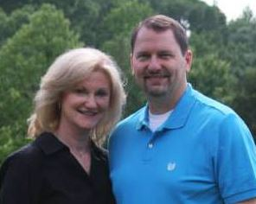 | Willis, Michael & Angie  110 Heritage W. Court  Greenwood, SC 29649  (864) 229-0622  michang_willis@live.com
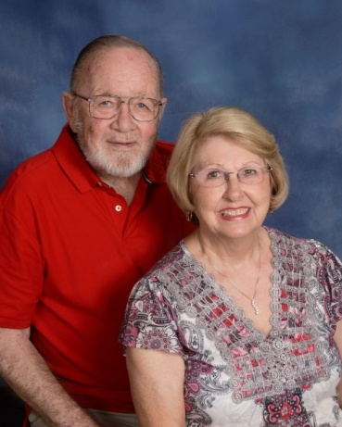 | Wilson, Jerry & Sandy  131 Bridge Point Road  Greenwood, SC 29649  (864) 223-4739  jwilson@greenwood.net
Wilson, Jim & Aundrea
108 Mayapple
Greenwood, SC 29649

(864) 223-3204

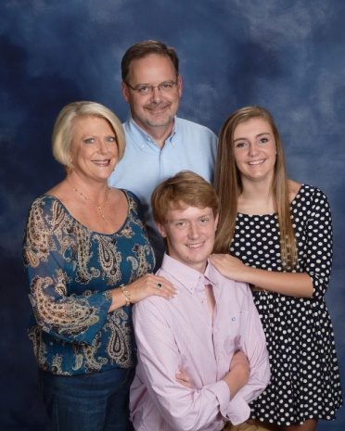 | Wilson, Tod & Cheryl  Brock, Hayden  115 Limerick Road  Greenwood, SC 29649  (864) 227-0924  tcwilson64@gmail.com
Winchester, Brandon and Tara
Wells, Kayla
412C S. Cambridge St.
Ninety-Six, SC 29666

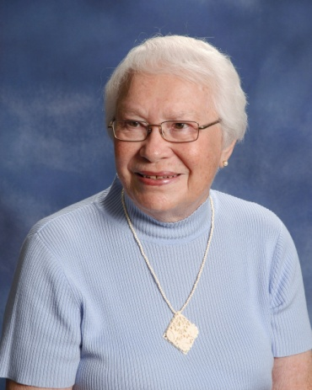 | Witte, Jeanne  Wesley Commons  1110 Marshall Road  Greenwood, SC 29646  (864) 227-7343  jwitte@mywesleycommons.org
Wood, Clint Douglas &Tracy
Erica, Paige
204 Lakewood Drive
Greenwood, SC 29649

(864) 223-4770
twood@mynucu.org

Woods, Ken & Bo
Mallory Hull
101 Wentworth Drive
Greenwood, SC 29649

(864) 992-6310

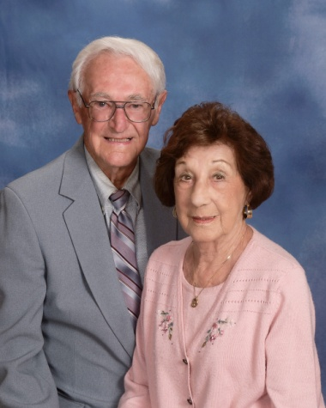 | Worthington, Joe & Millie  604 Old Abbeville Hwy.  Greenwood, SC 29649  (864) 229-7471
Wright, Robin
138 Shearbrook Drive
Greenwood, SC 29646

(864) 227-1617

Yassney III, Joe
126 Country Club Drive
Greenwood, SC 29646

(864) 223-4825

Young, Andrew & Wendi
Sara Beth, Annie
5021 Hwy. 221 S.
Bradley, SC 29819

(228) 365-8026
wendi0312@gmail.com

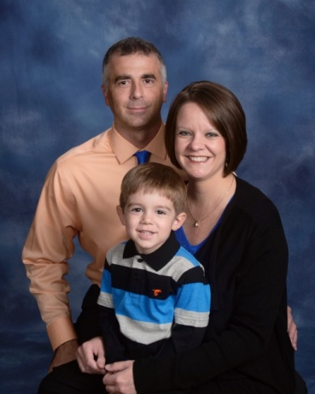 | Young, Jeff & Beth  Bradley, Dylan  P. O. Box 44  Troy, SC 29848  (864) 227-1730  beyoung926@gmail.com
Young, Jordan & Jacque
Addie
3192 Gwin Oaks Drive
Lawrenceville, GA 30044

Zehr, Russell & Sandra
120 Devon Court
Greenwood, SC 29649

(864) 543-5295

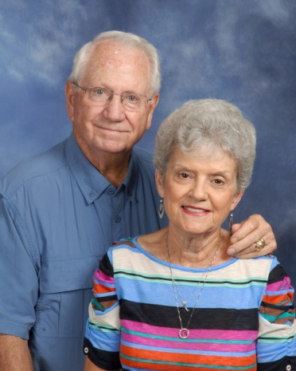 | Zittrouer, Sam & Gene  426 Herndon Drive  Ninety-Six, SC 29666  (864) 543-2591  samzsc@yahoo.com

