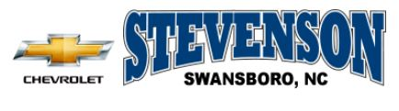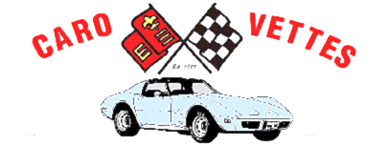

Caro-Vettes Corvette Club
Presents
Peoples Choice Corvette Show
NCCC Sanction CA-356-004 Host: Caro-Vettes Corvette Club
Location: Stevenson Chevrolet,

1435 W. Corbett Ave., Swansboro, NC 28584

Saturday 20 August 2016 8:00 A.M. –Car Show Registration

11:30 A.M. - Drivers Meeting (Cleaning Stops)

12:00 Noon - Judging Begins
3:30 P.M. – Awards Presentation at Stevenson Chevrolet

AWARDS FOR 1ST, 2ND & 3RD PLACE IN EACH “C” CLASS

“BEST IN SHOW” AWARD
Information: Jim Roddy, (910)389-8914 Shane Manary, (910)326-1804

Pre-Registration Fee: $15.00 (Until 5 August 2016): Fee: $20.00 (After 12 August 2016)

Proceeds to: Onslow County Habitat for Humanity

Lodging Hampton Inn, 215 Old Hammock Road, swansboro NC (910)325-9000

National Council of Corvette Clubs Judging & Rules applies for this Sanctioned Event

Complete registration form for each Corvette entered and make checks payable to:
Caro-Vettes Corvette Club

Mail To: P.O. Box 1654, Jacksonville, NC 28540
NAME: | CLUB:
ADDRESS:
CITY: | STATE: ZIP:
PHONE: | DATE:
NCCC# | VETTE YEAR: COLOR:
SIGNATURE: | MODEL:
E-MAIL: | FEE ENCLOSED: $
NOTE: Lodging Deadline to secure rate guarantee: 12 August 2016

