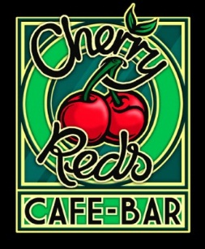
Valentine’s Menu

Two cocktails * Two mains * Sharing starter or dessert £30

Sharer Starters
Meatballs topped with mozzarella, grilled chorizo, chicken & roast veg skewer
Falafel & salsa, olives, halloumi & roast veg skewer, houmous & crudites
Nachos topped with homemade salsa, sour cream, melted cheese & jalapenos

Mains
Beef burger topped with cheddar served with proper chips & salad
Pork loin with chorizo sausage, kale mash and gravy
Honey & mustard salmon fillet with sweet potato wedges and roast vegetables
Butternut squash stuffed with spiced quinoa, on kale mash
Falafel burger topped with salsa served with proper chips & salad

Sharer Desserts
Homemade Cake Sundae with warm sponge, ice cream & whipped cream
Dessert trio of chocolate brownie, lemon cake and salted caramel ice-cream
Homemade American-style Pancakes with blueberries & whipped cream

Bottle of Prosecco £18 Add a course for £6
Liefmans fruit beer £4.80 pint See our menu for extra toppings/other drinks

Offer available at John Bright St www.cherryreds.com

