In regards to the morning temple service, the Levites would recite a psalm (usually by chant or song) that would be suited to the significance of that particular day of the week. As a memorial to the Temple, these psalms have been incorporated into the Siddur for daily prayer.
Sunday- 1st day: psalm teaches that everything belongs to Yahweh
Monday- 2nd day: this psalm shows that Jerusalem is the seat of HIS holiness.
Tuesday- 3rd day: the theme of this psalm is the maintenance of equity and justice
Wednesday- 4th day: this psalm speaks of Yahweh being an Elohim of vengeance
Thursday- 5th day: this psalm was chanted in the Holy Temple on Yom Teruah
Friday -6th day: this psalm speaks of the messianic era, when Elohim will don grandeur
Shabbat- 7th day: this psalm speaks of the world to come, and comforts those who suffer

TO RECITE BEFORE EACH DAILY PSALM: Come, let us raise our voices in jubilation to the Rock of our deliverance (salvation). Let us approach Him with thanksgiving; let us raise our voices to Him in song. For יהוה is a great El and a great King over the entire universe.
SUNDAY Psalm 24 The earth belongs to יהוה, and the fullness thereof – The world and those who dwell in it. For He has founded it upon the seas, and upon the waters He does establish it. Who shall ascend the hill of יהוה? And who shall stand in His set-apart place?
He who has clean hands and a pure heart, who does not lift up his soul to what is false and does not swear deceitfully. He receives a blessing from יהוה, And righteousness from the Elohim of his salvation. This is the generation of those who seek Him; who seek the face of the Elohim of Ya’acov. Selah. Lift up your heads, O you gates! And be lifted up, you everlasting doors! And let the King of glory come in. Who is this King of glory? יהוה strong and mighty, יהוה mighty in battle. Lift up your heads, O you gates! Even lift up, you everlasting doors! And let the King of glory come in. Who is this King of glory? יהוה of hosts, He is the King of glory! Selah.
MONDAY Psalm 48 Great is יהוה, and greatly to be praised in the city of our Elohim, His holy mountain. Pretty on high, The joy of all the earth, Is Mount Zion on the sides of the north, The city of the great King. Elohim is in her citadels; He is known as her refuge. For look, the kings met, They passed by together. They saw, so they marveled; They were alarmed, they hastened away. Trembling took hold of them there, Pain, as of a woman in labor, With an east wind You break the ships of Tarshish. As we have heard, so we have seen in the city of יהוה of hosts, In the city of our Elohim, Elohim establishes her forever. Selah. We have thought, O Elohim, of Your kindness, In the midst of Your sanctuary. According to Your Name, O Elohim, So is Your praise to the ends of the earth; Your right hand is filled with righteousness. Let Mount Zion rejoice, Let the daughters of Yehudah exult, Because of Your right-rulings. Walk about Zion, And go all around her. Count her towers; Set your heart upon her rampart; Go through her citadels; So that you report it to the coming generation that this Elohim is our Elohim, Forever and ever; He will lead us eternally.
TUESDAY Psalm 82 Elohim stands in the congregation of judges; among the judges He renders judgment. How long will you judge perversely, And show partiality to the wrong? Selah. Render justice to the needy and the orphan, deal righteously with the poor and the destitute. Rescue the weak and the needy; Deliver them from the hand of the wicked. They do not know, nor do they understand, They walk about in darkness. All the foundations of the earth are shaken. I said, “You are elohim, And all of you are sons of the Most High. “But as men you die, you will fall like any prince.” Arise, O Elohim, judge the earth, For You possess all the nations.
WEDNESDAY Psalm 94 O יהוה, Ěl of vengeance; O Ěl of vengeance, shine forth! Raise Yourself up, O Judge of the earth; Render punishment to the proud. יהוה, how long are the wrong, How long are the wrong going to exult? They pour forth words, They speak arrogantly; All the workers of wickedness boast in themselves. They crush Your people, O יהוה, And they afflict Your inheritance. They slay the widow and the stranger, And murder the fatherless. Yet they say, “Yah does not see, And the Elohim of Ya’aqov pays no heed.” Take heed, you senseless among the people; And you fools, when would you become wise? He who planted the ear, does He not hear? He who formed the eye, does He not see? He who disciplines the nations, Does He not reprove – The One teaching man knowledge? יהוה knows the thoughts of man, That they are but a breath. Blessed is the man You discipline, O Yah, And instruct out of Your Torah, To give him rest from the days of evil, Until the pit is dug for the wrong. For יהוה does not leave His people, Nor does He forsake His inheritance. For right-ruling returns man to righteousness, And all the upright in heart follow it. Who would rise up for me against evil-doers? Who would stand up for me against workers of wickedness? If יהוה had not been my help, My being would soon have settled in silence. When I said, “My foot has slipped,” Your kindness, O יהוה, supported me. When anxiety was great within me, Your comforts delighted my being. Would a throne of destruction, Which devises trouble by decree, Be joined with You? They band together against the life of the righteous, And declare innocent blood wrong. But יהוה is my defense, And my Elohim the rock of my refuge, And brings back on them their own wickedness, And cuts them off in their own wrongdoing; יהוה our Elohim does cut them off.
THURSDAY Psalm 81 Shout for joy to Elohim our strength; Raise a shout to the Elohim of Ya’acov. Lift up a song and beat the tambourine, The pleasant lyre and with the harp. Blow the ram’s horn at the time of the New Moon, At the full moon, on our festival day. For this is a decree for Yisra’ĕl, And a right-ruling of the Elohim of Ya'acov. He appointed it in Yosĕph for a witness, When He went throughout the land of Mitsrayim; I heard a language that I did not know. He says, “I removed his shoulder from the burden; His hands were freed from the baskets. “You called in distress, and I rescued you; I answered you in the covering of thunder; I proved you at the waters of Merivah. Selah. “Hear, O My people, and let Me warn you, O Yisra’ĕl, if you would listen to Me! “Let there be no strange mighty one among you, And do not bow down to a foreign mighty one. “I am יהוה your Elohim, Who brought you out of the land of Mitsrayim; Open your mouth wide, and I fill it. “But My people did not listen to My voice, And Yisra’ĕl would not submit to Me. “So I gave them over to their own stubborn heart, To walk in their own counsels. “O, if My people had listened to Me, Yisra’ĕl would walk in My ways, “I would subdue their enemies at once, And turn My hand against their adversaries! “Those who hate יהוה would cringe before Him; And their time of punishment be forever. “He would feed them with the finest of wheat; And with honey from the rock I would satisfy you.”
FRIDAY Psalm 93 יהוה shall reign, He shall put on excellency; יהוה shall put on strength; He shall gird Himself. Indeed, the world is established, immovable. Your throne is established from of old; You are from everlasting. Rivers shall lift up, O יהוה, Rivers shall lift up their voice; Rivers lift up their breakers. יהוה on high is mightier Than the noise of many waters, The mighty breakers of the sea. Your witnesses have been very trustworthy. Set-apartness befits Your house, O יהוה, forever.

SHABBAT
Psalm 92 It is good to give thanks to יהוה, And to sing praises to Your Name, O Most High;
To declare Your kindness in the morning, And Your trustworthiness each night, On ten strings, and on the harp, To the sounding chords of the lyre. For You have made me rejoice with Your work, O יהוה, I shout for joy at the works of Your hands. O יהוה, how great are Your works! Your thoughts are very deep! A senseless man does not know, And a fool does not understand this. When the wrong spring up like grass, And all the workers of wickedness blossom, It is for them to be destroyed forever. But You, יהוה, are on high forever. For look, Your enemies, O יהוה, For look, Your enemies do perish; All the workers of wickedness are scattered. But You lift up my horn like a wild ox; I have been anointed with fresh oil. And my eye looks upon my enemies; My ears hear the evil-doers Who rise up against me. The righteous one flourishes like a palm tree, He grows like a cedar in Lebanon. Those who are planted in the House of יהוה flourish in the courts of our Elohim. They still bear fruit in old age; They are fresh and green, To declare that יהוה is straight, My rock, and in Him is no unrighteousness.

OPTIONAL: (This prayer may be added after the daily psalm)
Save us, יהוה , our Elohim, and gather us in from the nations, to thank Your Holy Name and to glory in Your praise. Blessed is יהוה, the Elohim of Israel, from this world to the world to come, and let all the people say “Amen! HalleluYah!” Blessed is יהוה from Zion, He who dwells in Jerusalem, HalleluYah. Blessed is יהוה , Elohim, the Elohim of Israel, Who alone does wonders… Blessed is His glorious Name forever, and may all the earth be filled with His glory. In Messiah Yahshua’s name, Amen and Amen.

__________________________________
Ref: “Tehillim” by Ohel Yosef Yitzchak (I inserted “the universe” from original)

Works Cited: Complete Artscroll Siddur, “Tehillim” by Ohel Yosef Yitzchak, “The Scriptures” 1998 Ed., Various Bible writings.
Cover picture: Carta’s Illustrated Encyclopedia Of The Holy Temple In Jerusalem

~ylht
TEHILLIM

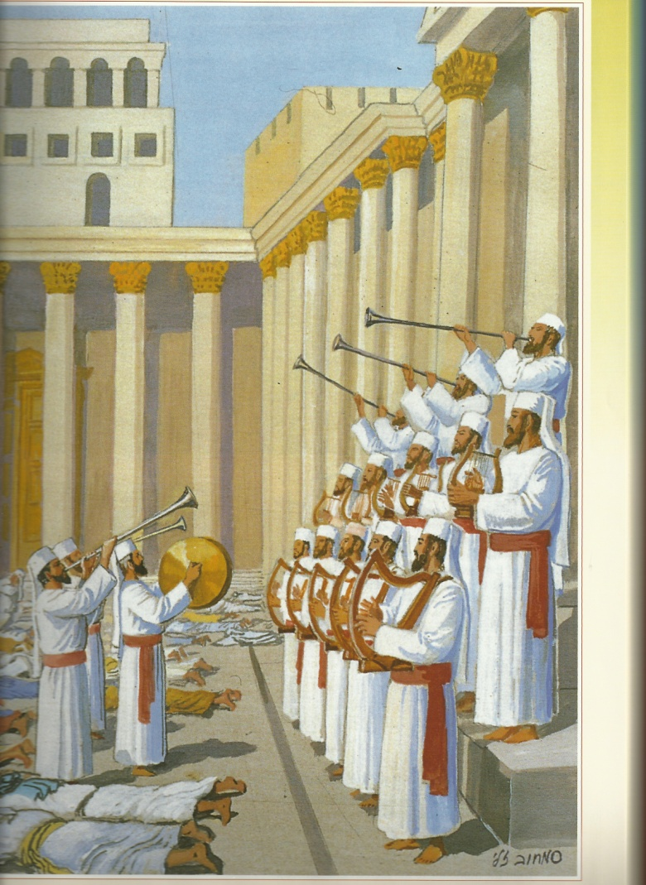

~wy lv ryv
Song of the day

