Instructions on how to prepare the TRACT

1.) Print “Coupon Tract Outside” file/image first. You may have to save the picture to
your hard drive and then print it as it may not print to size from the webpage.
2.) Next, print the other side with the “Coupon Tract Inside” file. Make sure you line it up so that the top margin is close on both sides as shown.
Fig 1 Fig2
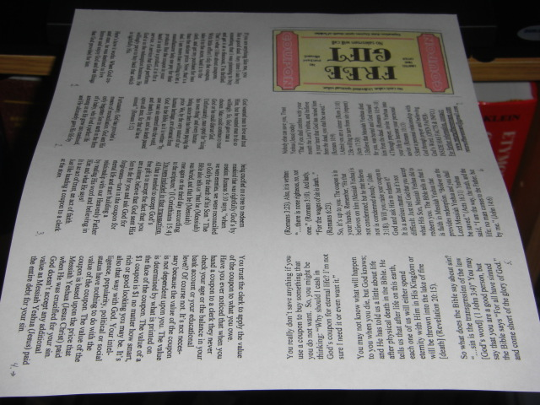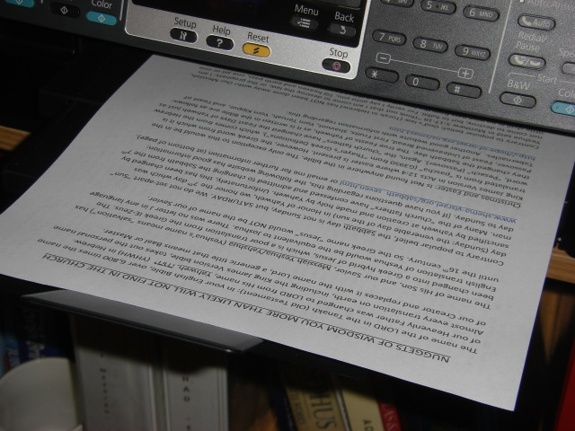
Fig 3 Fig 4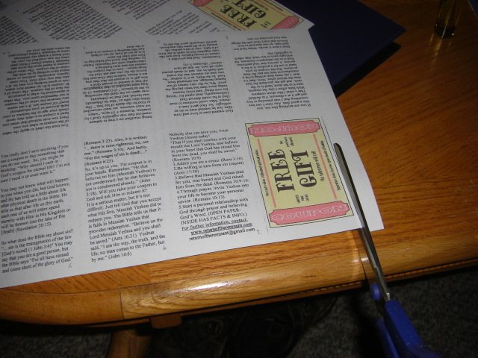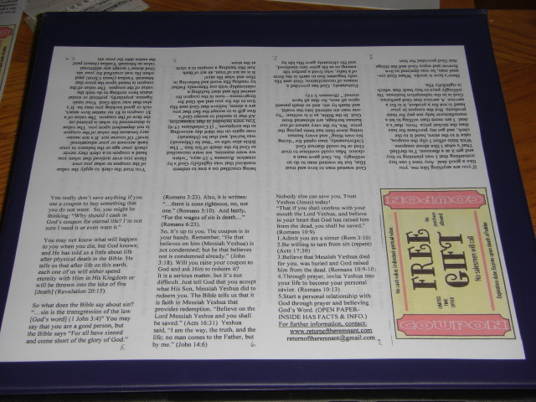

3.) Cut along the bottom, all the way across (Fig 3)– you will cut off roughly 1 ” of the edge so that it will look like Fig 4. (depending on which way your printer margins are set, you may have to cut extra off the other edge. You may have to experiment until you find the right settings.
4.) Next, fold the TRACT in half (length way). Fig 5
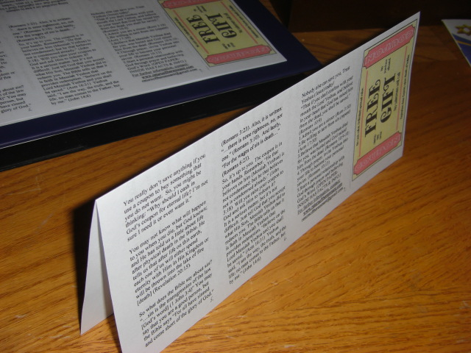
5.) Start the folding process of the TRACT starting at the “Free Gift” image and work your way to the end. Fig 6 (you may have to cut off ¼” off at the other end) Fig 7
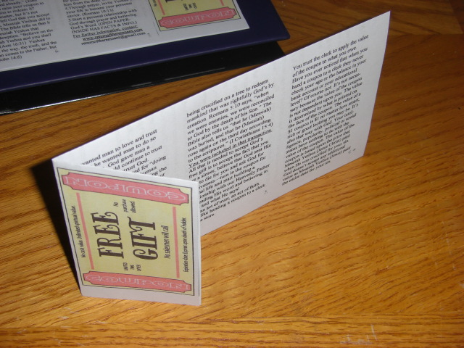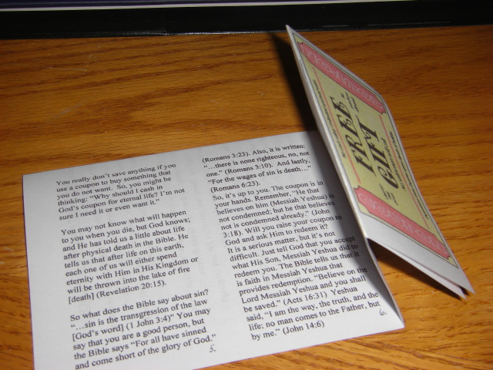
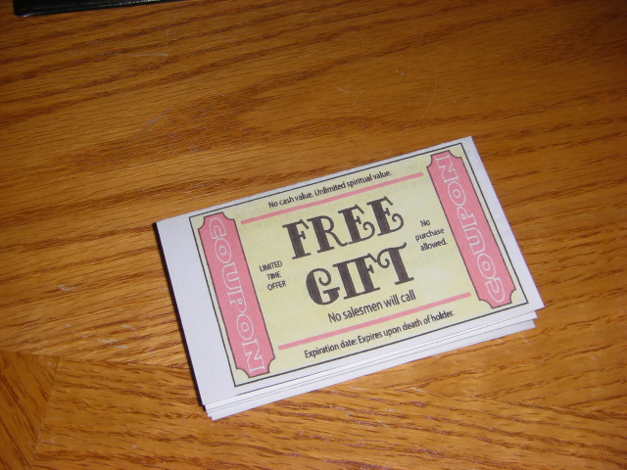
Fig 8
You have successfully put together a TRACT !!! Now go out and spread the WORD!!!!

