Counting of the Omer 2017
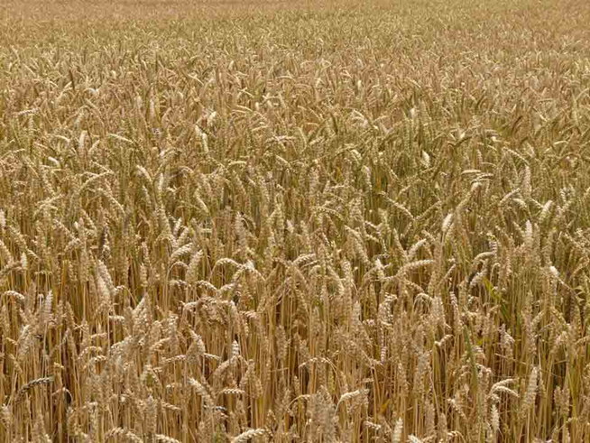
ספירת העומר

Lev 23:15-16 ‘And from the morrow after the Sabbath, from the day that you brought the sheaf of the wave offering, you shall count for yourselves: seven completed Sabbaths. ‘Until the morrow after the seventh Sabbath you count fifty days, then you shall bring a new grain offering to יהוה.
We are instructed by יהוה to count 49 days (7 completed Sabbaths) concluding with the celebration of Shavuot on the 50th day. This period is called "Sefirat HaOmer", the counting of the Omer. According to Rabbinic sources, the Omer count recalls an earlier event when the children of Israel prepared themselves for receiving the Torah at Mt. Sinai at Shavuot. It is also important to note that on Shavuot ("Pentecost" in Greek) the disciples of Yeshua were filled with the "Spirit of Elohim" (Acts 2). May you draw near to HIM and be filled with the spirit of wisdom and truth during these 50 days.

The daily counting of the Omer is a yearly reminder of how we are to count the years leading to the Yovel (Jubilee) year.

Similarities of counting: Shavuot and Yovel

Shavuot Yovel (Jubilee)

Leviticus 23:10-11, 15-17 Leviticus 25:2-5, 8-12
Begins of the 1st day of Begins on the 1st year
the week and ends on and ends of the 50th
the 50th day, the 1st day year, the 1st year of the
of the week next Yovel cycle

(7) Sabbaths (7) Land Sabbaths

50th Day – Shavuot 50th Year – Yovel

Day 1 [Sunday following the regular Shabbat during unleavened bread]
€ Romans 1

Day 2
€ Romans 2

Day 3
€ Romans 3

Day 4
€ Romans 4

Day 5
€ Romans 5

Day 6
€ Romans 6

Day 7 Shabbat ~ First Completed Week ~ April 22nd
€ Romans 7

Day 8
€ Romans 8

Day 9
€ Romans 9

Day 10
€ Romans 10

Day 11
€ Romans 11

Day 12
€ Romans 12

Day 13
€ Romans 13

Day 14 Shabbat ~ Second Completed Week ~ April 29th
€ Romans 14

Day 15
€ Romans 15

Day 16
€ Romans 16

Day 17
€ 1 Corinthians 1

Day 18
€ 1 Corinthians 2

Day 19
€ 1 Corinthians 3

Day 20
€ 1 Corinthians 4

Day 21 Shabbat ~ Third Completed Week ~ May 6th
€ 1 Corinthians 5

Day 22
€ 1 Corinthians 6

Day 23
€ 1 Corinthians 7

Day 24
€ 1 Corinthians 8

Day 25
€ 1 Corinthians 9

Day 26
€ 1 Corinthians 10

Day 27
€ 1 Corinthians 11

Day 28 Shabbat ~ Fourth Completed Week ~ May 13th
€ 1 Corinthians 12

Day 29
€ 1 Corinthians 13

Day 30
€ 1 Corinthians 14

Day 31
€ 1 Corinthians 15

Day 32
€ 1 Corinthians 16

Day 33
€ 2 Corinthians 1

Day 34
€ 2 Corinthians 2

Day 35 Shabbat ~ Fifth Completed Week ~ May 20th
€ 2 Corinthians 3

Day 36
€ 2 Corinthians 4

Day 37
€ 2 Corinthians 5

Day 38
€ 2 Corinthians 6

Day 39
€ 2 Corinthians 7

Day 40
€ 2 Corinthians 8

Day 41
€ 2 Corinthians 9

Day 42 Shabbat ~ Sixth Completed Week ~ May 27th
€ 2 Corinthians 10

Day 43
€ 2 Corinthians 11

Day 44
€ 2 Corinthians 12

Day 45
€ 2 Corinthians 13

Day 46
€ James (Ya’akov) 1

Day 47
€ James (Ya’akov) 2

Day 48
€ James (Ya’akov) 3

Day 49 Shabbat ~ Seventh Completed Week ~ June 3rd
€ James (Ya’akov) 4

Day 50 ~ SHAVUOT! ~ (Yom HaBikurim) – June 4th
€ James (Ya’akov) 5, Megilath Ruth

Notes:

Notes:

Notes:

Additional readings on Shavuot:
Acts 2:1 - 47 Numbers 28:26 - 31
Exodus 19:3 - 20:26 Deuteronomy 14:22 - 16:17
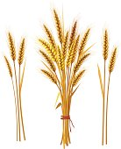
Leviticus 23:15 – 21
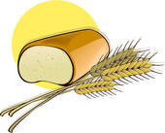

Other dates to remember during the counting of the Omer:

Apr 24th Holocaust Memorial day (Yom Hashoah)
May 1st Memorial Day (Yom Hazikaron)
May 2nd Israel Independence Day (Yom Ha'Atzmaut)
May 24th Jerusalem Day (Yom Yerushalayim)
May 25th Hebron (Liberation) Day (Yom Hebron)

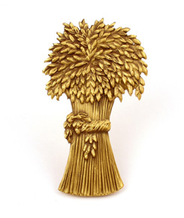
For further information, go to:
www.returnoftheremnant.com

