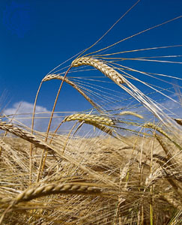
Counting of the Omer 2016

ספירת העומר

Lev 23:15-16 ‘And from the morrow after the Sabbath, from the day that you brought the sheaf of the wave offering, you shall count for yourselves: seven completed Sabbaths. ‘Until the morrow after the seventh Sabbath you count fifty days, then you shall bring a new grain offering to יהוה.
We are instructed by יהוה to count 49 days (7 completed Sabbaths) concluding with the celebration of Shavuot on the 50th day. This period is called "Sefirat HaOmer", the counting of the Omer. According to Rabbinic sources, the Omer count recalls an earlier event when the children of Israel prepared themselves for receiving the Torah at Mt. Sinai at Shavuot. It is also important to note that on Shavuot ("Pentecost" in Greek) the disciples of Yeshua were filled with the "Spirit of Elohim" (Acts 2). May you draw near to HIM and be filled with the spirit of wisdom and truth during these 50 days.

The daily counting of the Omer is a yearly reminder of how we are to count the years leading to the Yovel (Jubilee) year.

Similarities of counting: Shavuot and Yovel

Shavuot Yovel (Jubilee)

Leviticus 23:10-11, 15-17 Leviticus 25:2-5, 8-12
Begins of the 1st day of Begins on the 1st year
the week and ends on and ends of the 50th
the 50th day, the 1st day year, the 1st year of the
of the week next Yovel cycle

(7) Sabbaths (7) Land Sabbaths

50th Day – Shavuot 50th Year – Yovel
Day 1 [Sunday following the regular Shabbat during unleavened bread]
€ Daniel 1

Day 2
€ Daniel 2

Day 3
€ Daniel 3

Day 4
€ Daniel 4

Day 5
€ Daniel 5

Day 6
€ Daniel 6

Day 7 Shabbat ~ First Completed Week ~ April 30th
€ Daniel 7

Day 8
€ Daniel 8

Day 9
€ Daniel 9

Day 10
€ Daniel 10

Day 11
€ Daniel 11

Day 12
€ Daniel 12

Day 13
€ Revelation 1

Day 14 Shabbat ~ Second Completed Week ~ May 7th
€ Revelation 2

Day 15
€ Revelation 3

Day 16
€ Revelation 4

Day 17
€ Revelation 5

Day 18
€ Revelation 6

Day 19
€ Revelation 7

Day 20
€ Revelation 8

Day 21 Shabbat ~ Third Completed Week ~ May 14th
€ Revelation 9

Day 22
€ Revelation 10

Day 23
€ Revelation 11

Day 24
€ Revelation 12

Day 25
€ Revelation 13

Day 26
€ Revelation 14

Day 27
€ Revelation 15

Day 28 Shabbat ~ Fourth Completed Week ~ May 21st
€ Revelation 16

Day 29
€ Revelation 17

Day 30
€ Revelation 18

Day 31
€ Revelation 19

Day 32
€ Revelation 20

Day 33
€ Revelation 21

Day 34
€ Revelation 22

Day 35 Shabbat ~ Fifth Completed Week ~ May 28th
€ Ezekiel 33

Day 36
€ Ezekiel 34

Day 37
€ Ezekiel 35

Day 38
€ Ezekiel 36

Day 39
€ Ezekiel 37

Day 40
€ Ezekiel 38

Day 41
€ Ezekiel 39

Day 42 Shabbat ~ Sixth Completed Week ~ June 4th
€ Ezekiel 40

Day 43
€ Ezekiel 41

Day 44
€ Ezekiel 42

Day 45
€ Ezekiel 43

Day 46
€ Ezekiel 44

Day 47
€ Ezekiel 45

Day 48
€ Ezekiel 46

Day 49 Shabbat ~ Seventh Completed Week ~ June 11th
€ Ezekiel 47

Day 50 ~ SHAVUOT! ~ (Yom HaBikurim) – June 12th
€ Ezekiel 48, Megilath Ruth

Notes:

Notes:

Notes:

Additional readings on Shavuot:
Acts 2:1 - 47 Numbers 28:26 - 31
Exodus 19:3 - 20:26 Deuteronomy 14:22 - 16:17
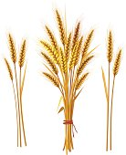
Leviticus 23:15 – 21
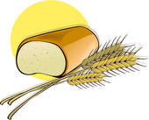

Other dates to remember during the counting of the Omer:

May 5th Holocaust Memorial day (Yom Hashoah)
May 11th Memorial Day (Yom Hazikaron)
May 12th Israel Independence Day (Yom Ha'Atzmaut)
June 5th Jerusalem Day (Yom Yerushalayim)
June 6th Hebron (Liberation) Day (Yom Hebron)

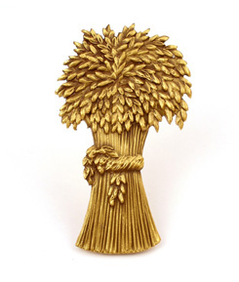
For further information, go to:
www.returnoftheremnant.com

