BSA Troop 43
Camping and Catamount Adventure Park Trip

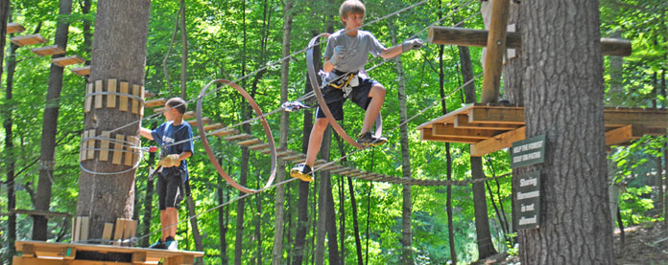

Where: Taconic State Park, Copake Falls, NY
When: Saturday June 15th – Sunday June 16th

Cost: Covers Camping Fees, Food and Park Admission
$44 per Scout (Ages 10-11)
$51 per Scout (12+) and Adult

RSVP: By June 10th TroopMeeting (No later)or let us know before at outdoortrip43@gmail.com
Permission Slips and payment will be due June 10th.

Included: Camping (Location to be determined), All Camp Meals (Lunch Dinner, Breakfast).
Entrance to Catamount Adventure Park.

What to bring: Camping gear, Swimsuit, Bug/Tick Spray, and lunch money for concessions at park ($10).

What to expect at Catamount:
FUN!!
Catamount Video

