US Department of Housing OMB Approval No: 2502-0538
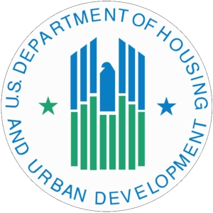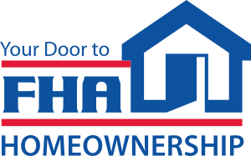
and Urban Development (HUD)
Federal Housing Administration

For Your Protection: Get a Home Inspection
Name of Buyer (s) _________________________________________________________________________________________________________
Property Address _________________________________________________________________________________________________________
Why a Buyer Needs a Home Inspection

A home inspection gives the buyer more detailed information about the overall condition of the home prior to purchase. In a home inspection, a qualified inspector takes an in-depth, unbiased look at your potential new home to:

• evaluate the physical condition: structure, construction, and mechanical systems
• identify items that need to be repaired or replaced
• estimate the remaining useful life of the major systems, equipment, structure, and finishes

Appraisals are Different from Home Inspections

An appraisal is different from a home inspection. Appraisals are for lenders; home inspections are for buyers. An appraisal is required for three reasons:

• to estimate the market value of a house
• to make sure that the house meets FHA minimum property standards/requirements
• to make sure that the house is marketable

FHA Does Not Guarantee the Value or Condition of your Potential New Home

If you find problems with your new home after closing, FHA can not give or lend you money for repairs, and FHA can not buy the home back from you.

Be an Informed Buyer
It is your responsibility to be an informed buyer. Be sure that what you buy is satisfactory in every respect. You have the right to carefully examine your potential new home with a qualified home inspector. You may arrange to do so before signing your contract, or may do so after signing the contract as long as your contract states that the sale of the home depends on the inspection.

