**Home Energy Surveys**

**HOME ENERGY RATING SYSTEM (HERS) CERTIFICATE**

* Completed during construction by a certified Home Energy Rater.
* The Home Energy Rater inspects the home and measures its energy characteristics. This includes insulation levels, window efficiency, the heating and cooling system efficiency, appliances, lighting, and the solar orientation. It also includes performance testing. The blower door test measures the building leakage. The duct leakage test measures the leakage of the HVAC duct system.
* The inspection results in a HERS Index score.
* The HERS Index (see example below) is a scoring system established by RESNET (Residential Energy Services Network). A HERS Index of 100 is given to a home in which specifications match that of a HERS Reference Home that is based on the 2006 International Energy Conservation Code. The lower the home's HERS Index, the more energy efficient it is compared to the HERS Reference Home. Each 1-point reduction in the HERS Index corresponds to a 1% reduction in the energy consumption and a 1% improvement in the energy efficiency of the home. Thus, a home with a HERS Index of 70 is 30% more energy efficient than the HERS Reference Home. A HERS Index of 0 would represent a home where renewable power generation is being utilized (such as solar energy) at a level where the energy generation matches the energy consumption of the home based on the HERS Index. These homes have implemented energy efficient features as well as renewable energy generation.

[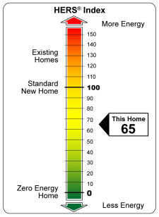](http://www.resnet.us/images/content/yardstick_large.jpg)

**BANDERA ELECTRIC**

* Provides a basic energy audit at no charge. If the attic is assessable from the house they will check the insulation. They use a temperature gun and can make an educated guess about insulation in walls. They will check for leaks around windows and doors and check the setting of the hot water heater. Primarily, they provide information but do make recommendation.
* Sign up for “smartwatch” at banderaelectric.com to see your energy usage and costs for a two year period by day, week, and month
* The following information is from the bandera electric website concerning home generation of electrical power:
  + *(* [*http://www.banderaelectric.com/renewables*](http://www.banderaelectric.com/renewables) *)*

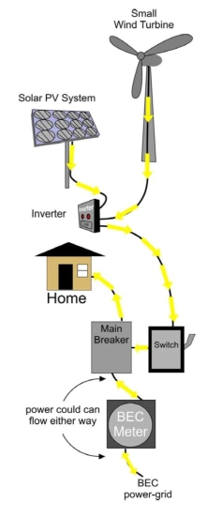**Installing Renewables (Distributed Generation)**

**Thinking of Installing Renewables?***Here is what you need to know if you are considering purchasing a wind turbine or solar panel system*

Members who want to make their own power from renewable resources should read our [Distributed Generation Tariff](http://www.banderaelectric.com/images/DG%20Tariff%20-%206-2008.pdf) (a PDF file).  This outlines the responsibilities of the Cooperative and the Member.    
  
The Cooperative needs to be notified 60 days prior to installation of any distributed generation (dg) system.  This is for the safety of the Member, the linemen, and the system.  Any units installed must have an auto disconnect feature.  
  
If you plan on installing a grid tie dg system (or if you already have such a system the cooperative is unaware of) you will need to fill out our [DG Application](http://www.banderaelectric.com/getfile.php?f=36" \t ") (a PDF file).  *There is a small application fee (outlined in the* [*Distributed Generation Tariff*](http://www.banderaelectric.com/images/DG%20Tariff%20-%206-2008%281%29.pdf)*), depending on the size of the system.*   
Bandera Electric has fully implemented "net metering" for all  Members.  The meters will record electricity that flows from our lines to your home and electricity that flows from your home to our lines, should you produce more than you consume.  
  
Many Members looking into dg systems ask if the co-op will buy electricity from them if they install such a system.  BEC will not write a check for the excess power a Member’s equipment has produced; however, we do give you credit kilowatt-hour for kilowatt-hour.  If your system produces more than you consume, it is our policy to “bank” excess kilowatt-hours.  In future months when usage exceeds power production, BEC will draw from your "bank" and apply the previous excess production to your current bill.   
  
If you have any questions regarding installing a renewable system, contact our offices at 1-866-226-3372 and speak to someone in our engineering department.  
  
[Local installers for Renewable Energy Products](http://www.banderaelectric.com/DGInstallers)  
  
[See article and diagram on Grid-connected Solar PV system](http://www.banderaelectric.com/solarpv)

[TREIA - **The Texas Renewable Energy Industries Association**](http://www.treia.org/mc/page.do;jsessionid=BD891BA3E06FA7CD4AB52E29FB22FB36.mc0?sitePageId=83208)  
  
TREIA represents over 500 member companies, organizations, agencies and individuals providing products, services and information in the areas of solar electric generation, solar hot water, large and small-scale wind electric generation, biomass electric generation and liquid renewable fuels, geothermal heating and cooling, geothermal electric generation, and sustainable (green) building design and construction.  For more information, [click here.](http://www.treia.org/mc/page.do;jsessionid=BD891BA3E06FA7CD4AB52E29FB22FB36.mc0?sitePageId=83208)

Last Modified: August 24, 2011