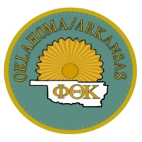**Beta Delta Phi Chapter of Phi Theta Kappa Honor Society**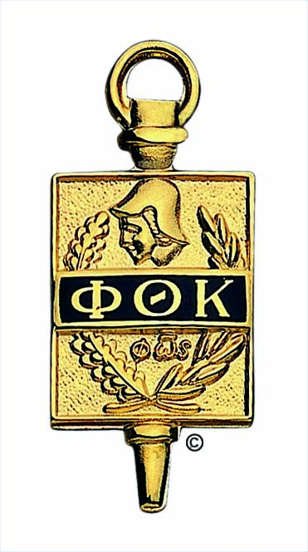

"The purpose of Phi Theta Kappa shall be to recognize and encourage scholarship among two-year college students. To achieve this purpose, Phi Theta Kappa shall provide opportunity for the development of leadership and service, for an intellectual climate for exchange of ideas and ideals, for lively fellowship for scholars, and for stimulation of interest in continuing academic excellence."

Phi Theta Kappa's mission is two-fold: 1) recognize and encourage the academic achievement of two-year college students and (2) provide opportunities for individual growth and development through participation in honors, leadership, service and fellowship programming.

**Beta Delta Phi Chapter—** promotes core values of: Scholarship, Leadership, Service and Fellowship to our members through various activities and fund raising projects.

Membership provides an opportunity to develop and expand leadership skills by being a local chapter officer or involved member, and seek office as Regional President and Vice-President (one year term), International office, scholarship opportunities, become involved with chapter, college, community, region, and internationally. Beta Delta Phi hosts Red Cross Blood Drives, book drives, food drives, and toy drives. Beta Delta Phi has also adopted one mile of roadside in Pocahontas, “Adopt a Highway” and participates in Operation Green. Active chapter officers may receive special benefits.

Monthly chapter meetings are held the first Monday of each month at 5pm in AC100 Pocahontas and TC 106 Paragould these are CVN meetings, and the first Tuesday at 4:30 in SC108.

Chapter College Project –members are ambassadors for College.

Relay for Life—first Friday night 6pm to Saturday 6am of June. Raise funds and participate in Relay for Life for cancer research, treatment, and assistance, annual beauty pageant—held in spring. Funds go toward Relay for Life; gifts to nursing home residents, and other projects.

Attend OK/AR regional meetings in fall and spring hosted by a chapter in Oklahoma or Arkansas. The next Regional Convention is in Conway, AR, February 25 and 26, 2011. The Annual Convention is in Seattle, WA, April 7-9, 2011.

**Qualifications**: Eligible—a 3.50 grade point average, cumulative, based on a completion minimum of 12 college credit hours, excluding any remedial classes, and actively seeking in a degree. Maintain membership—3.25 grade point average, cumulative.

For more information contact chapter advisor Dr. Moss, office SC-101, phone 248-4000 ext 4136, e-mail lindam@blackrivertech.edu.