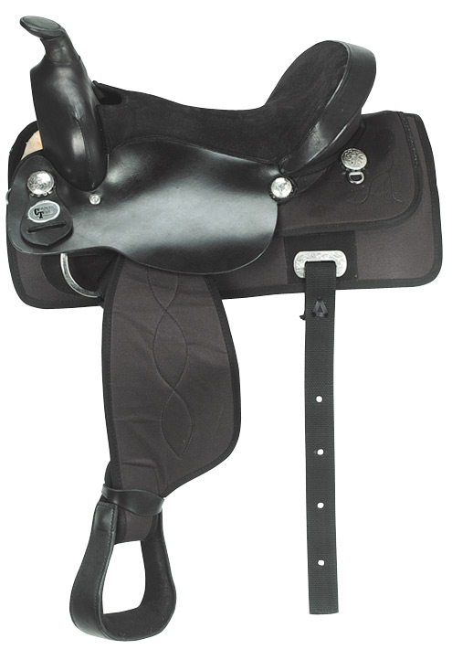
SPONSORSHIP FORM
∇ Á la Carte Sponsorships $10 – One Line Posted on Website $15 – One Line Printed in Program
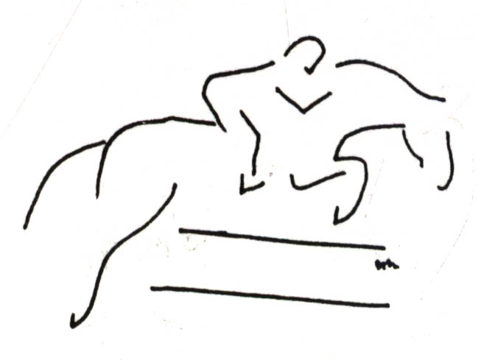
$20 – Your Banner Placed at Show $25 – Public Address every two hours
$30 – Business Card Ad in Program $45 – Public Address every hour
$50 – Vendor Space $50 – Quarter Page Ad in Program
$75 – Half Page Ad in Program $100 – Full Page Ad in Program
$100 – New Banner Placed at Show $200 – Jackpot Sponsor
$200 – Dressage Sponsor $200 – Combined Test Sponsor
$250 – Stadium Jump Sponsor $300 – Derby Jump Sponsor
Bronze Sponsor $75 – Business Card Ad in Program, Your Banner Placed at Show, Public Address every two hours & Bronze Sponsor Link on Website
Silver Sponsor $100 – Half Page Ad in Program, Your Banner Placed at Show, Public Address every two hours & Silver Sponsor Link on Website
Gold Sponsor $200 – Full Page Ad in Program, Your Banner Placed at Show, Public Address every hour & Gold Sponsor Link on Website
Platinum Sponsor $400 – Dressage or Jackpot Sponsor, Full Page Ad in Program, Public Address every hour, Your Banner Placed at Show & Platinum Sponsor Link on Website
Diamond Sponsor $500 or more – Jump Sponsor, Full Page Ad in Program, Your Banner Placed at Show, Public Address every hour & Diamond Sponsor Link on Website ++ Corporate Perks

◊ Product/Service Payment Same structure except payment is twice the price
(i.e. $60 in gift certificates = Business Card Ad ; $200 service = Silver; 150 hoof picks for $1 each = Bronze)
** ALL Sponsors will be linked on the Horse Show Website
Name of Sponsor: ________________________________________________________________________________
Address: _______________________________________________________________________________________
City, State, Zip: __________________________________________________________________________________
Telephone Number: _________________ Email Address: ______________________________________________
Website Address: ________________________________________________________________________________
Special coordinating instructions: ____________________________________________________________________
________________________________________________________________________________________________
________________________________________________________________________________________________
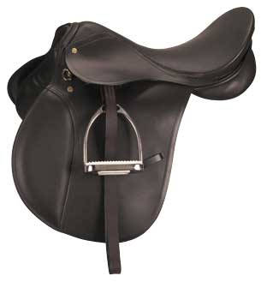
Please send this form, ad file (.jpg or .bmp) for 8 ½”x11” Program (business cards can be reduced or enlarged to fit), maximum 30 seconds recorded or typed (email is acceptable) Public Address Announcement, and payment (checks payable to Sunny Sands c/o Kelly Dobert) to:

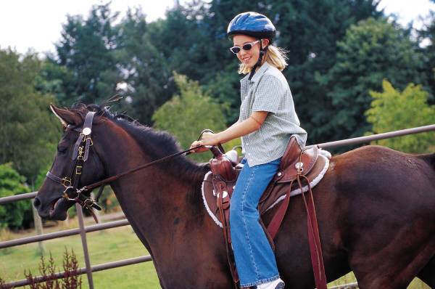
Sunny Sands Horse Events Sponsorship
Major Kelly Dobert
33174 199th Street
Leavenworth, KS 66048
(828) 505-6208 or (804) 931-6450
sunnysands2011@yahoo.com

Payment must be received BEFORE April 25th, to guarantee your inclusion in Show Program. Remember, the earlier you become a Sponsor the earlier you get advertising on the Website! Competitors, friends and family check it early and often to find out more, ensure that their entries have been accepted and to find out when they ride. Let us know if there is anything we can do to fulfill your sponsorship needs.
Check Number _________ Cash Amt. ____________
Prize Pymnt. _________________________________
Payment mailed / received on _____________
Received by ________________________________

Sunny Sands Horse Events
May 7th & 8th, 2011
Fort Leavenworth Stables Activity, Fort Leavenworth, KS
http://webstarts.com/SunnySandsHorseEvents2011

RECEIPT --- Thank you very much for your support!
Sponsor Level:
Diamond Platinum Gold Silver Bronze ∇ A la Carte

◊ Product/Service Payment Same structure except payment is twice the price (i.e. $60 in gift certificates = Business Card Ad ; $200 service = Silver; 150 hoof picks for $1 each = Bronze)

