SUNNY SANDS
Jackpot Gymkhana
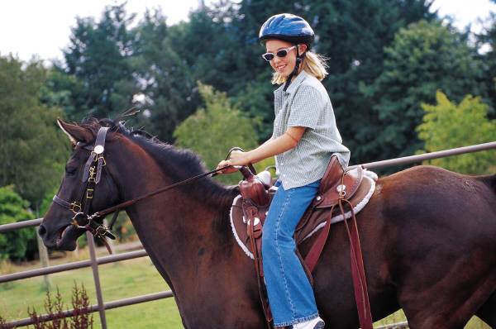
MOUNTED GAMES OPEN FUN SHOW
At Fort Leavenworth Stables Activity, Fort Leavenworth, KS
10 am – Sunday, May 8, 2011

Organizer / Show Manager: Major Kelly Dobert – kelly.dobert@yahoo.com (828) 505-6208 / (804) 931-6450
Show Website: http://SunnySandsHorseEvents2011.webstarts.com Show Email: sunnysands2011@yahoo.com

Events: 1. Tire Race (I & P), 2. Saddling Race (I & P), 3. Ribbon Race (P), 4. Musical Feedbags (I),
5. Egg & Spoon Race (I & P), 6. $it-A-Buck (I), 7. Pole Bending (Left First) (I & P),
8. Pole Bending (Right First) (I & P), 9. Command Class (I), 10. Keyhole Race (I & P),
11. Baby Bottle Race (I & P), 12. Run, Ride, Lead (I & P), 13. Stake Race (I & P), 14. Ball & Cone Race (I & P), 15. Flag Race (I & P), 16. Knockdown & Out (I), 17. Pairs Class (P), 18. Cloverleaf Barrels (Left First) (I & P),
19. Cloverleaf Barrels (Right First) (I & P), 20. EDGE Mystery Class (I)
Divisions: I = Individual, P = Pair
Levels: Open (any age) Masters (≥45) Adult (23 – 44) Senior (19 – 22) Junior (15-18) Youth (11-14) PeeWee (≤10)
Walk/Trot/Jog (any age) Walk (any age) Lead Line (any age) Management reserves the right to combine levels if number of entries warrants.

JACKPOT = $200 ADDED, 100% PAYBACK
(minimum)
Jackpot Payout: 1st = 50% 2nd = 35% 3rd = 10% 4th = 5%

All Open Individual Entries may elect to enter the optional jackpot for that Event. There is $10 added to each jackpot. The EDGE Mystery Class has $30 added to the jackpot to make the Grand Finale even more exciting! Competitors do have input into what the Mystery Event rules will be if they wish, so no one will know if it might be their favorite event from today, another standard event that is not listed, or a completely made up on-the-spot race until right before the event is run. Be sure to stay and catch all the anticipation and excitement! It is sure to be a crowd pleaser, as well as one the competitors who dare to take the challenge will not soon forget!
