SUNNY SANDS
Jackpot Gymkhana
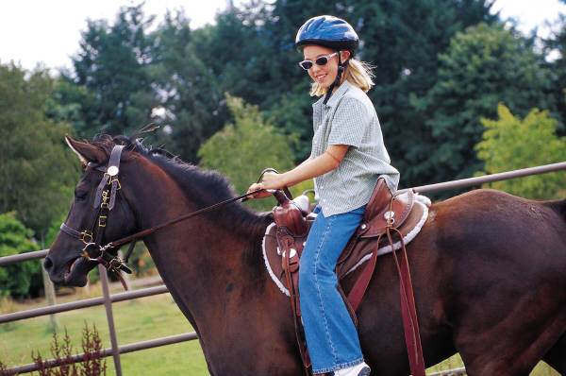
MOUNTED GAMES OPEN FUN SHOW
At Fort Leavenworth Stables Activity, Fort Leavenworth, KS
10 am – Sunday, May 8, 2011

Organizer / Show Manager: Major Kelly Dobert – kelly.dobert@yahoo.com (828) 505-6208 / (804) 931-6450
Show Website: http://SunnySandsHorseEvents2011.webstarts.com Show Email: sunnysands2011@yahoo.com

Events: 1. Tire Race (I & P), 2. Saddling Race (I & P), 3. Ribbon Race (P), 4. Musical Feedbags (I),
5. Egg & Spoon Race (I & P), 6. $it-A-Buck (I), 7. Pole Bending (Left First) (I & P),
8. Pole Bending (Right First) (I & P), 9. Command Class (I), 10. Keyhole Race (I & P),
11. Baby Bottle Race (I & P), 12. Run, Ride, Lead (I & P), 13. Stake Race (I & P), 14. Ball & Cone Race (I & P), 15. Flag Race (I & P), 16. Knockdown & Out (I), 17. Pairs Class (P), 18. Cloverleaf Barrels (Left First) (I & P),
19. Cloverleaf Barrels (Right First) (I & P), 20. EDGE Mystery Class (I)
OFFICE FEE: $10 per # (Horse/rider combos entering same event more than once must use different # for ea. ride, points accrue separately for ea. #)
ENTRY FEE: (member*/nonmember) Individual (I): $5 / $8 per event Pair (P): $9 / $15 per event *proof of membership required
PRE-ENTRY: See Website. Online entries encouraged. One lucky pre-entry will win their entries for FREE (25 pre-entry minimum)! Also, get a % of your entry fees REFUNDED on ALL PRE-ENTRIES based on how early your complete entry is received. So register ASAP!!!
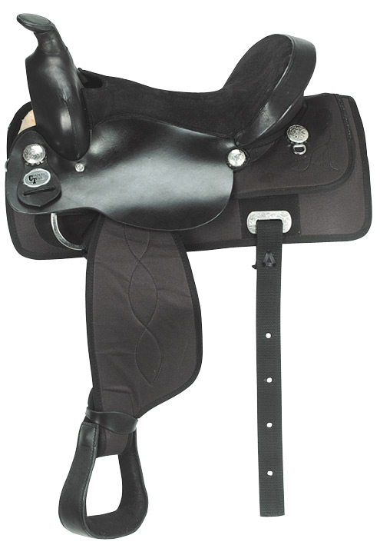

JACKPOT FEE: $10 per ride (+ Individual Open level only) Payout: 1st = 50% 2nd = 35% 3rd = 10% 4th = 5%
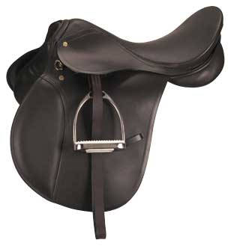
(OPTIONAL)

JACKPOT = $200 ADDED, 100% PAYBACK
(minimum)

Mail entries (payable to Sunny Sands c/o Kelly Dobert) w/ Coggins to: Sunny Sands Gymkhana, 33174 199th St, Leavenworth, KS 66048; or pay online & email Coggins.

-------------------------------------------------------------------------------------------------------------------------------------------------------------------------------------------------------------------------------------------

DIVISION: (circle one) Individual Pair One form per # (horse/rider combo, pair or individual), per level, please.

LEVEL: (circle one) Open (any age) Masters (≥45) Adult (23 – 44) Senior (19 – 22) Junior (15-18) Youth (11-14) PeeWee (≤10)
Walk/Trot/Jog (any age) Walk (any age) Lead Line (any age) Management reserves the right to combine levels if number of entries warrants.

EVENTS(I): (circle) 1 2 4 5 6 7 8 9 10 11 12 13 14 15 16 18 19 20
EVENTS(P): (circle) 1 2 3 5 7 8 10 11 12 13 14 15 17 18 19
JACKPOTS(I): (circle) 1 2 4 5 6 7 8 9 10 11 12 13 14 15 16 18 19 20
(OPTIONAL)
Last Name: ________________________ First Name: ___________________ Show Day Age: ___________ Address: ___________________________________________________ City: _________________________
Phone: ___________________ Email: _________________________________ State: ____ Zip: __________
Horse’s Name: _________________________________ Member (circle if applicable) 4-H PC USEA USEF IHSA FLH FLSA

HOLD HARMLESS LIABILITY RELEASE: ALL ENTRIES ARE AT MY OWN RISK. I understand that equine activities are inherently dangerous and agree not to hold Sunny Sands Horse Events management, Fort Leavenworth, its officials, volunteers, spectators or competitors liable for injuries, loss of life, theft or damage to horses, property, spectators or competitors.
Signature __________________________________________________________________________ Date ____________________
(Legal Parent or Guardian if Under 18)
↑ Individual Entry ↑

Last Name: ________________________ First Name: ___________________ Show Day Age: ___________ Address: ___________________________________________________ City: _________________________
Phone: ___________________ Email: _________________________________ State: ____ Zip: __________
Horse’s Name: _________________________________ Member (circle if applicable) 4-H PC USEA USEF IHSA FLH FLSA

HOLD HARMLESS LIABILITY RELEASE: ALL ENTRIES ARE AT MY OWN RISK. I understand that equine activities are inherently dangerous and agree not to hold Sunny Sands Horse Events management, Fort Leavenworth, its officials, volunteers, spectators or competitors liable for injuries, loss of life, theft or damage to horses, property, spectators or competitors.
Signature __________________________________________________________________________ Date ____________________
(Legal Parent or Guardian if Under 18)
↑ Pair Entries ↑

