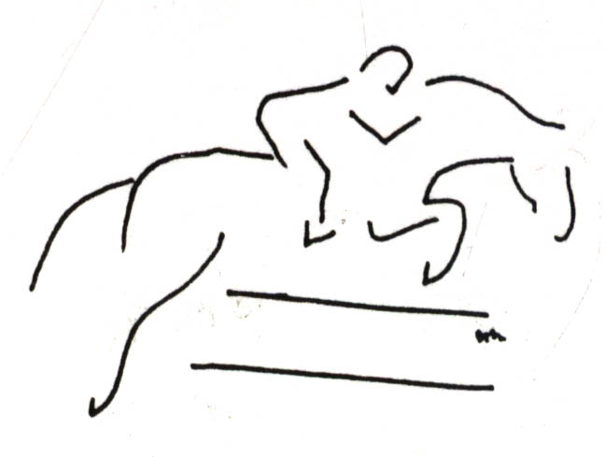

SUNNY SANDS

DRESSAGE, COMBINED TRAINING & JUMPER DERBY

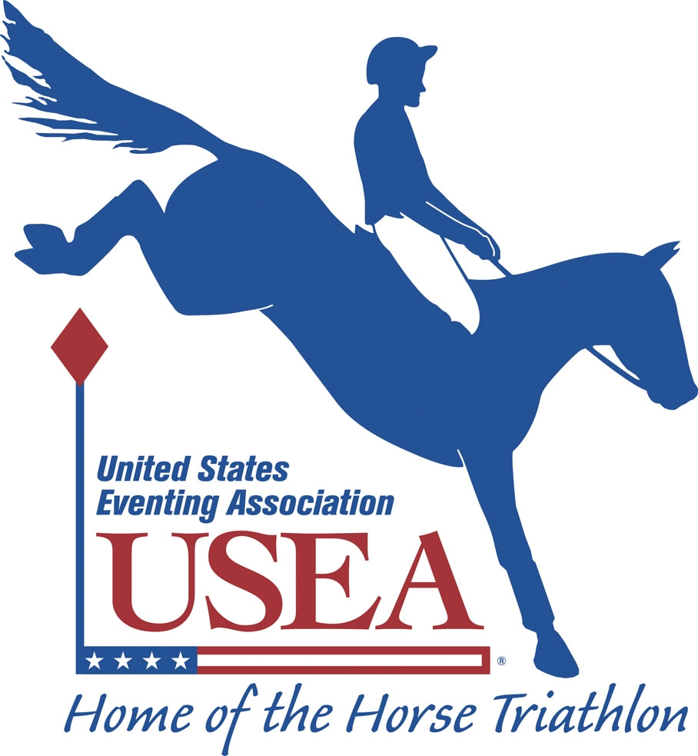
Fort Leavenworth, KS USEA Recognized Schooling Horse Show & Clinic May 7, 2011

Opening Date: March 22, 2011 Closing Date: April 20, 2011
Organizer & Technical Delegate: Major Kelly Dobert – kelly.dobert@yahoo.com (828) 505-6208 / (804) 931-6450
Show Website: http://SunnySandsHorseEvents2011.webstarts.com Show Email: sunnysands2011@yahoo.com

COMBINED TEST - $45 / division Dressage Judge: Rebecca O’Bea DRESSAGE - $25 / test
WALK/TROT Learner Graduate w/ Distinction ’11 Introductory Level Test A, B & C
Amoeba Dressage: ’11 Intro Test A ’11 Training Level Test 1, 2 & 3
Stadium “Jumps”: Ground Rails ’11 First Level Test 1, 2 & 3
Tadpole Dressage: ’11 Intro Test A ’11 Second Level Test 1, 2 & 3
Stadium Jumps: 18" X Rails max. ’11 Third Level Test 1, 2 & 3
Maiden Dressage: ’11 Intro Test B ’11 Fourth Level Test 1, 2 & 3
Stadium Jumps: 2' max. ’11 FEI Tests & Freestyles ($30)
VOLUNTEERS NEEDED!!!
(No experience needed. We’ll help you learn everything you need to know.)
SIGN UP NOW:
FREE FOOD & PRIZES!
WALK/TROT/CANTER ’11 Quadrilles & Pas des Deux ($15/rider)
Maiden W/T/C Dressage: ’11 Intro Test C ‘10 USEA Tests of Choice
Stadium Jumps: 2' max. Prix Caprilli – Intro-12”, Training-2’ & First-2’6”
PreNovice Dressage: ’10 BNov Test A ‘11 USEF Dressage Seat Equitation ($10)
Stadium Jumps: 2'7" max. ’11 Dressage Sport Horse In Hand ($10)
Novice Dressage: ‘10 Novice Test A ’11 Dressage Sport Horse Under Saddle ($10)
Stadium Jumps: 2'11" max. Walk Dressage Test A & B ($15)
Training Dressage: ‘10 Training Test A Western Dressage ($15)
Stadium Jumps: 3'3" max.
Jumper Derby - $35
PreNovice & Novice Levels *must have 10 entries to hold class
$5 to prize pot if horse/rider combo complete equivalent level CT
Payout: 1st = 50% 2nd = 35% 3rd = 10% 4th = 5%
Must pay in to win payout.
~ Concessions and vendors are planned.
~ Schooling Jump Rounds after judged rounds.
~ Dressage Arena – Dirt Footing, small when allowed.
~ One FREE entry for Family Members of deployed Soldiers.
~ All refunds: less $10 office fee. NO REFUNDS AFTER Closing Date!!
~ Ride Times will be emailed and posted on Show Website after 9pm May 4th.
~ Safety equipment is REQUIRED (i.e. boot w/ a heel, approved helmet with harness for jumping).
~ Entries received COMPLETE, on time and with no changes will receive a $2 rebate when # returned.
~ No one will be eliminated, but given penalty points, instruction, and allowed to continue safely in the competition.
~ If you do not know the rules please feel free to ask questions; education for all (competitors and spectators) is the goal!
~ Entries can be made online through PayPal w/ 5% convenience fee. However, NO entry will be processed without payment!
~ If schedule permits, complete entries RECEIVED AFTER the closing date will require a late fee of $10 / division, test or round.
~ USEF & USEA rules apply except: braids waived, but award to best turned out; whips, leg wraps, dressage test callers allowed, and no eliminations.
~ Riders can enter multiple tests &/or divisions with the same &/or different horses. Horses may be shared by two or more riders w/ prior permission.
~ Limited entries – get yours in early! Classes may be combined or split, based on number of entries. Priority may be given to those entered in the most classes.
~ Prizes & ribbons to Champ./Res. for Dressage, CT Dressage, CT & to 6th Place. Competitor and Volunteer prizes totaled $2000 for 2000-2008. Sponsors needed for 2011!!!
~ This will be a fun & educational event to introduce the equestrian sports of Dressage and Combined Training; judges will provide written & oral feedback for each test or round.
~ Tests may be ridden more than once (Fix-a-Test Clinic) with first ride to count for class placing and subsequent rides of the same test to count towards most improved ride award as well as overall fix-a-test clinic class results. All judge and organizer decisions are final.
DIRECTIONS to FORT LEAVENWORTH STABLES – WAINWRIGHT RIDING COMPLEX: See website.
Mail entries (payable to Sunny Sands c/o Kelly Dobert) w/ Coggins to: Sunny Sands D&CT, 33174 199th Street, Leavenworth, KS 66048; or pay online & email Coggins.
-------------------------------------------------------------------------------------------------------------------------------------------------------------------------------------------------------------------------------------------
Rider's Name: ________________________________ Owner’s Name: ______________________________
Horse's Name: ____________________ Horse’s Name on Coggins: __________________ For sale? ◊Yes ◊No
Rider’s Mailing Address: ___________________________________________________________________
Rider’s Email Address: ___________________________________ Rider’s Phone #: ____________________
Rider’s Birthday: ______ 4-H / PC / Academy (circle one) Club Name ______________ I will VOLUNTEER: ◊YES ◊No
Dressage / CT / Jumping experience of Rider: __________________________________________________
Dressage / CT / Jumping experience of Horse: __________________________________________________
Specify ALL Tests (& # of times to be ridden): ____________________________________________________________
Jumper Derby: ◊ PreNovice ◊ Novice Schooling Jumper Derby Round ($15 ea): ◊ PreNovice ◊ Novice
Schooling Stadium Jumping Round ($5 ea): ◊ Amoeba ◊ Tadpole ◊ Maiden ◊ PreNovice ◊ Novice ◊ Training
HOLD HARMLESS LIABILITY RELEASE: ALL ENTRIES ARE AT MY OWN RISK. I understand that equine activities are inherently dangerous and agree not to hold Sunny Sands Horse Events management, Fort Leavenworth, its officials, volunteers, spectators or competitors liable for injuries, loss of life, theft or damage to horses, property, spectators or competitors.
Signature __________________________________________________________________________ Date ____________________
(Legal Parent or Guardian if Under 18)

