ESL Pathways Series

 | 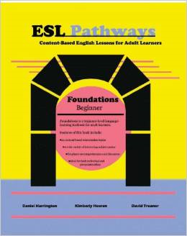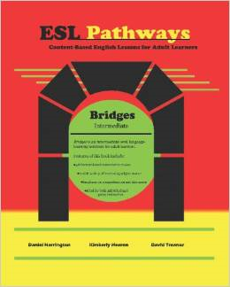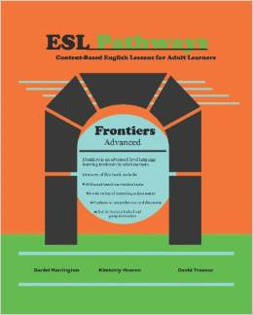 |  | +
Price for all three: $43.17
Show availability and shipping details
Buy the selected items together
- This item: Esl Pathways (Book 1): Foundations by Dan Harrington Paperback $14.39
- Esl Pathways (Book 2): Bridges by Dan Harrington Paperback $14.39
- Esl Pathways (Book 3): Frontiers by Dan Harrington Paperback $14.39

Book 1 - Foundations includes 24 lessons for beginner-level adult ESL students. Each lesson is 4 pages and includes a reading passage, review questions, discussion questions, and several activities and exercises to reinforce the material. Lessons focus on everyday activities such as running into friends, shopping, eating at restaurants, going to the bank, travelling, and more. Useful for both individual and group instruction.
Book 2 - Bridges contains 48 lessons, comprising 2 pages each. Many of the topics are similar to those in Book 1 - Foundations, but Book 2 - Bridges goes into more depth and introduces more complicated grammar and vocabulary points. Book 2 - Bridges contains longer reading passages and extensive discussion and comprehension questions, as well as several review activities. Useful for both individual and group instruction.
Book 3 - Frontiers contains 48 lessons for advanced-level adult ESL students who want to sharpen their reading and vocabulary skills. Each lesson is 2 pages and includes a long reading passage with extensive discussion and comprehension questions, as well as several review activities. These lessons are suitable for adult students who wish to attain English fluency, as the lessons include material and phrasings often seen in newspapers and more formal English settings. Useful for both individual and group instruction.

