Harford District
2018 Cub Scout Day Camp
June 26 – June 30
Cub Buccaneers, Adventures on the High Seas

Walk the Plank
(GaGa Ball)

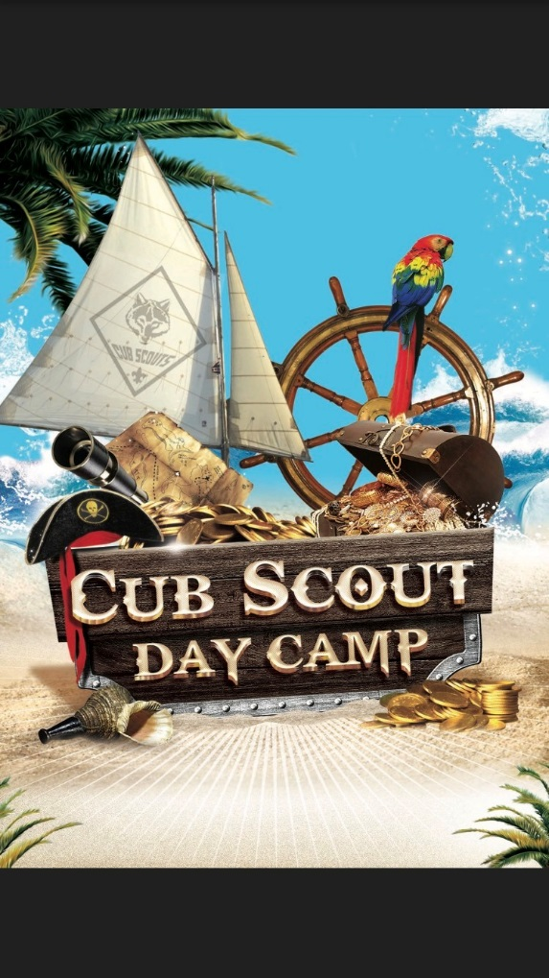

Station Volunteer’s Guide

Volunteers do not necessarily have the time;
They have the heart. And YOU are the heart of our camp. Thank you!

Please, please read this guide!
What is being covered at most stations is important so that the scouts earn the correct achievements toward rank or advancement. Some stations are JUST for fun, though and are not designed for earning anything.

HOW YOU present the material is not set in stone and can be presented in any manner that best suits you, as LONG AS THE REQUIREMENTS ARE MET FOR THE SCOUT.
…..in other words…
If you find a better way to accomplish the requirements or if the method we have outlined doesn’t seem to be working…please feel free to change it! This is only a guide…do what works best for you and the scouts coming to your station.

One other thing to keep in mind – some stations will be visited by all ranks. That means you may have 6 year olds through 11 year olds and may have to simplify or intensify the methods to meet the skills and knowledge of all the scouts.

Thanks again – we are glad to have you as part of Harford Day Camp!

Station Procedures
- Read your schedule and BE PREPARED!
- Monday: stations begin at 10:15am; Tues-Fri: stations begin at 9:15am
- Usually 2 dens at a time (max 24 youth),,,,,but there could be more
- Greet dens as they arrive. Ask for their cheer!!!
- It is very important that you start and end on time!
- Each time limit is only 45 minutes. Late arrivals CANNOT stay late; it interferes with the overall schedule. If available, they can come back at a free time.
- Execute the station with energy and enthusiasm! Let the scouts do as much for themselves as possible. It doesn’t need to be perfect, they just need to Do Their Best!
- Remember the Alamo, um BEADS!! One bead/scout/participation. (Beads can be given to the den leader for distribution.)
- Take a breath, then prepare for your next group.

- Last station of the day
Organize station items in the bag/container provided and store where directed. In case of inclement weather, take your station items to the nearest shelter where directed.
Complete a Station Evaluation (inside front cover). Return to the Admin tower or the Crouse Building.

******Last station of the week******

Dispose of anything no longer useable: please recycle when appropriate.
- Inventory your station (See the inventory sheet in the front pocket of the station guide)
- Return all items that you can to Crouse/trailer staff.
- You are ALWAYS invited to help pack up the camp!

Beginning Station Inventory
GaGa Ball
Your station should have the following:

        - Station guide
        - GaGa pit
        - GaGa balls 3

Station Objectives/Overview:
GaGa Ball

- This station is for fun, and not to meet rank or belt loop requirements.

- Since this is a wide area game with lots of boys, supervision by volunteers is important to ensure that boys are showing good sportsmanship and not being too aggressive; that each boy gets a chance to play.

- Excitement and encouraging your team is great but we will not tolerate overly aggressive play or language.

- Welcome the scouts and begin your game:

- There are two sea captains (referees). They can be youth or adult volunteers. They will stand on PORT AND STARBOARD (opposite sides) to ensure they can see the everywhere in the Walk the Plank Pit. They are the sole authorities during play and are responsible for settling disputes and ensuring fair play.
- The referee begins play only after all players are standing ON THE SHIP’S DECK and have indicated that they are ready to start.
- One of the referees will throw the cannonball (aka ball) into the pit so it bounces. Players will yell “WALK” on the first bounce, “THE” on the second bounce and “PLANK” on the third bounce. The ball in only in play after the 3rd bounce.
- Players can only hit the cannonball with their hands.
- They may not carry or throw the ball – it must be punched with an open hand or fist.
- Any player who is touched by the cannonball (either directly or by a rebound off the wall) must WALK THE PLANK by stepping out of the pit.
- If the cannonball contacts a player or a player’s clothing below the waist, they must WALK THE PLANK by stepping out of the pit.
- If the cannonball contacts the player above the waist, they are safe on the ship.
- If the cannonball goes out of the Infection pit, the last player to touch the ball (the player who hit it out) is eliminated.
- Once the player hits the cannonball, he or she must wait until the cannonball touches someone else before hitting it again (no double touches).
- If there are only two players remaining, a player may hit the cannonball again once the cannonball comes in contact with the wall.

******Last station of the week******
Lucky YOU!!
- Dispose of anything no longer useable: please recycle when appropriate.
- Inventory your station (See the inventory sheet in the front pocket of the station guide)
- Return all items that you can to Crouse/trailer staff.
- You are ALWAYS invited to help pack up the camp!

Inventory

Walk the Plank (Ga Ga Ball)

 | opening | closing
station guide | 1
Gaga balls

