Harford District
2017 Cub Scout Day Camp
June 26-June 30
BUGS

GermNation

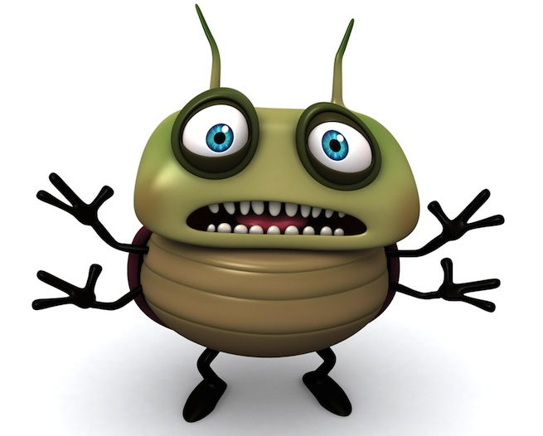

Station Volunteer’s Guide

Thank you for being a station volunteer! The stations are the heart of camp and truly provide our scouts with an opportunity to try out a new skill (or build on one they know) while having a great time. Our volunteers’ knowledge and enthusiasm is what makes our camp great!
To make running the station easier, please take some time to read through the station guide. While, what is being covered at the station needs to remain as outlined so that the scouts earn the correct achievements, how it is covered is only one of many methods. If you find a better way to accomplish the requirements or if the method we have outlined doesn’t seem to be working…please feel free to change it! This is only a guide…do what works best for you and the scouts coming to your station.
One other thing to keep in mind – some stations will be visited by all ranks. That means you may have 6 year olds through 11 year olds and may have to simplify or intensify the methods to meet the skills and knowledge of all the scouts.
Thanks again – we are glad to have you as part of Harford Day Camp!
Station Procedures
- The first station begins at 10:15 on Monday and 9:15 other days…so you have some time! We’ve tried to only schedule 2 dens at a time (max. 24 boys) but, there may be times when you have 3. Consult your station schedule so you will know who to expect and when.
- Greet dens as they arrive. Many will have a den cheer, ask to hear it!
- Once all the dens arrive or the start time has come, begin going through the procedures for the station. It is very important that you start and end on time! Each time slot lasts 45 minutes. If a den arrives 10 minutes late, they CANNOT stay 10 minutes past the end of the station…that would make you and them late for the next station. If a den doesn’t get finished, suggest they come back during a break or take the remaining activity with them to work on at the den.
- Execute the station with energy and enthusiasm! Let the scouts do as much for themselves as possible. It doesn’t need to be perfect, they just need to Do Their Best!
- Don’t forget the beads. Each scout earns a bead at every station for participating. Beads can be given to the den leader for distribution.
- Once the den is finished, begin resetting for the next group.
- Close the station at the end of the day by packing/organizing the supplies and cleaning and disposing of all trash. Let the Program Director responsible for the station (either Tiger/Wolf/Bear or Webelos) know if supplies are running short!

Station Overview
Discussion and hands-on activities will complete this station.

Set-up:
Open bins and:

- Take out the supplies for Handwashing Experiment (lotion, glitter, paper towels). Also take out the handwashing poster and put together.
- Take out the supplies for the Bread Mold Experiment (bread, tongs, baggies, sharpie, example moldy bread).
- Take out hand washing station supplies (dishpans, hand soap, paper towels, buckets of water)

Break-Down
- Return all materials to the bins.
- Please assure that all bins are closed tightly and place under the tent for the night.
- In the event that rainy weather is expected, please take the bins into the Crouse building for the night.

Station Objectives:
Each scout will learn about how easily germs are spread, what it looks like on food, and the easiest way to avoid getting sick.

Activity 1: Bread Mold Experiment
- Each den will need 4 baggies and 4 pieces of bread.
- Have the scouts work on labeling the baggies:
  - NOT TOUCHED 1
  - NOT TOUCHED 2
  - TOUCHED 1
  - TOUCHED 2
- Have 1 scout hold a NOT TOUCHED baggie open while another scout uses the tongs to take a piece of bread out of the package and place it into the baggie. Then seal the baggie.
- Have another set of scouts work on placing the second NOT TOUCHED bread into the baggie.
- As a den, have the scouts take 1 piece of bread out of the package and pass it around so each scout touches it with their hands. This is to get the germs onto the bread. Then place it into one of the TOUCHED baggies.

- Repeat step 5 with the second TOUCHED piece of bread.
- Discuss with the scouts why they needed to have the control pieces that were not touched to compare to the touched pieces of bread so they can see the difference when the mold begins to grow on the TOUCHED bread.
- Show the scouts what their TOUCHED piece of bread will look like after a few days (using the example in the box).
- All 4 baggies with bread in them will go back with the den to their den area. They will check the bread every day to watch for mold growth.

Activity 2: Germ Spread Experiment
- Have all the scouts use a small amount of lotion on their hands. Have them lightly rub it in. This is to simulate sweat and help hold the “germs” onto their hands.
- Then place glitter into the hands of 1 scout. Make sure there is a good amount of glitter.
- Have the first scout shake hands with the next scout to pass on the “germs” (aka glitter).
- Continue having the scouts go around and shake hands so everybody has “germs” on their hands.
- Explain that this is how germs can spread from person to person.

Activity 3: Handwashing Experiment
- Now they will experiment with how to best clean their hands to stop the spread of germs. First, have them try to rub the glitter off with just a paper towel (lightly). See how many “germs” are left.
- Next, have them wash their hands under plain cold water (NO soap). Look to see how many “germs” are left.
- Then, have them use soap and water. Compare how many “germs” are left now.
- Discuss the importance of handwashing. “What does the glitter represent (Germs)? What happened when you tried to get it off with just paper towels? Cold water? Warm, soapy water? Why is it important to properly wash your hands?
- Teach them the hand washing song found below.

Background that may be helpful….
What's Going On in the bread mold experiment? Mold will grow on both slices, but much sooner and more abundantly on the “Touched” slice. Help your child understand that the germs that he or she did not see on the “wiped-off” hands became food for the mold. We certainly wouldn’t want to eat those germs, would we? Best to wash them off before we handle food! Teach your child to sing following song while scrubbing hands at the sink. It will keep them scrubbing long enough to get the germs off!

The Handwashing Song (To the Tune of Frere Jacques)
Over, under
Over, under
Scrub between
Scrub between
Rinse the tops and bottoms
Rinse the tops and bottoms
Hands are clean!
Hands are clean!

