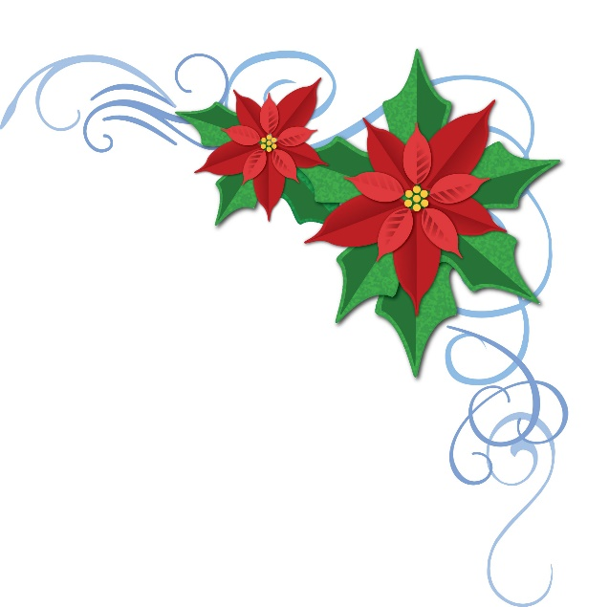
Christmas 2018

Our Pastoral Legacy
Rev. & Mrs. Joseph Judah Woolley 1882-1906
Dr. Mary E. Woolley-Missionary
Rev. & Mrs. John J. Brokenshire, D. D. 1907-1917
Rev. & Mrs. Henry Burnham Kirkland 1919-1923
Rev. David Nelson Beach 1924-1927
Dr. & Mrs. Ralph Orin Harpole 1928-1945
Rev. & Mrs. Carl Archibald Glover 1943-1957
Rev. John Roland Palangio 1958-1963
Rev. & Mrs. Whitmore Beardsley 1963-1972
Rev. Maxwell L. Clough 1974-1980
Rev. Gary A. Bouchard 1998-2006
Rev. Robert Mitchell 1972-1984

The large White Poinsettia on the Altar is given to the Glory of God by the Larson Family in loving memory of Stephen’s Aunt, Pricilla Taylor

In Loving Memory of… Given by…
Devin Abbott Wayne Patenaude & Glenn Marr
Joseph & Maria Aulisio, Kevin Dunn and the rest of the Family Claudia Dunn
Mary Beck & Lynn Dieterich Wayne Patenaude & Glenn Marr
Harold & Erma Birchall Bill & Darlene McMillan
Agnes Bonar Wayne Patenaude & Glenn Marr
Pastor Gary & Mimi Bouchard Wayne Patenaude & Glenn Marr
Gerrit & Jan Brouwer Leslie Brouwer
Alice & Paul Brown & Alice’s daughter Marian D. Fusco Barbara & Dan Langford
Frank Carter from his loved ones
Hayworth Carter, & Wray loved ones the Carter Family
CC Drolet Wayne Patenaude & Glenn Marr
David David & Jido Wayne Patenaude & Glenn Marr
Claudia Deschenes & Wendy Lincoln Bill & Darlene McMillan
Judy Fernald Leslie Brouwer
Mr. & Mrs. Richard Fontaine, Sr. the Gray-Frappier Family
Mr. & Mrs. Edwin Gray the Gray-Frappier Family
Jack Hamel Wayne Patenaude & Glenn Marr
Kim Harris Shirley Harris
Cam Horton Wayne Patenaude & Glenn Marr
Richard & Dorothy Leonard the Ouellette Family
Robert & Ruth Lewis the Ouellette Family
William & Grace Lewis the Ouellette Family
Evelyn Malchowski (Mom) Glenn Marr & Wayne Patenaude
William & Margaret McMillan Bill & Darlene McMillan
Claude & Edna Mixer Bill & Darlene McMillan
All our Loved Ones the Neves Family
Clarence Ouellette the Ouellette Family
Bill Pacelt Carl & Peggy Boesch
William Pacelt with love, the Pacelt & Usher Families
Pacelt Family from their loved ones
Ralph & Eileen Patenaude Wayne Patenaude & Glenn Marr
Maggie Ginny Platt
Vicky Ginny Platt
Normand & Wilhelmina Robbie Wayne Patenaude & Glenn Marr
Theresa “Mimi” Troiano from her grandchildren & great-grand children
Betty Sides Glenn Marr & Wayne Patenaude
Fr. Aaron Usher Jr. Aaron, Lynn, Kaitlyn & Cali
Mr. & Mrs. Christopher Wray the Carter Family
Harry & Bev Wray Ellen & Isabella
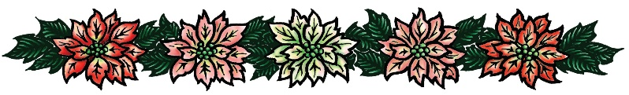

In Honor of… Giving by…
Ellen Pacelt Carl & Peggy Boesch
Isabella Carter Carl & Peggy Boesch
My Grandchildren Catherine Shute

A Christmas Prayer
O God our loving father, help us rightly to remember the birth of Jesus that we may share in the song of the angels, the gladness of the shepherds and the worship of the wise men. Close the door of hate and open the door of love all over the world. Deliver us from evil by the blessing that Christ brings, and teach us to be merry with clear hearts.
May the Christmas morning make us happy to be thy children and the Christmas evening bring us to our beds with grateful thoughts, forgiving and forgiven, for Jesus' sake. Amen.
-Robert Louis Stevenson

Memorial & Honorary Poinsettias
December 2019
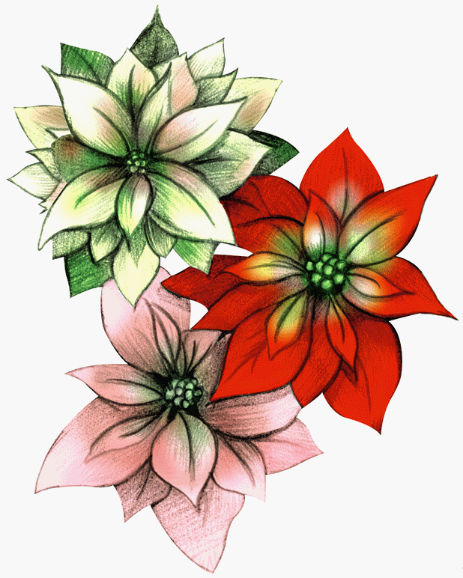

Christmas may be a day of feasting or of prayer,
but always it will be a day of remembrance —
a day in which we think of everything we have ever loved.

