C:\Users\Owner\Pictures\Clip Art Work\matt18.tiff**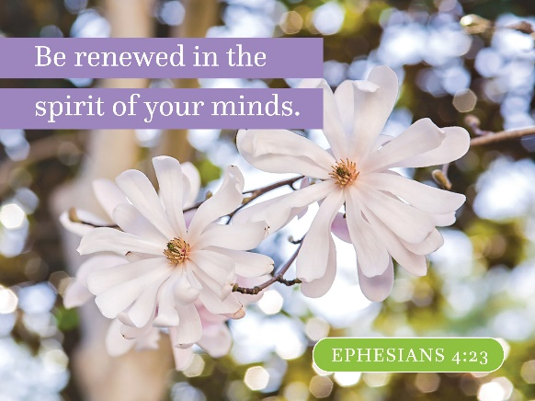The Spire**

June 2019

The Pastor’s Moment…

Dear Park Place friends and family,

Spring is one of my favorite times of the year as everything that has been in a state of hibernation becomes promises of renewed life. As the trees begin their process of awakening, the tips of the branches begin to change color and, soon enough, begin to sprout buds that will turn into flowers and then leaves. There will be leaves of every shape and color and it will be beautiful. Grass which many times has turned to a dull Brown hue, begins to show signs of new life and starts to turn green. Bushes and flowers begin to bloom as well and seemingly, almost like overnight, the world is a full array of color and abundance of life.

As we are nearing the end of Eastertide, this is so appropriate as we have been celebrating new life in our church year as well. We strive to be beacons of light and to be extravagant signs of welcome in God’s world. We strive to be God’s messengers and ambassadors of good will, charity, kindness and love. We work together to do our part to feed the hungry, clothe those in need of clothing and offer kind words and deeds to a world that so desperately needs to be loved. Come and share with us as we offer ourselves in love and service to our community and our world. May we all work together to make the world a better place...for we, you and I can make it better if we work together as brothers and sisters for a better world. Come and be part of the journey!!!

With Love in Christ’s Service,

Pastor Wayne

**C:\Users\Linda\Desktop\Clip Art\assist_9632c.wmfMay Worship Assisting**

**stepup_6677cGreeters & Ushers:** *Mike Padula & Ginny Platt; Padula family; Lois & George Grenier*

**Lay Readers:** *Darlene McMillan; Andrea Padula; Shirley Harris; Kristine Gervais*

**Coffee Hour Hosts**: *Darlene McMillan; Lynn Usher; Wayne Patenaude*

***Coffee Hour needs TWO HOSTS per week in June. If you’d like to host a Sunday, please fill out the sign-up sheet downstairs in the hall. Thank you!***

**Worship Schedule**

*Worship begins at 10 a.m. each Sunday Morning!*

**June 2:** *Holy Communion Worship – 10 a.m. with Pastor Wayne leading– Deacons:* *Darlene McMillan & Dawn Shaw / Coffee Hour 11 a.m./* Sinai Church 1-3 p.m./ *Singing at the Holiday Retirement Home 2 p.m. - All are welcome!*

**June 9:** *Pentecost Sunday- Worship- 10 a.m. with Pastor Bill leading; Baby Dedication: Grace Chiaramonte/ Coffee Hour 11 a.m. /* Sinai Church 1-3 p.m.

**June 16:** *Trinity Sunday - Worship – 10 a.m. with Pastor Bill leading* /Happy Father’s Day!*/ Coffee Hour 11 a.m./* Sinai Church 1-3 p.m.

**June 23:** *Worship- 10 a.m. with Pastor Wayne leading/ Coffee Hour 11 a.m./* Sinai Church 1-3 p.m.

**June 30:** *Worship 10 a .m. with Pastor Wayne leading/ Coffee Hour 11 a.m. /*Sinai Church 1-3 p.m./ *Music & Praise 6 p.m. Featuring the Singing Pastors!*



**Dedication & Baptisms!**

On June 9, Grace Chiaramonte will be dedicated to the Glory of God! Grace is the loving daughter of Mark & Andrea Chiaramonte and granddaughter of Bill & Darlene McMillan.

On June 23, Clayton Matthew Benevides will be baptized to the Glory of God! Clayton is the loving son of Dominick Benevides and Ashley Carter. Clayton is great-grandson of Isabel Carter.

Blessings to both of our New Babies and their families. May the Lord bless them and watch over them as they grow in faith.

***Anthem Dedication...***

*Oh Sunday, May 12, the Anthem, “We Are One in the Lord,” was given to the Glory of God by Ginny Platt in loving memory of Maggie Platt on the 8th Anniversary of her entry into her heavenly home.*

Hello Everyone,

Seems summer is finally arriving; hope you are enjoying the sunshine. We have a busy month of June. In addition to our regular activities there will be the PMO Concert on the 1st and Karen Grenier’s concert June 22nd. I can’t forget Father’s Day on Sunday, June 16th. I would like to take a moment to recognize my Dad, something I never did when he was alive. He was a quiet, unassuming man, well known in my hometown in CT. I have two fond memories – when I was about five years old I was at the fire house with him when a call came in. I rode in the fire truck with him - an open cab, no doors, no seatbelts! My pigtails were flying in the wind. My Dad held onto my shirt with his right hand, drove and shifted with his left hand. It was wonderful! The other memory is when he saved a man’s life. We were walking at the Town dock/marina and suddenly my Dad took off running back the way we had come. My Mother and I then saw a man tangled in rope hanging off a boat. Other than gratitude from the man, there was no recognition for my Dad, except that he remains a hero in my memories. Happy Father’s Day in Heaven, Dad, and to all sorts of Dads everywhere. And a safe and blessed summer to all Park Place Family members.

With warm blessings,

Shirley

****Park Place Congregational UCC Missions**

***Please remember* *All are welcome to join any activity or***

***just drop in to see what is going on!***

**C:\Users\Linda\Pictures\Clip Art\music_3516c.wmf*Let’s Sing!***

We will be going to The Holiday Retirement Home in Manville, RI, and sing to/with the residents for about an hour on June 2. We’d love to have you join us.

***Thrift Shop – Stop on Buy!!!***

Come stop by on Wednesdays & Saturdays from 8:30 a.m.-12:30 p.m. Great clothes to choose from for the young kids to teens and adults! We also have great treasures to find, from jewelry to framed art to knickknacks! Come see what peeks your interest.

C:\Users\Linda\Pictures\Pictures\PPC Clip Art\food_1129c.tifThe Board of Deacons are collecting non-perishable foods for our needy community members. Items needed are: single serve peanut-butter, jelly, tuna & chicken salad with crackers, crackers & cheese, single serve mac & cheese, easy open soups, single cups of tea and coffee and travel size sun screen. Please bring items to church on Sundays and place in the box in the Narthex. Thank you for your generosity.

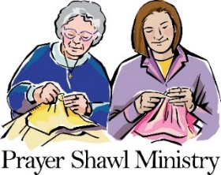Our Prayer Shawl Ministry continues to add to the lives of all who receive them; so much so that we are running very low on our wonderful prayer shawls! ***Prayer Shawls continue to be greatly needed!*** Our meetings are every 3rd Sunday of the month from 2-3:30 p.m. Hope to see you in June! Please continue to make shawls. Prayer shawls should be 25-30 inches wide and 70 inches in length.

**June Memorial & Honorary Altar Flowers**

**June 2:** *The Altar flowers are given to the Glory of God by Rodger Lawton, Joan, and Laurie Lynn Lawton in loving memory of his mother Jean Lawton.*

***June 9:*** *The Altar flowers are given to the Glory of God by Cathy Shute in honor of our wonderful Chancel Choir.*

***June 16:*** *The Altar flowers are given to the Glory of God by Bill and Darlene McMillan in loving memory of Mom & Dad McMillan and Mom & Dad Mixer.*

***June 23:*** *The Altar flowers are given to the Glory of God as an expression of love and birthday remembrance of Alice D. Picard by her family.*

***June 30:*** *Open Sunday…If you would like to donate flowers for this Sunday, please see either Dawn Shaw, Terry May Neves or Ginny Platt. Thank you*

*(Note: Thank you for your donations of the beautiful altar flowers each week, your continued support is greatly appreciated. Please remember that payment of $35.00 for the altar flowers is due during that month. Thank you for your attention.)*

**? ? ? ? ? ? ? ? ? ? ? ? ? ? ? ? ? ? ? ? ? ?**

**Bible Quiz**



Which follower of Jesus preached to the crowds after receiving the Holy Spirit on Pentecost?

A. John

B. Peter

C. Mary Magdalene

D. Paul

**\*\*\*\*\*\*\*\*\*\*\*\*\*\*\*\*\*\*\*\*\*\*\*\*\*\*\*\*\*\*\*\***

**Angels along life’s trail**

Weary long-distance hikers sometimes encounter “trail angels” — people who offer food and drink, bandages, shoelaces and even a place to do laundry. Along the Pacific Crest Trail, one home, dubbed Hiker’s Heaven, serves as a mail drop. Trail angels say they find great joy in offering kindness to strangers.

Unexpected kindnesses — and regular rest stops — make any journey less grueling and more enjoyable. That’s also true on the journey of life as we experience (and bestow) generosity and pause to spend time with God. After all, “It is God to whom and with whom we travel,” said Elisabeth Elliot. “And while he is the end of our journey, he is also at every stopping place."

For Our Youth…



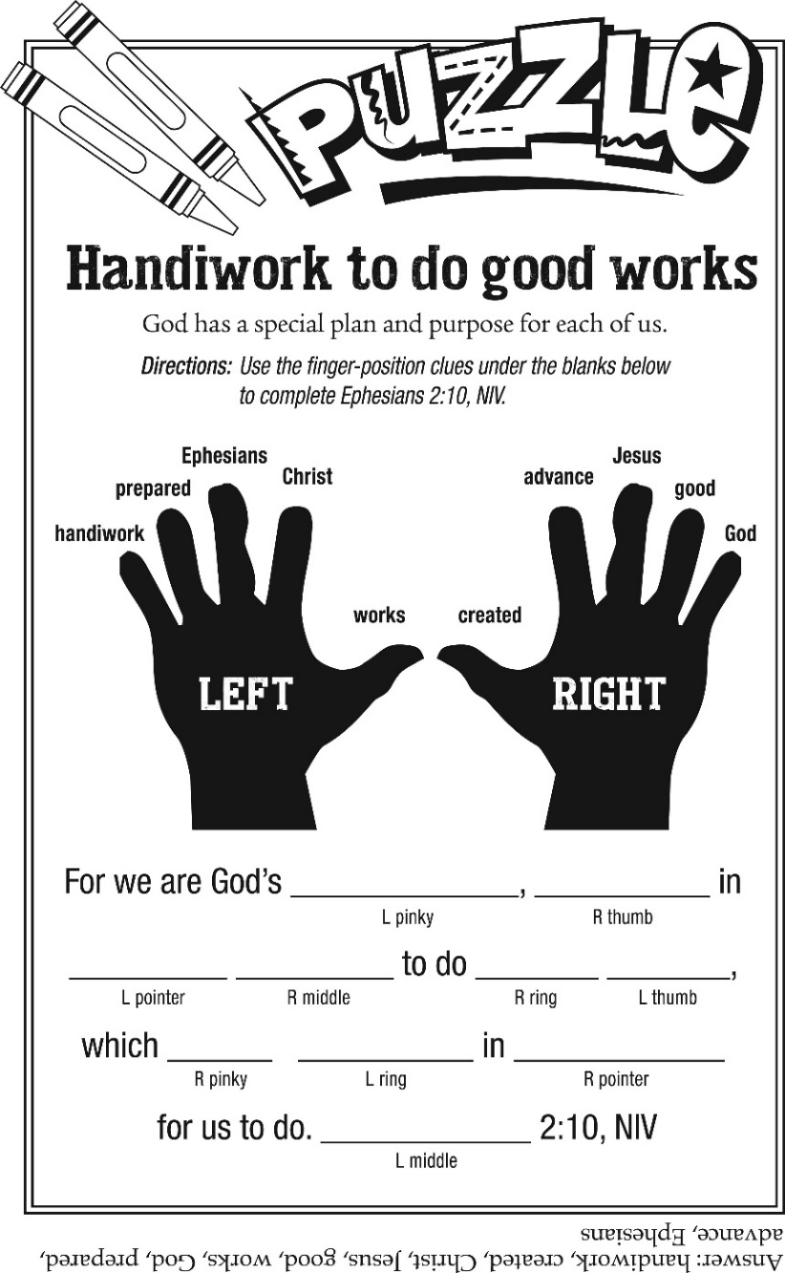

Bible Quiz Answer:Answer: B (See Acts 2:14ff.)

Park Place Congregational United Church of Christ

71 Park Place

Pawtucket, RI 02860

Phone: 401-726-2800

Email: [office@ppucc.necoxmail.com](mailto:office@ppucc.necoxmail.com)

Website: parkplaceucc.com