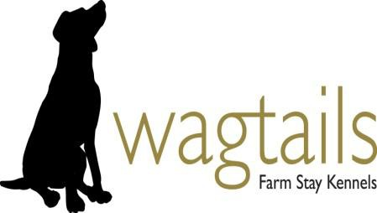WAGTAILS FARM STAY KENNELS
New Acres Farm, New Acres Road, Stanley, Co Durham. DH9 7HH Telephone 01207 233 534 / 07561 006 779
BOOKING FORM

Arrival date & time Departure date & time No of nights stay
Arrival between 3.30pm - 5.00pm Departure between 9.30am - 11.00am

Single Kennel £16/night/dog. Family Kennel (2/3 dogs) £13.50/dog/night Please enclose Deposit - 50% of total Kennel fee £
Office use
Vaccine & KC
Microchip
Kennel deposit
Kennel balance
other
other
other
Total
Account no
Booking ref no
Invoice no

(Please make cheques payable to 'Wagtails')

OWNER DETAILS
Name Address

Post code Telephone Mobile Email

CONTACT DETAILS
WHILE DOG/S AT KENNELS VETERINARY DETAILS

Name Name Address Address

Post code Post code

Telephone Telephone

Mobile

DETAILS DOG 1 DETAILS DOG 2 DETAILS DOG 3
Name of dog Date of birth Microchip No. Sex M/F Neutered Y/N Breed/description

Medicine

Food

